**Impact of Initial Population Size on Resource Distribution and Societal Equilibrium in Sugarscape Models**

**Aim:**

The objective of this study is to rigorously examine the intricacies of agent-based behaviors within the three distinct Sugarscape models: Sugarscape 1 Immediate Growback, Sugarscape 2 Constant Growback, and Sugarscape 3 Wealth Distribution, with a specific focus on varying initial population sizes. As population density can greatly influence the dynamics of agent interactions, resource utilization, and emergent societal behaviors, it becomes imperative to understand its nuanced effects within these models. This research will delve deep into questions such as: How does a denser or sparser initial population affect resource allocation? Are there evident patterns or thresholds in wealth distribution that arise due to the change in starting populations? How do these models react in terms of societal stability, and are there breakpoints at which behaviors dramatically shift? By systematically altering the initial population size, we endeavor to unearth the underlying mechanisms and behaviors that come to the forefront, thus aiming to provide a comprehensive understanding of population dynamics. This exploration will not only enhance our comprehension of the Sugarscape models but will also draw parallels and offer insights into real-world challenges surrounding population growth, resource scarcity, and societal behaviors.

**Method:**

In the context of this research, three distinct Sugarscape models were extensively probed, each calibrated to emphasize the ramifications of different initial population densities on model dynamics. Across the entirety of these models, the agent population was systemically set to vary from an initial count of 100, incrementing up to 1,000 in steps of 100 agents.

For the Sugarscape 1 Immediate Growback model, visualization was deactivated to purely focus on numerical outputs, as reflected in the parameter ["visualization" "no-visualization"]. Concurrently, the initial population was varied using the ["initial-population" [100 100 1000]] setting. Similarly, in the Sugarscape 2 Constant Growback model, visual representation was again eschewed in favor of pure data analysis, represented by the ["visualization" "no-visualization"] parameter. The population variations were manipulated using the ["initial-population" [100 100 1000]] parameter, mirroring the setup from the first model. Diverging slightly in its setup, the Sugarscape 3 Wealth Distribution model integrated a richer layer of parameters. Here, the sugar endowments for agents were set to fluctuate between a minimum threshold of 5 and a ceiling of 25, controlled by the ["maximum-sugar-endowment" 25] and ["minimum-sugar-endowment" 5] parameters. Visualization was uniformly disabled using the ["visualization" "no-visualization"] parameter, and population counts were varied in line with the previous models using the ["initial-population" [100 100 1000]] setting.

To ensure data reliability and robustness, every simulation within this study was executed 100 times, with each run persisting for a time span of 100 units. Throughout these experiments, two primary metrics were rigorously monitored: the total agent count, captured by count turtles, and the mean sugar amount held by the agents, derived from mean [sugar] of turtles. Both metrics provided invaluable insights into how initial population densities sway agent interactions and resource allocation across the Sugarscape landscape.

**Results:**

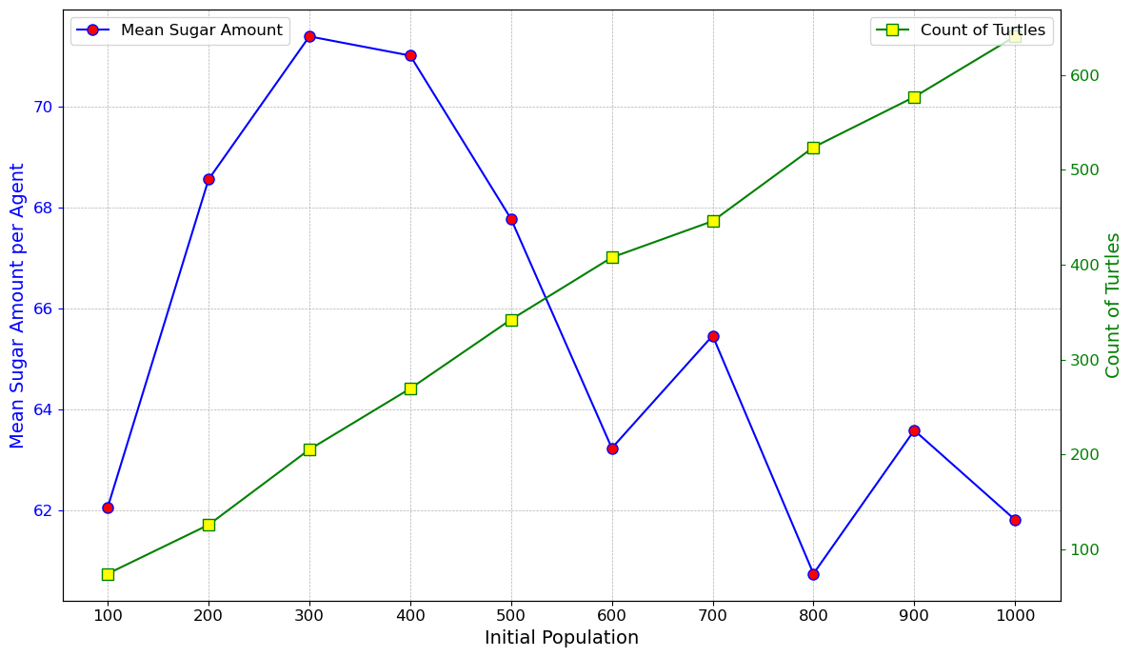

Figure 1. Mean Sugar Amount and Turtle Count vs. Initial Population in Sugarscape 1 Immediate Growback.

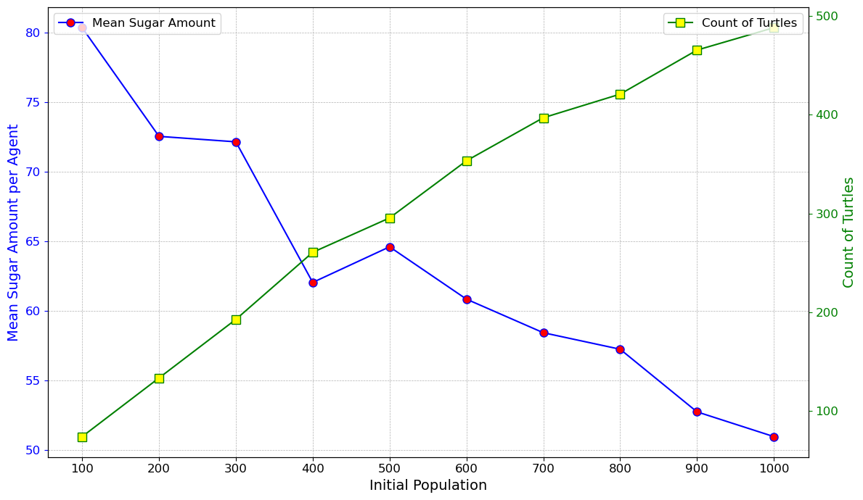

Figure 2. Mean Sugar Amount and Turtle Count vs. Initial Population in Sugarscape 2 Constant Growback.

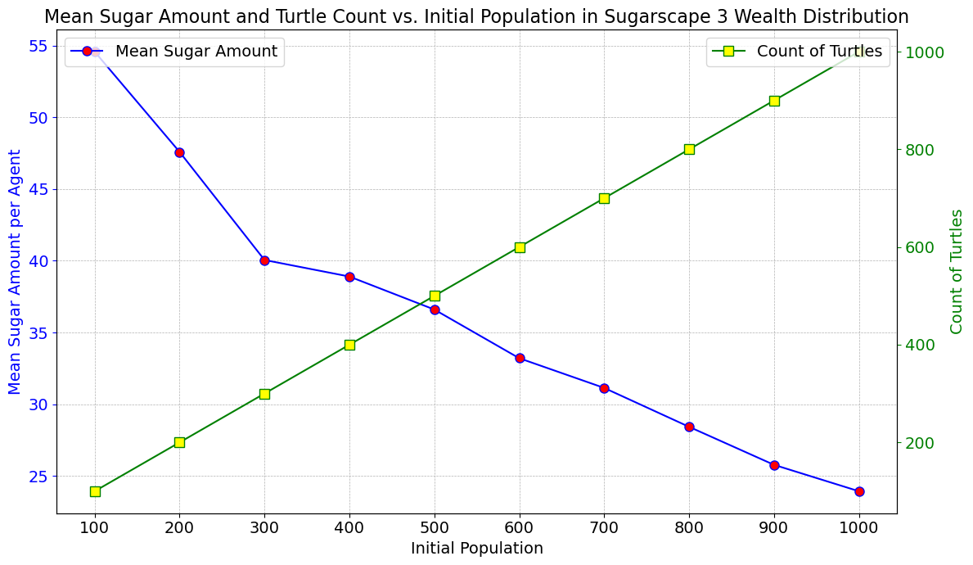

Figure 3. Mean Sugar Amount and Turtle Count vs. Initial Population in Sugarscape 3 Wealth Distribution.

**Discussion:**

Upon reviewing the results of the three Sugarscape models - Immediate Growback, Constant Growback, and Wealth Distribution - we can draw several conclusions that offer insights into the dynamics of resource allocation, sustainability, and the impact of population on resource consumption.

In the Immediate Growback model (Model 1), the mean sugar amount possessed by agents demonstrates a nuanced relationship with the initial population. As the initial population rises, there's a subtle decline in the average sugar amount. This pattern seems indicative of a growing competition for sugar resources among the agents. The more agents there are, the harder it becomes for each to gather significant amounts of sugar. This behavior is expected in environments where resources immediately replenish, as agents constantly exploit the sugar patches, ensuring a continuous yet competitive supply. Interestingly, the number of turtles or agents in this model scales in a manner that's relatively proportional to the initial population, hinting at a supportive ecosystem where resources, though competitive, are abundant enough to sustain the population.

Moving on to the Constant Growback model (Model 2), the results present a distinct narrative. The mean sugar amount begins on a higher note for smaller initial populations but undergoes a more pronounced decline as the populations grow. While the sugar in this model regrows at a constant rate, it appears not to be swift enough to fully satisfy a larger population. Consequently, as more agents enter the ecosystem, the per-agent sugar quantity drops, reflecting a stiffer competition. The turtle count in this model showcases an intriguing non-linear correlation with the initial population, perhaps alluding to inherent population stabilization mechanisms embedded in the model's rules.

The Wealth Distribution model (Model 3) offers a fascinating exploration into the dynamics of resource equity. With stipulated maximum and minimum sugar endowments, it starts with a lower average sugar amount per agent. As the initial population rises, this average witnesses a decline, suggesting that even in a wealth-distributed environment, competition remains an undeniable force. The increase in turtle count with the initial population is more gradual compared to Model 1, hinting at an environment that, while fairer, might be slightly less resource-rich or supportive

Taking a step back and comparing the models, several overarching themes emerge. Model 1, with its immediate growback mechanism, appears to be the epitome of sustainability, effortlessly supporting a large turtle population. Model 2, despite its constant resource replenishment, doesn't quite match up to the population support level of Model 1. Model 3, with its emphasis on equitable resource distribution, makes an intriguing case: fairness might sometimes come at the expense of overall resource abundance. Another pivotal observation is the universal impact of population on resource distribution. Across all models, a swelling initial population invariably strains resources, leading to a reduced average sugar per agent. This highlights a fundamental ecological principle: resources, no matter how abundant, can only support a limited population, and beyond a certain threshold, scarcity and competition become inevitable.

**Conclusion:**

In alignment with our stated aims, our exploration into the Sugarscape models has provided a deeper comprehension of agent-based behaviors under varying population densities. Our focus on Sugarscape 1 Immediate Growback, Sugarscape 2 Constant Growback, and Sugarscape 3 Wealth Distribution, each with its unique dynamics, has revealed several pivotal findings.

Our first key observation pertains to the direct correlation between initial population sizes and resource allocation. A denser population, while indicative of a thriving ecosystem, inherently exerted pressure on resource consumption, leading to decreased average resource allocation per agent across all models. This aligns with the anticipated challenges of real-world population growth and the consequent resource scarcity. Further, nuances in wealth distribution were observed, especially pronounced in the Wealth Distribution model. As initial populations grew, even an environment that aimed at equitable resource distribution began to showcase strains, thus underscoring the inherent challenges associated with sustaining larger populations, even in a designed equitable system. Regarding societal stability, all three models exhibited different thresholds and patterns. While the Immediate Growback model showcased a remarkable resilience, supporting larger populations with relative ease, the Constant Growback model showed signs of strain, even with its continuous resource replenishment. The Wealth Distribution model, while providing a fair start, still hinted at the complex interplay between fairness, resource abundance, and population size.

To conclude, by modulating the initial population sizes within the Sugarscape models, this research has successfully unearthed intricate agent behaviors and their repercussions on resource consumption and distribution. The observed patterns resonate with challenges faced in real-world scenarios, emphasizing the importance of sustainable resource management, especially in the face of burgeoning populations. Our findings thus not only achieve the objectives of understanding the Sugarscape models in depth but also accentuate the importance of these insights in broader societal contexts, bridging the gap between simulated environments and real-world challenges.