**计算机视觉课程设计-华为内容三**

**目录**

实验3-1

实验3-2

选做1

**实验3-1**

**实验要求：**

在modelarts上跑通肺实质分割训练及推理代码。

**代码及结果如下：**

import multiprocessing  
import os  
import mindspore.dataset as ds  
from mindspore import Tensor  
import numpy as np  
import mindspore.dataset.vision.py_transforms as py_vision  
from mindspore.dataset.transforms.py_transforms import Compose  
from mydataset import DatasetGenerator  
from mindspore import nn  
from mindspore.train.serialization import load_checkpoint, load_param_into_net  
from mindspore.train.model import Model  
from mindspore.train.loss_scale_manager import FixedLossScaleManager  
from mindspore.train.callback import LossMonitor, TimeMonitor, ModelCheckpoint, CheckpointConfig  
from mindspore import context  
from nestedunet import NestedUNet  
from FWIoU_metric import EvalCallBack, FWIoU  
from loss import WeightedBCELoss  
from UNet import UNet  
from attention_Unet import AttU_Net  
import argparse  
*# import moxing as mox*import learning_rates  
from config import cfg  
  
*# 训练代码*def train():  
  
 *# 训练图像集* imgtrain_list = []  
 train_dataset_generator = DatasetGenerator(os.path.join(cfg.DATA_DIR, cfg.TRAIN_DIR), cfg.IMAGE_DIR, cfg.LABEL_DIR, imgtrain_list)  
 *# 测试图像集* imgtest_list = []  
 valid_dataset_generator = DatasetGenerator(os.path.join(cfg.DATA_DIR, cfg.VALID_DIR), cfg.IMAGE_DIR, cfg.LABEL_DIR, imgtest_list)  
  
 train_dataset = ds.GeneratorDataset(train_dataset_generator,["image", "label"], shuffle=False)  
 valid_dataset = ds.GeneratorDataset(valid_dataset_generator,["image", "label"], shuffle=False)  
  
 train_dataset = train_dataset.batch(cfg.BATCH_SIZE, num_parallel_workers=1)  
 valid_dataset = valid_dataset.batch(cfg.BATCH_SIZE, num_parallel_workers=1)  
  
 *# 损失函数  
 # loss = WeightedBCELoss(w0=1.39, w1=1.69)* loss = nn.BCEWithLogitsLoss()  
 *# loss = nn.DiceLoss()* loss.add_flags_recursive(fp32=True)  
  
 *# 网络模型  
 # train_net = UNet()* train_net = NestedUNet()  
 *# 不同的网络在这里进行设置，可以选择不同的模型  
 # 不同的网络在这里进行设置，可以选择不同的模型  
 # 不同的网络在这里进行设置，可以选择不同的模型* if os.path.exists(cfg.CKPT_PRE_TRAINED):  
 param_dict = load_checkpoint(cfg.CKPT_PRE_TRAINED)  
 load_param_into_net(train_net, param_dict)  
  
 *# optimizer* iters_per_epoch = train_dataset.get_dataset_size()  
 total_train_steps = iters_per_epoch * cfg.EPOCHS  
 if cfg.LR_TYPE == 'cos':  
 lr_iter = learning_rates.cosine_lr(cfg.BASE_LR, total_train_steps,  
 total_train_steps)  
 elif cfg.LR_TYPE == 'poly':  
 lr_iter = learning_rates.poly_lr(cfg.BASE_LR,  
 total_train_steps,  
 total_train_steps,  
 end_lr=0.0,  
 power=0.9)  
 elif cfg.LR_TYPE == 'exp':  
 lr_iter = learning_rates.exponential_lr(cfg.BASE_LR,  
 cfg.LR_DECAY_STEP,  
 cfg.LR_DECAY_RATE,  
 total_train_steps,  
 staircase=True)  
 else:  
 raise ValueError('unknown learning rate type')  
  
 opt = nn.SGD(params=train_net.trainable_params(),  
 learning_rate=lr_iter,  
 momentum=0.9,  
 weight_decay=0.0001,  
 loss_scale=cfg.LOSS_SCALE)  
  
 *# loss scale* manager_loss_scale = FixedLossScaleManager(cfg.LOSS_SCALE,  
 drop_overflow_update=False)  
 model = Model(train_net,  
 optimizer=opt,  
 amp_level="O3",  
 loss_fn=loss,  
 loss_scale_manager=manager_loss_scale)  
 epoch_per_eval = {"epoch": [], "FWIou": []}  
 *# callback for saving ckpts* time_cb = TimeMonitor(data_size=iters_per_epoch)  
 loss_cb = LossMonitor()  
  
 *# 保存模型  
 # save_checkpoint_steps表示每隔多少个step保存一次，keep_checkpoint_max表示最多保留checkpoint文件的数量* config_ckpt = CheckpointConfig(  
 save_checkpoint_steps=cfg.SAVE_CHECKPOINT_STEPS,  
 keep_checkpoint_max=cfg.KEEP_CHECKPOINT_MAX)  
 *# prefix表示生成CheckPoint文件的前缀名；directory：表示存放模型的目录* cbs_1 = ModelCheckpoint(prefix=cfg.PREFIX,  
 directory=cfg.OUTPUT_DIR,  
 config=config_ckpt)  
 *# eval_cb = EvalCallBack(model, valid_dataset, cfg.EVAL_PER_EPOCH,  
 # epoch_per_eval)  
   
 # 需要打印的参数列表* cbs = [time_cb, loss_cb, cbs_1]  
 *# 训练模型* model.train(cfg.EPOCHS, train_dataset, callbacks=cbs, dataset_sink_mode=False)  
  
 *# mox.file.copy_parallel(src_url=cfg.OUTPUT_DIR,  
 # dst_url='obs://lqy/img-segment-main/output_train/unet++')  
  
 # mox.file.copy_parallel(src_url=cfg.SUMMARY_DIR,  
 # dst_url='obs://lqy/img-segment-main/summary_log/unet++')*if __name__ == "__main__":  
 *# device_id = int(os.getenv('DIVICE_ID', 0))  
 # context.set_context(mode=context.GRAPH_MODE, device_target="CPU", save_graphs=False, device_id=device_id)  
  
 # 使用晟腾显卡  
 # context.set_context(mode=context.PYNATIVE_MODE, device_target="Ascend")  
 # 使用CPU* context.set_context(mode=context.PYNATIVE_MODE, device_target="Ascend")  
  
 train()

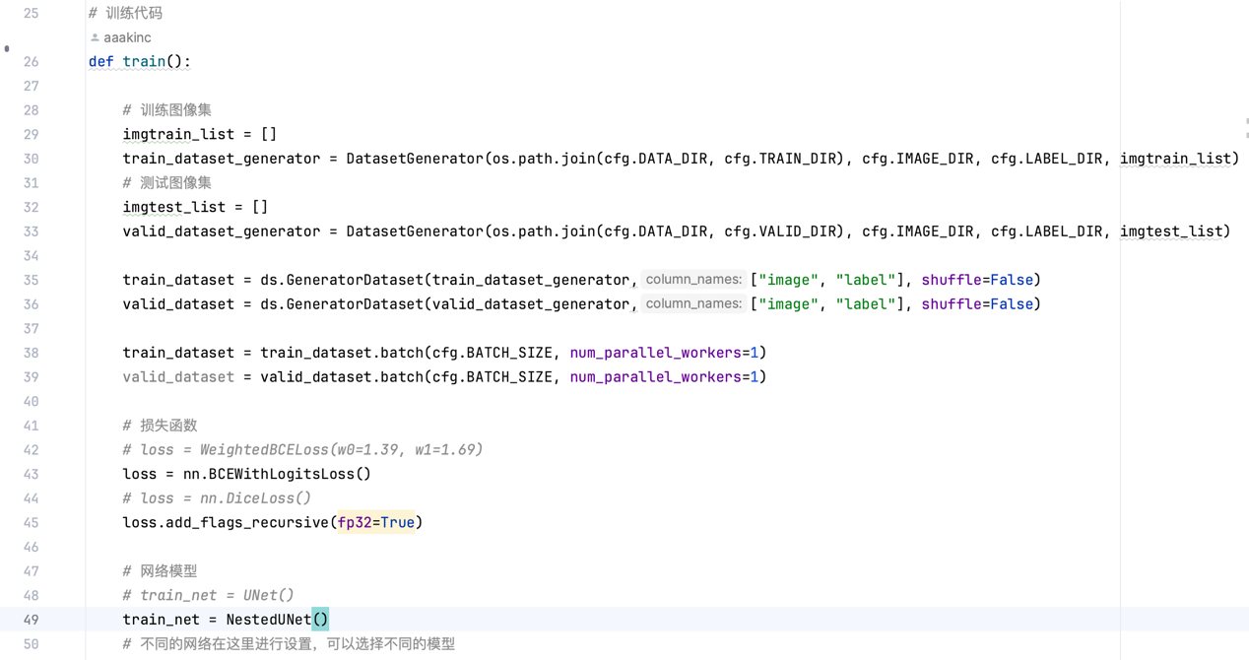

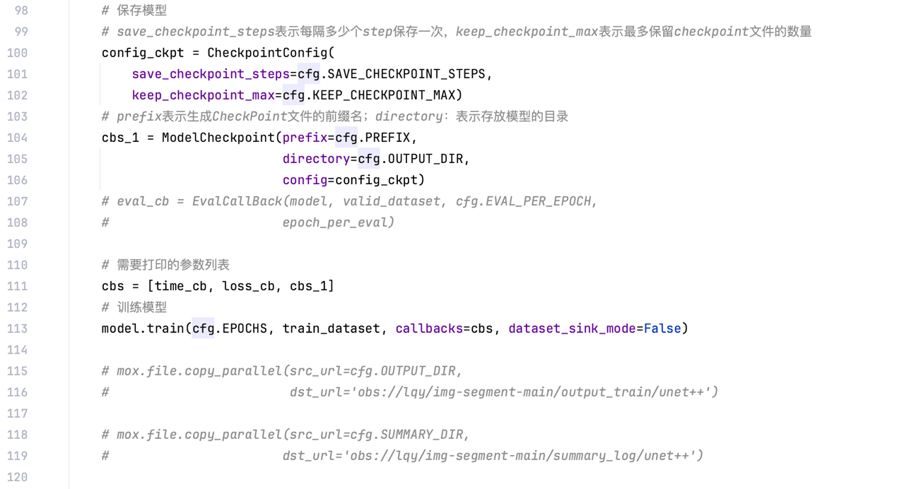

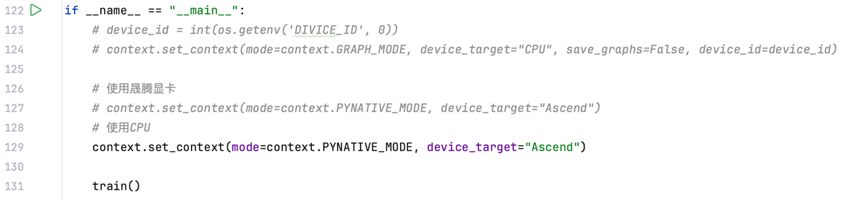

**实验3-2**

**实验要求：**

将推理结果在itk-snap中进行三维重建。

结果如下：



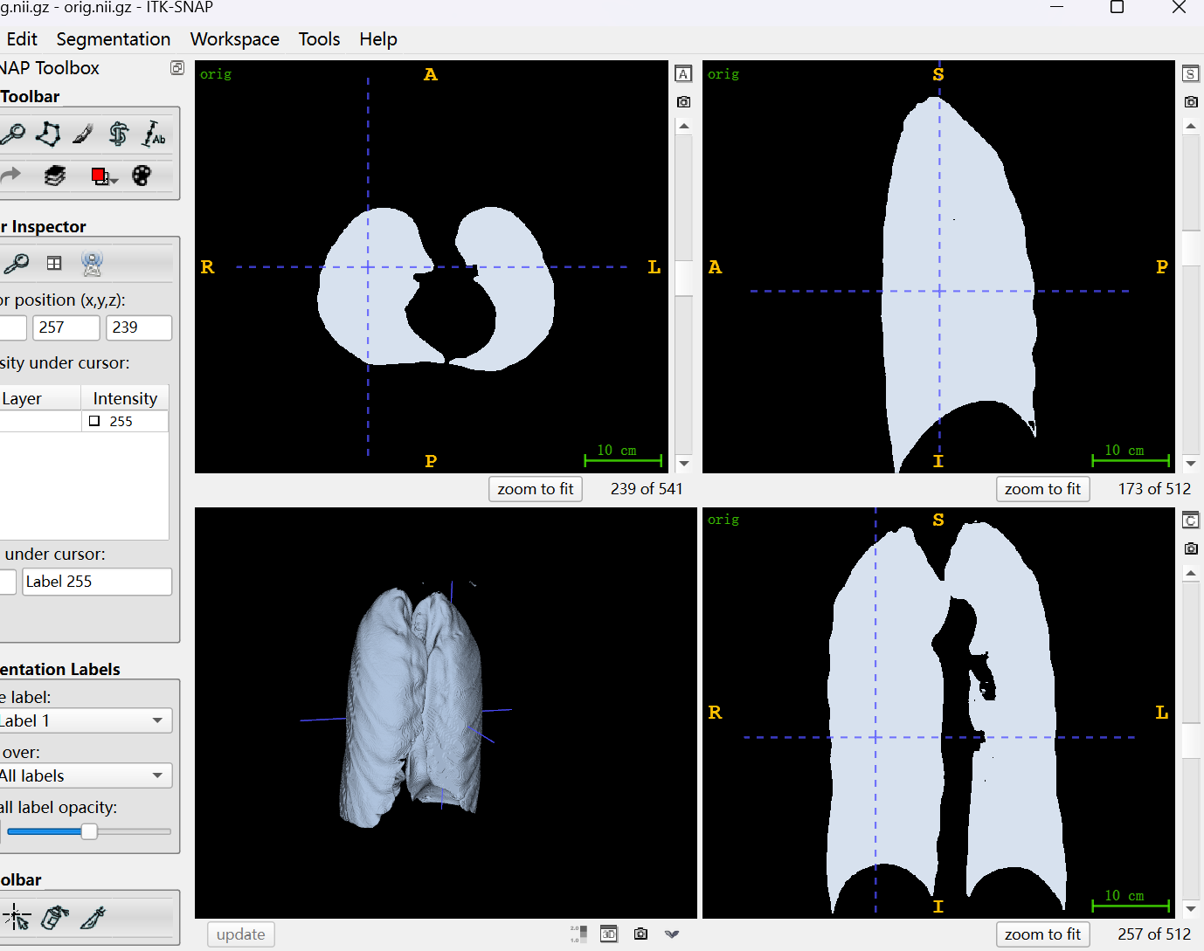

**选做1**

**实验要求：**

将推理结果做后处理操作后在进行三维重建。

提示：1. 使用最大连通域方法进行后处理

2. 使用numpy库函数构建长方体

3. 将后处理后的的图像保存

要求：用不同颜色来显示后处理前后的三维重建结果

**结果如下：**



