**buglySymbolUpload**

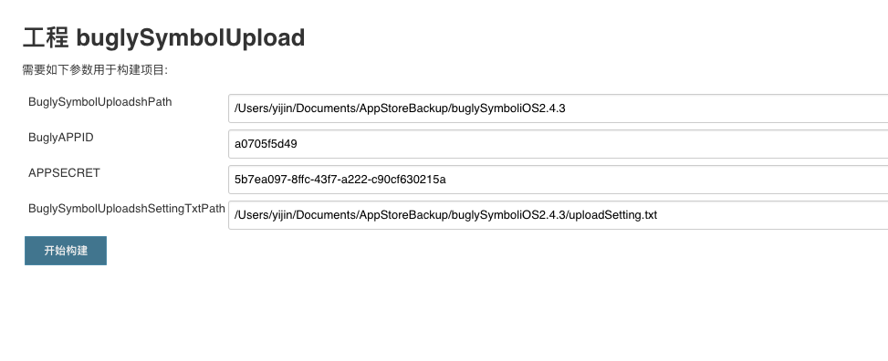

shell:

cd ${BuglySymbolUploadshPath}

pwd

settingarray=($(cat ${BuglySymbolUploadshSettingTxtPath}))

if [ ! ${#settingarray[@]} -eq 3 ]; then

echo "setting文件异常"

exit 1

fi

dsymPath=${settingarray[0]}

bundleID=${settingarray[1]}

version=${settingarray[2]}

echo "开始上传"

java -jar buglySymboliOS.jar -i ${dsymPath} -u \

-id ${BuglyAPPID} -key ${APPSECRET} \

-package ${bundleID} -version ${version}

echo "上传成功,你好牛逼啊"