自动打包上传appstore

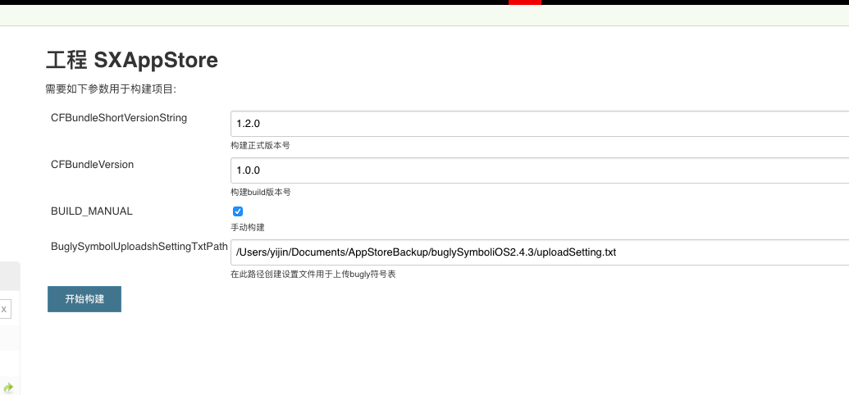

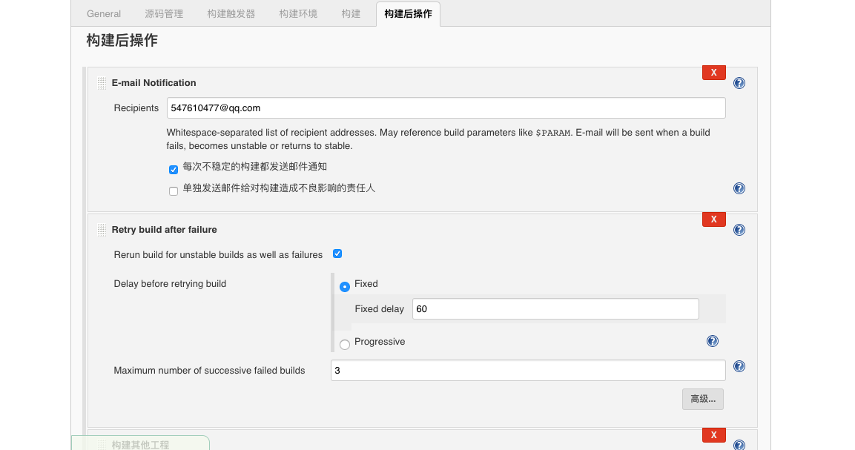

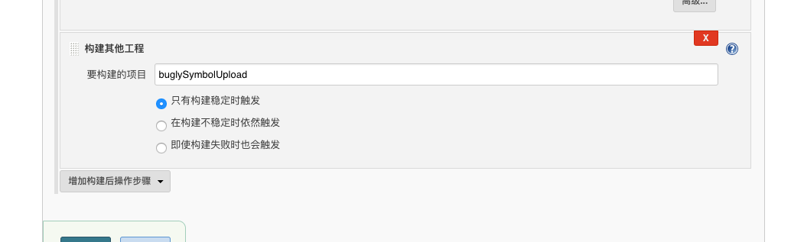

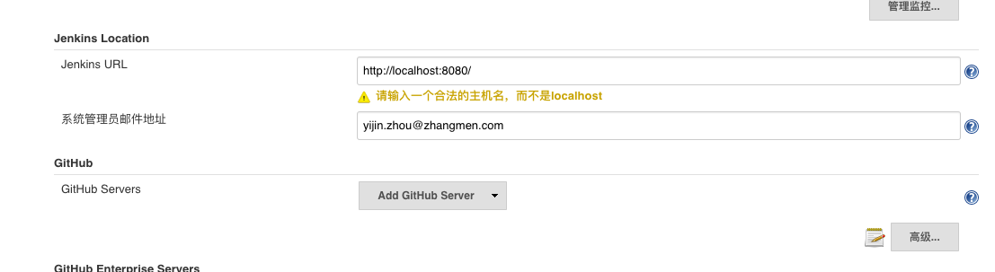

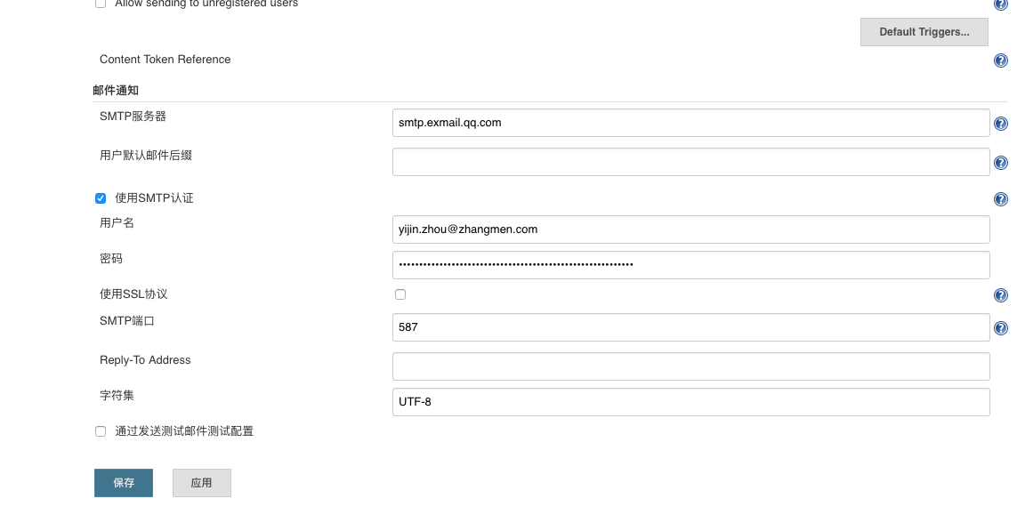

shell 1 :拉取更新依赖

#更新依赖的项目

#bin/bash - 1

export LANG=en_US.UTF-8

export LANGUAGE=en.US.UTF-8

export LC_ALL=en_US.UTF-8

PROJECTBASEPATH=$WORKSPACE/SXMainProject

cd $PROJECTBASEPATH

RN_ShengXue=../RN_ShengXue

ZMTeacherCommunity=../ZMTeacherCommunity

ZMPKit=../ZMPKit

if [ -d ${RN_ShengXue} ];then

if [ "`ls -A ${RN_ShengXue}`" = "" ]; then

echo "${RN_ShengXue} is empty"

git clone -b sx_release git@zmgitlab1.zmlearn.com:xiaoyong.chen/RN_ShengXue.git ${RN_ShengXue}

else

echo "${RN_ShengXue} is not empty"

cd ${RN_ShengXue}

git pull origin sx_release

fi

else

git clone -b sx_release git@zmgitlab1.zmlearn.com:xiaoyong.chen/RN_ShengXue.git ${RN_ShengXue}

fi

cd $PROJECTBASEPATH

if [ -d ${ZMTeacherCommunity} ];then

if [ "`ls -A ${ZMTeacherCommunity}`" = "" ]; then

echo "${ZMTeacherCommunity} is empty"

git clone -b sx_release git@zmgitlab1.zmlearn.com:ios/ZMTeacherCommunity.git ${ZMTeacherCommunity}

else

echo "${ZMTeacherCommunity} is not empty"

cd ${ZMTeacherCommunity}

git pull origin sx_release

fi

else

git clone -b sx_release git@zmgitlab1.zmlearn.com:ios/ZMTeacherCommunity.git ${ZMTeacherCommunity}

fi

cd $PROJECTBASEPATH

if [ -d ${ZMPKit} ];then

if [ "`ls -A ${ZMPKit}`" = "" ]; then

echo "${ZMPKit} is empty"

git clone -b sx_release git@zmgitlab1.zmlearn.com:yaozong.lin/ZMPKit.git ${ZMPKit}

else

echo "${ZMPKit} is not empty"

cd ${ZMPKit}

git pull origin sx_release

fi

else

git clone -b sx_release git@zmgitlab1.zmlearn.com:yaozong.lin/ZMPKit.git ${ZMPKit}

fi

shell2:

#bin/bash - 1

export LANG=en_US.UTF-8

export LANGUAGE=en.US.UTF-8

export LC_ALL=en_US.UTF-8

PROJECT_DIR=$WORKSPACE/SXMainProject

cd ${PROJECT_DIR}

echo "当前路径:"

pwd

PROJECT_NAME=ShengXue

PROJECT_SCHEME=ShengXue

BUILD_CONFIGURATION=Release

EXPORTOPTION_PATH=${PROJECT_DIR}/AutoPackage/SXAPPSTOREExportOptions.plist

WORKSPACE_FILE=${PROJECT_NAME}.xcworkspace

INFOPLIST_PATH=${PROJECT_DIR}/${PROJECT_NAME}/info.plist

NOTISERVICE_INFOPLIST_PATH=${PROJECT_DIR}/NotificationService/info.plist

if [ ${BUILD_MANUAL} == "true" ]; then

#设置App构建版本号

/usr/libexec/PlistBuddy -c "Set CFBundleShortVersionString ${CFBundleShortVersionString}" ${INFOPLIST_PATH}

#设置推送服务构建版本号

/usr/libexec/PlistBuddy -c "Set CFBundleShortVersionString ${CFBundleShortVersionString}" ${NOTISERVICE_INFOPLIST_PATH}

#设置build构建版本号

/usr/libexec/PlistBuddy -c "Set CFBundleVersion ${CFBundleVersion}" ${INFOPLIST_PATH}

fi

echo "移除并创建新的打包输出相关文件夹"

BUILDTIME=`date +%Y-%m-%d_%H:%M:%S`

EXPORTBASEDIR=${PROJECT_NAME}_Release_${BUILDTIME}_v${CFBundleShortVersionString}

ARCHIVE_DIR=~/Desktop/${EXPORTBASEDIR}/build_archive

EXPORT_DIR=~/Desktop/${EXPORTBASEDIR}/build_ipa

DSYM_DIR=~/Desktop/${EXPORTBASEDIR}/build_dsym

rm -rf ~/Desktop/${EXPORTBASEDIR}

mkdir -p ${ARCHIVE_DIR}

mkdir -p ${EXPORT_DIR}

mkdir -p ${DSYM_DIR}

LOGPATH=~/Desktop/${EXPORTBASEDIR}/log.txt

touch ${LOGPATH}

echo "打包之前先清理"

xcodebuild clean -configuration ${BUILD_CONFIGURATION} -scheme ${PROJECT_SCHEME} -quiet >> ${LOGPATH}

echo "清理完成"

echo "更新cocoapods库"

/usr/local/bin/pod install

/usr/local/bin/pod update ZMYAnalyse --no-repo-update

echo "开始编译打包成Archive"

BEGIIN_TIME=`date +%s`

CONFIGURATION_BUILD_PATH=${CONFIGURATION_BUILD_DIR}/${BUILD_CONFIGURATION}-iphoneos

ARCHIVE_PATH=${ARCHIVE_DIR}/${PROJECT_SCHEME}.xcarchive

xcodebuild archive -workspace ${WORKSPACE_FILE} -scheme ${PROJECT_SCHEME} -configuration ${BUILD_CONFIGURATION} -archivePath ${ARCHIVE_PATH} -quiet >> ${LOGPATH}

echo "~~~~~~~~~~~~~~~~~~~~~~~~ 查看是否版本构建成功 ~~~~~~~~~~~~~~~~~~~~~~~~"

#xcrachive 是一个文件夹不是个文件 所以使用 -d 来判断

if [ -d $ARCHIVE_PATH ]

then

echo "版本构建成功!"

APPDSYM=${ARCHIVE_PATH}/dSYMs/${PROJECT_NAME}.app.DSYM

if [ -d ${APPDSYM} ]; then

cp -rf ${APPDSYM} ${DSYM_DIR}/

echo "DSYM文件导出成功!"

fi

else

echo "版本构建失败......"

exit 1

fi

END_TIME=`date +%s`

ARCHIVE_TIME="构建版本所耗时间$[ END_TIME - BEGIIN_TIME ]秒"

BEGIIN_TIME=`date +%s`

echo "开始导出ipa包"

xcodebuild -exportArchive -archivePath ${ARCHIVE_PATH} -exportOptionsPlist ${EXPORTOPTION_PATH} -exportPath ${EXPORT_DIR} -allowProvisioningUpdates -quiet >> ${LOGPATH}

EXPORT_IPA=${EXPORT_DIR}/${PROJECT_SCHEME}.ipa

#如果是文件则说明成功

if [ -f ${EXPORT_IPA} ]

then

echo "导出ipa成功!"

open ${EXPORT_DIR}

else

echo "ipa导出失败......"

exit 1

fi

END_TIME=`date +%s`

EXPORT_IPA_TIME="导出ipa所耗时间$[ END_TIME - BEGIIN_TIME ]秒"

echo "时间消耗"

echo "$ARCHIVE_TIME"

echo "$EXPORT_IPA_TIME"

echo "开始上传ipa到AppStore"

#验证并上传到App Store

# 将-u 后面的XXX替换成自己的AppleID的账号，-p后面的XXX替换成自己的密码

altoolPath="/Applications/Xcode.app/Contents/Applications/Application Loader.app/Contents/Frameworks/ITunesSoftwareService.framework/Versions/A/Support/altool"

echo "开始ipa验证"

"$altoolPath" --validate-app -f ${EXPORT_IPA} -u studyonline@china-start.cn -p Study2018

echo "开始上传"

"$altoolPath" --upload-app -f ${EXPORT_IPA} -u studyonline@china-start.cn -p Study2018

echo "准备上传符号表"

echo "创建setting.txt"

if [ -f ${BuglySymbolUploadshSettingTxtPath} ];then

rm ${BuglySymbolUploadshSettingTxtPath}

fi

#获取bundleid

CFBundleIdentifier=$(/usr/libexec/PlistBuddy -c "Print CFBundleIdentifier" ${INFOPLIST_PATH})

echo ${APPDSYM} > ${BuglySymbolUploadshSettingTxtPath}

echo ${CFBundleIdentifier} >> ${BuglySymbolUploadshSettingTxtPath}

echo ${CFBundleShortVersionString} >> ${BuglySymbolUploadshSettingTxtPath}

echo "你好牛逼啊！！！！！！"