Characterizing Cannabis Use in EHR Notes
Annotation Guidelines
Prepared by Swati Rajwal and Selen Bozkurt
University of Emory

Overview and Annotation Objective
The goal of this annotation task is to identify and characterize documentation of cannabis use in clinical text snippets extracted from electronic health record (EHR) notes of patients with autoimmune rheumatic diseases. Annotators will label each snippet according to (1) cannabis use status and temporality, and (2) the documented reason for cannabis use, following a structured and reproducible framework.
Annotations will be used to train and validate natural language processing (NLP) models. Therefore, consistency, adherence to definitions, and careful handling of ambiguity are critical.
Each snippet should be annotated independently, based solely on the information explicitly present in the text.

Unit of Annotation
The unit of annotation is a text snippet extracted from a clinical note. Each snippet may consist of one or more sentences but represents a single contextual mention of cannabis-related terminology.
Annotators should not infer information beyond what is written in the snippet.

Annotation Tasks
Each snippet must receive:
- One Cannabis Use Status label (Categories 1–5)
- One Reason for Cannabis Use label (Categories 1–7), if applicable

Task 1: Cannabis Use Status Classification
Annotators must assign exactly one of the following five mutually exclusive categories.
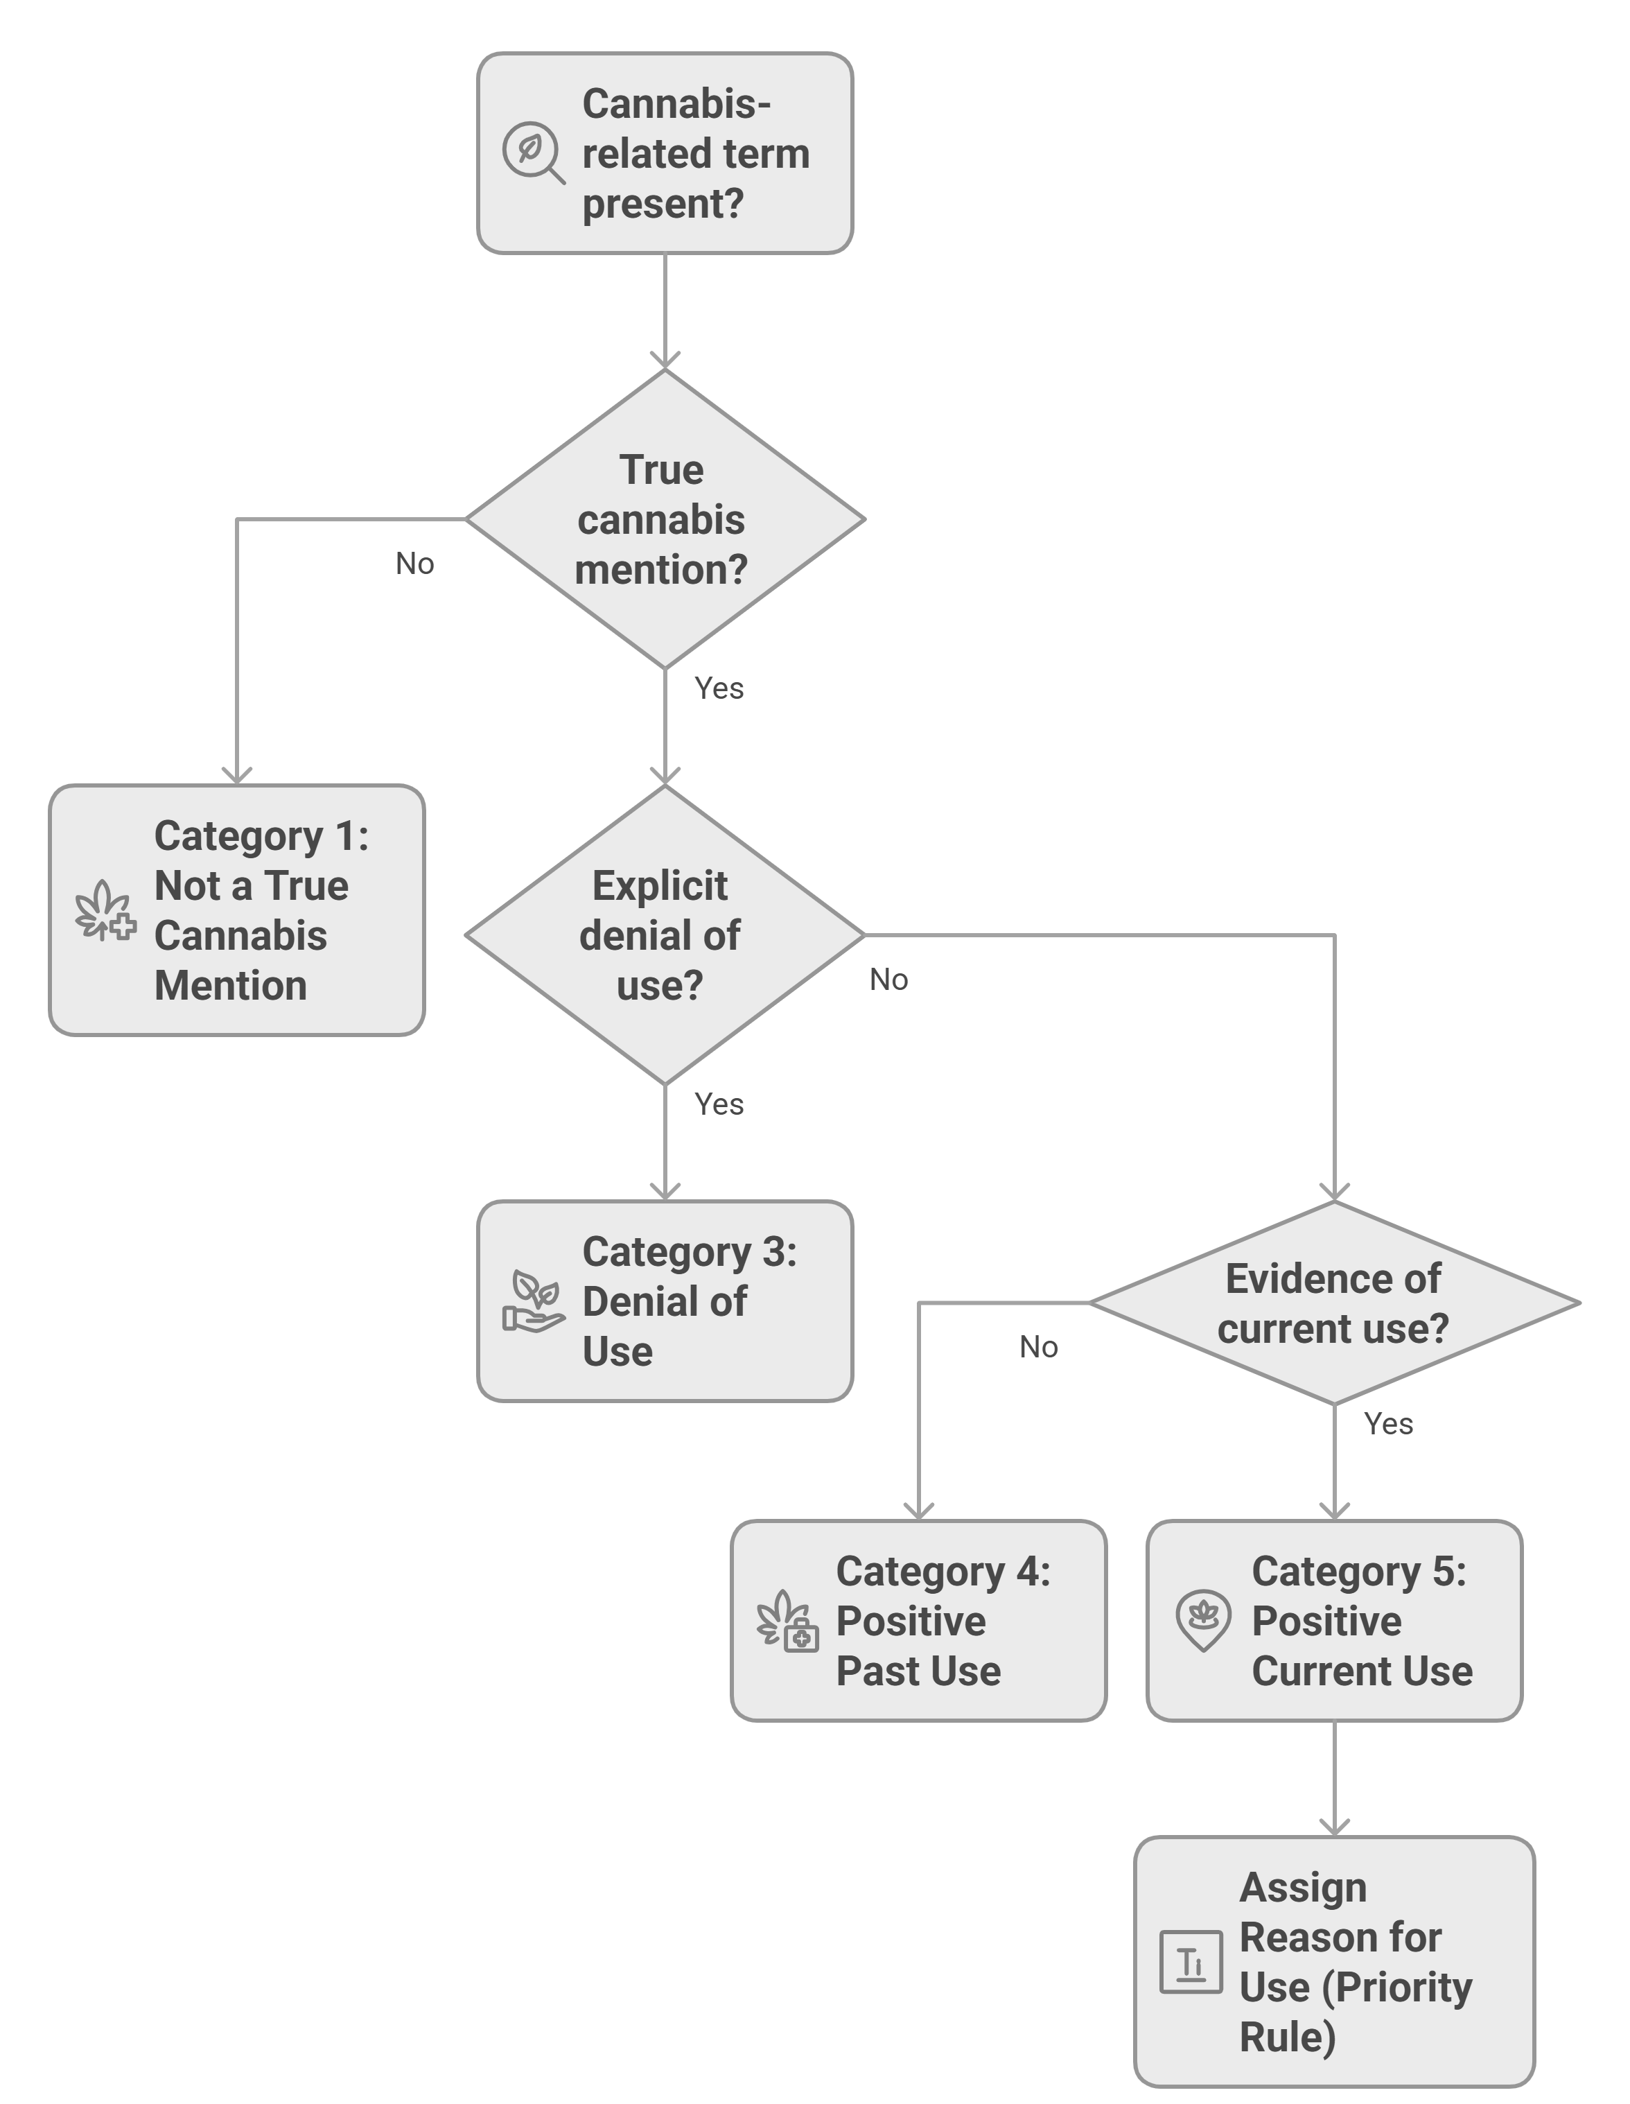
Cannabis use status and reason assignment.

Category 1: Not a True Cannabis Mention or True Mention but Uncertain or Not Reporting Use
Assign this label when:
- The note does not refer to cannabis use by the patient.
- Cannabis-related terms appear in a non-use context.
- Cannabis is referenced, but there is no clear statement about the patient’s use.
- The snippet reflects uncertainty, inquiry, or indirect evidence without confirmation.
Examples include:
- Mentions of “MJ” or “CBD” as part of a name, laboratory value, anatomical structure, or unrelated medical terminology.
- References to imaging findings (e.g., “CBD dilation” referring to the common bile duct).
- Questions about cannabis or CBD (e.g., “asking about CBD oil”).
- Laboratory results indicating THC presence without contextual confirmation of use.
Key rule: If mention does not plausibly indicate patient cannabis use, select Category 1. Do not assume use unless it is explicitly stated.

Category 2: Denial of Use
Assign this label when:
- The patient explicitly denies cannabis use, either currently or historically.
This commonly appears in structured social history sections or questionnaires (e.g., “Marijuana: denies” or “Marijuana: NA” or statements like “no history of marijuana use”).

Category 3: Positive Past Use
Assign this label when:
- The note clearly states that the patient used cannabis in the past but is no longer using it.
- The language implies discontinuation with no indication of current use.
Examples include:
- “Used marijuana years ago”
- “Previously used medical marijuana but stopped”

Category 4: Positive Current Use
Assign this label when the note clearly indicates active cannabis use. This includes:
- Explicit statements of current use.
- Use within the past month.
- Statements implying ongoing or planned continued use due to symptom relief.
- References to cannabis-related diagnoses (e.g., cannabis use disorder) implying active use.
If Category 4 is selected, proceed to Task 2.

Task 2: Reason for Cannabis Use Classification
This task applies only if Category 5 (Positive Current Use) is selected.
Annotators must assign exactly one reason label per snippet, even if multiple reasons are mentioned.
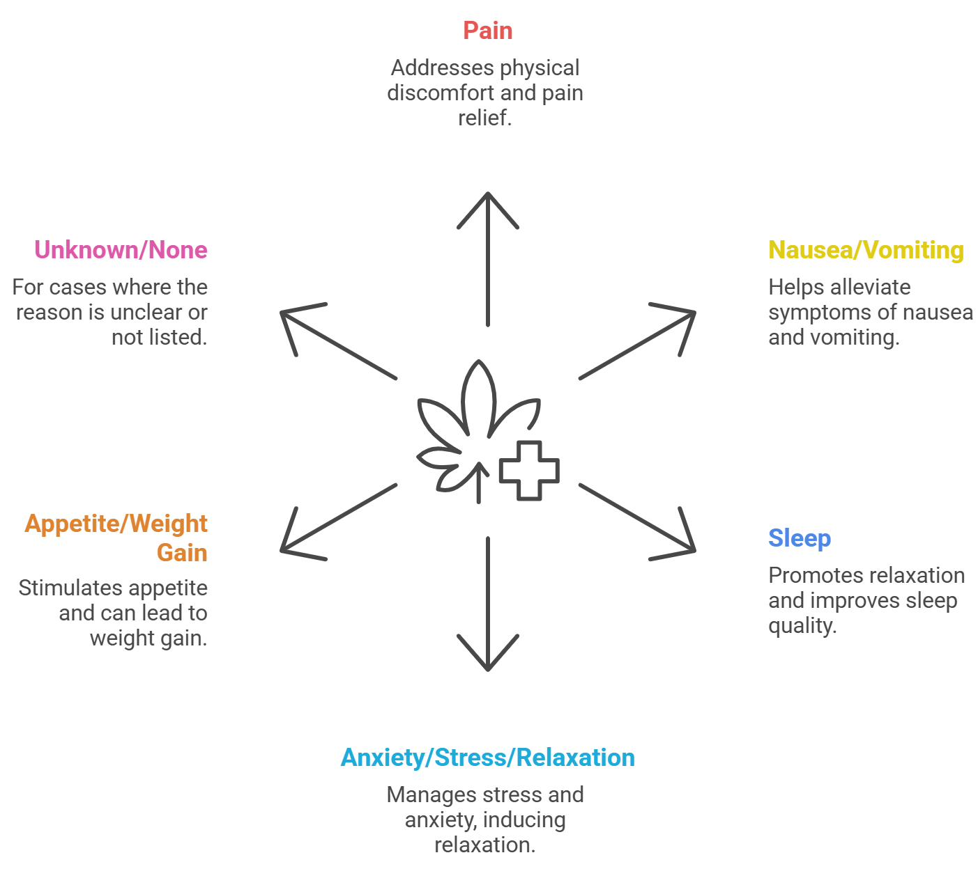
Positive cannabis use related annotation classes.

Reason Labels
The available reason labels are:
- Explicit Current Use for Pain
- Explicit Current Use for Nausea / Vomiting
- Explicit Current Use for Sleep
- Explicit Current Use for Anxiety / Stress / Relaxation
- Explicit Current Use for Appetite / Weight Gain
- Explicit Current Use for Unknown / None of the Above Reasons/Not Current Explicit Use / NA

Tie-Breaking Rule for Multiple Reasons
If multiple reasons are mentioned in the same snippet, annotators must apply the following priority order and select the highest applicable label:
- Pain
- Nausea / Vomiting
- Sleep
- Anxiety / Stress / Relaxation
- Appetite / Weight Gain
- Unknown / None of the Above
Example: “Patient uses CBD to help with pain and sleep” $→$ Label as Explicit Current Use for Pain.

Clarifications
- If cannabis use is current but no reason is stated, select Unknown / None of the Above.
- If cannabis is mentioned but not as something the patient is currently using, select Not Current Explicit Use / NA.

General Annotation Principles
- Annotate only what is explicitly stated; do not infer intent or behavior.
- Ignore broader patient history not present in the snippet.
- Each snippet must receive exactly one label per task.
- Ambiguous cases should default to the more conservative (less assumptive) category.

Quality Control and Agreement
All snippets should be annotated independently by multiple human annotators (domain experts). Disagreements should be reviewed and resolved through guideline discussion and refinement. Inter-rater agreement should be monitored (e.g., Cohen’s Kappa) to ensure consistency.

