Title Page
Title of Thesis or Dissertation

by

Author’s Full Name

Undergraduate degree, institution, year

Master’s degree, if applicable, institution, year

Submitted to the Graduate Faculty of the

Click to choose your school in partial fulfillment

of the requirements for the degree of

Click to choose your degree

University of Pittsburgh

Year

Committee Page
UNIVERSITY OF PITTSBURGH

Click to choose your school

This thesis or dissertation was presented

by

Author’s Full Name

It was defended on

Select the Date

and approved by

Committee Member’s Name, Academic Rank, Department Affiliation

Committee Member’s Name, Academic Rank, Department Affiliation

Committee Member’s Name, Academic Rank, Department Affiliation

Thesis Advisor/Dissertation Director: Name Academic Rank, Department Affiliation

Copyright © by Author’s Full Name

Year

Abstract
Title of Thesis or Dissertation

Author’s Full Name, Abbreviation of degree, e.g., MA or PhD

University of Pittsburgh, Year

This is the abstract of the thesis, or dissertation. It should have no more than 350 words.

Table of Contents
Preface viii
1.0 Heading 1 1
1.1 Heading 2 1
1.1.1 Heading 3 2
1.1.1.1 Heading Level 4 2
2.0 Second Section 4
2.1 Subsection 5
Appendix A Title 6
Appendix B Letters 7
Appendix C Section Examples 8
Appendix C.1 Appendix Sub-section 8
Appendix C.1.1 Sub-subsection 8
Appendix D Chemicals 9
Bibliography 10

List of Tables
Table 1 Captions Go Above for Tables 4

Appendix Table 1 Letters and Number 7

List of Figures
Figure 1 Lackawanna Valley 3

Appendix Figure 1 Paragraph Mark 6
Appendix Figure 2 Caffeine 8
Appendix Figure 3 Adenosine 8

Preface
It is recommended that acknowledgments, nomenclature used, and similar items should be included in the Preface.
The Preface is optional. If you wish to delete the Preface, you need to place the cursor in the Preface title and apply the Normal style to remove the currently applied style. Then delete the Preface content, being careful not to delete the preceding and subsequent sections.

Heading 1
You will start your main text at this level. You should apply the Normal style to any text sections in your document. To show how paragraphs and sections will style, we have inserted standard Lorem ipsum text as a placeholder.
To insert a new subsection, press Return to start a new line and then select the Heading 2 style from the Style menu. To start a new main section press Return and select the Heading 1 style.

Heading 2
Lorem ipsum dolor sit amet, consectetur adipiscing elit. Pellentesque sodales libero id bibendum maximus. Aliquam ante neque, blandit a rutrum in, faucibus et sem. Phasellus turpis turpis, cursus sed nibh id, aliquam hendrerit risus. Pellentesque vel purus scelerisque, fermentum ex in, dignissim enim. Donec rutrum ultrices tempus. Sed volutpat ligula a purus vestibulum, interdum imperdiet ante bibendum. Nam bibendum metus sit amet orci imperdiet, a pretium tortor malesuada. Aliquam erat volutpat. Curabitur sed augue lorem. In a rhoncus nisl. Sed ac ante felis. Integer pharetra dapibus velit non mattis. Vestibulum a aliquam nisi. Praesent rutrum mauris nec nunc imperdiet, in venenatis felis vulputate. Fusce venenatis, orci et pretium consequat, quam magna pretium odio, ac convallis velit enim ac diam.
Aliquam condimentum risus ante, ut congue odio mollis sed. Phasellus tincidunt sem aliquet nibh ornare porttitor. In dapibus odio eu purus fermentum, et sagittis nibh placerat. Nunc luctus, turpis semper auctor malesuada, augue justo molestie velit, a suscipit purus velit nec risus. Vivamus malesuada sem vel dictum aliquam. Sed molestie lacus dolor, in tristique tortor sollicitudin at. Sed tempus laoreet efficitur. Nulla facilisi. Maecenas interdum tempor est eget vestibulum. Curabitur dolor turpis, aliquet et suscipit eu, ultrices ac mi. Sed tellus sapien, feugiat eget sem nec, dignissim ultrices urna. Pellentesque ac tortor et ligula pretium scelerisque. Etiam mattis suscipit molestie. Curabitur interdum, ante vitae mattis lobortis, turpis lectus vehicula ipsum, id rhoncus lacus ex ac turpis. Etiam a venenatis mi.
Maecenas semper leo elit, at bibendum ex commodo nec. Fusce luctus pulvinar lorem. Ut pharetra blandit nisl, eget elementum tortor ultricies id. Vestibulum in tincidunt mi, vel ullamcorper mi. Lorem ipsum dolor sit amet, consectetur adipiscing elit. Etiam mollis cursus elementum. Duis faucibus sapien id luctus eleifend. In pharetra fringilla risus, ut condimentum ligula tincidunt at. Etiam porttitor sem quam, at dignissim ante rutrum vitae. Fusce nec lacus sem. In porta non nibh sed maximus. Praesent faucibus augue turpis, eget tempor nulla faucibus fermentum.

Heading 3
Aliquam erat volutpat. Curabitur sed augue lorem. In a rhoncus nisl. Sed ac ante felis. Integer pharetra dapibus velit non mattis. Vestibulum a aliquam nisi. Praesent rutrum mauris nec nunc imperdiet, in venenatis felis vulputate. Fusce venenatis, orci et pretium consequat, quam magna pretium odio, ac convallis velit enim ac diam.

Heading Level 4
Aliquam erat volutpat. Curabitur sed augue lorem. In a rhoncus nisl. Sed ac ante felis. Integer pharetra dapibus velit non mattis. Vestibulum a aliquam nisi. Praesent rutrum mauris nec nunc imperdiet, in venenatis felis vulputate. Fusce venenatis, orci et pretium consequat, quam magna pretium odio, ac convallis velit enim ac diam. Aliquam erat volutpat. Curabitur sed augue lorem. In a rhoncus nisl. Sed ac ante felis. Integer pharetra dapibus velit non mattis. Vestibulum a aliquam nisi. Praesent rutrum mauris nec nunc imperdiet, in venenatis felis vulputate. Fusce venenatis, orci et pretium consequat, quam magna pretium odio, ac convallis velit enim ac diam.

Second Section
The figure below is inserted so that there is an item in the sample List of Figures.

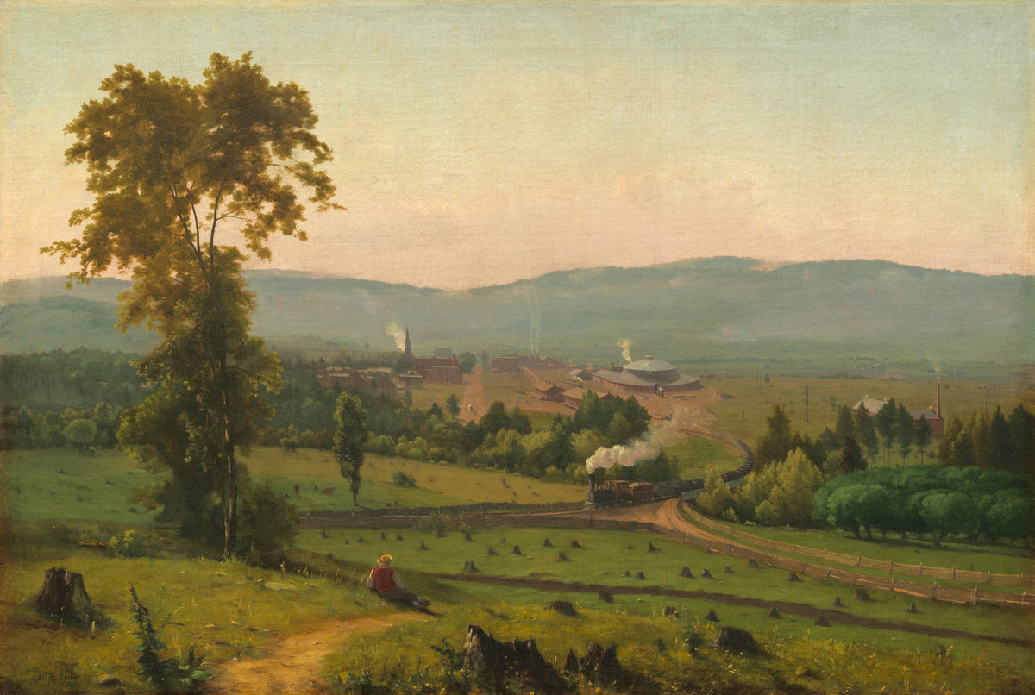

Figure 1 Lackawanna Valley

To insert a caption, right-click on the figure and select Insert Caption. It should be noted that captions go below image for figures but are placed above a table.

Subsection
The table below is include d so that there is an item in the sample List of Tables. To add a caption, select the table using the table control box and then right-click to select Insert Caption.

Table 1 Captions Go Above for Tables
 | Discoverer | Year of Discovery
Electron | Joseph J. Thomson | 1897
 | James Rutherford | 1919
Neutron | James Chadwick | 1932
Positron | Carl D. Anderson | 1932

Be sure that when adding new sections or captions, to return to the table of contents or list of figures/tables and right click on one of the listed items. Then be sure to select Update Field – Update Entire Table, so that any new or edited content is reflected there.

        - Title
Appendices contain supplementary or illustrative material or explanatory data too lengthy to be included in the text or not immediately essential to the reader’s understanding of the text.
When using the Appendix Style, type the title of the Appendix section after the inserted heading.
        - Letters
To insert a subsection in the Appendix, use the App Section Style to create each subsection. Appendix Sub-subsection.
Appendix Figure 1 Paragraph Mark
Be sure to use the Appendix Figure or Appendix Table labels if you wish to start a new numbering format for these figures. If you want to continue the numbering sequence from the body of the tex, simply use the labels Figure or Table

To create alternate Appendix Figure/Table caption labels, begin by inserting a caption as you would for any other figure or table. Then use the new label button to specify a new label for the caption. You will need to either create a separate list of figures/tables for these labels or use the ETD formatting guide for creating custom Appendix labels.
        - Section Examples
If your Appendix requires further subsections, use the App Subsection Style to continue adding content.
          - Appendix Sub-section
The font family and size are not restricted to the Normal style. You can include appropriate supplemental material in the forms of figures, tables, text, and equations.
            - Sub-subsection

Appendix Table 1 Letters and Number
abc | 123 | abc | 123 | abc | 123
efg | 456 | efg | 456 | efg | 456
hij | 789 | hij | 789 | hij | 789

        - Chemicals
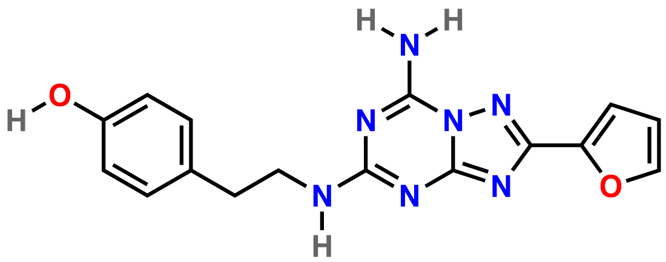

Appendix Figure 2 Caffeine

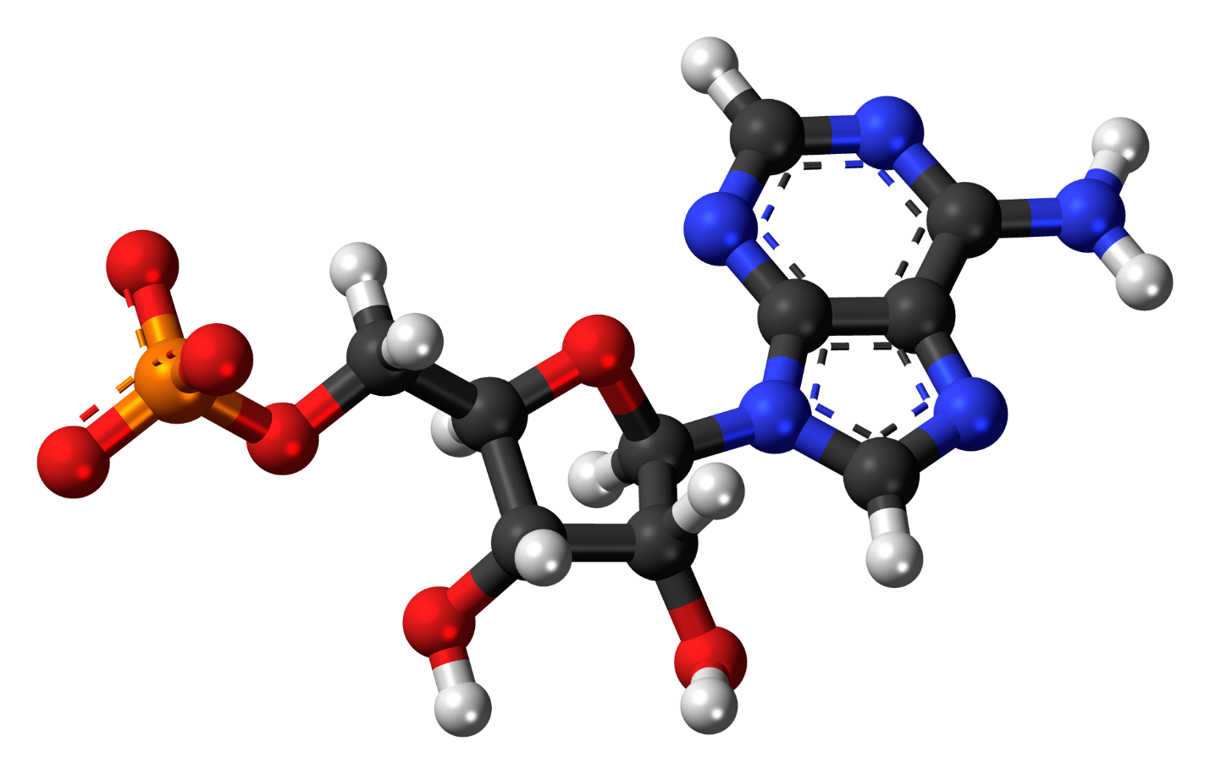

Appendix Figure 3 Adenosine

Bibliography
To enter references for your work use the Bibliography Entry style. Single-spaced within entries. Usually ‘hanging’ from the second line on, like this. The default format will be block justified but you can make the entries left justified if desired. (The latter often helps URLs not cause spacing issues.)
Here are some examples from different styles.
Author's last name, first name. Book title. Additional information. City of publication: Publishing company, publication date. [MLA]
Author's last name, first initial. (Publication date). Book title. Additional information. City of publication: Publishing company.
Author’s last name, first name. "Title." Journal Title. Volume number, Issue number. (Publication date): pages. DOI. [Chicago]

