**統計應用方法**

**Homework 1**

1. (55 points)

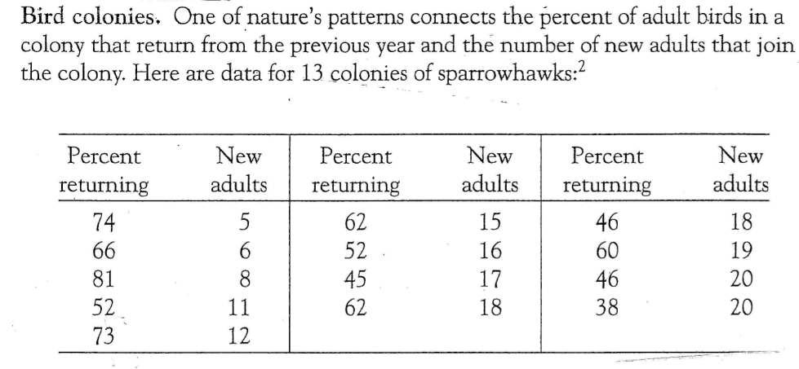

1. (10 points) Please plot the data with  indicating “Percent returning” and  indicating “New adults”. Comment on the main features of the plot. Any possible outliers? (Lecture 1介紹如何解讀圖)
2. (10 points) Compute , ,  and . Then apply the formula to compute Pearson’s correlation:

.

1. (10 points) Use R (軟體) to compute Pearson’s correlation, Kendall’s tau and Spearman’s rho. (相關係數指令在 Lecture 1 最後; 平均數標準差也可以參考上學期前三次課程的指令)
2. (15 points) Please fit the regression model:

.

Find ,  (用上課給的公式) and



1. (5 points) What is the value of ? Is it true that 
2. (5 points) Please plot  (Y axis) versus  (X axis). Comment on the residual plot. What does this plot indicate?

2.

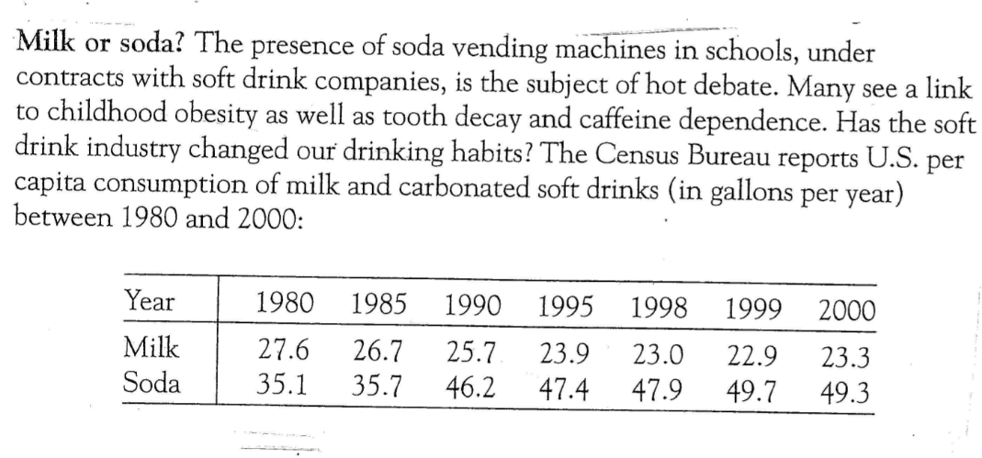

1. (10 points) Please plot the data with  indicating “Soda” and  indicating “Milk”. Comment on the main features of the plot. Any possible outliers? 這裡我建議把 Milk 當成 Y, 是因為牛奶攝取是營養學家或家長比較在意的.
2. (10 points) Use R (軟體) to compute Pearson’s correlation, Kendall’s tau and Spearman’s rho.
3. (10 points) Use R to fit the regression model:

.

Show your output and explain the meaning of .

1. (15 points) Show the residual plot and normal plot. Make your comments.

Hint: You need to know the purposes of these two plots and judge whether the plots support the assumptions that

.