Website: <http://www.cs.waikato.ac.nz/ml/weka/>

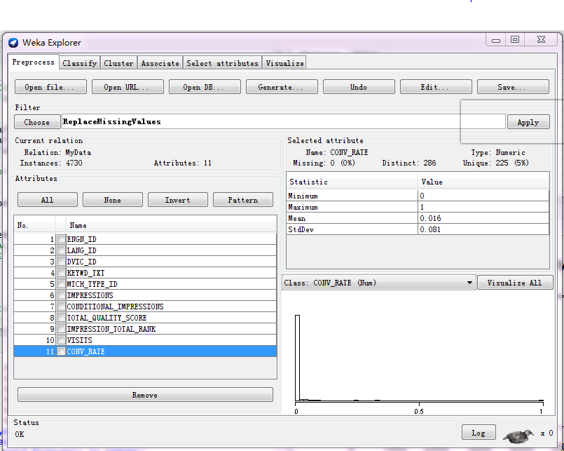

1. **Click here to select the file containing the processed data**

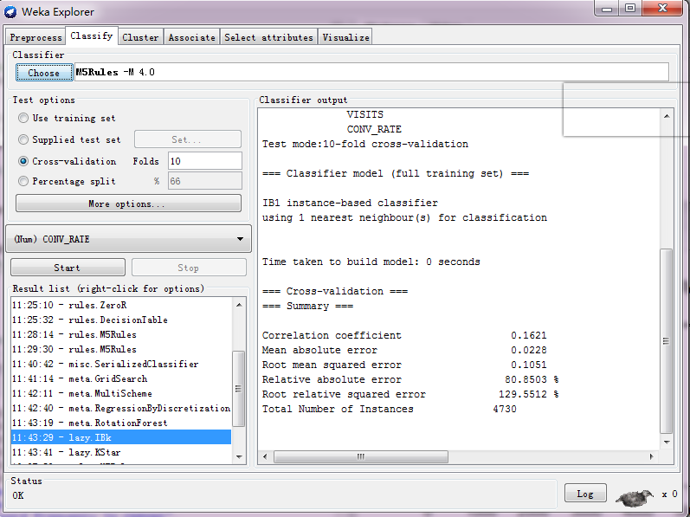

**2. Select the model here**

**3. Choose the number of folds for cross-validation**

**4. Choose the dependent variable**

**5. Start to build the model**