Welcome to Deep Energy Method based on LLM!

- Open the website: https://demllm.streamlit.app/

- Add your own api key from open ai to “OPENAI API KEY (OPTIONAL)”: Add the api key from open ai to here (red box):

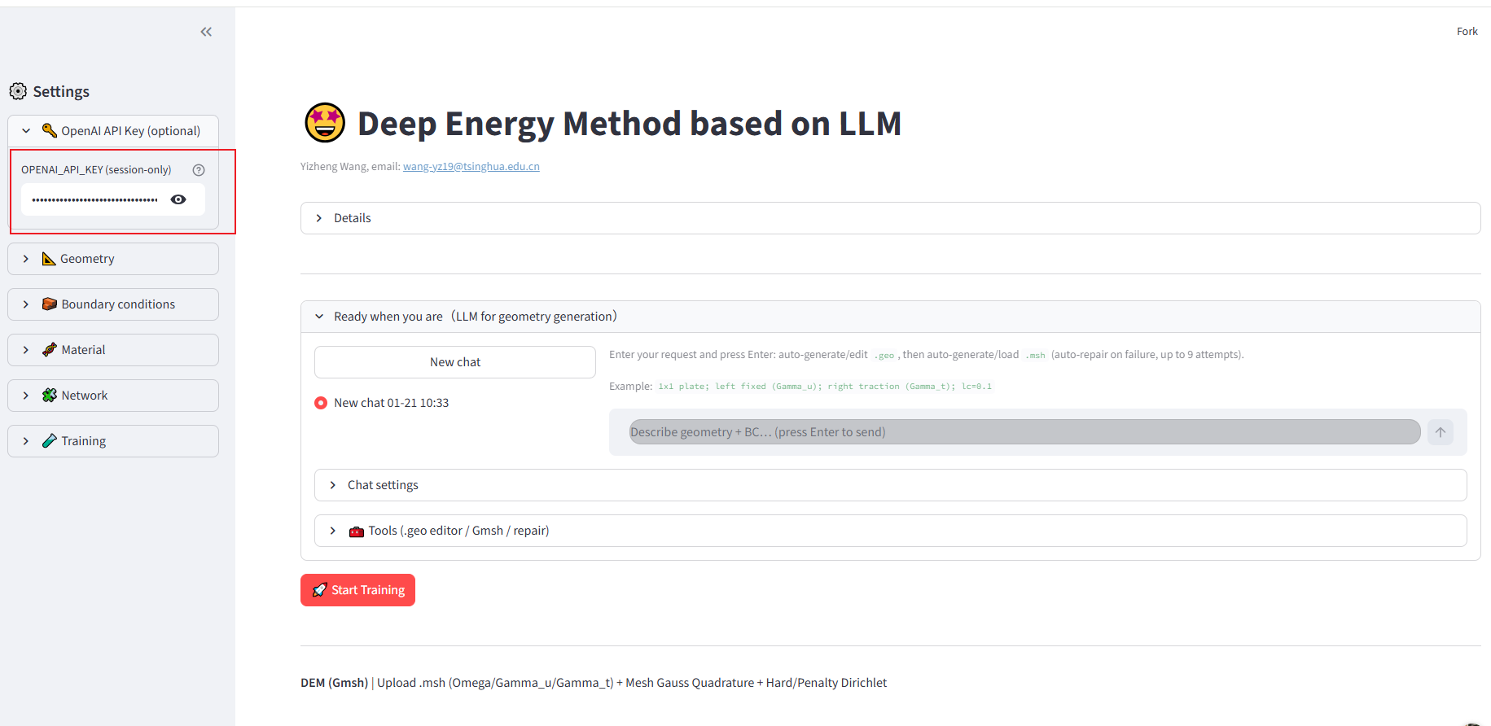

- Use language to create geometry and boundary:

For example: “a bottle, top is Neumann boundary, bottom is Dirichlet boundary”, and then click ENTER. It will create the geometry using LLM model
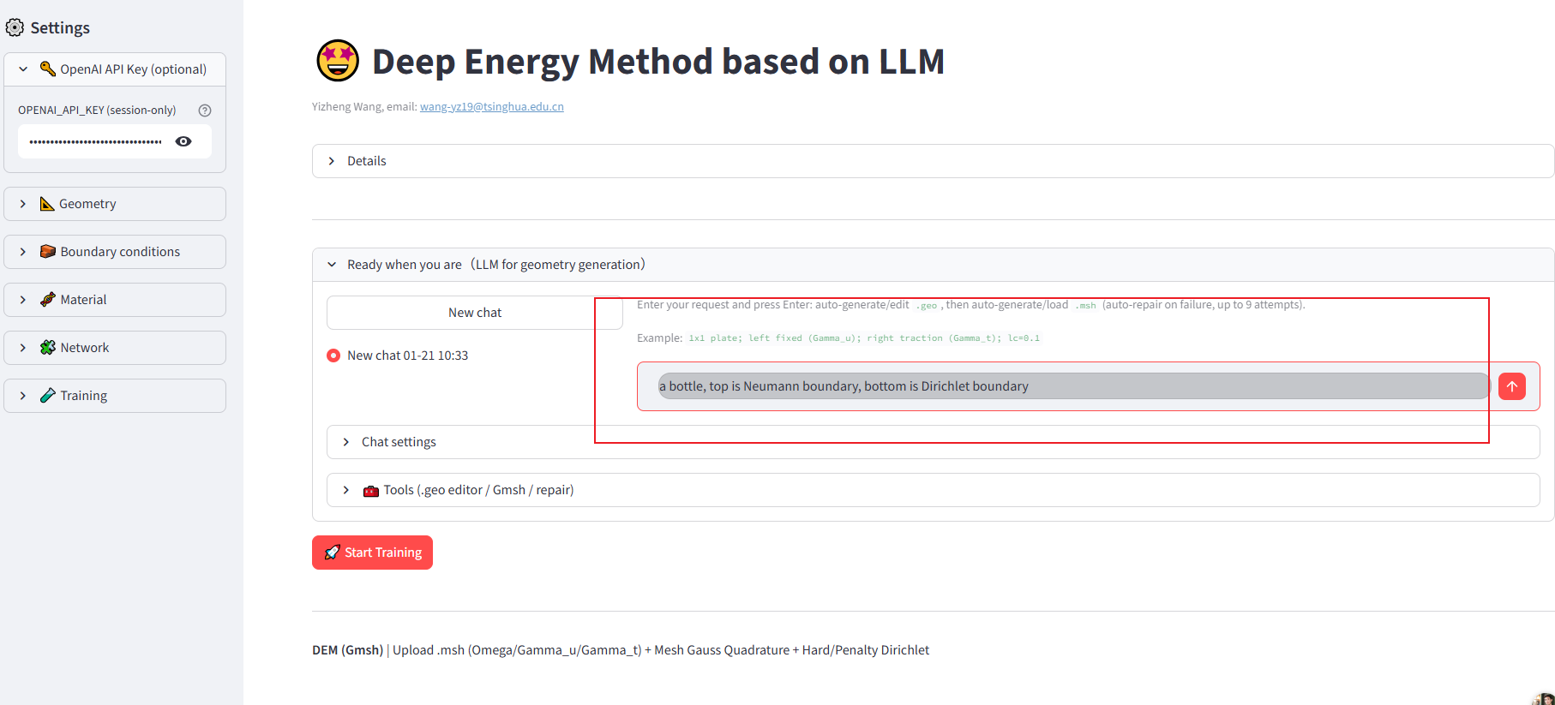

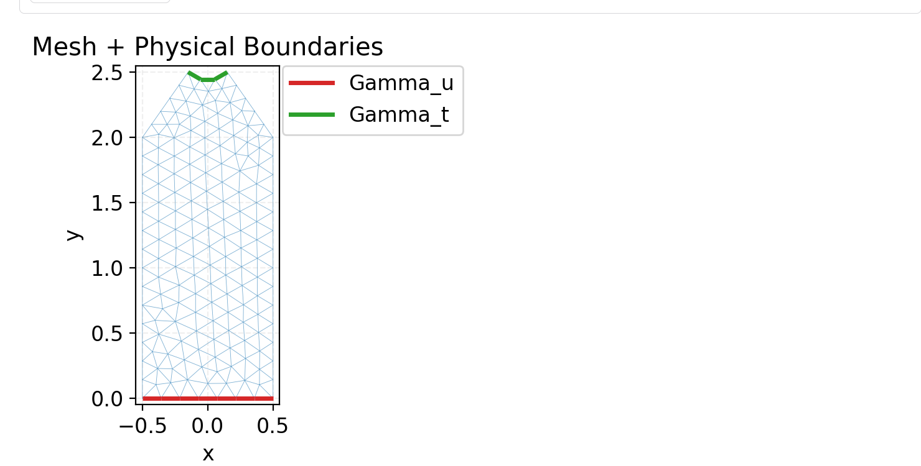

- Then choose the requirements for simulation: For example, we choose “Linear Elasticity (2D)”, and make the ty=3.8, and then click “Start training”, and you can get the result of DEM and FEM. Or you can choose vtu for post-process.
::

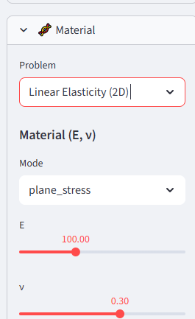
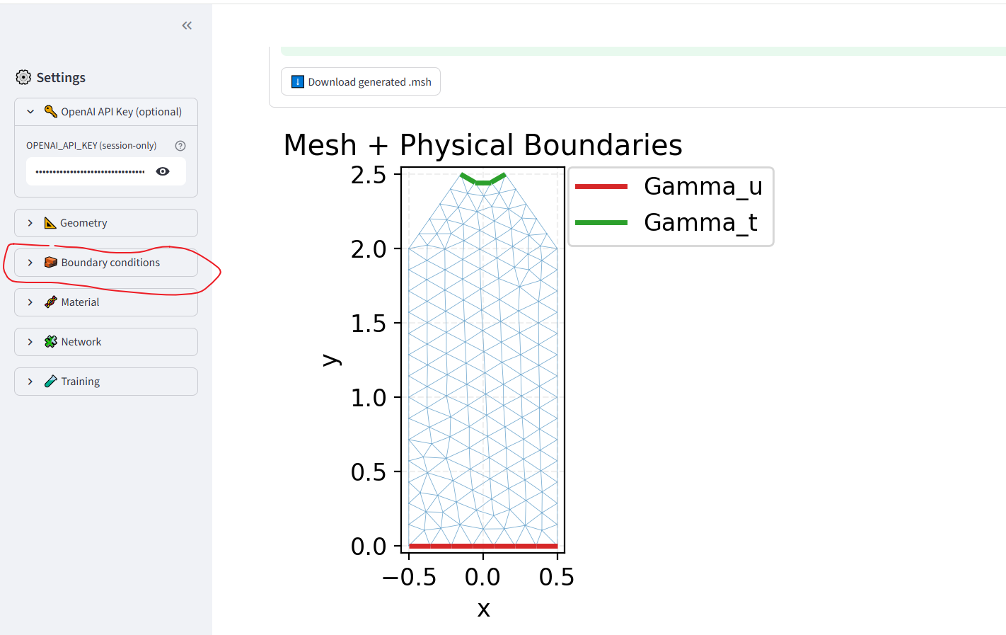

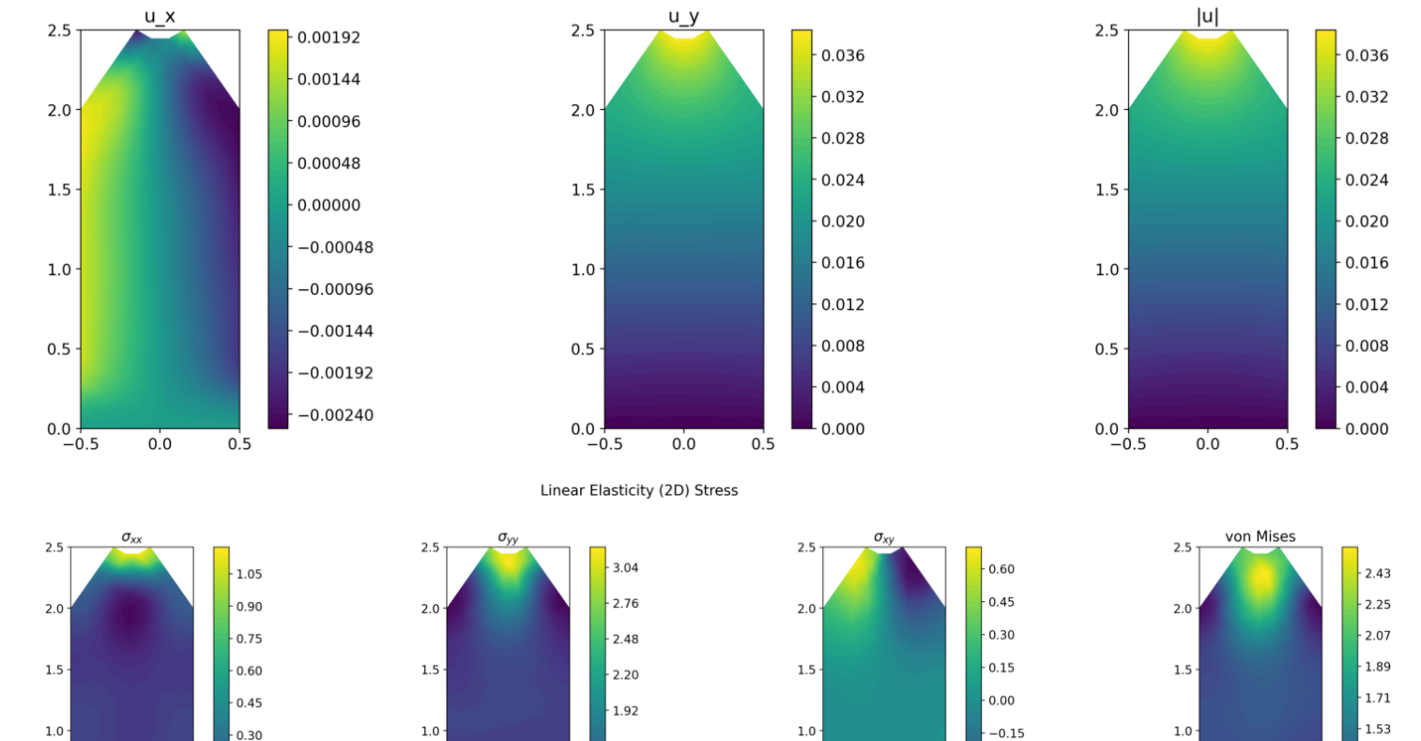

- If you want to create 3D geo, choose 3 in mesh dimension in Geometry botton:
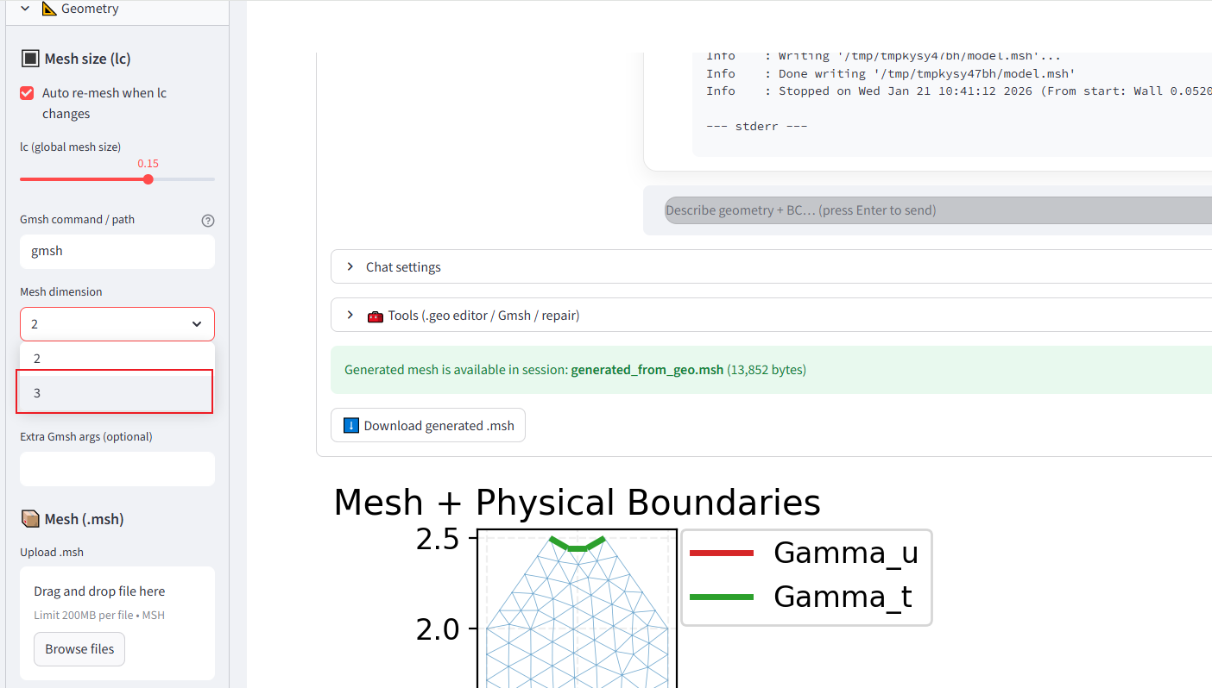

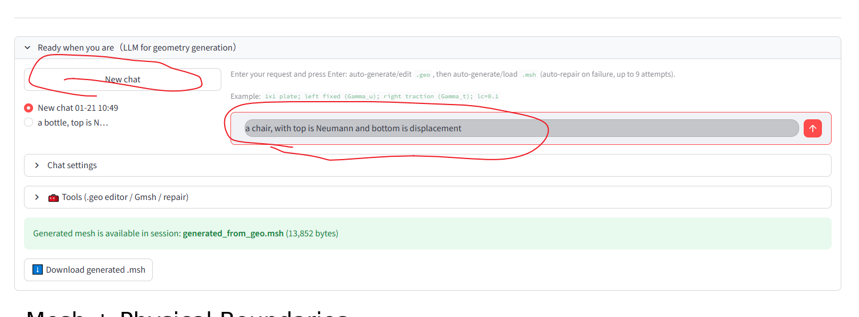
6, click “new chat” and input like “a chair, with top is Neumann and bottom is displacement ”

