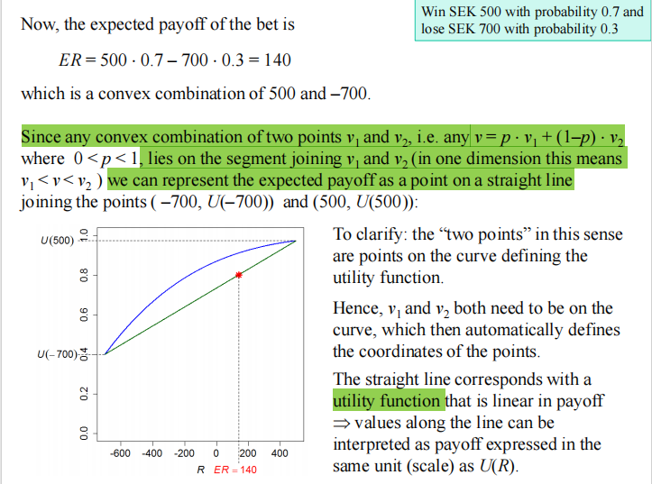

What do niu1 and niu2 mean?
What does the niu = p * niu1 +(1-p) *niu2 mean?
Why there is a casual relationship in the underlined sentences?
What does the straight green line mean?

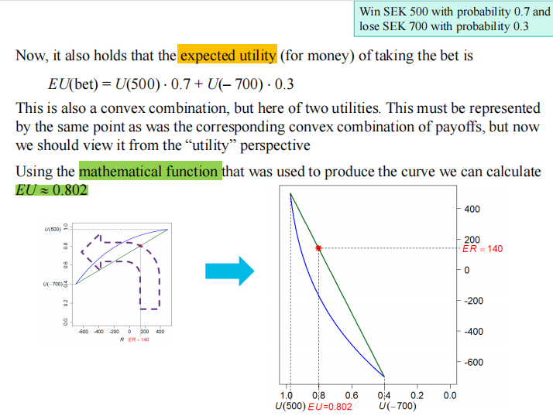

What is this function how to calculate?
Whty the the point can be on the straight line?

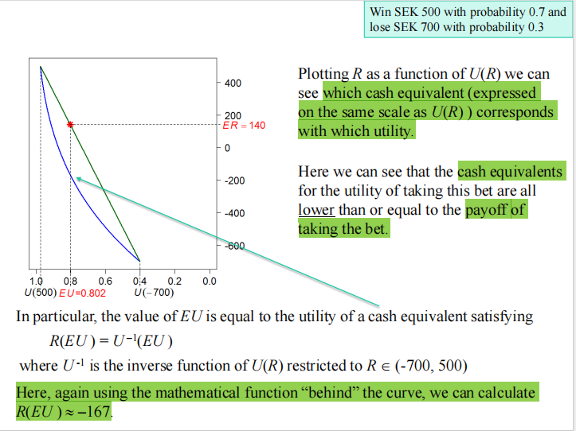

What does this mean ?
We can see cash equivalent (expressed on the same scale as U(R) ) corresponds with which utility.

What is the cash equivalents for the utility?
What is the payoff of taking the bet?
Why there is a lower relationship?
Also the same question, what is the mathematic function?

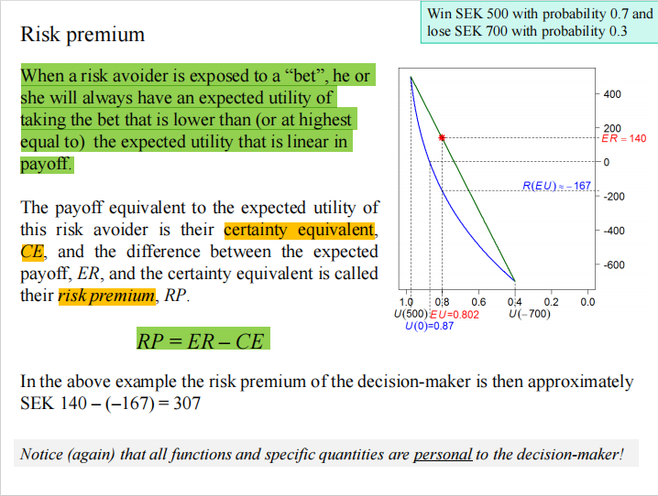

How to understand first paragraph. Why this is the case?

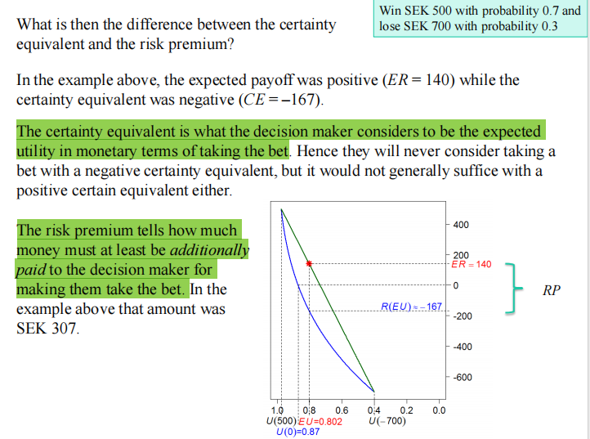

What do the two sentences mean especially for the second one.

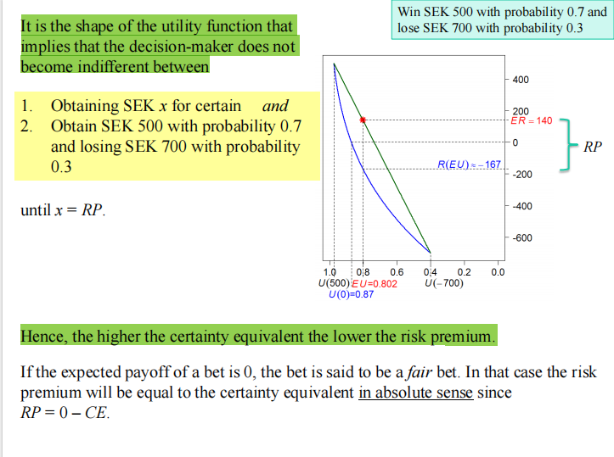

Why do these two sentences hold up.

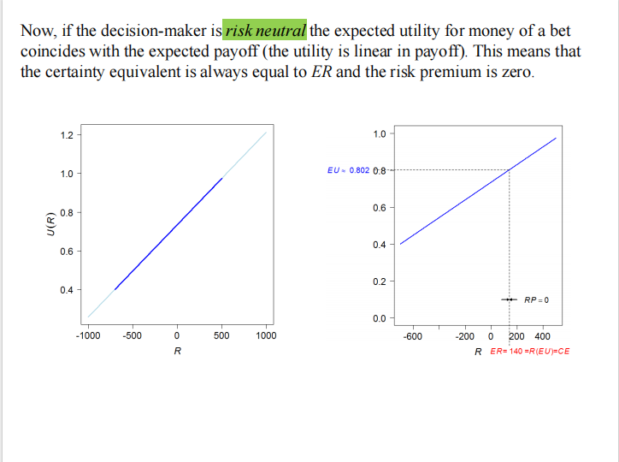

Why this is the case.

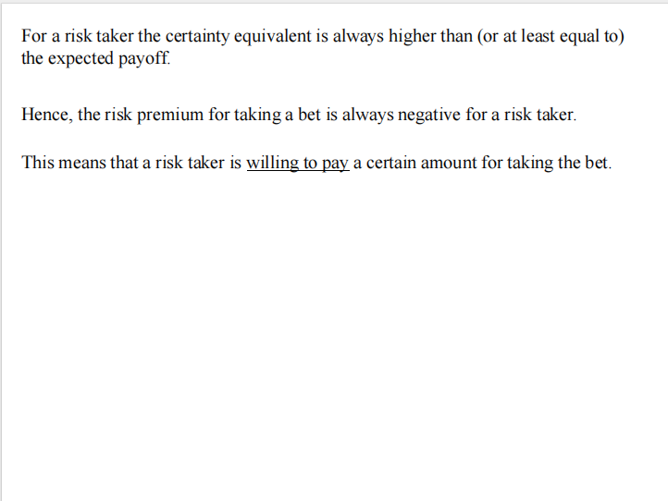

I cannot tell why there is such a relationship.

Key questions: 1 8 4

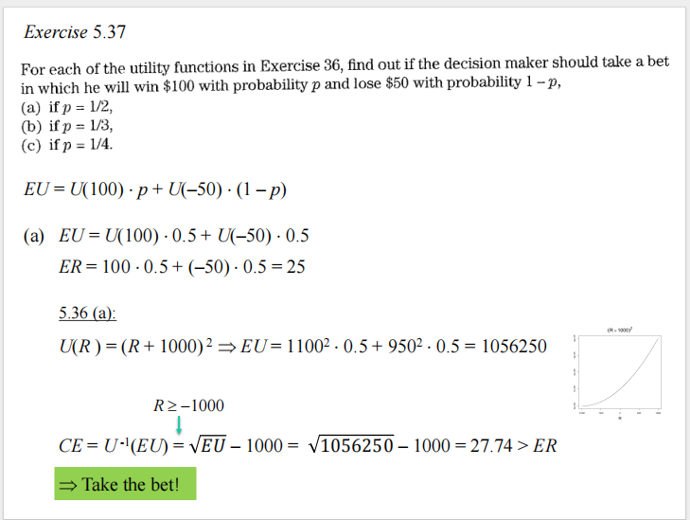

Why we should take a bet here.

