**Practice 1: Build Your Own Login Page**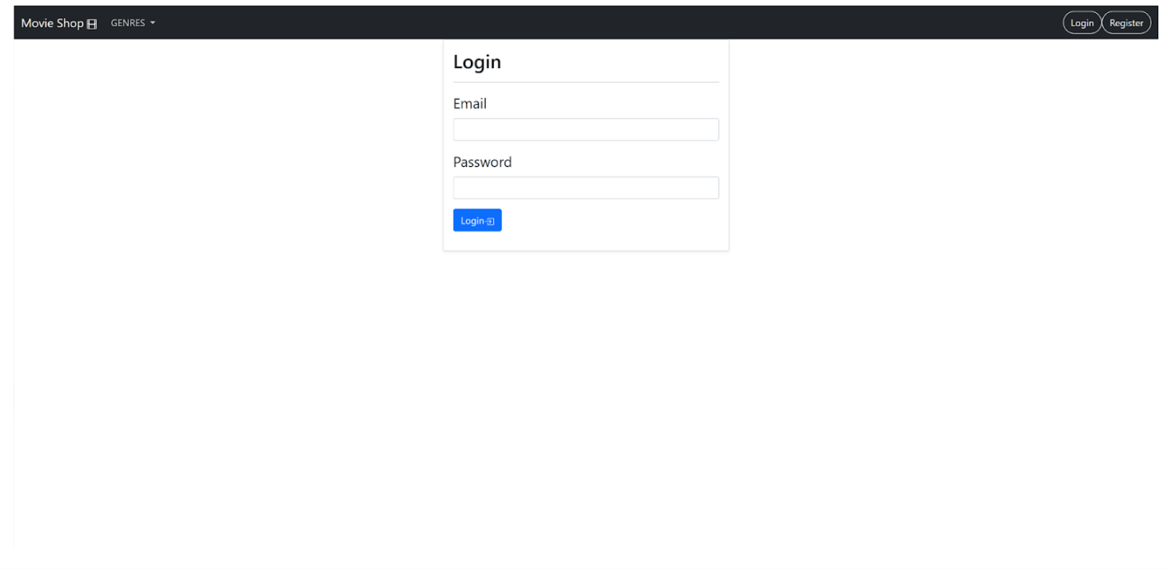

**Task:** Create a simple login page using **Bootstrap 5**.  
 Your design doesn’t have to look exactly like the example, but it must include the required components listed below.

**Requirements**

1. **Navbar** – Add a simple navigation bar at the top of the page.
2. **Form Component** – Use Bootstrap’s **Form controls** to build the login form.  
     
   * The form must include at least:  
       
     + An **Email** input field
     + A **Password** input field
     + A **Login button**

**Practice 2: Build Your Own Registration Page**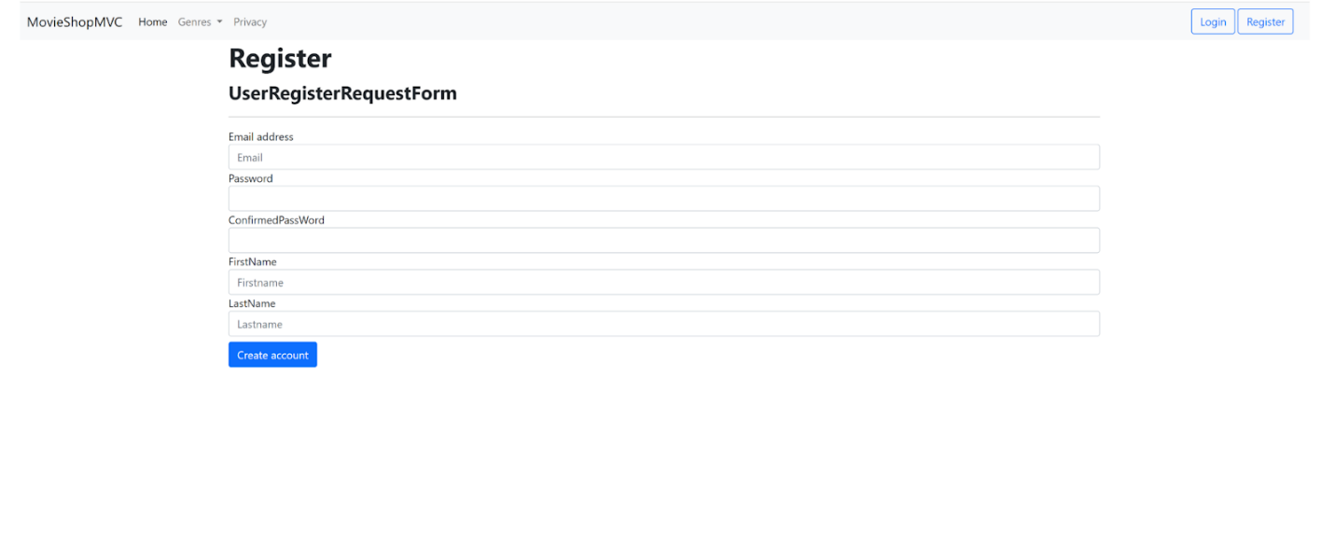

**Task:** Create a simple **registration page** using **Bootstrap 5**.  
 Your design doesn’t need to look exactly like the example, but it must include the required components listed below.

**Requirements**

1. **Navbar** – Add a navigation bar at the top of the page.  
     
   * The navbar must include **Login** and **Register** buttons.
2. **Form Component** – Use Bootstrap’s **Form controls** to build the registration form.  
     
   * The form must include at least:  
       
     + **Email address**
     + **Password**
     + **Confirm Password**
     + **First Name**
     + **Last Name**
     + A **Submit button** (e.g., "Create Account").

**Practice 3: Build Your Own Blog Page**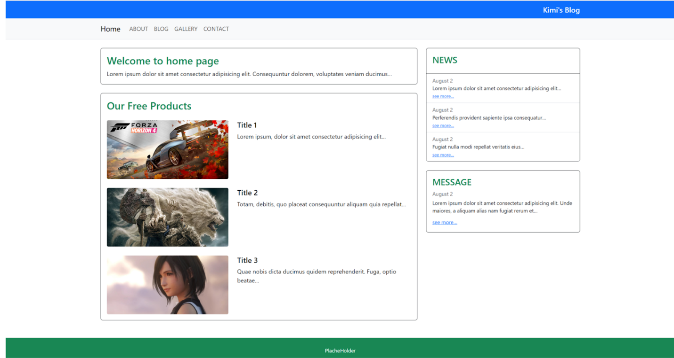

**Task:** Create a simple blog-style web page using **Bootstrap 5**.  
Your design does not have to look exactly like the given example, but it must include the required components listed below.

**Requirements (You must include these)**

1. **Navbar** – Use the Bootstrap Navbar component for your site navigation (e.g. Home, About, Blog, Contact).
2. **Grid System** – Structure your page with the Bootstrap grid (rows and columns).
3. **Card Component** – Display your main content (like posts, products, or articles) inside Bootstrap cards.
4. **Image** – Use at least one <img> tag inside your content (e.g. inside a card).
5. **Footer** – Add a footer section at the bottom of the page.