## 介绍

[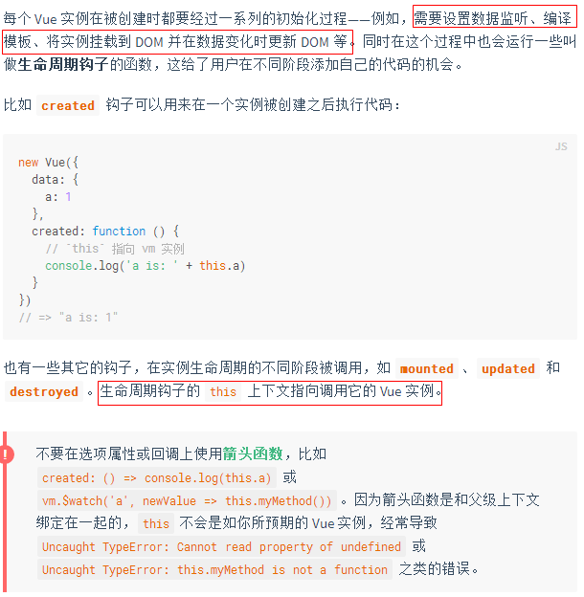](https://developer.mozilla.org/zh-CN/docs/Web/JavaScript/Reference/Functions/Arrow_functions)

## Vue的实例和生命周期钩子图解

[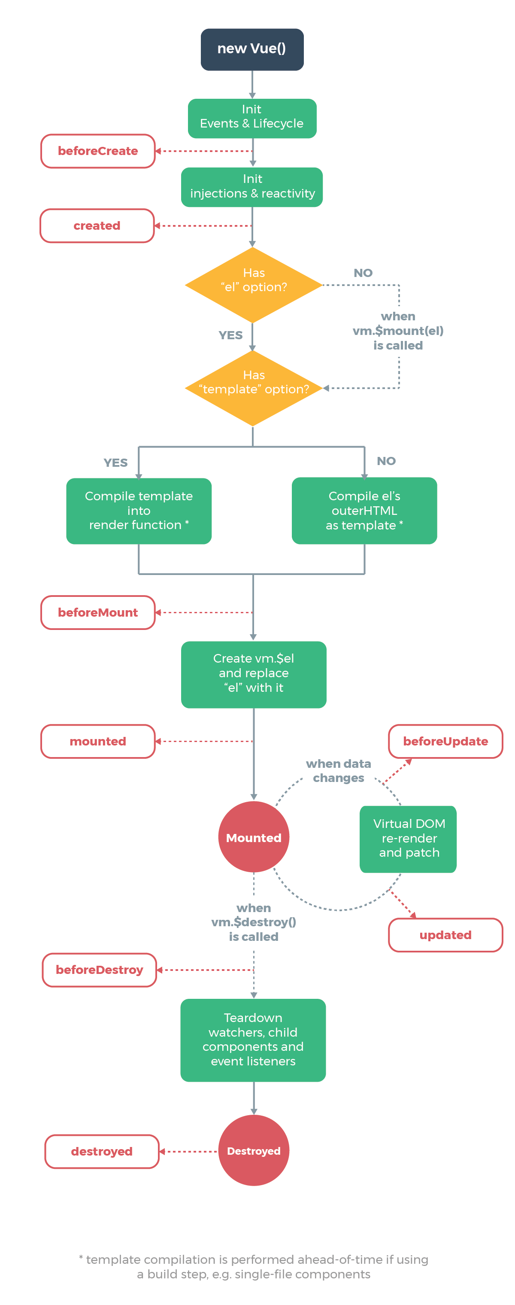](https://cn.vuejs.org/images/lifecycle.png)