# **Single Degree-of-Freedom Prototype**

## Introduction

In this assignment, a subset of your team will construct a haptic device with a single actuated degree of freedom. The performance characteristics of this 1DOF device must be similar to the performance requirements for whichever axis of your final device will consume the most power. As you work on the motion system, other members of your team will be working to produce prototypes of the mechanism which will transmit power from the motor to the user. Once both groups have working prototypes, they will work together to design an integrated system.

The functional requirement for these 1dof devices is as follows: **allow a human user to move an end effector freely along a single degree of freedom, until it collides with a virtual endstop, which feels like a stiff wall**. The position of the virtual wall must be movable, even when the user is in contact with it; passive brake solutions aren’t going to be sufficient.

The devil of this assignment is in the technical details — linear vs. rotary axes, stiffness, inertia, and damping requirements, backdrivability, cogging, ripple, impedance vs. admittance control, and so on.

## Part 1: Create a design | 1 week

Start by producing a detailed concept sketch and block diagram of the 1DOF device you wish to build. Look at your highlighted area of the architecture diagram and identify any “black box” elements that need to be fleshed out. Fig. 1 shows the relevant section from our previous example of a mobile manipulator robot.

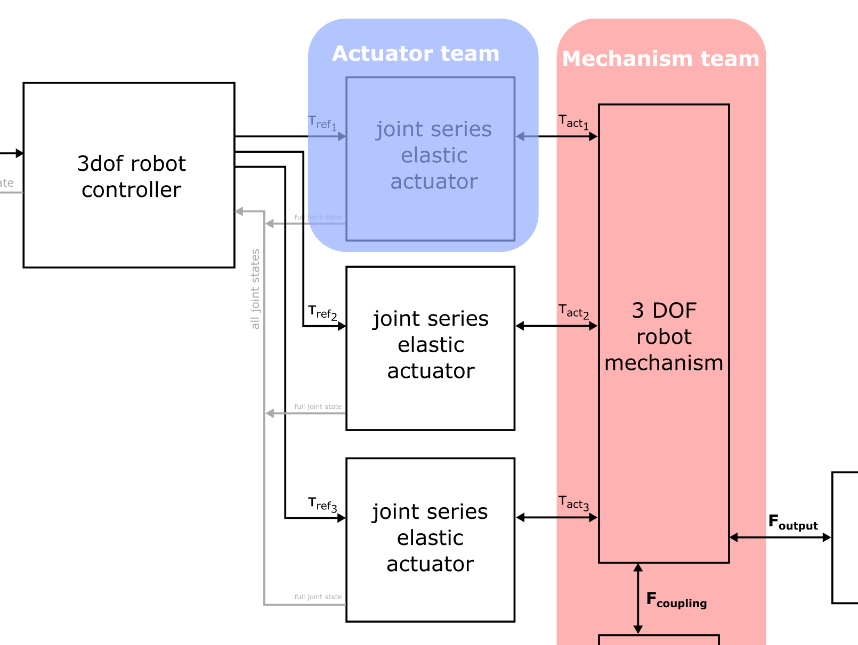

**Fig 1. Actuator section of system diagram**

In this example, the actuator team needs to prototype a “joint series elastic actuator” which accepts a reference torque command and delivers that torque as a physical output.

A diagram of such an actuator is shown in Fig. 2, below.

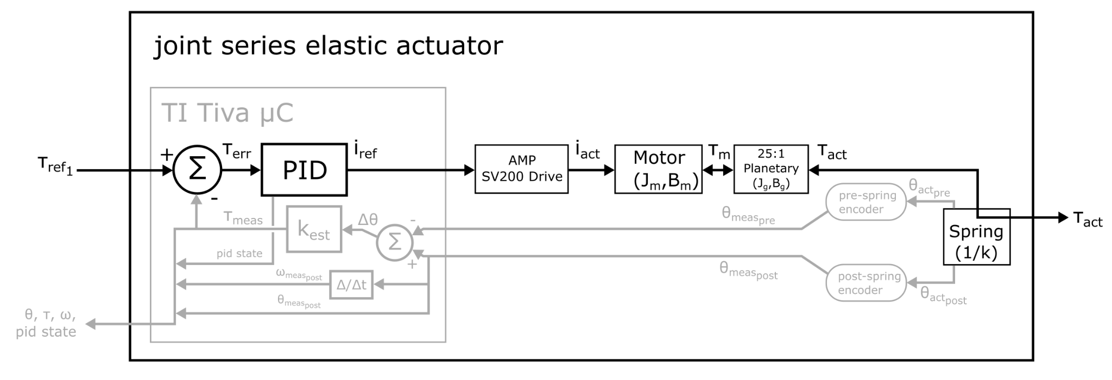

**Fig. 2: Example actuator design for mobile manipulator**

You should try to achieve the level of detail in Fig. 2 with your own actuator block diagram. Try to at least acknowledge the presence of any dynamic effects that could impact performance. It’s okay to abstract these effects into lumped blocks (as with the inertia and damping of the motor in Fig. 2).

The goal of a block diagram is to get an idea of how information and power flow through the device. In addition, make a sketch illustrating how you think the device will actually be constructed. Take the same approach we’ve been using for concept sketches in class. Since the components of the device will be off-the-shelf, you don’t need to worry about designing them. Instead, focus on the way in which they will fit together. Will you need to build any custom brackets or transmission components?

Part 1 deliverables: A detailed sketch and block diagram of the single-dof robot the team intends to build.

## Part 2: Determine Component Performance Envelope | 1 week

Each group will choose a motor, amplifier, sensors, power source and microcontroller. Your choice of components should depend on the technical requirements you established as a team. These requirements should help you place bounds on the torque and speed envelope for the motors, the current and control mode of the amplifier, and the types of transmission and sensors required.

We will spend some time working on this step together in class, though you may have to do some research on your own time as well. Component selection is an important skill, especially in the current climate of parts shortages. Because high performance motors and drives are not available on short notice these days, we have pre-sourced a number of motors and drives that we anticipate will be useful for your projects. Beyond that, you are welcome to request additional components, so long as they will arrive in time to be useful.

Part 2 deliverables: Components for the prototype have been selected, and their selection has been justified.

## Part 3: Build Minimum Viable Prototype | 2 weeks

Build your actuator! In addition to assembling the physical components, wiring up the power supplies, motor and sensor(s), and programming the device, you must document your work. Maintain a Bill of Materials (BOM), wiring diagram, drawings of custom parts, configuration instructions for any commercially-sourced components, and full comments on any source code (including build and programming instructions).

The functional goal for the minimum viable prototype actuator is some kind of physical motion, with human-readable sensor feedback. You don’t have to implement a proper controller; just show us something well documented that can move, and produces a *.csv file of its sensor data. The human-readable feedback step is important… this is how we will ultimately evaluate your controller’s performance!

Part 3 deliverables: A fully documented prototype capable of producing motion.

## Part 4: Controls and Documentation | 2 weeks

Implement a haptic controller for your device. As you develop your controller, keep your block diagram up to date. This way you will be able to explain the operation of the controller to somebody unfamiliar with your device.

The final demo for this assignment is a stiff-wall haptic interaction. A person should be able to grab the output of the device and move it freely, until they encounter what feels like a hard obstacle. We expect performance in line with the technical requirements for a single axis of your team’s final device, ideally the most powerful axis. We’ll measure the force output using a load cell, and collect position data from the feedback log generated by your device.

Part 4 deliverables: The prototype is capable of performing the desired control task, and a stiff-wall demo is available for evaluation. The documentation is up to date, and the block diagram has been refined to reflect as much detail as possible about the system.