# **Requirements & Architecture**

## Introduction

The goal of this assignment is to establish rough technical requirements for your device and create an outline of the device architecture. This architecture diagram will be very abstract and contain many unknowns or black boxes. Working on independent subsystems with an abstract overall architecture in mind is sometimes called **top-down design**.

This approach tries to split hard problems into smaller, more manageable chunks, without disregarding the way all the pieces will eventually have to interact. Its success may depend on a good initial architecture choice, though it is sometimes possible to use subsystems developed for one architecture within the framework of another.

This assignment will be worked on during class, during your first two team meetings with the course instructors, as well as out of class.

## Part 1: Understand the problem

Each project specification document contains a relatively vague description of the device you are supposed to build, and a list of questions. Your goal is to answer as many of these questions as possible, in the form of a list of technical requirements for your device.

Technical requirements must be testable via physical measurement or observation of a device. They should focus on the *what* instead of the *how*; we aren’t trying to design the robot here, just explain the performance we want from it. Requirements aren’t always quantitative, but they should be as specific as possible. The process of reducing ambiguity in requirements will help the whole team agree on the overall goal of the project.

Examples of bad requirements:

1. The device shall be easy to hold.
2. The device shall attach to the user’s forearm.
3. The device shall produce the sensation of a stiff wall at the end effector.

Examples of good requirements:

1. The device shall weigh no more than 3kg, excluding tethered benchtop components.
2. The device shall permit the user to move freely within a 3m square room.
3. The device shall simulate unilateral collisions with a stiffness of at least 1000N/m.
4. The device shall produce up to 5N of force in any direction on an object held in the user’s hand.

Note that some sub-par requirements can be turned into good requirements by making them more specific. When a requirement depends on subjective evaluation, try to turn it into an objective criterion. It’s okay if the numbers you choose aren’t perfect; they can be revised.

Part 1 deliverables: First draft of technical requirements

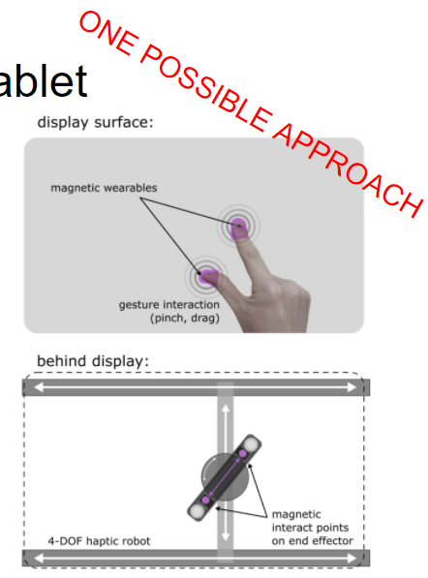

## Technical Requirements

### Qualitative

*Should we require a display?*

Need a display of some sort to give visual feedback to the user.

*What should coming into contact with the surface feel like?*

Surface should be a rigid, smooth surface and have low amount of friction

*What should coming out of contact with the surface feel like?*

Ideally it should require little force to come out of contact with the surface

*Do the two contact points have any allowable motion constraints (e.g. rotation limits)*

Contact points bound within edges of display. Rotation of contact points should be limited to possible rotation of wrist

*What range of hand sizes needs to be supported?*

At least, our group’s hand sizes must be supported. Ideally we would also be able to support ____

*What use cases / demos will best illustrate the utility of this device?*

Game-Pong? Labyrinth? Knobs/buttons/switches?

## Qualitative

* The device should have a display to provide visual feedback to the user.
* The device should actively track the location of 1 or 2 fingers on the interactive display.
* Disengaging from the device should feel like removing one’s fingers from a ‘sticky’ surface.
* The device should be aware when the user places and removes their fingers from the interactive display.
* The two contact points of the device are limited by the edges of the display. Consideration could be given to rotation limits
* The user should feel no forces when they are not in contact with the interactive display.

## Quantitative

* The device shall have a traversable area of at least 7” by 10”.
* The two contact points shall be able to go as close as ⅜” together or 5” apart
* The two contact points should be able to handle 2 full rotations from a neutral starting point.
* In free motion, the user should experience no more than 0.22 lbs or 100 g of inertia.
* In free motion, the gantry device should be able to match finger speeds up to 150 mm/s or 5.9 in/s.
* NEED FRICTION REQ
* When the user is interacting with a virtual wall, the device will be able to respond with a stiffness of 1 N/mm or 5.71 lbs/in
* For sensing and actuation the device will have a resolution of 2500 points/linear inch.
  + May need finer resolution to provide stiffness req
  + Think about velocity resolution(pos. res/timestep)->likely need finer resolution
  + Guess: ~10 microns
* The device will have sensing capability that can track the X/Y positions of the two fingers and the two magnets
* The device will be able to provide a maximum of 5 lbs of force
  + Aggressive
* The device will be able to engage and disengage the magnetic attraction between the gantry and the fingers

### Quantitative

*How large does the workspace need to be?*

*At least Tablet sized (7 by 10 inch), though we might benefit from a wider surface*

*Must allow for hand pinching movement*

*How far apart do the two contact points need to get?*

8 inches

*How close together do the two contact points need to get?*

⅜ inch

*How free should free motion be?*

*How much inertia?* 100 grams

*How much damping?*

*Maximum speed?* 150 mm/s

*How stiff should stiff walls be?*

1N/mm

*What positional/angular resolution is required?*

Positional: 50points/inch

Angular: Derived from positional if necessary

*What force resolution is required?*

*What variables need sensors?*

Variables:

* Position of finger 1
* Position of finger 2
* Position of Device point 1
* Position of Device point 2

*How strong should constraints be?*

*Force from actuators* 5 pounds

*Max length(screen to fingertip) of magnetic interaction*

0”->Need a way to switch magnets on/off

## Part 2: Brainstorm

As a team, brainstorm some overall concepts for how this device might work. This is a time for open-ended discussion and crazy ideas, but a bit of back-of-the-envelope feasibility calculation wouldn’t hurt. You will not be committing to any of the designs proposed at this stage. Try to produce a wide range of feasible ideas that capture as much of the design space as possible.

Part 2 deliverables: At least five device concept sketches, as varied as possible.

## Categories

Movement system

Interaction methods(engaging/disengaging)

Hand/finger tracking

Display system

## Part 3: Define abstract system architecture

Look at your device concept sketches. They may be quite diverse, but can you find similarities? Try to create a very abstract diagram of your device that is descriptive of as many of the concepts as possible. You don’t need to follow a particular format for system diagramming, as long as the result communicates the architecture clearly. Focus on the purpose of each high level block in the diagram, without worrying too much about the implementation.

As an example, consider a mobile manipulator robot that uses force control. A rough diagram is shown in Fig. 1, below.

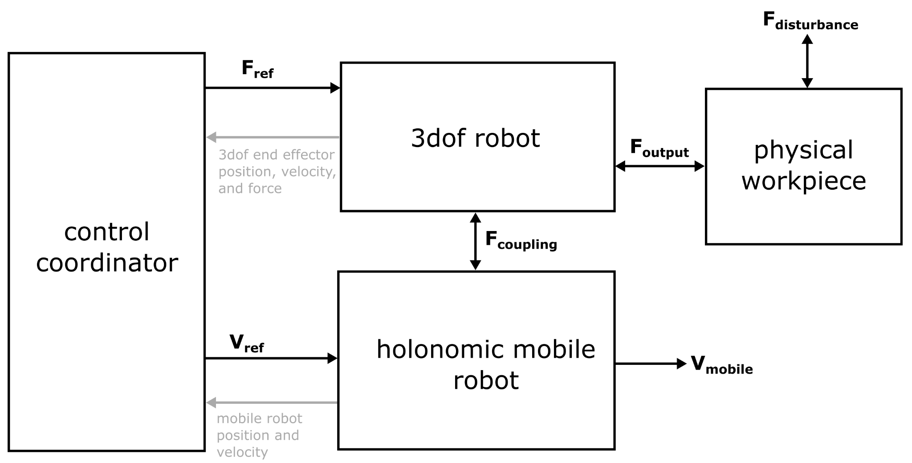

**Fig. 1: System architecture for mobile manipulator**



This simple diagram defines one possible architecture for a mobile manipulator. This robot consists of a mobile base and a 3 degree-of-freedom robotic manipulator. A central computer commands a velocity for the mobile robot and a force to be delivered by the arm. Note that the type of controller in use isn’t established, but the controlled quantities are. As a rule, try to use the word *reference* to mean a theoretical or desired quantity, *measurement* to refer to sensed quantities, and *actual* to refer to real-life quantities. This can help reduce ambiguity in these sorts of informal diagrams.

If we are willing to constrain our design a bit more, we can add additional detail to the diagram to obtain Fig. 2.



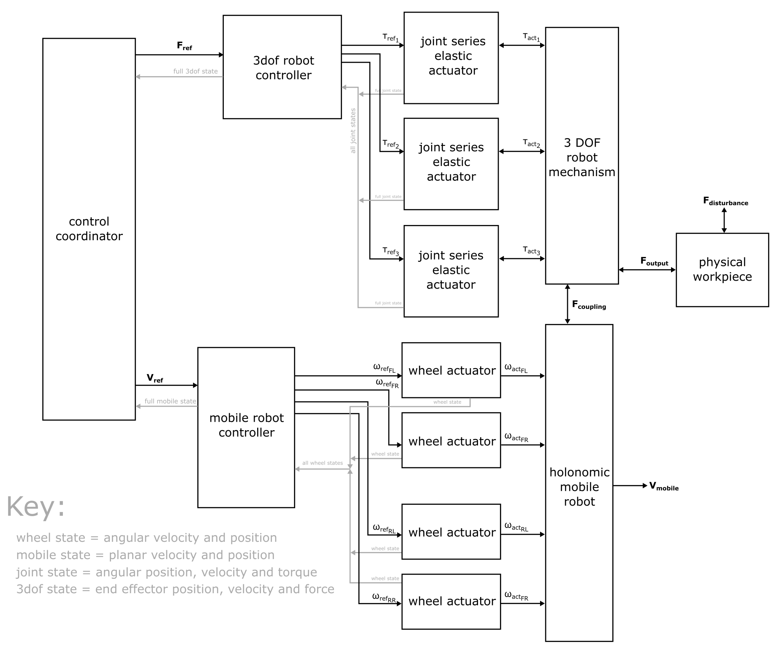

**Fig. 2: Refined system architecture for mobile manipulator**

In this diagram, several new assumptions have been made. We assume the 3DOF robot will use three force-controlled series elastic actuators, and we assume the mobile robot will use four independently driven velocity-controlled wheels. Note the addition of a key to help clarify definitions.

For this step of the assignment, try to start with a diagram like that of Fig. 1, and refine it to roughly the level of detail shown in Fig. 2. It is okay to make some decisions about actuator type and control modes here. This is the first step in reducing an abstract system architecture to something practical that can be built.

After this step, your team will split into two sub-teams: the actuator control group and the mechanism group. The actuator group will work to construct a single degree-of-freedom actuator prototype complete with a closed loop controller that meets the performance requirements for your device’s most powerful joint. The mechanism group will work to design and prototype the mechanism(s) necessary to transmit power from the actuator to the user.

To complete this assignment, look over your finished system architecture document as a group, and highlight the areas that the actuator group and mechanism group will be working on. The result should look something like Fig. 3:

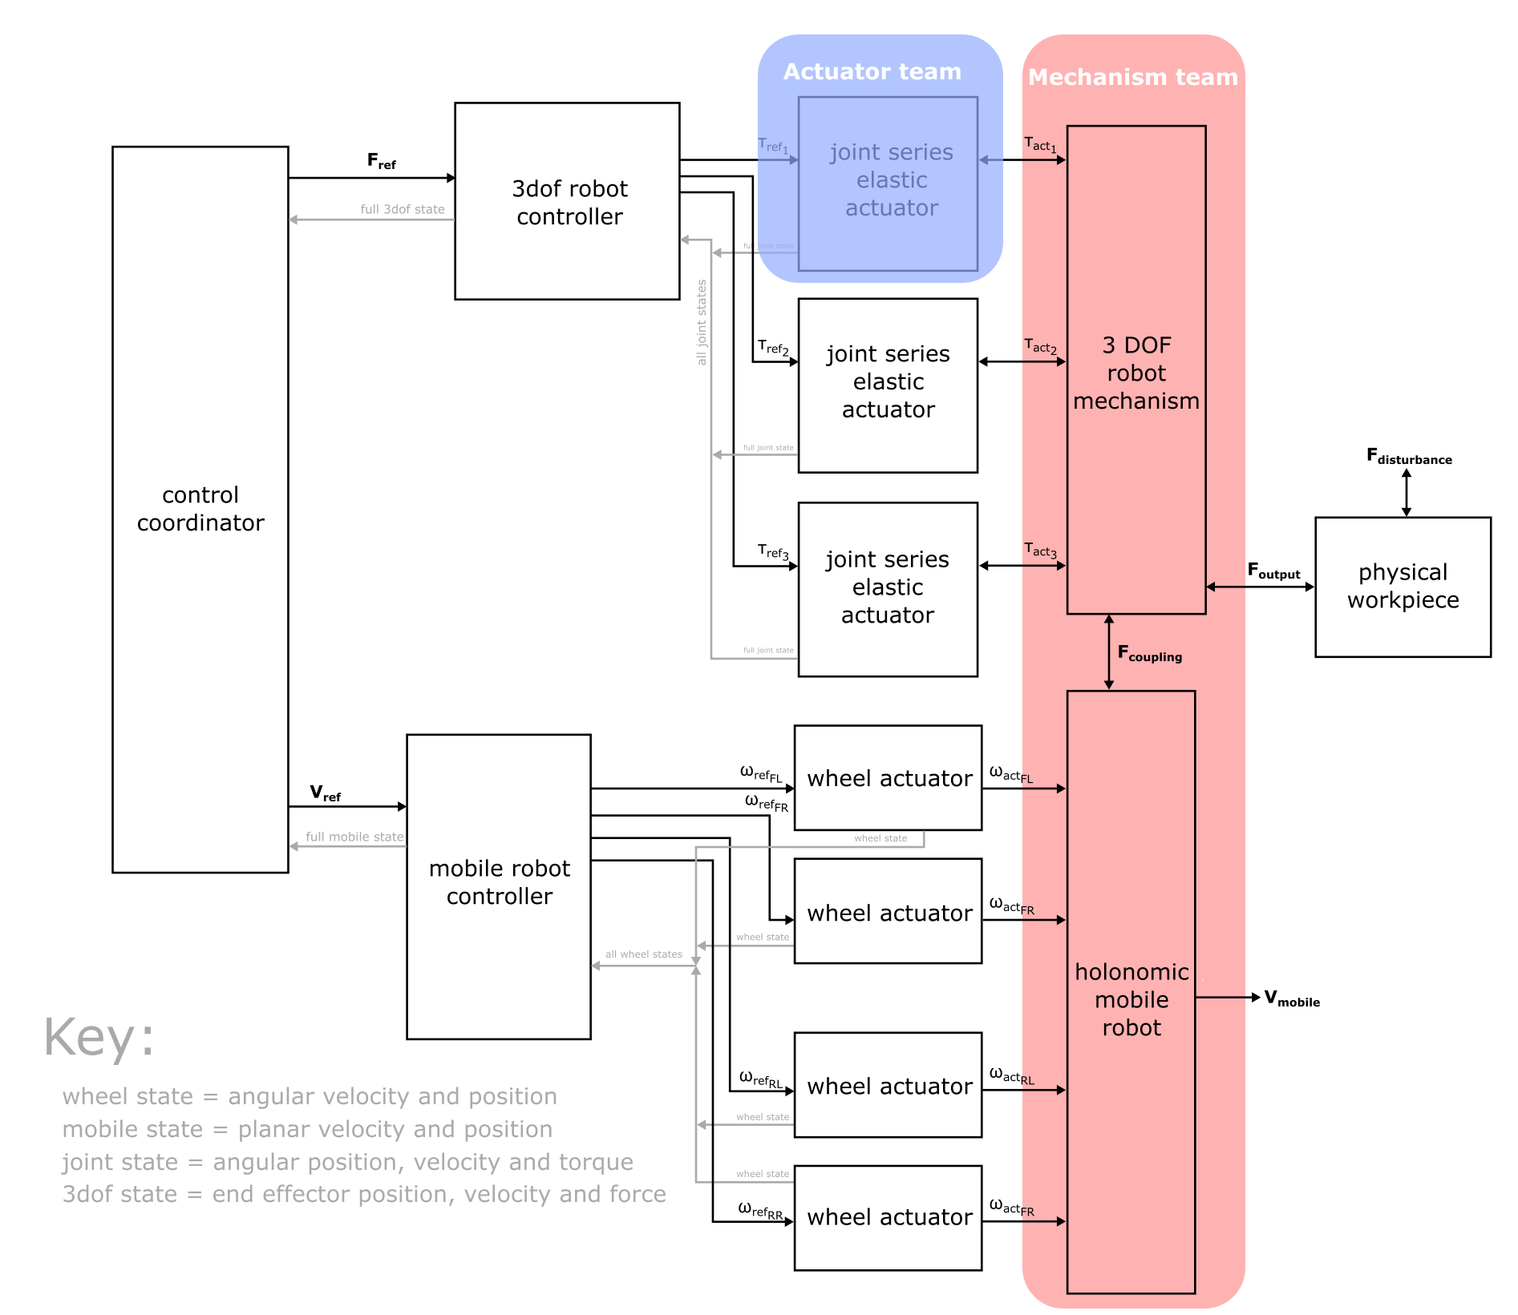

**Fig. 3: Architecture diagram with sub-team focus areas identified**

Hopefully, having completed this step will help the sub-teams answer questions like:

* *How many degrees of freedom (including passive degrees of freedom) will the mechanism have?*
* *What sort of sensors and transmission elements need to be built into the actuator prototype, to facilitate closed loop control?*
* *What type of actuator(s) will drive the input(s) of the mechanism? Linear or rotary; backdrivable or not, inertia or forces? Will the actuator(s) be performing impedance or admittance control?*
* *What (if any) information does the mechanism need to provide to the controller? Positions of joints or end effectors? Force measurements?*

Part 3 deliverables: A top-down architecture has been drawn to drive forward development. The concept diagram has been refined (though it still contains many black boxes), the sections of the diagram that will be addressed by the 1DOF and mechanism sub-teams have been identified, and students have been assigned to those teams.