Projection Methods and the Fast ICA Algorithm

Background:

Data from real-world experiments often naturally arise in the form of collections of values of a (possibly large) number, say p, of variables. Such data are thus most naturally depicted in a p-dimensional scatter diagram. For p>3 this is both difficult to draw and visualise, and somewhat hard to interpret sensibly.
Several methods exist for graphically depicting data of dimension higher than two, ranging from specially annotated 2-D scatter plots to the more complicated Chernoff Faces, however these are both limited in the scope of the suitable data, and severely so in the interpretation possible from the final result.
One method, noteworthy for being capable of handling arbitrarily high dimensional data, is to associate an observed vector x to its Andrews Curve:
f_{x}(t) =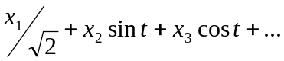
And, noting that 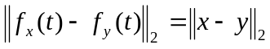, one can draw the curves of all the data points on one graph and attempt to identify outliers within the data, though little else.

This unsatisfactory situation motivates Principal Component Analysis (PCA) and what follows. A technique is needed, in general terms, to discover ‘hidden’ (since we cannot satisfactorily depict the data) trends within the data and/or condense the data into fewer dimensions, without foregoing too much of the available information.
Geometrically considering the original p-dimensional scatter plot can provide motivation for some of the methods of PCA. If we assume that the data are subject to normal error terms (as usual justified by an appeal to the Central Limit Theorem (CLT)), then the covariance matrix of the random vector is positive semi definite and the data will generally occupy a p-dimensional hyperellipsoid, ie a level surface of 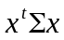, whereis the covariance matrix of the underlying random variable. We now consider projecting the data onto various directions. If we are to consider a direction interesting (insofar as revealing a trend) or important (insofar as the projected data containing much of the total information) then we might seek to minimise the total of the (squared) distances between the data and their projections onto the given direction.
In the simplest case of choosing a direction from 2-dimensional data (though this case generalises fairly simply) we want to:
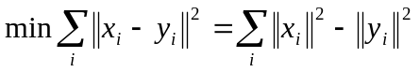by Pythagoras, where y_{i} is the projection of x_{i} (both vectors) onto some one dimensional subspace.
So equivalently: 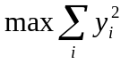.
Thus we are led to choose the direction by maximising the variance of the data projected onto it, the central tenet of PCA.

Principal component Analysis

The aims of the method are:
- To accept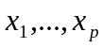, correlated variables and yield 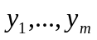 where 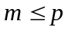, uncorrelated variables (it will be seen that this is equivalent to choosing orthogonal principal components).
- To reduce the dimension of the data, ie produce more manageable data, while still explaining as much of the ‘salient’ or inherent information of the original data as possible.
- To produce clusters, as described below.
The method proceeds to find all the principal components, and then we may consider which to retain and which to discard. Consider each data point as an observation on the random variable X.
If 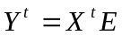 and 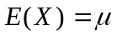 then,
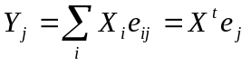 and we set 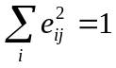 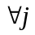to fix a scale.
Then 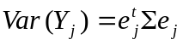, where 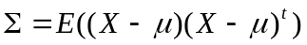 the covariance matrix of X.
So we choose the principal components by maximising the variance:
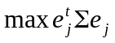 such that 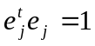.
Lagrangian methods easily lead to 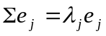 (no summation).
Now is a real symmetric matrix, so has real eigenvalues and the 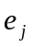 are just the (normalised) set of orthogonal eigenvectors. The covariance matrix of Y is now 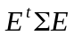=diag(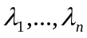) where 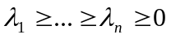. So, as claimed, the new variables are uncorrelated.
Generally, the method is applied not to X, the vector of raw data, but to scaled and centred data, so that each variable has mean zero and standard deviation one. This treats each variable on an ‘equal footing’ and gives dimensionless and directly comparable data in a way that the raw data are not. Assuming this to be the case, tr()=n and 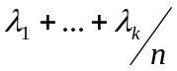 can be used to show the proportion of the total variance ‘explained’ by the first k principal components.
If one wishes to reduce dimensionality one might keep the first k principal components such that they ‘explain’ about 0.8 or so of the total variance, though this is no more than a rule of thumb. In this k dimensional subspace reification, or interpretation, of the 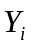 may be possible, especially if a relies strongly only on two or three of the original variables (‘height+weight’ may be considered a measure of ‘size’ for instance). If this is not immediately possible a rotation of the k new variables may help.
It may be that the original variables partition themselves, in terms of strong dependence, amongst the , and in this case they are said to ‘cluster’. An index of such a cluster may be derived from the form of the principal components.
PCA is in fact a simple, analytically soluble, case of a much more general technique known as Projection Pursuit (PP). PP similarly seeks lower dimensional subspaces onto which the data are projected. Firstly one defines or chooses a measure by which directions will be chosen (thus in PCA this measure was the variance of the projected data). In more complicated schemes than PCA there will be no simple analytic solution (such as choosing eigenvectors) and PP will in general have to search for the basis of the required subspace by some iterative and computationally intensive manner.

Independent Component Analysis

The above provides the setting for a further type of projection pursuit, that of Independent Component Analysis (ICA). The basic premise of ICA is that the random errors which cloud genuine trends in the data are normal (by appealing to the CLT). Thus in the language of PP, the most interesting directions in the data are the ones that are least normal.
Alternative, and equivalent, motivation comes from the problem of ‘unmixing’ observed data. If there exists some source vector of underlying, independent random variables then one may postulate that in fact 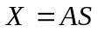 is observed experimentally, for some unknown mixing matrix A. Thus finding important components of  is akin to finding the original source .
For the purposes of ICA we assume that the sources are independent and non-normal. We also impose a source variance of one, so that S is determined up to sign. Also notice that the order of the components of cannot be determined by this method, since A is completely unknown. Source normality is forbidden partly because experimental error will generally be normal, and partly because extracting an ‘interesting’ direction could then be impossible: A set of uncorrelated normal variables remains so after any orthogonal transformation.

Under these assumptions an appeal to the CLT tells us that a sum of random variables is generally more normal than the summands. Thus an algorithm which seeks and finds the least normal components ought to pick out each non-normal source in isolation, and not simply more unknown mixtures of the sources.

Measure of Normality

Classically this is achieved using Kurtosis, defined by: 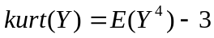 for such that 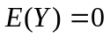 and 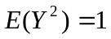. This statistic is zero if ~N(0,1) and is non-zero for most (but not all) non-normal variables.
- If kurt>0, is said to be leptokurtic, and is typically ‘spikey’, with long tails.
- If kurt<0, is said to be platykurtic, and is typically flat.

However |kurt| or kurt² are not good statistics to sample as they are very sensitive to outliers among the data, and so are not used for ICA.
In fact the measure that is used is known as Negentropy. Entropy is defined by: 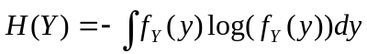.
A result of Information Theory is that of all random variables of equal variance the normal one has the largest entropy. Thus normals are the ‘least structured’ of all random variables, and entropy is generally small for spikey or clearly clustered variables.
Then Negentropy is defined by: 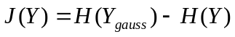,
where 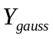 is a multivariate normal with the same covariance matrix as . Hence we have that 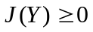 and 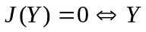is normal.
J may be approximated by: 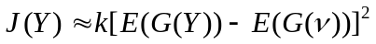,
for some 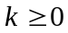,~N(0,1) and when is standardised.
G here is a non-quadratic function and is picked to avoid the problems of kurtosis with outliers. Examples include 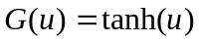 and 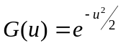.

Before getting stuck into the algorithm the data should be preprocessed. Firstly centre each variable, so 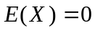 and ‘whiten’ so 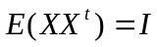. To achieve this take 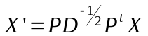 where 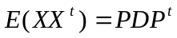 and 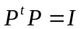 and  is diagonal.
As a result, after this transformation, the A we seek is orthogonal:
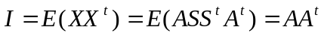, by assumption on .

The Fast ICA Algorithm

One version of the algorithm, known as deflation, seek successive vectors to solve: 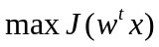 such that 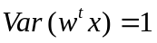, ie 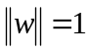 (for centred whitened data),
and such that is orthogonal to all previously determined directions.
Aliter we may seek the required number of directions all at once, in this case decorrelating 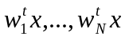 after each iteration so that they converge to different maxima.
In either case the algorithm follows an approximate Newton Iteration until a certain tolerance is met. The deflationary scheme achieves orthogonality using a simple Gram-Schmidt scheme, and the other method utilises the eigenvalue decomposition of a symmetric matrix.

Programming the Algorithm

The final result has been tested successfully. Included are some very simple examples of PP and an example of some signal unmixing, in which the original signals, one saw-tooth and one sinusoidal, were ‘mixed’ via premultiplication by a matrix. The mixed signals were the only input into the ICA, and the ‘unmixed’ output is shown. Note that the signals recovered are ambiguous in sign and their order, though the original signals are recovered well. Also the extracted components have a variance of unity, and so are scaled slightly differently to the original signals. This is however selling the code short, as the whole intention was to produce a faster way to perform the algorithm, and this aspect was tested by using the code to apply ICA to the huge data sets provided by FMRI brain scans. In this instance the code was found to be about six time faster than simply using built-in R utilities to run the algorithm, and so the project is considered a success.

