**1. Introduction**

The purpose of this document is to analyze customers’ reviews of Kindle app from Apple App Store (US) and Google Play Store (English, not US) for the past 1 year (5/1/18~5/30/19). In total, there were 18,632 reviews (with ratings) at average rating of 4.5 for iOS, and 21,048 reviews (with ratings) at average rating of 3.8 for Android.

* Note that “Review” is different from “Rating”, as in “Rating” is stars (1~5) given by a customer without comments, whereas “Review” requires a customer to enter in their text feedback about the respective app in each platform (iOS or Android), and they tend to have much lower average number of stars given than the average stars given in “Rating”, partly the reason being is more of ‘negative’ perceptions drive more motivation for customers to go out of their ways and leave a review than satisfied customers.

While overall store-facing ratings from App Store rating (4.8) and Play Store rating (4.2) have been fairly stable for some time now, mostly due to the large number of past ratings given, if we were to focus on the newly posted reviews for the past 1 year, average ratings(with reviews) have decreased ~14% (3 months rolling average) from 5/1/18 (4.63) to 5/30/19 (3.99).

This decreasing trend is problematic because of the following reasons:

1. To some extent, we can generalize the feedback given by reviews as reflections of how rest of iOS and Android users are feeling about Kindle apps
2. Reviews’ ratings, while they do not seem to be showing much meaningful correlation with overall reading engagement metrics for the respective surfaces, they do seem to have moderately strong correlation with New to Kindle customers’ reading engagement metrics

|  |  |
| --- | --- |
| **Var 1 & Var 2** | **Correlation Score (Pearson's)** |
| iOS weekly rating & number of unique NTK customers reading | 0.14 |
| iOS weekly rating & number of NTK customers reading | 0.24 |
| Android weekly rating & number of unique NTK customers reading | 0.12 |
| Android weekly rating & number of NTK customers reading | 0.12 |

**2. Methods/Approaches**

App Annie provides easy-to-use interface where app review data for Kindle-for-iOS and Kindle-for-Android can be downloaded at daily level, containing ratings (1~5) and texts of customer reviews.

Using review text data, removed commonly occurring stop-words such as (I, me, on, is, being, etc.), and created filtered lists of words as well as normalizing different variations of same words, for example grouping words like “crash”, “crashes”, “crashing”, “crashed” into “crash”. Some of the most frequently used words from each platform were the followings:

* iOS
  + “Library”: 1,948 times, “purchase/buy”: 1,699 times, “download”: 1,198 times, “sync”: 863 times, “font”: 644 times
* Android
  + “Download”: 1,331 times, “library”: 430 times, “crash/bug/glitch”: 425 times, “fix”: 410 times, “uninstall”: 194 times

Also have manually gone through most frequently occurring words and created a list of key words that are closely related to different Kindle features or customer experiences to specifically trying to understand sentiment shifts along these key Kindle terms.

* The entire list of Kindle keywords can be found in **Appendix 2.1**

Next with the cleaned texts and manually vetted key Kindle terms, change in average ratings per each of key Kindle terms for the entire period to get better understandings of recent shifts in Kindle customers’ perceived values. You will find multiple comparison time-series plots of average ratings (with reviews) per each of the key Kindle terms for iOS and Android in **Appendix 2.2**, and we will be noting for any interesting pattern we observe.

Lastly with the cleaned review texts, created and ran a customized implementation of VADER (Valence Aware Dictionary and e-sentiment Reasoner) sentiment analysis framework to get insights on shift in customer sentiments.

* VADER uses a combination of A sentiment lexicon is a list of lexical features (e.g., words) which are generally labelled according to their semantic orientation as either positive, negative, and Neutral. It is known to work exceedingly well on social media type text, which resembles majority of style and tone of review texts on App store and Play Store.
  + Overall sentiments for iOS and Android for the period can be found in **Appendix 2.3**
    - VADER outputs Positive, Negative, and Neutral scores, as well as Compound score, which is a summary of all positive, negative, and neutral output for ease of consumption.
* VADER is flexible
  + You can customize VADER for different uses. There are certain keywords related to Kindle that are not well reflected in standard VADER implementation, such as words like “Crash”, “Bug”, “Glitch”, which have relatively moderate negativities in social contexts, but much more critical when thought from Kindle customers’ perspectives. To effectively customize for this caveat, key terms related to Kindle experiences have been either added or relative weights been adjusted in proportional to their rolled-up mean ratings to reflect Kindle specific sentiments better.
    - iOS Sentiment by Kindle keywords can be found in **Appendix 2.4.1**
    - Android Sentiment by Kindle keywords can be found in **Appendix 2.4.2**

**3. Observations**

[placeholder]

**4. Recommendations/So what?**

[placeholder]

**Appendix**

Appendix 2.1:

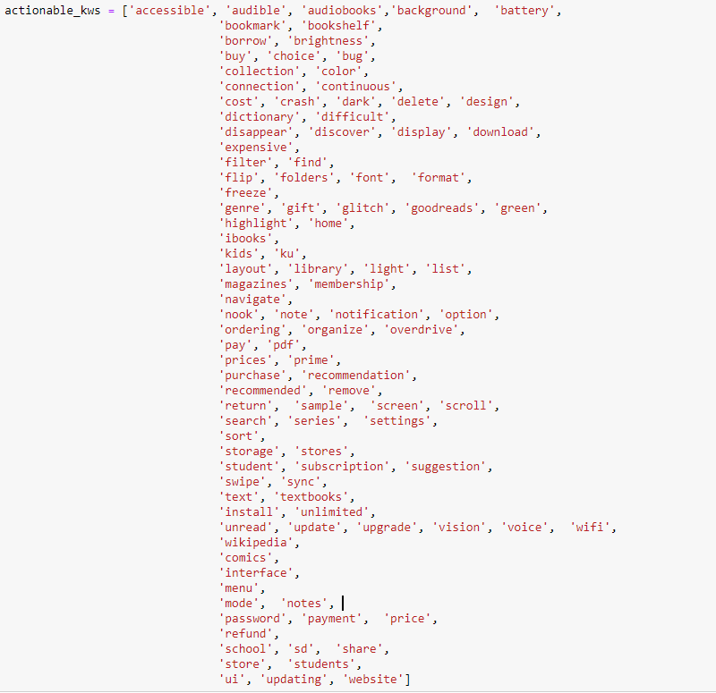

Appendix 2.2

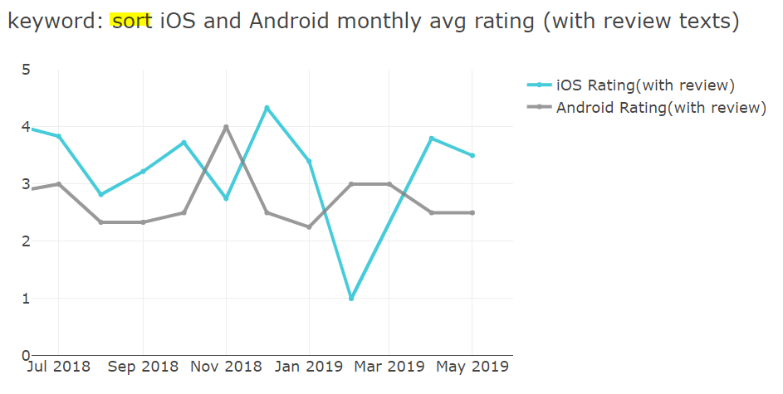

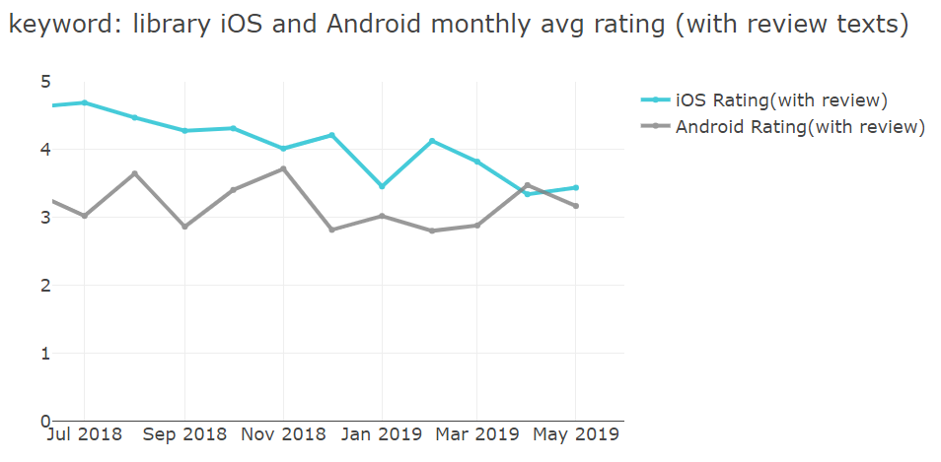

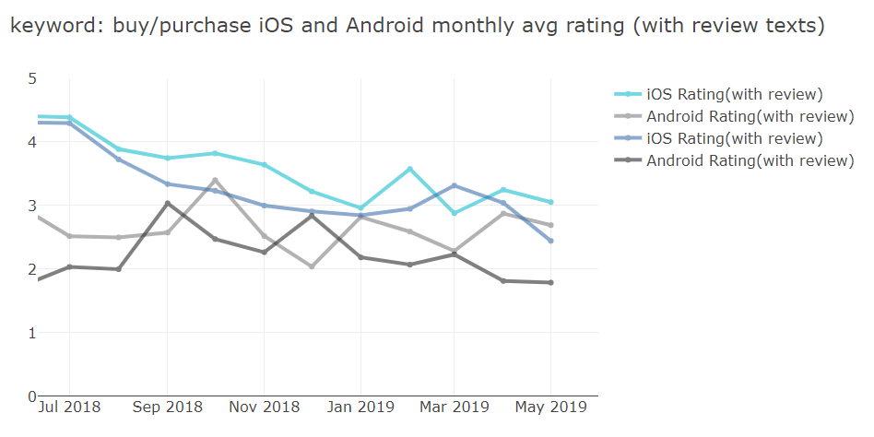

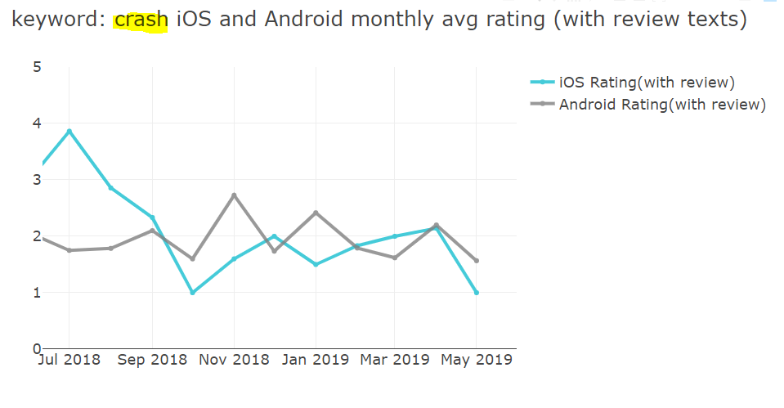

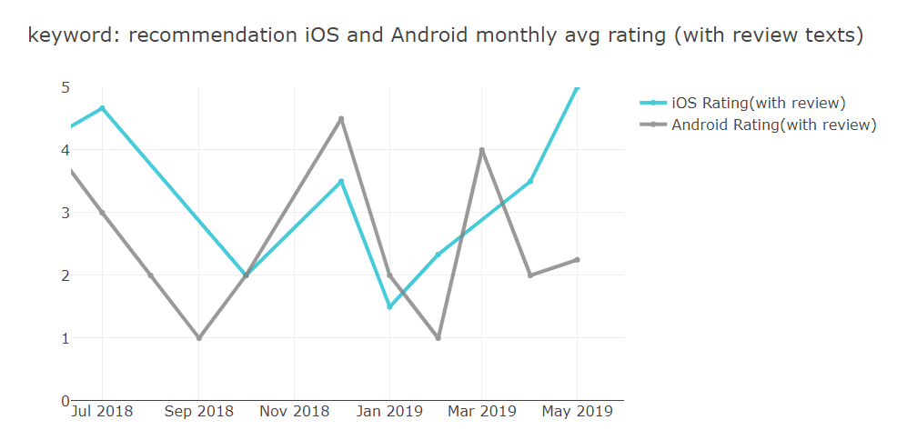

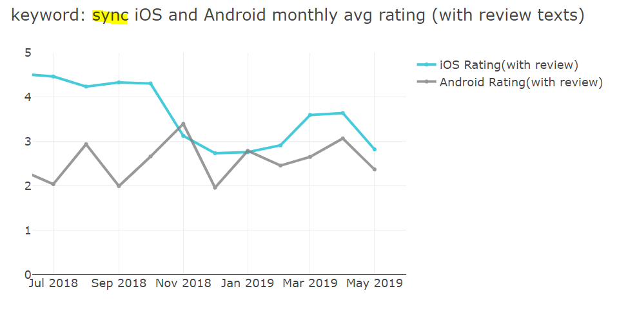

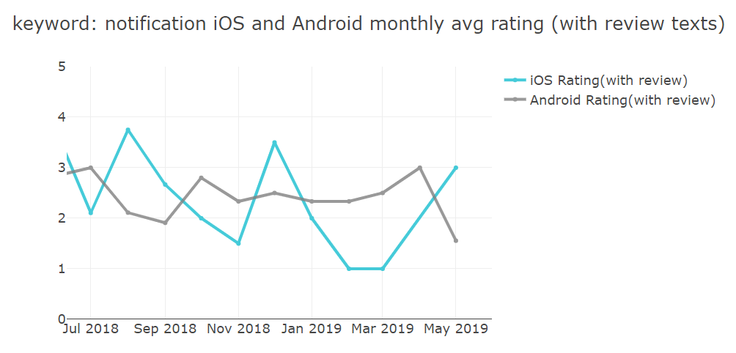

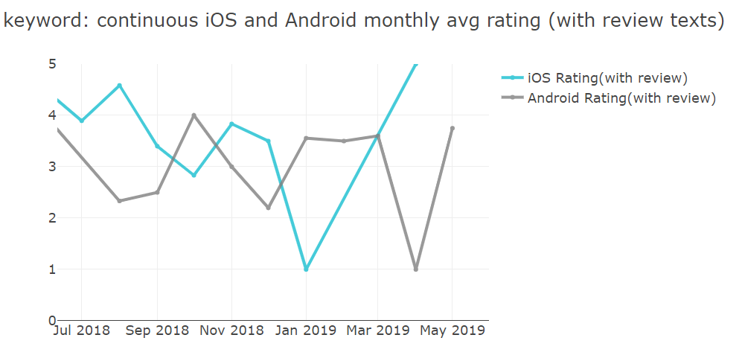

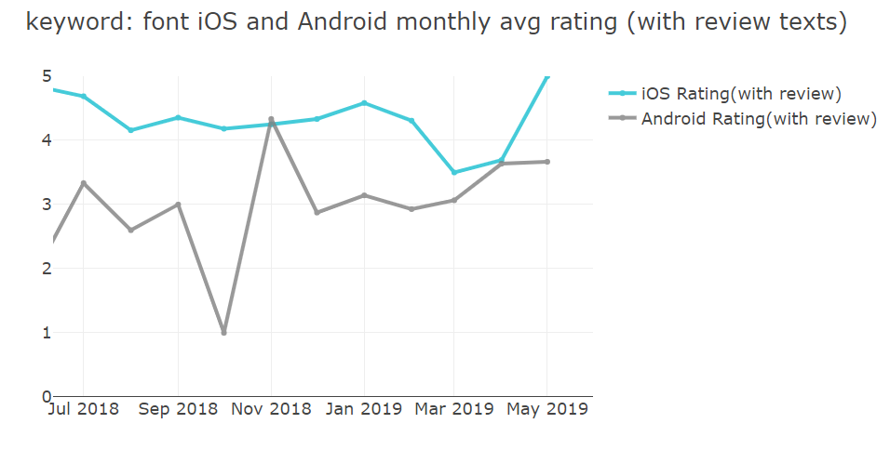

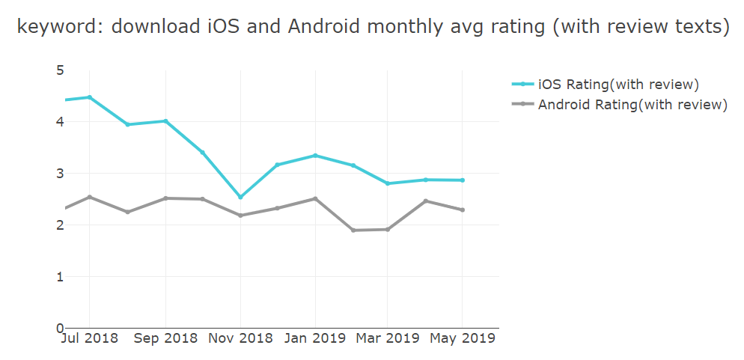

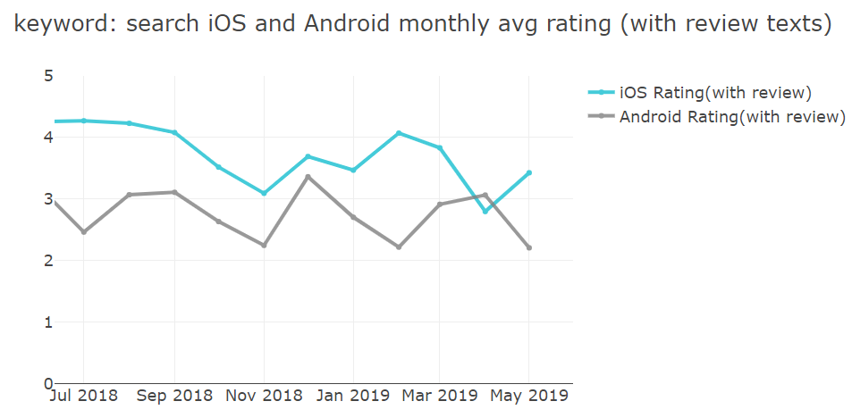

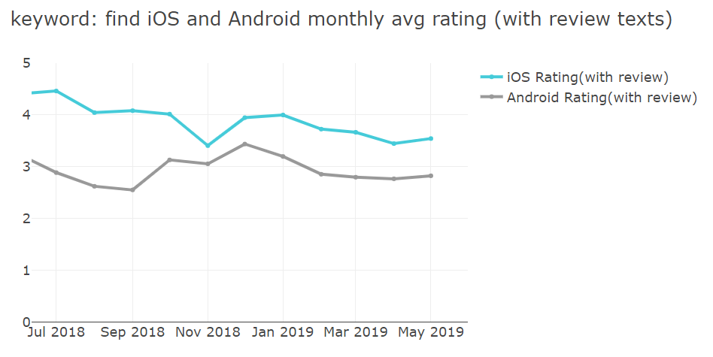

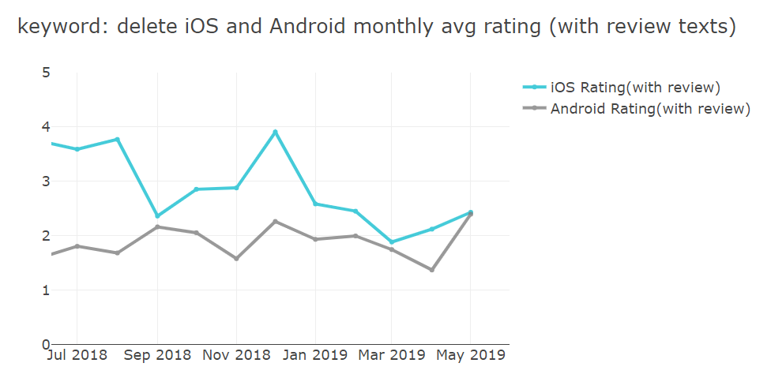

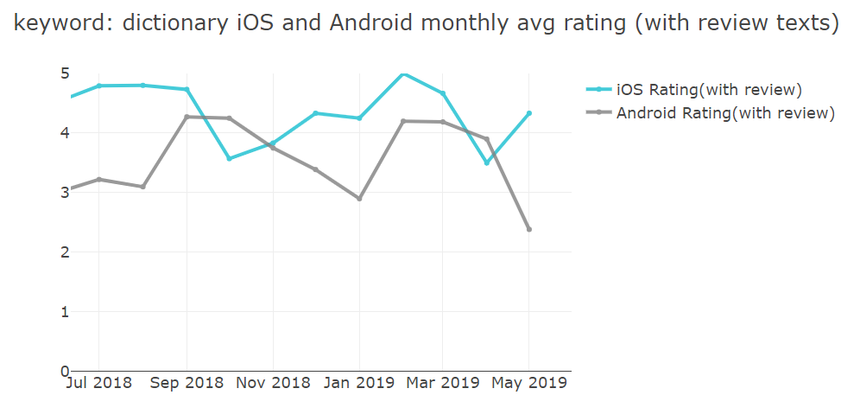

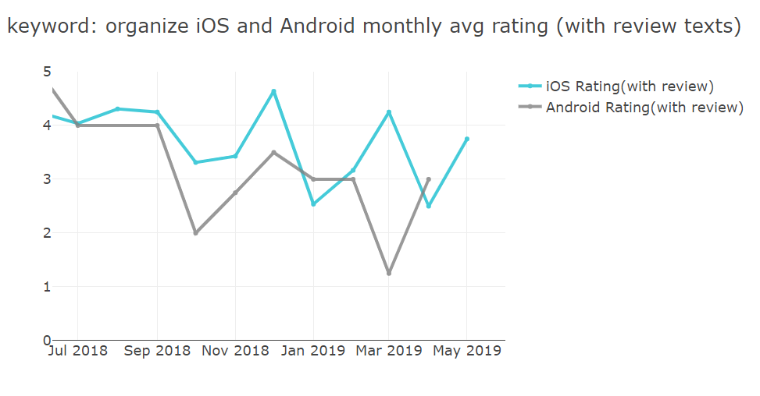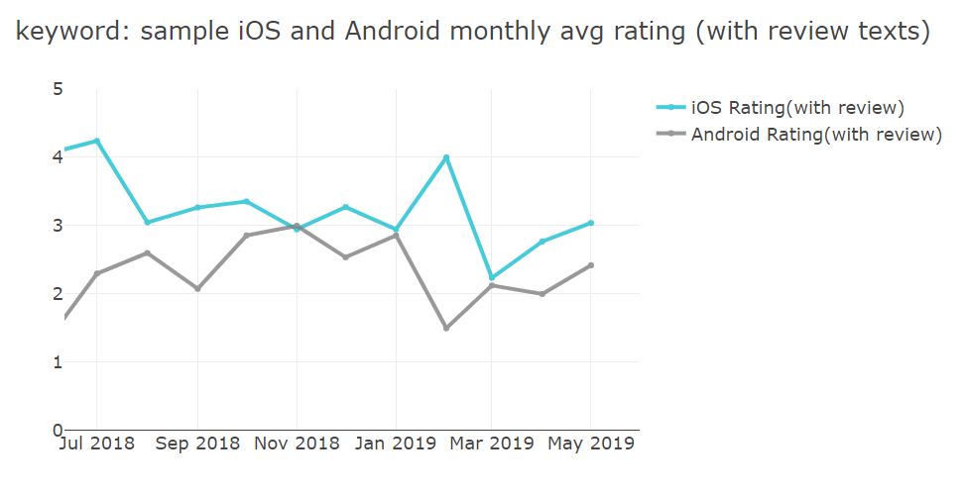

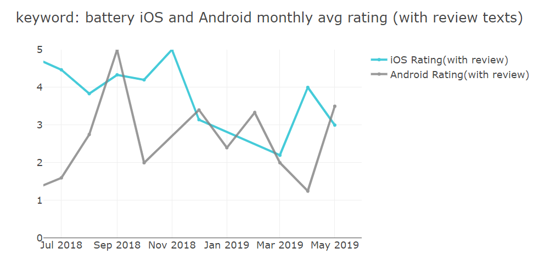

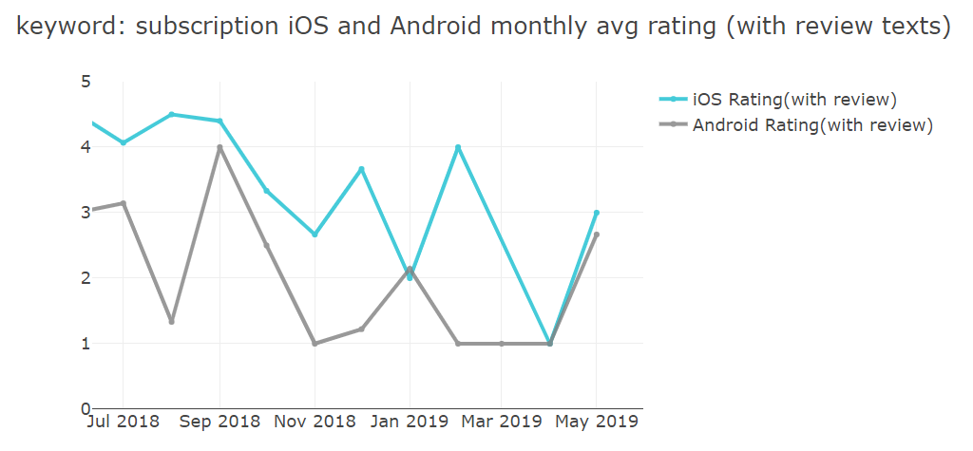

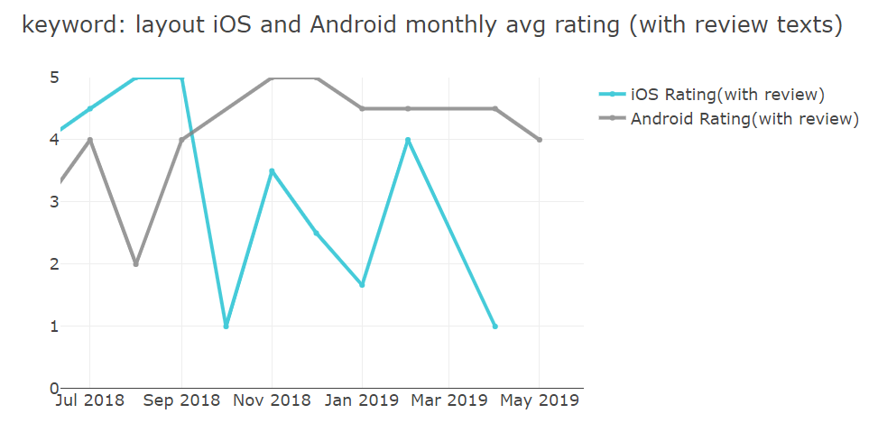

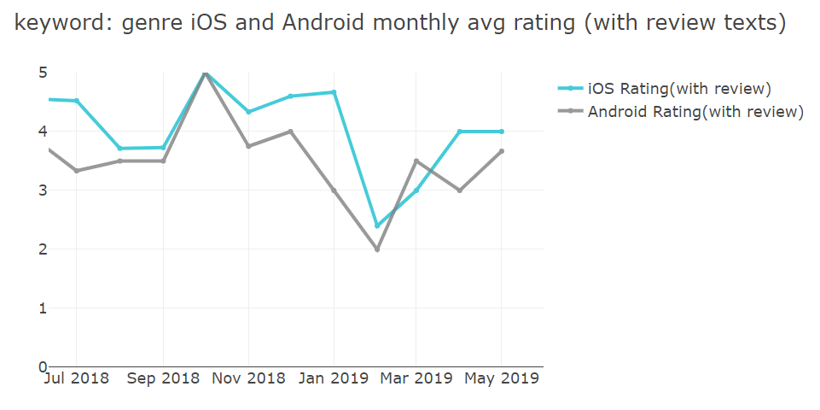

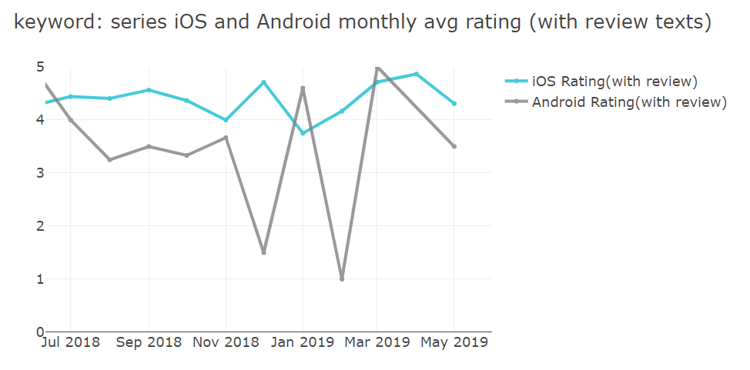

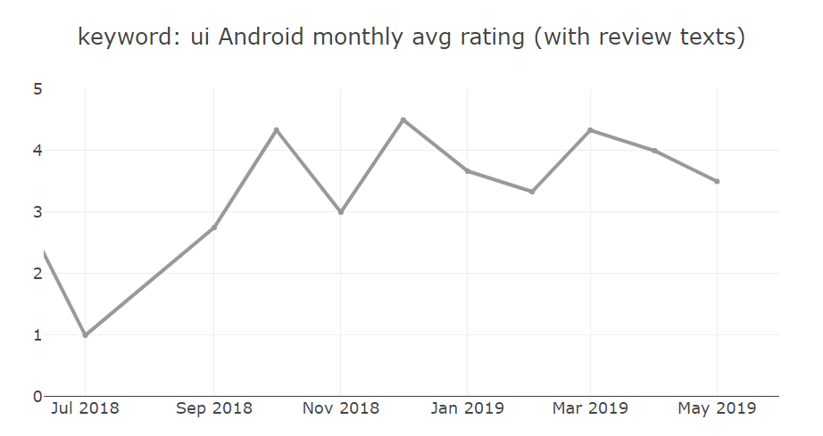

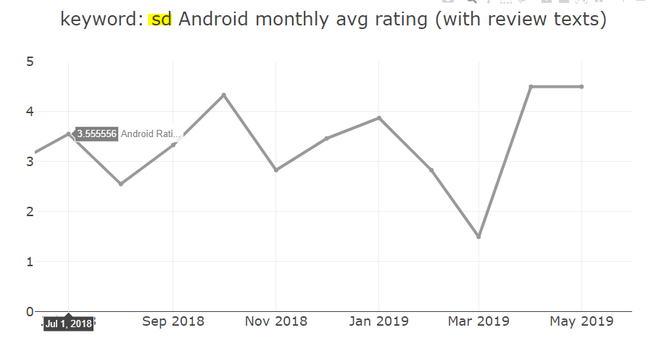

Appendix 2.3

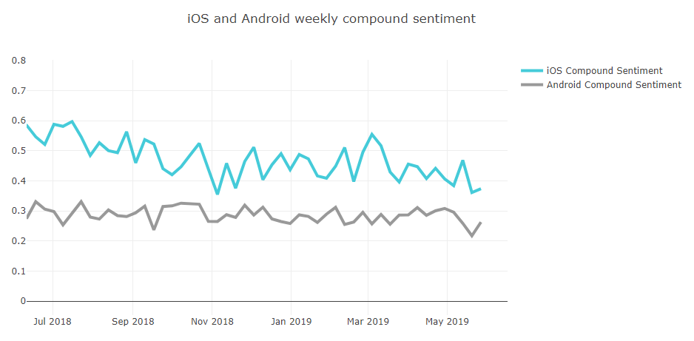

Appendix 2.4.1

|  |  |  |  |  |  |
| --- | --- | --- | --- | --- | --- |
| **iOS Sentiment** | | | | | |
| **keywords** | **rating** | **Compound** | **Positive** | **Neutral** | **Negative** |
| discovering | 4.75 | 0.81 | 0.25 | 0.73 | 0.02 |
| sortable | 4.00 | 0.81 | 0.10 | 0.85 | 0.04 |
| collector | 4.50 | 0.80 | 0.18 | 0.81 | 0.02 |
| recommendation | 4.33 | 0.77 | 0.28 | 0.71 | 0.01 |
| discovery | 3.60 | 0.70 | 0.20 | 0.75 | 0.05 |
| dictionary | 4.65 | 0.69 | 0.22 | 0.75 | 0.03 |
| filters | 3.40 | 0.69 | 0.15 | 0.84 | 0.01 |
| collecting | 5.00 | 0.69 | 0.15 | 0.82 | 0.03 |
| assortment | 4.86 | 0.68 | 0.20 | 0.78 | 0.02 |
| highlight | 4.44 | 0.67 | 0.21 | 0.76 | 0.03 |
| discovered | 4.78 | 0.65 | 0.18 | 0.79 | 0.03 |
| disappoint | 5.00 | 0.63 | 0.28 | 0.58 | 0.15 |
| find | 4.39 | 0.59 | 0.19 | 0.77 | 0.04 |
| library | 4.63 | 0.58 | 0.19 | 0.78 | 0.03 |
| search | 4.16 | 0.57 | 0.18 | 0.78 | 0.04 |
| removed | 2.67 | 0.57 | 0.14 | 0.84 | 0.02 |
| sorted | 4.60 | 0.56 | 0.14 | 0.81 | 0.05 |
| sync | 4.33 | 0.55 | 0.18 | 0.78 | 0.04 |
| collection | 3.99 | 0.54 | 0.17 | 0.78 | 0.05 |
| discover | 4.14 | 0.49 | 0.17 | 0.79 | 0.04 |
| filter | 3.79 | 0.49 | 0.15 | 0.83 | 0.03 |
| scroll | 3.82 | 0.46 | 0.19 | 0.76 | 0.05 |
| sample | 3.55 | 0.43 | 0.16 | 0.79 | 0.05 |
| sorting | 3.72 | 0.38 | 0.17 | 0.78 | 0.05 |
| assorted | 5.00 | 0.38 | 0.07 | 0.90 | 0.03 |
| delete | 3.14 | 0.28 | 0.13 | 0.81 | 0.06 |
| filtering | 4.00 | 0.22 | 0.12 | 0.75 | 0.13 |
| disappear | 4.00 | 0.20 | 0.13 | 0.74 | 0.13 |
| remove | 3.35 | 0.17 | 0.11 | 0.82 | 0.07 |
| removing | 3.31 | 0.16 | 0.11 | 0.83 | 0.06 |
| disappointing | 2.83 | 0.15 | 0.14 | 0.75 | 0.11 |
| bug | 3.60 | 0.13 | 0.13 | 0.76 | 0.11 |
| disappointed | 3.26 | 0.11 | 0.17 | 0.72 | 0.11 |
| crash | 2.59 | (0.08) | 0.10 | 0.74 | 0.15 |

Appendix 2.4.2

|  |  |  |  |  |  |
| --- | --- | --- | --- | --- | --- |
| **Android Sentiment** | | | | | |
| **keywords** | **rating** | **Compound** | **Positive** | **Neutral** | **Negative** |
| discover | 4.83 | 0.76 | 0.31 | 0.69 | - |
| remover | 2.00 | 0.64 | 0.12 | 0.88 | - |
| collecting | 3.00 | 0.59 | 0.17 | 0.83 | - |
| filters | 2.25 | 0.44 | 0.16 | 0.72 | 0.13 |
| highlight | 3.39 | 0.42 | 0.21 | 0.72 | 0.07 |
| collection | 3.64 | 0.37 | 0.31 | 0.65 | 0.05 |
| discovered | 2.67 | 0.34 | 0.15 | 0.77 | 0.07 |
| filter | 3.11 | 0.33 | 0.14 | 0.81 | 0.05 |
| dictionary | 3.54 | 0.32 | 0.19 | 0.76 | 0.05 |
| scroll | 3.37 | 0.28 | 0.18 | 0.77 | 0.06 |
| find | 3.16 | 0.24 | 0.16 | 0.78 | 0.07 |
| library | 3.37 | 0.23 | 0.18 | 0.77 | 0.06 |
| recommendation | 2.55 | 0.21 | 0.11 | 0.83 | 0.06 |
| search | 2.85 | 0.18 | 0.14 | 0.79 | 0.07 |
| addiction | 5.00 | 0.12 | 0.13 | 0.76 | 0.11 |
| sync | 2.65 | 0.10 | 0.12 | 0.80 | 0.08 |
| sample | 2.29 | 0.08 | 0.14 | 0.79 | 0.07 |
| filtering | 3.00 | 0.07 | 0.14 | 0.77 | 0.09 |
| sort | 2.83 | 0.06 | 0.11 | 0.81 | 0.08 |
| collect | 2.67 | 0.01 | 0.05 | 0.92 | 0.04 |
| delete | 1.82 | (0.06) | 0.08 | 0.82 | 0.10 |
| remove | 1.75 | (0.07) | 0.09 | 0.79 | 0.12 |
| bug | 2.47 | (0.16) | 0.11 | 0.77 | 0.12 |
| sorts | 2.33 | (0.23) | 0.08 | 0.78 | 0.14 |
| disappear | 2.26 | (0.26) | 0.07 | 0.79 | 0.14 |
| crash | 1.91 | (0.33) | 0.07 | 0.72 | 0.21 |