Project : Flipcard Game 傅繹嘉107598051

Game Rules:

-interface default iphone7

-reset button to start a new game with random theme

-flipall button you can see cards before game

-two cards matched get 2points(cake matching)

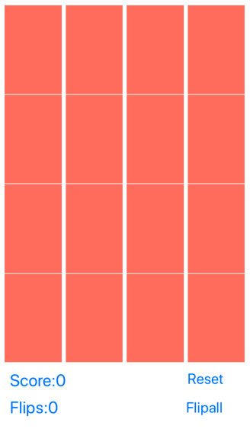 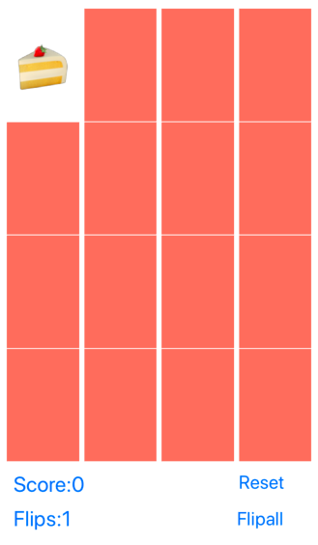 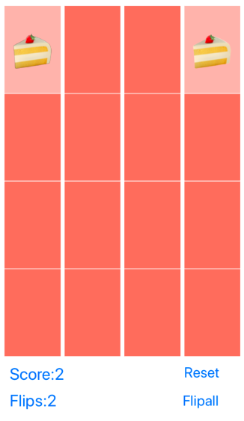

-the card faces up, then faces down the same minus 1point(bread clicking 2 times)

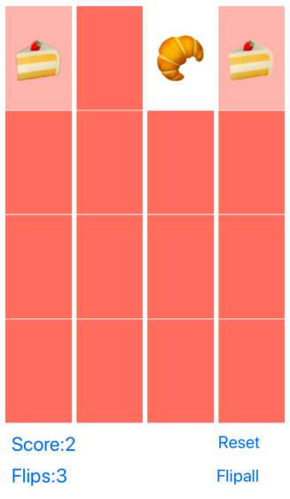 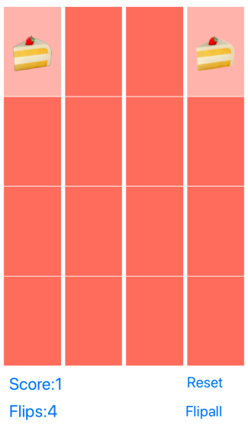

-if the card second time faces up no matching minus 1point(burger 2 times no matching)

