**Development Economics: Homework 2**

**Some brief discussions**

**Junhui Yang**

**Friday 8 February 2019**

q1.m delivers the two tables below, Table 1 and Table 2. Table 1 corresponds to Question 1, showing the welfare gains of removing (Remove) the seasonal component (Seasonal) from the stream of consumption as well as the welfare gains of removing the nonseasonal consumption risk (NonSeasonal) separately for each degree of seasonality (Low, Mid, High). Table 2 corresponds to Question 2, showing the welfare gains of removing (Remove) the seasonal component (all combinations of deterministic and stochastic, Seasonal) from the stream of consumption as well as the welfare gains of removing the nonseasonal consumption risk (NonSeasonal) separately for each degree of seasonality (Low_Low, Low_Mid, Low_High, Mid_Low, Mid_Mid, Mid_High, High_Low, High_Mid, High_High).

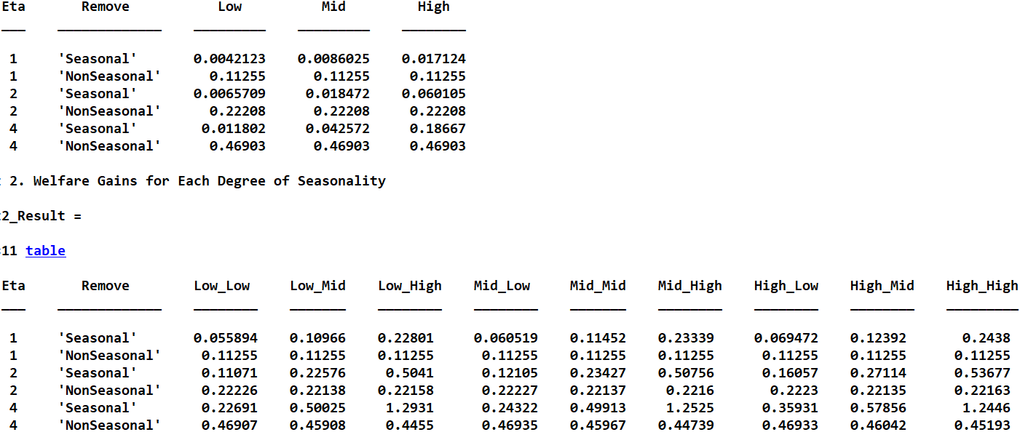

**Table 1**

A couple of discussions regarding Table 1:

First, removing the nonseasonal consumption risk (NSCR) always yields the same welfare gains, whatever the seasonality is. I am not sure but I think this is because after removing NSCR, the only way that households can be different is through ln *u* (the utility function is of the log form). This difference should be trivial when we are considering many households and a long time period.

Second, the welfare gains of removing the seasonal component increase with the degree of seasonality. This is reasonable because the degree of seasonality represents the degree of uncertainty facing households. Households should gain more when they change from a more uncertain scenario to an insured scenario.

Third, the welfare gains strictly increase with Eta, when all the other conditions are the same. This is because Eta represents the coefficient of relative risk aversion and the utility function has a CRRA form. The greater the Eta, the more risk averse the household is. So, households should feel more gains when they change from an uncertain scenario to an insured scenario.

Fourth, the welfare gains of removing NSCR are greater than those of removing the deterministic seasonal component, when all the other conditions are the same. This may relate to the fact that NSCR and the deterministic seasonal component appear differently in consumption. The influence of NSCR dominates not only because |*-*| > |*g*(*m*)| in ten months of the year (Mar – Dec), but also because NSCR has an extra term $ε_{t}$ which varies every year.

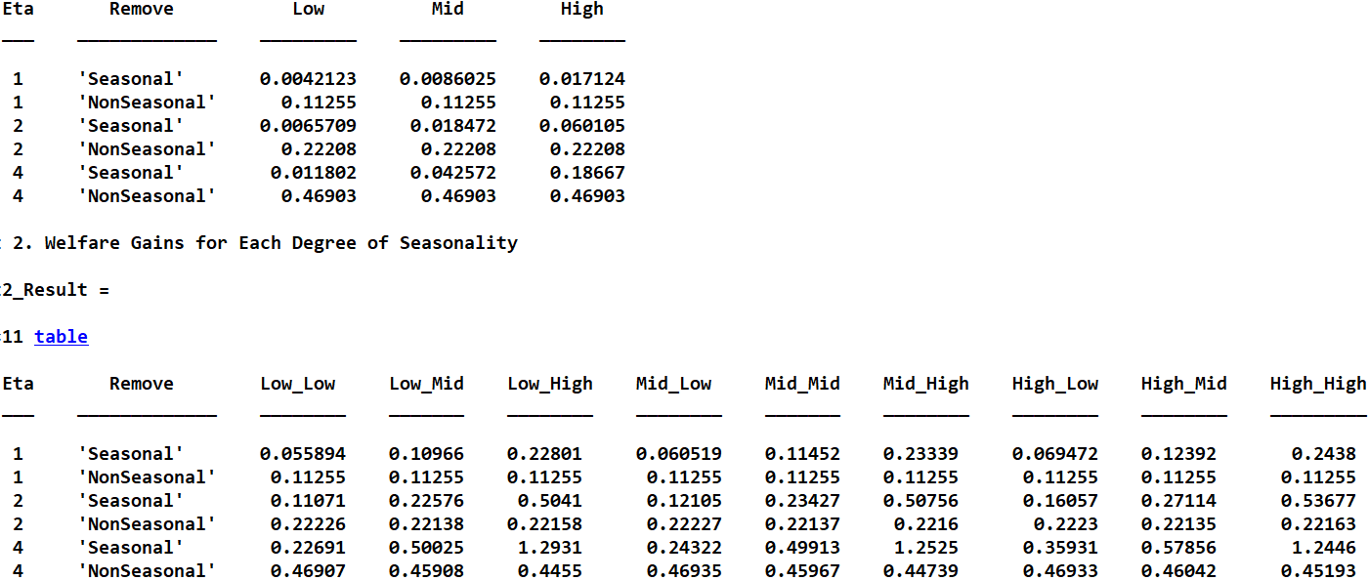

**Table 2**

In Table 2, Low_Mid, for example, means the situation with a low degree of deterministic seasonal component (DSC) and a middle degree of stochastic seasonal component (SSC). So, in terms of notation, the first three letters always refer to DSC.

A couple of discussions regarding Table 2:

First, the welfare gains of removing the seasonal component (i.e., both DSC and SSC) seem to be largely dominated by SSC instead of by DSC. When we keep all the other conditions the same, we see that such gains have the following order: Low_Low < Mid_Low < High_Low < Low_Mid < Mid_Mid < High_Mid < Low_High < Mid_High < High_High, except when Eta = 4, where we observe Low_Mid > Mid_Mid and Low_High > Mid_High > High_High. The explanation of this point is similar to that of the fourth point in my discussions of regarding Table 1.

Second, when Eta = 1, removing the nonseasonal consumption risk (NSCR) always yields the same welfare gains, whatever the seasonality is, but this does not hold when Eta = 2 or 4. Regarding this, I do not know why exactly.

Third, the welfare gains strictly increase with Eta, when all the other conditions are the same. The explanation is given in my discussions regarding Table 1.

Fourth, when the seasonality is Low_Low, Mid_Low or High_Low and all the other conditions are the same, the welfare gains of removing NSCR are greater than those of removing the seasonal component. This maybe relate to the changes of the relative magnitudes of the components’ influences when we change the components themselves.

q2.m delivers the two tables below, Table 3 and Table 4. Table 3 corresponds to Part (a) where we assume a DSC and an SSC for labor supply both of which are highly positively correlated with their consumption counterparts, and Table 4 to Part (b) where we assume the opposite. The effects are isolated for consumption and labor. When I implement the positively correlated DSC, I simply let it equal for labor and consumption; when implementing the negatively correlated DSC, I let it opposite for labor and consumption. When I implement the positively correlated SSC, I use a covariance of .03 between $\ln{ε_{m}^{labor}}$ and $\ln{ε_{m}^{consumption}}$ (to make sure that the variance-covariance matrix is always positive definite) to generate consumption SSC and labor SSC; similarly, when implementing the negatively correlated SSC, the covariance changes to -.03. So there are two scenarios in Table 4. One is when the DSC of consumption is as original and that of labor is the opposite (labeled as 1); the other scenario is the opposite situation (labeled as 2).

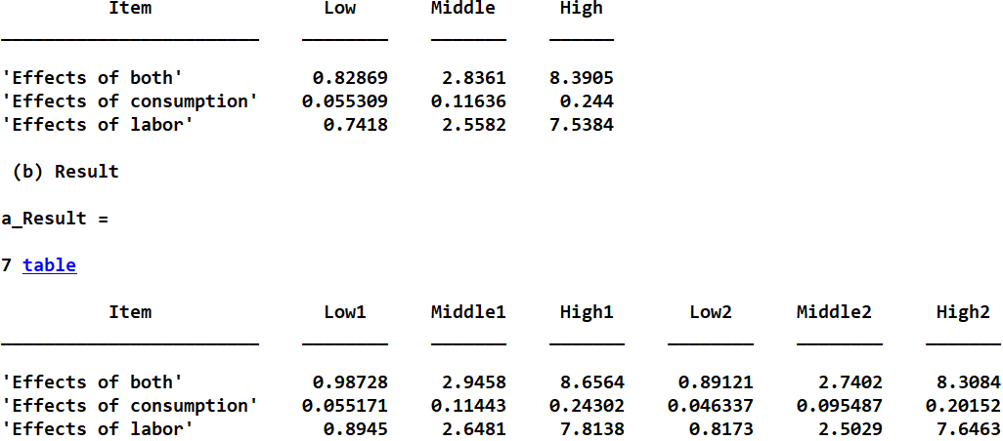

**Table 3**



**Table 4**

**How do my answers to (a) and (b) change if the nonseasonal stochastic component of consumption and leisure are correlated?**

I have not done this, but this can be easily implemented in the program. When the nonseasonal stochastic component of consumption and leisure are correlated, the effects in the tables should be larger, because changes of consumption or labor are associated with changes of other components, bringing about more influences.