An End-to-End scene text recognition system and its application in web security system
【Abstract】
The number of images is booming. Many application systems need to extract the text contents in web images in order to do image-content based analysis. For example image search engines, street-view based map guidance APPs. And even web security systems, which is proposed in this paper. For these systems, extracting texts from images is a core components. //pre-required.
Extracting texts from Natural images is a hard job, It usually involves in text detection, localization and recognition. For text localization, among which text Localization is a very important step which highly affect the performance of OCR , especially when handling with natural scene images. Recently MSER region detector has shown promising efficiency in scene text detection.
In this paper we proposed a robust end-to-end text exaction system . First an improved MSER method is proposed, the detected MSER regions are processed by a text candidate region filter made up with CNN classifier and a character recognition feedback component. Second, a region position and context based clustering algorithm is used to merge the text regions into words and text-lines. Finally they are recognized using a CNN classifier. The experiments show our algorithm has high efficiency in speed and state-of-the-art accuracy both in localizing and recognition. The comparison of this method with former methods on the ICADR 2011 Dataset is also demonstrated.
And the end-to-end extraction system has been used in a web-security system.

【Keywords】 Scene Text Localizing , MSER , CNN ,

1 Introduction
The number of images is booming. Many application systems need to extract the text contents in web images in order to do image-content based analysis. For example image search engines, street-view based map guidance APPs. And even web security systems, which is proposed in this paper. For these systems, extracting texts from images is a core components.
Extracting texts from Natural images is a hard job. As Fig.1 shows, an image text exaction algorithm usually involves in text detection, localization and recognition , among which text Localization is a important pre-processing step which highly affect the performance of OCR , especially when handling with natural scene images with backgrounds unstrained and texts in varied styles.While character recognition has become a more and more resolvable problem, an example is that even the CAPTCHA which is designed to prevent machine from recognition is threatened by deciphering , text detection and localization is still a problem which highly effects the quality of the finally retrieved text information from images.

Input images

Text detection and localization

Recognition(OCR)

OCR Results

1.1 Architecture of an text exaction system

Currently, The existing methods of text localization and extraction algorithms can be roughly categorized into two groups: sliding-window based and connected component (CC) based[]. Sliding-window methods are often slow for it has to detect the images in different scales.
Connected component based methods [, , , ] typically detect CCs from the image with approaches like edge detection, color clustering, or stroke width transform, then group the pixels into regions using text candidate detectors, classify out non-text regions using typically classifiers, and group extracted regions together into words or sentences. Its grouping strategy is based on the suppose that pixels belonging to the same character have some similar properties, for example color, gradient, stroke width and so on. Connected component based methods can do word or character
Recently, MSER has been identified as one of the best region detectors. Many papers [12] use Maximally Stable Extreme Regions (MSERs) [] based methods , some of them have reported good performance on the ICDAR 2011 Robust Reading Competition Dataset []. An ER is a extremal region which has extremal property of intensity than its outer boundary. And an ER of threshold θ(R θ) is such an region: ∀p ∈ R, q ∈ ∂R : C(q) > θ ≥C(p). An MSER is an particular case of an Extremal Region whose size remains virtually unchanged over a range of thresholds. MSER is very effective in text detection since text regions usually have a distinct contrast to its background and relatively uniform intensity or color, in order to be easily read by humans [10]. Besides, MSER can be calculated with a nearly linear time complexity[].
But MSER also have problems. First a image can contains a lot of high contrast areas, therefore it detects large amount of false positive text regions which need to be eliminated on the next. Second, as contrast based, it have a high miss rate on low-contrast images and the detection. Third, like other connected component based methods, the detected regions need to be clustered into words and text-lines as a final result of text recognition.
[] proposed a real-time scene image text localization algorithm based on ER classification. Their method first extract ER(extremal regions) and ER descriptors in a fast and incremental computed way , then the extracted ERs' several descriptors are served as features for a two-stage classification to detect text candidate regions. Their experiments show their proposed method have problems when handling with: (a) Characters with no contrast. (b) Multiple characters joined together. (c) A single letter (the claim that the McDonald’s logo is a letter “M” as defined by the annotation is questionable), the recall rate is low.
[] proposed a method which do “Perceptual Organization Clustering” for MSERs. They argued that text extraction problem could be posed as the detection of meaningful groups of regions In details the extracted MSER regions are grouped together in a bottom-up manner guided by similarity evidence obtained over various modalities such as color, size, or stroke width among others.The result show it has a state-of-the-art performance at text localization, especially when handling with images containing different language texts. The disadvantage is that different words are easily clustered together into one segmentation, and the precision is improvable relative to its recall. And the words are clustered based on their styles(such as stroke width, hole area rate) then on their position property.
[] proposed a method which use edge-enhanced
In this paper we proposed a scene text localization algorithm which has three points : first MSER regions are exacted using a edge enhanced MSER. Second novel features are proposed which will be used by adaboost for classification and non-text regions are eliminated; Third the character regions will be processed by a character recognizer using CNNand scores for the character regions as a certain character is calculated. Three, character regions are grouped into text lines based on the regions’ stroke width and spartial position. Four. Based on CRF model the most probable words are recognized from the character regions. And non-words are eliminated. sent back to filter out non-text regions. Third the region position and the character context will be used to cluster the regions into words and text-lines.
The following sectors are organized as follows: In sector II we will describe our text localization algorithm. In sector III we will make experiments to demonstrate its accuracy both in text detection and word recognition on ICDAR 2011. We will also make comparisons between our algorithm and the former algorithms. In sector IV we will make a summary of our work.

2 algorithm
Our algorithm can be organized as the flow-chat in figure 2.
Text
candidate
regions
Input
images
Edge-enhanced
MSER
Text Regions
Clustering

Geometric
Filtering

Regions

Useful
Text Regions

Character
Regions

Character
recognition
Text Line
Formation
word recognition

Character
Regions

Output
Texts

Fig. System flowchart

2.1 MSER exaction
The first step of our algorithm is to detect the character regions in an image. Images are transformed into gray images and MSER are extracted from the images. As we know, MSER detector is widely used in object detection. The core of the method is the intensity contrast of objects from the background. MSER is especially suitable for text region detection.
But since MSER is sensitive to blur, it often detect multiple characters as one region. To solve this, we apply a canny-edge to detected MSER to correct this.






figure 1: ＭSER detector has mixed "O" and "W" from "DOWN" with the background as a result of character's intensity change
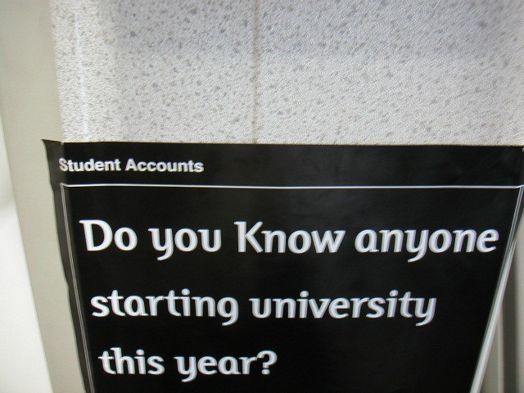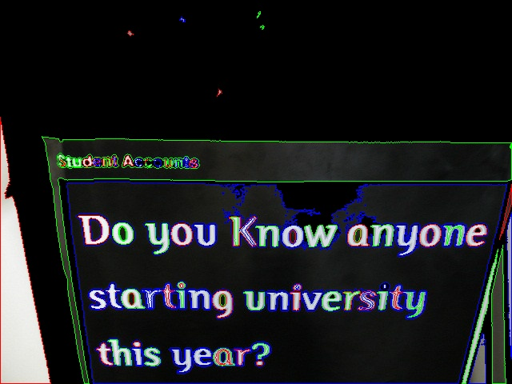
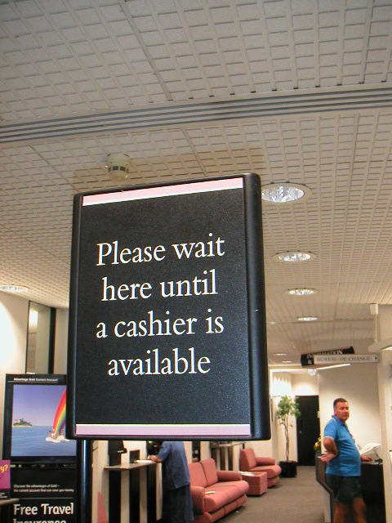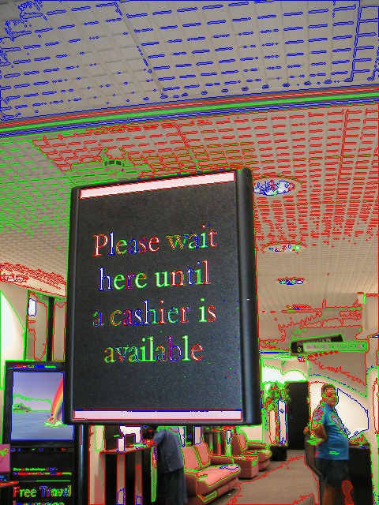
It has problem handling with text regions whose intensity overlaps with the bounding background. For example when the image has reflections, then the detected text regions would often mix with the background. As figure 1 shows, the MSER doesn't work well when the intensity of the character 'O' and 'W''s upper part concatenates with the background.

Edge-enhanced MSER enhances the edge texture features in order to detect text regions with intensity interrupted , just as fig. 1 shows.
In this way it improves the detection robust and improve the detection’s recall rate.
2.2 divided character region reconnecting
All English characters and digits are connected in geometry, except for character ‘i’ and ‘j’ . To connect character i and j, we first use several rules to find the regions that look like ‘i’ and ‘j’:
- Stroke width of lower part should be as close to upper part.
- Lower part should be more than twice longer than upper part.
- Both lower part and upper part should have no holes.
- Area of lower part should be more than 3 times that of upper part.
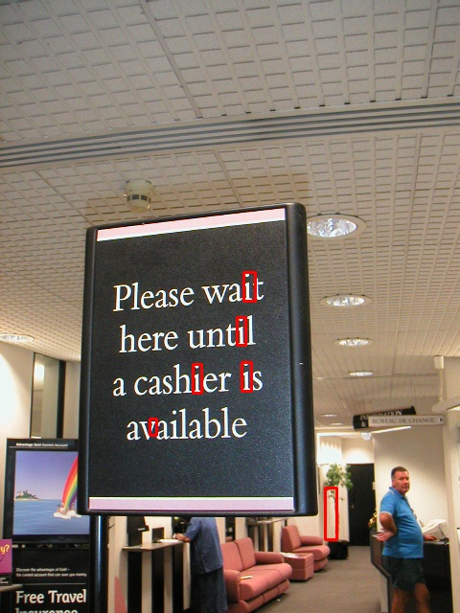

2.3 text region filtering
With the exaction of tuned MSER detector, a large number of CC regions are obtained. But many of them are non-text regions. So we need to label the regions as text regions or non-texts.
To realize this, we carried out a simple rule-based filtering at first, then we grouped the regions into groups based on their coordinate positions and their stroke width. Finally we analyze the region groups with the help of a classifier and eliminate non-text groups.
We take the following steps to do character region filtering:

2.3.1 Connected component analysis and filtering
Since typical text regions have many morphological features relative to non-text regions, which can be used for text region and non-text classification. we defined several geometric feature based rules. Then we check the regions' geometric properties to see if it matches the rules. Since the rules are defined loosely, regions that don’t match it can be judged as non-test regions and then eliminated. After this step, most non-text regions are eliminated and the computing complexity is reduced effectively.
we defined several rules as below:
- Area. Regions whose area is larger than half of the whole image or smaller than 2px*4px will be eliminated. The parameter is set based on the hypothesis that regions larger than half of the image can be judged as background; and regions which is too small is invalid since it can hardly be recognized by human eyes .
- Occupy rate. And in this way we can assert a text candidate region never be smaller than 4px*4px.
- Hole numbers. Typically, English characters have no more than two holes, here we use three as a threshold. Regions whose hole number bigger than three will be eliminated.
- Corner number. As we know, unlike natural objects such as leaf, text region’s contours are regular. Their corner numbers are limited. For an English character, corner number is between 4 and 12. With this rule, we can tell natural objects from human made characters.
- Commonly used aspect radios . For a character, typically the aspect radio range is between 1/3 to 4. Particularly when the aspect radio is more than 4 but smaller than 20, than we would make test if the region corresponds to character ‘i’ or ‘I’. We implement this by testing if the number of holes is zero and the number of corners is small enough.
Via the four rules above, we can eliminate most irregular regions that is unlikely to be texts correctly.
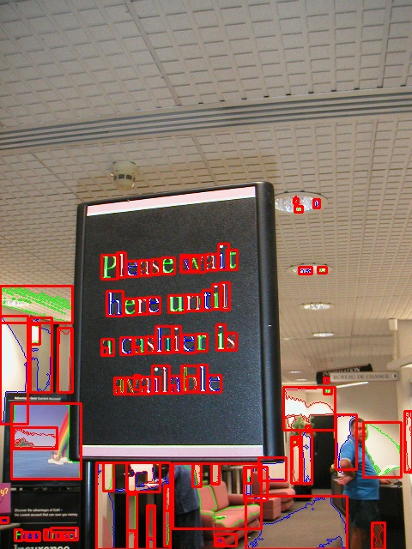
Fig. MSERs filtered out through step B
2.3.2 more complex feature filtering
Inspired by [] who proposes a two-stage classification on the regions, we break our filtering into two stages. In the second stage, the features used by our filterer is more complex , and also stronger in deciding whether the region is text region or non-text.
We choose the number of inflexion points both on the outer boundary and on the inner boundary. With this feature, we can easily apart the
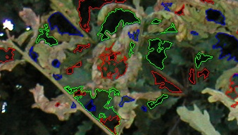
- Fig. The inflexion point number between text regions and non-text regions
fig. 1: isolate regions are filtered out while regions in text-line are reserved

2.3.3 Text region grouping and filtering
We group the regions into groups based on the y-coordinate and stroke width of the regions.
We first group the regions based on the y-coordinate. This result as many groups of Regions,say G1. Regions in the same group have a close y-coordinates. Then for each groups, we do a second stage classification based on the mean stroke width /max stroke width ratio and the color. This will result in new groups G2 of regions.
We do classification based on G2.
To eliminate text regions before further recognition , simple filtering is not enough. Many MSER based papers use classifiers to classify text from non-text regions based on several text region features. The classifier can also merge the regions into words and lines by the way.
In this paper, we choose several features for text region training and predicting. The features include:
Hole numbers
Stroke width/ region width:
Stroke is an important feature for text region detection.
Region’s area/ bounding rect’s area
Corner number:
And we use boost random forest as our classifier.
As we know, texts are human made marks which are different from
[] proposed a method to cluster the text regions into groups based on eleven features , for each of the eleven features, the regions are clustered , the co-occurrence between two regions is simulated when they are clustered into one region. Finally a clustering on the occurrence vector is done to choose out meaningful regions.

We use a sequential classifier to eliminate non-text regions.
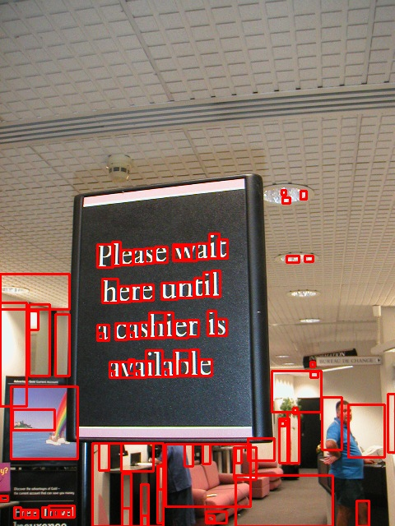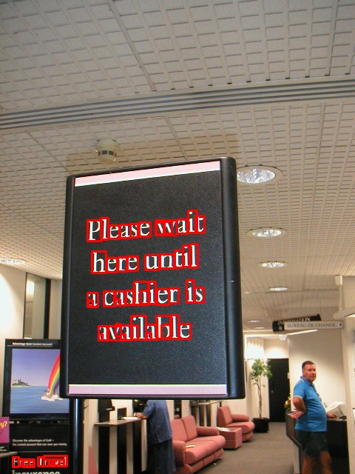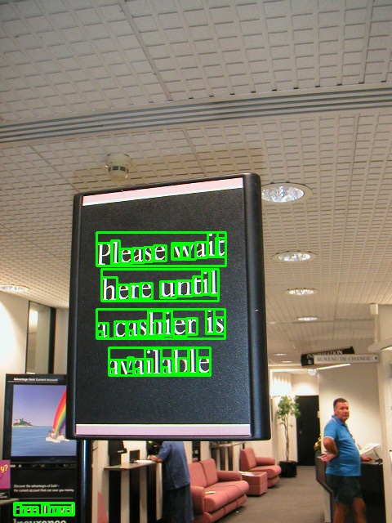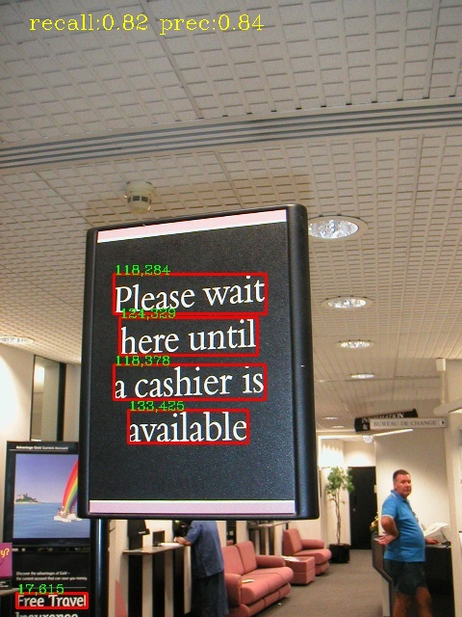

MSER regions classification and text line generation
E Text line generation
Characters need to be merged into words and text lines before further recognition. Many properties can be used for merging character regions. We choose properties such as stroke width, region position and area as the input of the merging process, on the assumption that characters in the same word and words in the same text line have similar stroke width and are spatially close to each other . In this way we chain appropriate neighboring character regions into words and neighboring words into text lines. We get an array of text lines composed by linked character regions.

As we have found the phenomenon that isolate regions are often meaningless, so we eliminate isolate character regions that are not in group with any other regions. The latter experiment show it has a high correctness and most of the eliminated regions are non-text regions.

F character regions recognition and verification
In this paper, motivated by [] which said recognition results should provide valuable feedback for text detection, we propose a CNN to predict character regions’ label as a character. The CNN will give score p_{ij} to character region x_{i} , as the probability of the region being character l_{j}. We define 32 character labels, one of them means non-character, other of them are digits and English alphabets. Since the scores are normalized, the score p_{ij} can represent the conditional probability of the region xi being the character l_{j},or say p(lj|xi). We reserve all the scores which will be used in the word recognition step.
G word recognition
Unlike traditional dictionary based methods, [] used a CRF based model for recognizing words. The CRF is deﬁned over a set of random variables x = {xi|i ∈ V}, where V = {1,2,...,n}. Each random variable xi denotes a potential character in the word, and can take a label from the label set L = {l1,l2,...,lk} ∪ε, which is the set of English characters and digits, and a null label to
suppress weak detections. (similar to [13]). The most likely word represented by the set of characters xi is found by minimizing the energy function, E : L n → R, corresponding to the random ﬁeld. The energy function E(·) can be typically written as sum of potential functions:
E(x) = ∑c∈Cψc(xc), (1)
where C represents a set of subsets of V, i.e. cliques. Here xc is the set of random variables
included in a clique c. The set of potential characters is obtained by the character detection step discussed in Section 2.1.
ψ1(xi = lj) = 1− p(lj |xi),
where p(li,lj) is the joint probability of the character pair li and lj occurring together in the Dictionary recognition algorithm which predict the scores of different will become the evidence for the region as a text-region, and the recognized result will also be used to generate OCR results.

4 Experiment Results
To evaluate our text detection algorithm,
our algorithm is both test on the ICDAR 2003 and ICDAR 2011 Dataset. On the ICDAR 2011 Dataset, the

4.1 ICDAR Text Detection
On ICDAR 2003, We show the text detection performance on the dataset in Table 1.

X.-C. Yin, X.-W. Yin, K.-Z. Huang, and H.-W. Hao,“Robust Text Detection in Natural Scene Images,”IEEE Trans. Pattern Analysis And Machine Intelligence,vol. , no. ,
B. Epshtein, E. Ofek, and Y.Wexler. Detecting text in natural scenes with stroke width transform. In CVPR 2010, pages 2963 –2970.
L. Neumann and J. Matas. A method for text localization and recognition in real-world images. In ACCV 2010, volume IV of LNCS 6495, pages 2067–2078, November 2010.
L. Neumann and J. Matas. Text localization in real-world images using efficiently pruned exhaustive search. In ICDAR 2011, pages 687–691, 2011.
Y.-F. Pan, X. Hou, and C.-L. Liu. Text localization in natural scene images based on conditional random field. In ICDAR 2009, pages 6–10. IEEE Computer Society, 2009.
1 2unzhao Shi, Chunheng Wang ,Baihua Xiao, Yang Zhang, Song Gao, “Scene text detection using graph model built upon maximally stable extremal regions”, In Pattern Recognition Letters 34 , 2013
J. Matas, O. Chum, M. Urban, and T. Pajdla, “Robust wide baseline stereo from maximally stable extremal regions,” in Proc. British Machine Vision Conference, vol. 1, 2002, pp. 384–393.
A. Shahab, F. Shafait, and A. Dengel, “ICDAR 2011 robust reading competition challenge 2: Reading text in scene images,” in Proc. Int. Conf. Document Analysis and Recognition, 2011, pp. 1491–1496.
Linear Time Maximally Stable Extremal Regions

