AptaRender
User tutorial: every tab, button, gesture and shortcut

AptaRender turns a sequence and a dot-bracket structure you supply into an editable 2D figure of a nucleic-acid secondary structure, ready to export as SVG or PNG for papers, posters and slides. It does not predict structures. You tell it the pairing, and it gives you full control over how the result looks.
This guide walks through the screen, a five-minute quick start, each tab of the control panel, everything you can do with the mouse on the canvas, the keyboard shortcuts, and a few step-by-step recipes for common figures.
Covers the build of October 2026, including box select, parts, rotate selection and zoom to selection.

Section | Topic
1 | The screen at a glance
2 | Quick start
3 | Writing a structure
4 | The control panel, tab by tab
5 | Working on the canvas (mouse)
6 | Keyboard shortcuts cheat sheet
7 | Recipes for common figures
8 | Saving, undo, and where your data lives
9 | Limitations and troubleshooting

1. The screen at a glance
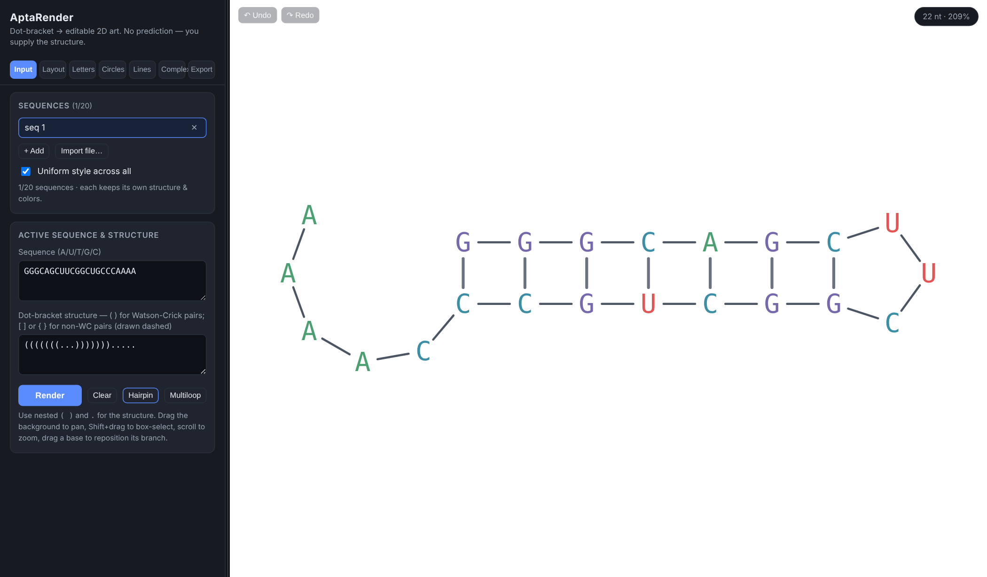
Figure 1. The AptaRender window with the built-in Hairpin example loaded.
Area | What it is
Control panel (left) | All settings, grouped into seven tabs along the top: Input, Layout, Letters, Circles, Lines, Complex, Export.
Selection bar | Appears under the tabs on Layout, Letters, Circles and Complex. Shows how many bases are selected, with Select all, Clear and Zoom buttons (see 4.0).
Canvas (right) | The drawing. Pan, zoom, select and drag bases here (see section 5).
Undo / Redo (canvas, top-left) | Step backward or forward through your edits. Greyed out when there's nothing to undo or redo.
Badge (canvas, top-right) | Length of what's on screen and the current zoom, e.g. "22 nt · 206%". In a complex it reads "13+13 nt (complex)".
Divider | The thin strip between panel and canvas. Drag it to make the panel wider or narrower; the width is remembered.

2. Quick start
- On the Input tab, paste your sequence into Sequence (A, U, T, G, C or N; spaces and line breaks are ignored, lowercase is fine).
- Paste the matching dot-bracket string into Dot-bracket structure. It must be exactly the same length as the sequence.
- Click Render. The structure is drawn and fitted to the canvas. If something's wrong, a red message under the buttons says exactly what and where.
- Use Letters, Circles and Lines to style it, and Layout to rotate or rearrange it. Drag bases on the canvas to fine-tune positions.
- On Export, pick a PNG scale (or go straight to SVG) and click SVG or PNG to download the figure.
Tip Click Hairpin or Multiloop on the Input tab to load a ready-made example into the current sequence slot. It's the fastest way to try every feature in this guide.

3. Writing a structure
The structure is one character per base, aligned with the sequence. Pairs must nest inside each other (no crossing pairs).
Character | Meaning
. (also - : , ) | Unpaired base.
( … ) | A Watson-Crick base pair, drawn as a solid rung.
[ … ] { … } < … > | A non-Watson-Crick pair, drawn as a dashed rung. Use these to mark wobble, Hoogsteen or other non-canonical pairs so they stand out.
Example: GGGCAGCUUCGGCUGCCCAAAA with (((((((...)))))))..... is a 7-bp hairpin with a 3-nt loop and a 5-nt 3′ tail. Changing the middle of the stem to ((([[[(...)]]])))..... would draw those three pairs dashed.

Error messages you might see
Message | How to fix it
Length mismatch | The sequence and structure have different lengths. The message gives both numbers.
Unexpected character … in sequence | Only A U T G C N are allowed in the sequence.
Unbalanced "(" / ")" at position N | An opening bracket was never closed, or a closing bracket has no partner. Count the brackets around position N.
Mismatched bracket | A pair was opened with one bracket type and closed with another, e.g. [ closed by ) . Use the same type on both ends.

4. The control panel, tab by tab

4.0 The selection bar
Most styling and layout actions work on the selected bases (orange rings on the canvas). The selection bar is your shortcut to manage it:
Control | What it does
n selected | How many bases are currently selected (across both strands in a complex).
Select all | Selects every base in the current view.
Clear | Deselects everything. Clicking empty canvas does the same.
Zoom | Centers the canvas on the selected bases and zooms in to fit them. With nothing selected it behaves like Fit to view.

4.1 Input tab: sequences and structure

Sequences list
Control | What it does
Sequence name | Click to open that sequence. Double-click to rename it. Empty slots are tagged "· empty".
× next to a name | Deletes that sequence. Any complex built from it is deleted too (a note tells you how many).
+ Add | Adds a new, blank sequence slot and opens it. Up to 20 sequences.
Import file… | Loads one or more sequences from a FASTA-style file (.fa, .fasta, .txt, .dbn, .seq, .dot). Each record is a >name line, then the sequence line(s), then optionally the dot-bracket line(s). Extras beyond the 20-sequence limit are skipped.
Uniform style across all | On (default): every sequence shares one look (font, colors, circles, lines, numbering, tail style, background). Off: each sequence remembers its own look. Per-base colors and dragged positions always belong to each sequence either way.

Active sequence and structure
Control | What it does
Sequence box | The sequence for the open slot. Saved as you type.
Dot-bracket structure box | The structure for the open slot (see section 3).
Render | Draws the structure from the two boxes and fits it to the view.
Clear | Empties the open slot's sequence, structure and colors. The slot stays in the list.
Hairpin / Multiloop | Loads an example into the open slot, replacing what's there, and renders it.
Watch out Render starts that sequence fresh: custom letter and circle colors, bond colors and dragged positions are reset. If you only meant to restyle, use the other tabs instead. If you clicked it by accident, press Ctrl + Z .

4.2 Layout tab: orientation and positions
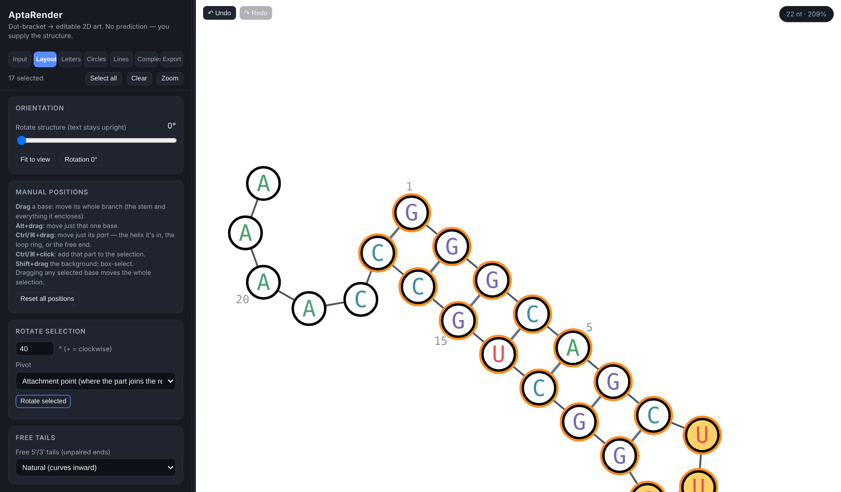
Figure 2. Layout tab. The hairpin arm was selected and rotated 40° about its base pair; the tail stayed put.
Control | What it does
Rotate structure slider | Turns the whole drawing 0–360°. Letters always stay upright.
Fit to view | Re-centers and zooms so the whole drawing fills the canvas.
Rotation 0° | Snaps the whole-structure rotation back to zero.
Reset all positions | Undoes every manual move (drags and rotated selections) in the current view, returning to the automatic layout.
Rotate selection: degrees | Angle to turn the selected bases. Positive = clockwise, negative = counter-clockwise.
Pivot | Attachment point: turns the selection about where it joins the rest of the structure (for a stem, its closing base pair), so it swings like a hinge. Center of the selection: spins it in place.
Rotate selected | Applies the rotation. Each click adds another turn, and every rotation can be undone.
Lock ring / Unlock ring | Varna-style ring rotation. Ctrl/⌘+click an unpaired base of a loop to select its ring, then click Lock ring (a dashed circle marks it). Now dragging any helix attached to that ring swings it around the ring; dragging the closing stem swings the whole rest of the molecule. The ring keeps its size and its unpaired bases spread out evenly between the helices, which act as dividers. A helix stops when its neighbour's arc gets too tight, so nothing overlaps. The ring's own bases are locked. Each swing is one undo step. Click Unlock ring or press Esc when done. Single-sequence view only.
Free tails | How unpaired 5′/3′ ends are drawn: Natural (curves inward like a loop: on a single hairpin the 5′ and 3′ ends form an open loop at the base of the stem that mirrors the hairpin loop, never touching; with several stems each end curls toward the stems), Flatten (straight line), L-shape (one bond straight, then a 90° corner outward), Perpendicular (turns 90° outward). Changing the style clears any drags on the tail bases. In a complex it also shapes each strand's leftover ends.
The Manual positions box on this tab is a reminder of the drag gestures. They're explained fully in section 5.

4.3 Letters tab: base letters
Control | What it does
Font size (all bases) slider | 8–60 px. Circles, lines and numbers scale with it, so this is effectively the overall size of the drawing.
Show base letters | Turns the letters on or off (e.g. for circles-only figures).
Bold letters | Bold weight for all letters.
Color by base (A U T G C swatches) | The identity palette. Changes show up immediately on circles set to "By base color"; letters take the new palette when you click Apply palette.
Apply palette | Recolors every letter by base identity.
Monochrome letter color + Apply monochrome | Recolors every letter in one color.
Letter color for selection + Apply | Recolors only the selected letters.
Control | What it does
Size of selected bases: Size slider + Apply to selected | Makes just the selected bases bigger or smaller (50–300%), letter and circle together, relative to the font size. The font-size slider still scales everything, including these. Very large sizes can touch neighbouring bases; drag them apart if needed.
Reset all sizes | Returns every base to 100%.
Color from file: Apply to menu | Where colors from the file go when a line doesn't say: Letters, Circle fill or Both.
Upload color file… | Reads a .txt file of colors and applies them (see 4.3.1). A note under the buttons says how many bases were colored and lists any lines it skipped.
Download sample | Saves a ready-to-edit color file for whatever is open, with every position listed and colored by part (stems blue, loops orange, free ends gray), plus comments explaining each column.

4.3.1 Color file format
A plain .txt file, one base (or range) per line: position [base] color [target] . Columns can be separated by spaces, tabs or commas. Lines starting with # are comments; a header line is ignored.
Column | What to put
position | 1-based position ( 12 ) or a range ( 5-9 ). Inside a two-strand complex, prefix A: or B: to pick the strand ( B:12 ); no prefix means strand A.
base (optional) | The base letter at that position. Only used as a check: if it doesn't match the sequence, the app warns that the file may be for a different sequence.
color | Hex ( #e15554 or #e15 ) or a color name ( red , orange , steelblue …).
target (optional) | letter , circle or both . Without it, the Apply to menu decides. Applying circle colors turns base circles on automatically.
Example lines: 12 G #e15554 · 5-9 orange circle · B:3, #3b6fb6, both . Positions not listed keep their current color, so you can layer several files.
Watch out Apply palette and Apply monochrome overwrite any per-base letter colors you set earlier. Apply them first, then color your selections.

4.4 Circles tab: base circles
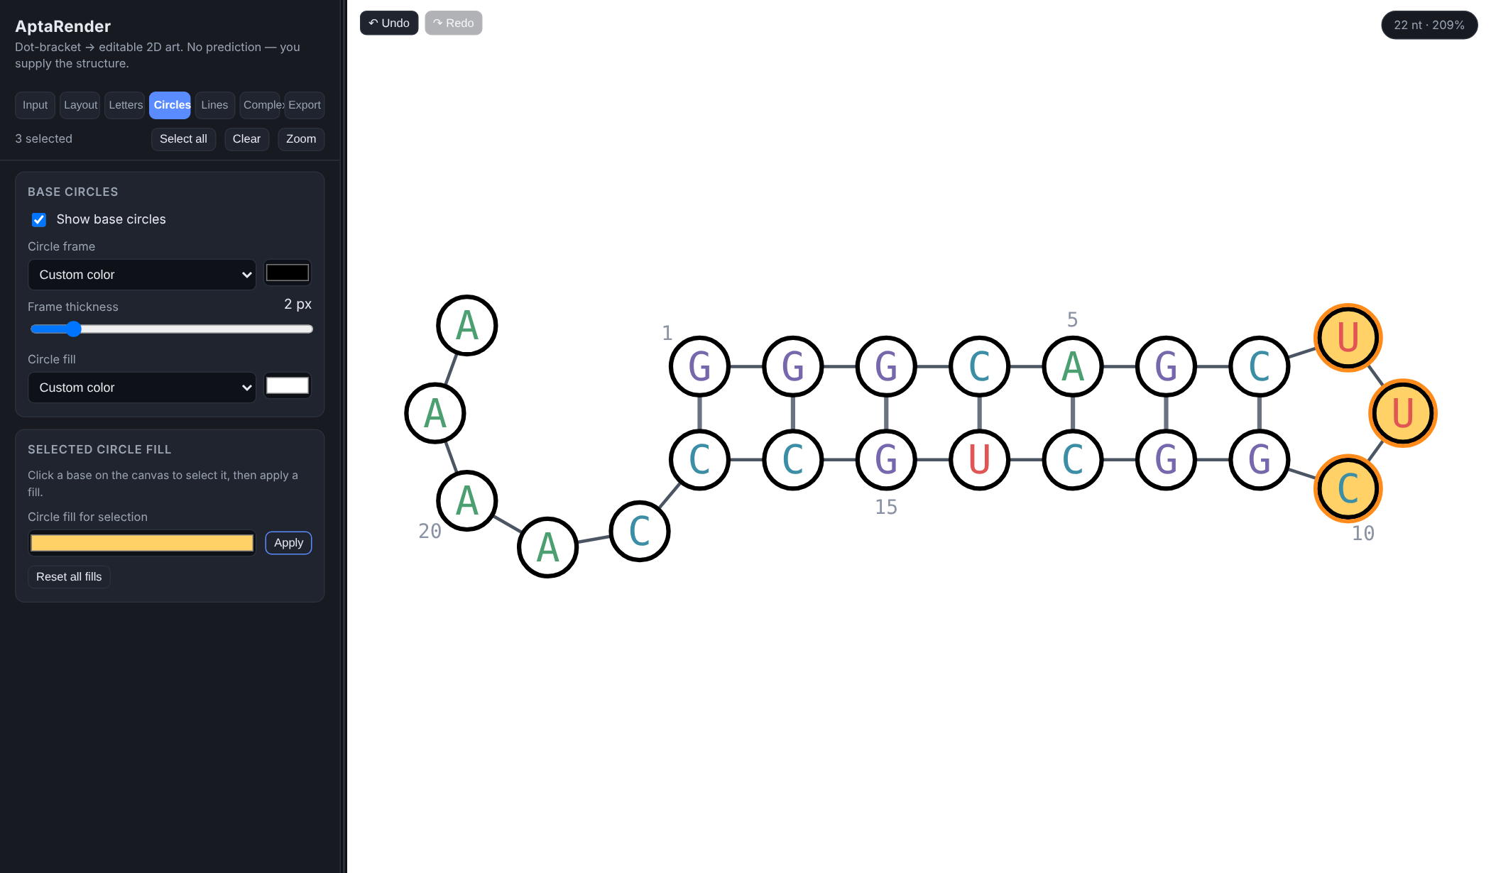
Figure 3. Circles on, numbering every 5 nt, and a custom fill applied to the three selected loop bases.
Control | What it does
Show base circles | Draws a circle behind every base.
Circle frame menu + swatch | Outline color: Custom color (use the swatch), By base color (identity palette), or None.
Frame thickness slider | 0.5–12 px outline width.
Circle fill menu + swatch | Inside color: Custom color, None (see-through), or By base color.
Circle fill for selection + Apply | Gives just the selected bases their own fill, overriding the global fill.
Reset all fills | Removes every per-base fill so all circles use the global fill again.

4.5 Lines tab: backbone, rungs and numbering
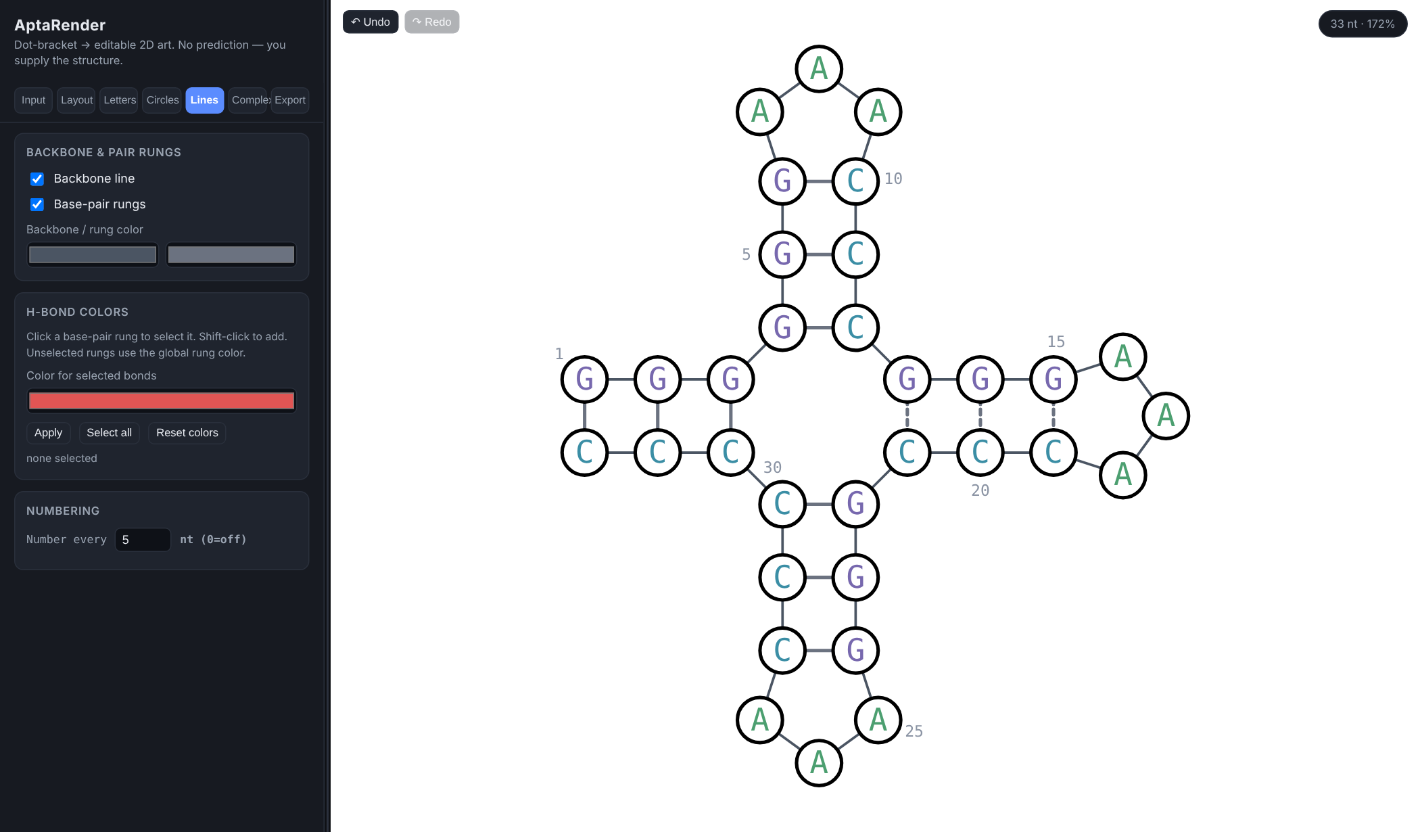
Figure 4. Lines tab. The middle-right stem was written with [ ] so its rungs are dashed; numbering every 5 nt.
Control | What it does
Backbone line | Shows the line joining consecutive bases.
Base-pair rungs | Shows the lines between paired bases (solid for ( ), dashed for [ ] { } < >).
Two color swatches | Left: backbone color. Right: default rung color.
Color for selected bonds + Apply | Colors the selected rungs. Select a rung by clicking it on the canvas; Shift+click adds more. Selected rungs glow yellow.
Select all (bonds) | Selects every rung.
Reset colors | Returns every rung to the default rung color.
Number every … nt | Labels every Nth base with its position (0 = off). The first base is always labeled. Each number is placed beside its base in open space (outside loops, on the outer side of stems), never on top of a base or line; if it has to sit a little further out, a thin line connects it to its base.
Individual rung coloring works on single sequences. In a complex, rungs keep the colors they were given on each strand's own sequence.

4.6 Complex tab: two-strand hybridization
A complex draws two of your saved sequences together with a stretch of one pairing with a stretch of the other. You choose the region; nothing is predicted.
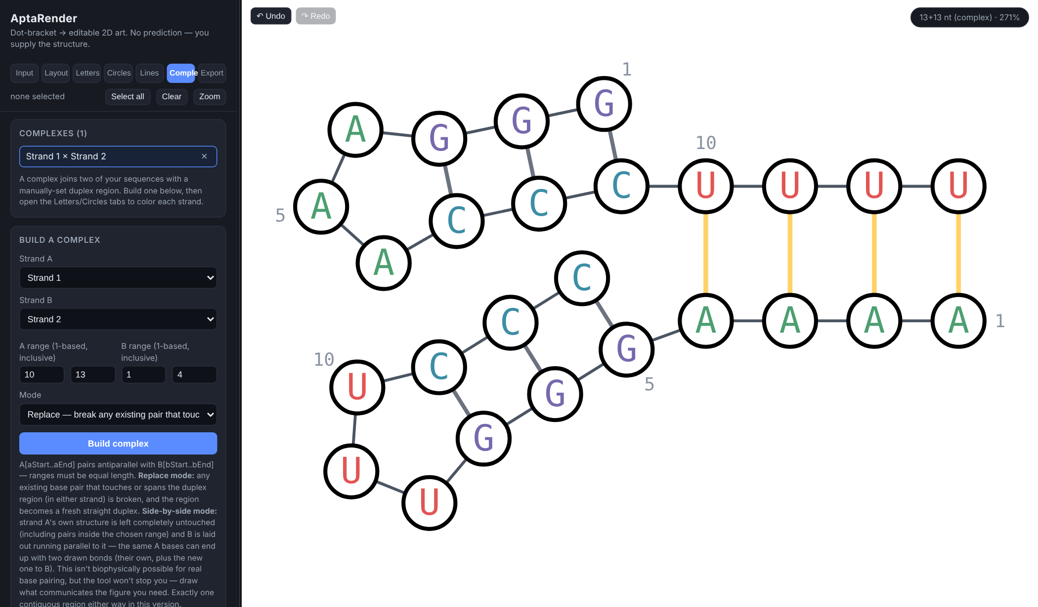
Figure 5. A Replace-mode complex. The four yellow rungs are the inter-strand duplex.
Control | What it does
Complexes list | Your saved complexes. Click a name to open it, × to delete it. Side-by-side ones are tagged "· side".
Strand A / Strand B | Pick two different sequences from your list. Both need a valid sequence and structure first.
A range / B range | Start and end positions (1-based, inclusive) of the pairing region on each strand. Both ranges must be the same length. They pair antiparallel: A's start pairs with B's end.
Mode: Replace | Any existing pair in either strand that touches the region is broken, and the region is drawn as a fresh straight duplex. The rest of each strand hangs off its end.
Mode: Side-by-side | Strand A is left exactly as it is. Strand B is drawn alongside A's chosen arm, pushed out far enough to clear the rest of A. Needs at least 2 nt. If A's range has no pairs of its own you'll get a hint that you probably meant to swap A and B.
Build complex | Creates the complex, opens it, and reports how many existing pairs were broken.
Duplex rung color | Color of the inter-strand rungs.

Working inside a complex
- Letters, Circles, Layout, Export, selection, dragging, rotation, numbering and undo all work in a complex exactly as they do on a single sequence.
- Colors you apply to bases in a complex are saved on the two source sequences, so they also appear when you open those sequences on their own, and vice versa.
- Dragged positions and the view (zoom, rotation) are saved with the complex.
- To leave the complex, click any sequence name on the Input tab.
- If you later edit a source sequence's structure, reopening the complex redraws it from the new structure.

4.7 Export tab
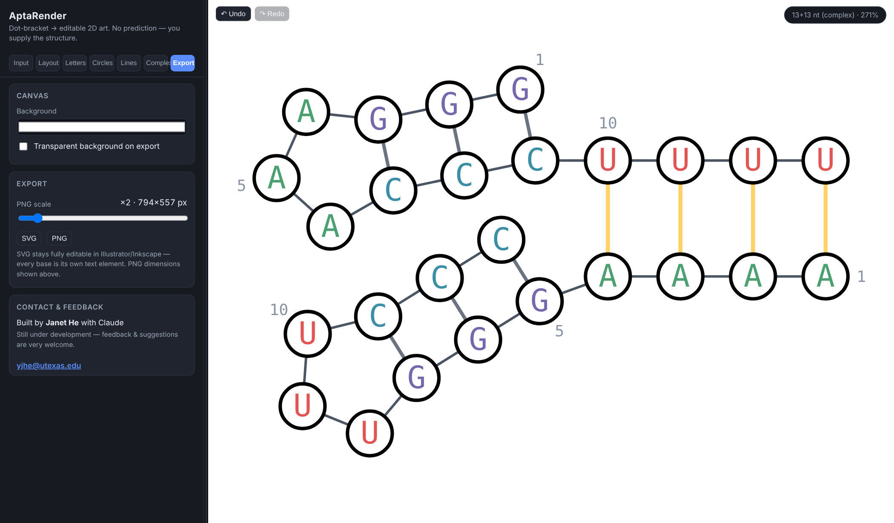
Figure 6. Export tab, showing the PNG pixel size for the current scale.
Control | What it does
Background | Canvas color, also used as the export background.
Transparent background on export | Leaves the exported SVG or PNG without a background, for placing on colored slides or posters.
PNG scale slider | 1×–12×. The label shows the resulting PNG size in pixels. Use 4× or higher for print.
SVG | Downloads aptarender.svg: fully editable vector art (every letter is its own text element) for Illustrator, Inkscape or Affinity.
PNG | Downloads aptarender.png at the chosen scale.
Exports contain exactly what's on the canvas (colors, rotation, dragged positions, numbering) cropped to the drawing with a small margin. Selection rings and highlight glows are left out, and zoom and pan don't matter.

5. Working on the canvas (mouse)

5.1 Selecting
Do this | Result
Click a base | Selects only that base. Click it again to deselect.
Shift + click a base | Adds it to, or removes it from, the selection.
Ctrl/⌘ + click a base | Adds or removes its whole part (see 5.3).
Shift + drag on empty canvas | Draws a dashed box. Every base inside is added to the selection.
Click a rung | Selects that base pair for bond coloring (Lines tab). Shift+click adds more. Single sequences only.
Click empty canvas | Clears the base and bond selection.

5.2 Moving and viewing
Do this | Result
Drag a base | Moves its whole branch: for a paired base, the stem and everything it encloses; for an unpaired base, just that base. The rest stays put.
Alt/Option + drag a base | Moves only that single base.
Ctrl/⌘ + drag a base | Moves only its part: just the helix, just the loop ring, or just the free end.
Drag a selected base (when 2 or more are selected) | Moves the whole selection together, even across both strands of a complex.
Drag empty canvas | Pans the view.
Scroll wheel / trackpad scroll | Zooms in or out around the pointer (5% to 3000%).
Tip Every move is recorded as one undo step, and Reset all positions (Layout tab) clears them all at once.

5.3 What is a "part"?
Parts let you grab a natural piece of the structure without selecting bases one by one. AptaRender works them out from the structure automatically:
- Helix: click a paired base and you get the unbroken stack of base pairs it belongs to (both strands of the stem), but not the loop at its tip.
- Loop ring: click an unpaired base inside a loop and you get all the unpaired bases of that loop (hairpin, internal or multiloop), skipping any stems branching off it.
- Free end: click an unpaired base outside every pair and you get its whole unpaired run, such as the 5′ or 3′ tail or a linker between stems.
In the Hairpin example, Ctrl/⌘+clicking any of the three loop bases selects exactly those three (that's how Figure 3's highlight was made), and Ctrl/⌘+dragging an A in the tail moves only the tail.

6. Keyboard shortcuts cheat sheet
On a Mac, use ⌘ Cmd wherever Ctrl is listed and Option for Alt.
Shortcut | Action
Ctrl + Z / ⌘ + Z | Undo
Ctrl + Y , Ctrl + Shift + Z / ⌘ + Shift + Z | Redo
Shift + click base | Add/remove base from selection
Shift + drag background | Box select
Ctrl/⌘ + click base | Add/remove its part from selection
Ctrl/⌘ + drag base | Move only its part
Alt/Option + drag base | Move only that base
Esc | Unlock a locked ring (ring rotation)
Shift + click rung | Add/remove bond from bond selection
Scroll | Zoom around pointer
Double-click sequence name | Rename sequence
Undo and redo shortcuts pause while you're typing in a text or number box, so the box's own undo works there. Click on the canvas first to use AptaRender's undo.

7. Recipes for common figures

7.1 A clean publication figure
- Enter the sequence and structure on Input and click Render.
- Letters: set Font size, then Apply palette (color by base) or Apply monochrome.
- Circles: tick Show base circles; choose frame and fill (e.g. black frame, white fill, 2 px).
- Lines: set Number every to 10.
- Layout: rotate the whole structure so it reads well; drag any crowded branch into a clearer spot.
- Export: tick Transparent background, set PNG scale to 4× or more, and download SVG and/or PNG.

7.2 Highlight a loop or binding site
- Ctrl/⌘+click one base of the loop to select the whole ring, or Shift+drag a box around the bases you want.
- Circles tab → pick a color under Circle fill for selection → Apply.
- Optionally Letters tab → Letter color for selection → Apply, e.g. white letters on a dark fill.
- Click empty canvas to clear the selection and check the result.

7.3 Swing a crowded stem out of the way
- Click a base pair at the bottom of the stem, then Shift+drag a box over the rest of that stem and its loop. Or simply drag a base of the stem: the whole branch moves with it.
- To turn it instead of moving it: Layout tab → Rotate selection, enter an angle (try 30 or −30), set Pivot to Attachment point, click Rotate selected. Repeat until it looks right.
- Press Zoom in the selection bar to inspect it up close, then Fit to view to see the whole figure again.

7.3b Re-angle a helix around a loop (Varna-style)
- Ctrl/⌘+click any unpaired base in the loop the helix is attached to. Its whole ring is selected.
- Layout tab → Lock ring. A dashed circle marks the locked ring.
- Drag a base of the helix in a circle around the ring. It slides along the ring while the ring's unpaired bases re-spread on either side.
- To swing everything else instead, drag the stem that closes the ring.
- Click Unlock ring (or press Esc ) and Fit to view.

7.3c Color by your own data (DMS, mutations…)
- Open the sequence, then Letters tab → Download sample.
- Edit the color column (or delete lines you don't need, and use ranges like 20-25 ). Keep the base column as a check that the file matches the sequence.
- Choose Apply to (letters, circle fill, or both), then Upload color file….
- Read the note under the buttons for anything skipped or mismatched.

7.4 Show two strands hybridizing
- On Input, add both strands as separate sequences (use + Add, or import a FASTA with both) and Render each one so it has a valid structure.
- Go to Complex, choose Strand A and Strand B.
- Enter the pairing ranges. Both must be the same length; remember A's first base pairs with B's last.
- Choose Replace to draw the region as a clean duplex, or Side-by-side to keep A's own fold untouched and lay B along it.
- Click Build complex, then style and export it like any other figure. Set the Duplex rung color to make the inter-strand pairs stand out.

8. Saving, undo, and where your data lives
- Saving is automatic. Everything (sequences, structures, colors, positions, complexes, styles, panel width) is stored in your browser as you work and comes back when you reopen the page.
- It stays on this computer, in this browser. Nothing is uploaded and nobody else can see it. A different browser or computer won't have it, and clearing your browser's site data deletes it. Export an SVG of anything you want to keep.
- Undo goes back up to 100 steps and covers rendering, colors, every style control, drags, rotations, adding/deleting/renaming sequences, and building/deleting complexes.
- Switching which sequence is open, changing the selection, and panning/zooming aren't undo steps, so Ctrl+Z won't jump you around.

9. Limitations and troubleshooting
Situation | What to know / do
My custom colors disappeared | Render, Apply palette and Apply monochrome reset colors. Press Ctrl/⌘+Z.
A branch looks misplaced after changing Free tails | Tail style re-lays out the drawing. Drags on the tail bases are cleared, but moves on stems and loops are kept. Use Reset all positions, then re-adjust.
Pseudoknots | Crossing pairs aren't supported. All brackets must nest. Use [ ] { } < > only to mark non-WC pairs.
Structure prediction | Not provided by design. Supply the structure from your own folding tool or data.
Bond coloring in a complex | Rung click-selection works on single sequences only. Color bonds on each strand's own sequence first; they carry into the complex.
More than two strands / several duplex regions | A complex is two strands with one contiguous pairing region in this version.
Hit the 20-sequence limit | Delete a sequence you no longer need (its complexes go with it).
Something else | Use the contact link at the bottom of the Export tab.

