**INTI International College Penang School of Computing**

**3+0 Bachelor of Science (Hons) in Computer Science, in collaboration with Coventry University, UK**

**3+0 Bachelor of Science (Hons) in Computing, in collaboration with Coventry University, UK**

**Coursework cover sheet**

**Section A - To be completed by the student**

|  |  |  |  |  |  |  |  |  |  |  |
| --- | --- | --- | --- | --- | --- | --- | --- | --- | --- | --- |
| **Student Details:**   |  |  |  | | --- | --- | --- | | Group Members | Full Name | CU Student ID Numbers | | 1 | TAN YI JIA | 12672752 | | 2 | TEH GER MIN | 12672763 | | |
| Semester: April 2024 | |
| Lecturer: Khor Jia Yun | |
| Module Code and Title:  6002CEM– Mobile App Development | |
| Assignment No. / Title: Coursework  CW2 – Project | % of Module Mark  75% |
| Hand out date:  **12-Apr-2024 (Friday of Week 2)** | Due date:  **24-June-2024 (Monday of Week 12)** |
| Penalties: No late work will be accepted. If you are unable to submit coursework on time due to extenuating circumstances you may be eligible for an extension. Please consult the lecturer. | |
| **Declaration:**  I/we the undersigned confirm that I/we have read and agree to abide by the University regulations on plagiarism and cheating and Faculty coursework policies and procedures. I/we confirm that this piece of work is my/our own. I/we consent to appropriate storage of our work for plagiarism checking.  A black text on a white background  Description automatically generated  Signature(s): ______yijia______ ___________________________  (TAN YI JIA) (TEH GER MIN) | |

**Marking Rubric**

Your report will be marked against the following criteria:

|  |  |  |  |  |  |
| --- | --- | --- | --- | --- | --- |
|  | 0-9 | 10-14 | 15-17 | 18-20 | Marks Given |
| Application complexity –    Coverage & Functionalities  (20%) | App with one screen and one feature.  Basic complexity (basic usage of elementary UI interface). | App with more than one screen and more than one feature.  Basic-medium complexity (basic- medium usage of UI interface elements). | App with more than two screens with more than two features.  Medium complexity (medium-good usage of UI interface elements). | App with more than three screens with more than three features.  High complexity (good usage of UI interface elements). |  |
|  | 0-2 | 3-4 | 5-7 | 8-10 |  |
| Application complexity –  Proper methods for persistence of data  OR  integration with API  (10%) | No cloud/local data persistence or other cloud services (e.g. authentication – authorization services/ other external APIs).  OR  Attempt to use persistence method or API but has errors and is not working. | Local or cloud persistence services and no authentication.  OR  Use of at least one external APIs or sensor. | Local or cloud persistence services and with / without authorization.  AND  Use of **one** external APIs or sensor. | Local or cloud persistence services with authorization.  AND  Use of **more than one** external API or sensors intensively. |  |
|  | 0-1 | 2-3 | 4 | 5 |  |
| Application of MVVM design concept  (5%) | No use of any MVVM or other design concept. | Might be using some type of separation of concern which is not MVVM. | Demonstrate some level of use of MVVM design without error. | Demonstrate good MVVM design concept. |  |
|  | 0-9 | 10-14 | 15-17 | 18-20 |  |
| Application UI Design  (20%) | Poor UI design. The work looks more like a draft and unfinished work. | GUI design is acceptable, but much improvement is needed on the choice of colour palette and / or the ease of use. Need major modifications to make it suitable for its purpose. | GUI design is acceptable, but some areas need improvement such as choice of colour palette or ease of use. The overall design might need minor modifications to make it suitable for its purpose. | GUI design is user-friendly, easy to understand and has suitable choice of colour palettes. The design is appropriate for its purpose. |  |
|  | 0-2 | 3-4 | 5-7 | 8-10 |  |
| Report - Contents  (10%) | Failed to include all required sections. Information presented is irrelevant to the report. | Include some of the required sections but organization required improvement.  Some information/explanation / discussion are unclear or lack of clarity  Simple use case diagram with basic notations used, however, with many mistake/errors. | Include all required sections and somehow organized.  Some of information/ explanation/ discussion required minor clarification.  Acceptable use case diagram and all notations are clear and used correctly with minor mistake/errors. | Include all required sections.  All information/ explanation/ discussion are very clear, comprehensive and no improvement needed.  Comprehensive use case diagram and all notations are clear and used correctly with zero mistake/error. |  |
|  | 0-2 | 3-4 | 5-7 | 8-10 |  |
| Report - Format  (10%) | Missing cover and table of contents.  Missing most of the labels and captions for figures and tables.  Missing screenshots of the program output. | Missing cover or table of contents.  Missing labels or headers for some sections.  Very few screenshots of the program output. | Complete with cover and table of contents.  Missing some labels and / or captions for figures and tables.  Adequate screenshots of the program output. | Complete with cover and tables of contents.  All figures are properly labelled and captioned.  Very comprehensive screenshots of the program output. |  |
|  | 0-2 | 3-4 | 5-7 | 8-10 |  |
| Submission – Completeness and punctuality  (10%) | Many required files are missing.  OR  Submission delayed in more than 1 hour but less than 24 hours. | Most of the essential files are submitted on time and some files might not be in the format as instructed. Some missing files such as README.  OR  Submission delayed in less than an hour. | All required files are submitted on time, but some files are not in the format requested. | All required files are submitted on time and in correct format as instructed. |  |
|  | 0-2 | 3-4 | 5-7 | 8-10 |  |
| VIVA Presentation  - Clarity, Relevance and Confidence  (10%) | The presentation was not smooth, or the student was speaking with a very unclear voice. Presentation was messy, much unnecessary elaborations. | The presentation was acceptable, but many improvements are needed for the student, such as relevance of contents, clarity of voice, confidence, and smoothness. | The presentation was acceptable, with some room for improvement. | The presentation was smooth and clear. The student spoke with confidence and clarity. The explanation was straight to the point and no-frills. |  |
|  | 0-1 | 2-3 | 4 | 5 |  |
| VIVA Presentation  - Q & A  (5%) | The student was not able to answer most of the questions and showed very little knowledge in his/her own area of work. | The student was able to answer some of the questions and showed slight confusion in his/her own area of work. | The student was able to answer most of the questions with confidence and showed good knowledge in his/her own area of work. | The student was able to answer all the questions with confidence and showed outstanding knowledge in his/her own area of work. |  |

**Table of Figures**

Figure 1 Use Case Diagram 2

Figure 2 Sign in Page 4

Figure 3 Message shown when not all fields are filled or invalid email or invalid password 5

Figure 4 Message shown when email is not verified 6

Figure 5 Reset Password 7

Figure 6 Reset Password Email 7

Figure 7 Changed Password 8

Figure 8 Failed to Send Reset Password Email 8

Figure 9 Sign Up Module 9

Figure 10 Error messages for the validation for account registration 10

Figure 11 Account Created Message 11

Figure 12 Confirmation Email to verify email existences 11

Figure 13 Home Page 12

Figure 14 Mood Entry Creation 14

Figure 15 Mood’s Date and Time Entry 15

Figure 16 Mood Details 16

Figure 17 Edit Mood Entry 17

Figure 18 Delete Mood Entry 18

Figure 19 Calendar Module 19

Figure 20 Habits Module 21

Figure 21 Slidable Habit Card 22

Figure 22 Edit Habit Entry 23

Figure 23 Delete Habit Entry 24

Figure 24 Habit Entry Creation 25

Figure 25 Habit Check in Entry 26

Figure 26 Discover Module 27

Figure 27 Discover Module - Meditation Guides (Mindfulness Meditation) 28

Figure 28 Discover Module - Meditation Guides (Breathing Exercise) 29

Figure 29 Discover Module - Meditation Guides (Sleeping Guide) 30

Figure 30 Discover Module - Play Meditation Videos in YouTube 31

Figure 31 User Profile Module 33

Figure 32 Update User Profile Information 34

Figure 33 Mood History 35

Figure 34 Privacy Policy, Terms & Conditions 36

**Table of Contents**

1.0 Introduction 1

2.0 Use Case Diagrams 2

3.0 Modules and Screenshots 4

1. Sign In Module, Forgot Password Module – Tan Yi Jia 4

2. Sign Up Module - Tan Yi Jia 9

3. Home Page Module – Tan Yi Jia, Teh Ger Min 12

4. Mood Creation Module – Tan Yi Jia 13

5. Calendar Module – Teh Ger Min 19

6. Habits Module – Teh Ger Min 20

7. Habits Creation Module – Teh Ger Min 25

8. Habit Check in Module – Teh Ger Min 26

9. Discover Module - Tan Yi Jia 27

10. User Profile Module – Tan Yi Jia 32

4.0 Strengths of the App 37

5.0 Limitations of the App 37

6.0 Future Enhancements 37

7.0 Reflections from the Group Members 38

7.1 Tan Yi Jia 38

7.2 Teh Ger Min 39

8.0 Appendix 41

Appendix A – GitHub 41

Appendix B – Turnitin 41

9.0 References 42

Code References 42

## 

## Introduction

In today's fast-paced world, individuals often struggle to maintain emotional balance and well-being due to overwhelming responsibilities and continuous stimuli from social media and work (Waris Qidwai, 2016). This can lead to stress, anxiety, and emotional exhaustion, worsened by a lack of tools and support for managing emotions. "Habitual Heart" is developed to address these challenges by promoting emotional awareness and cultivating positive habit formation by recognising the impact of habits on daily life and emotional health (José Antonio Ruiz-Hernández, 2022).

"Habitual Heart" is a mobile app designed to help users cultivate beneficial habits and improve emotional well-being. The application provides features like habit tracking, emotional reflection, and meditation tools. The functions enabled users to set and monitor goals effectively. The app aims to empower individuals to make lasting positive changes, enhance productivity, and achieve overall life fulfilment. "Habitual Heart" supports users in overcoming the challenges of habit development and achieving sustainable improvements through tools like habit goal setting.

## Use Case Diagrams

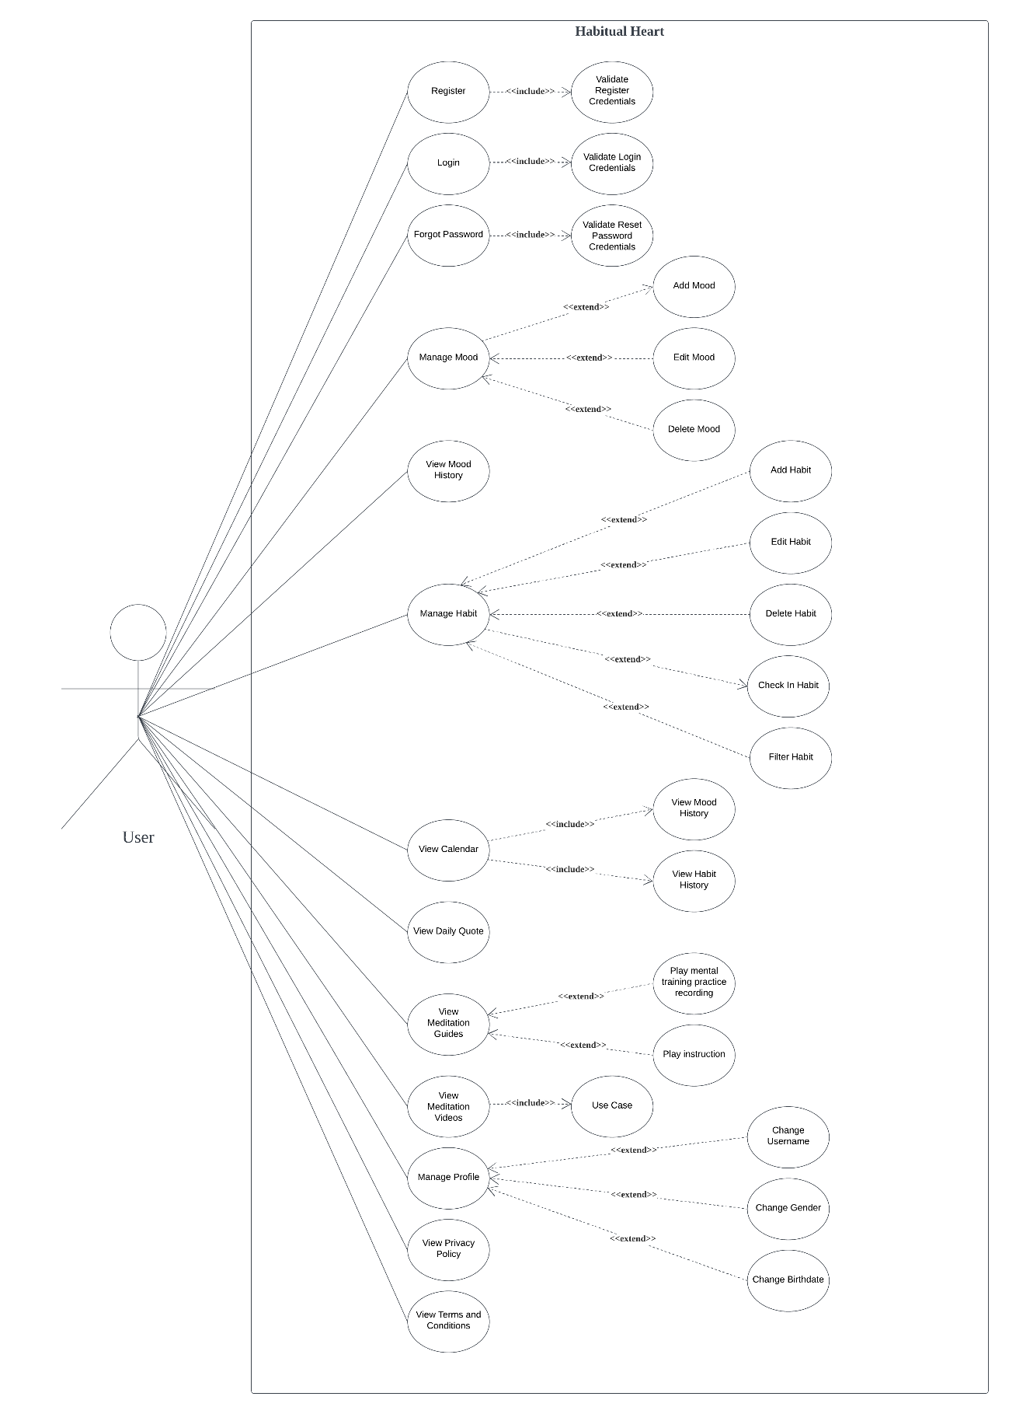

Figure 1 Use Case Diagram

The use case diagram for the "Habitual Heart" application outlines the various functionalities available to users. The primary actor as the user who interacts with the system to manage moods, habits, and other related activities. The main use cases include registering, logging in, and resetting passwords, each with a validation process to ensure correct and valid user information. Besides that, users can manage their moods and habits by adding, editing, deleting, and viewing mood and habits history. The application also allows users to view a calendar that displaying the mood and habit histories. Moreover, users can access daily inspirational quotes, meditation guides, and meditation videos, with functionalities to play the practice recordings and instructions. Lastly, users can manage the user profiles by changing the username, gender, and birthdate, and view the application's privacy policy and terms and conditions.

## Modules and Screenshots

#### Sign In Module, Forgot Password Module – Tan Yi Jia

When the app is first launched, the login page is showed as shown in Figure 2. Log in consists of only 2 inputs, email and password. If the email and password are empty, or email and password are invalid, an error message will pop out as shown in Figure 3. Figure 4 shoes if user have registered the account but not yet verify the email account, a message will show to ask user to verify the email account, then only can sign in.

If the user clicked on the “Sign Up” button, they will be directed to the Sign Up Module - **Tan Yi Jia**.

If the user clicked on the “Forgot Password?” button, a reset password email will send to the user’s email that filled in in the email text field. If the text field is empty, or the email does not exist, an error message will show as shown in Figure 8.

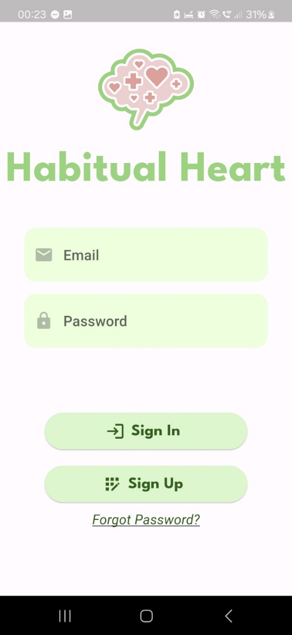

Figure 2 Sign in Page

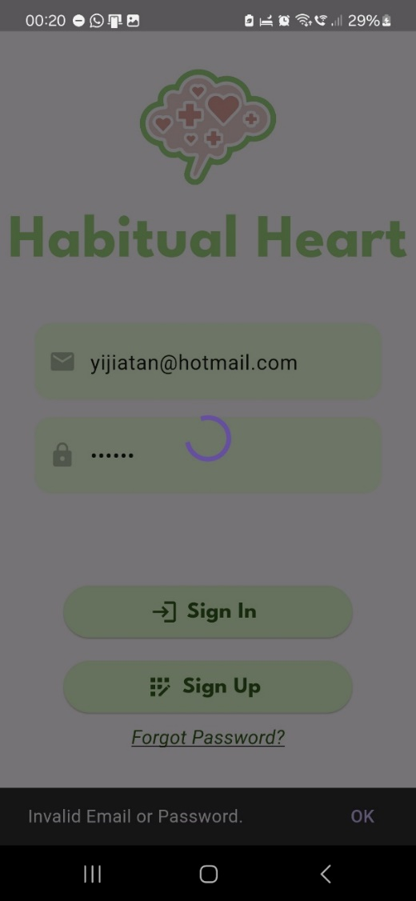

Figure 3 Message shown when not all fields are filled or invalid email or invalid password

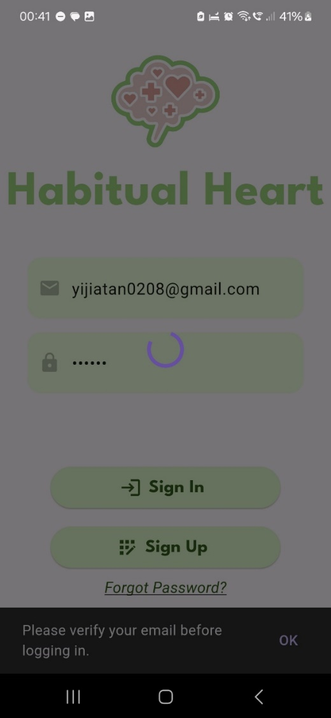

Figure 4 Message shown when email is not verified

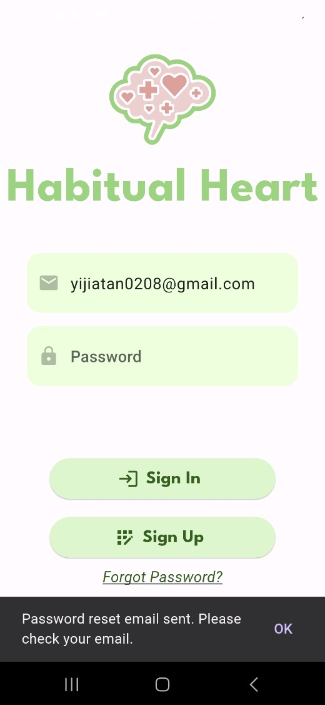

Figure 5 Reset Password

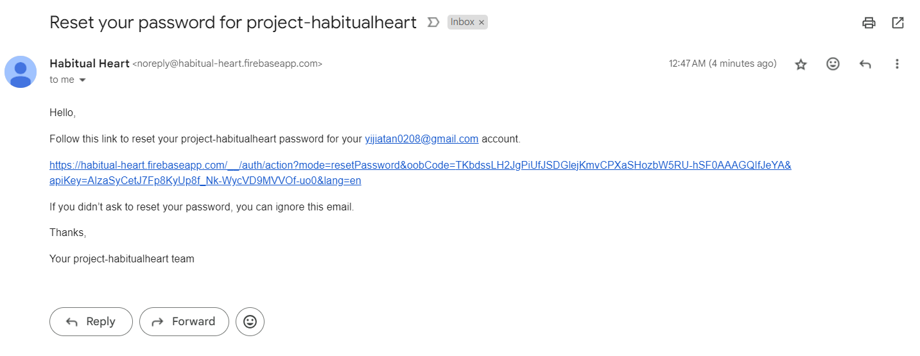

Figure 6 Reset Password Email

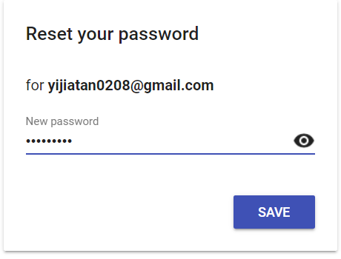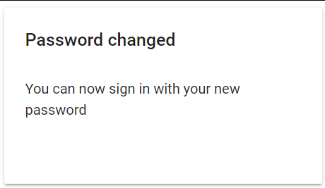

Figure 7 Changed Password

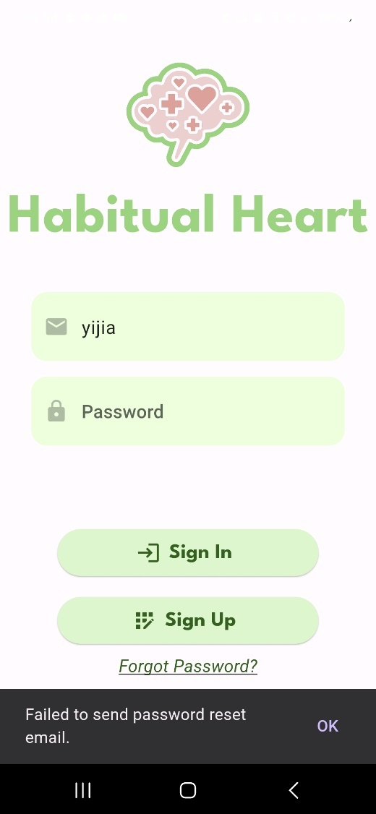

Figure 8 Failed to Send Reset Password Email

#### Sign Up Module - Tan Yi Jia

This module allows users to create an account by filling in their username, email, password, and confirm password fields (Figure 9). Each field must be completed for validation to proceed, and additionally, the password and confirm password fields must match (Figure 10).

If validation is successful, users are then redirected to the Sign In module with a confirmation message shows upon successful registration (Figure 11). Thus, a confirmation email is sent to verify the email address, ensuring it is valid (Figure 12).

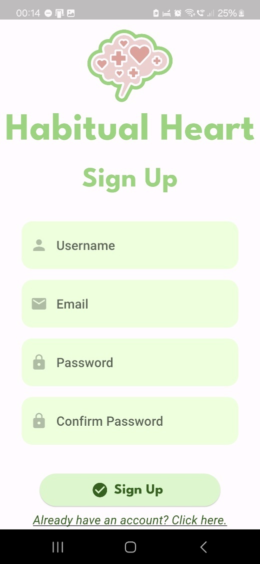

Figure 9 Sign Up Module

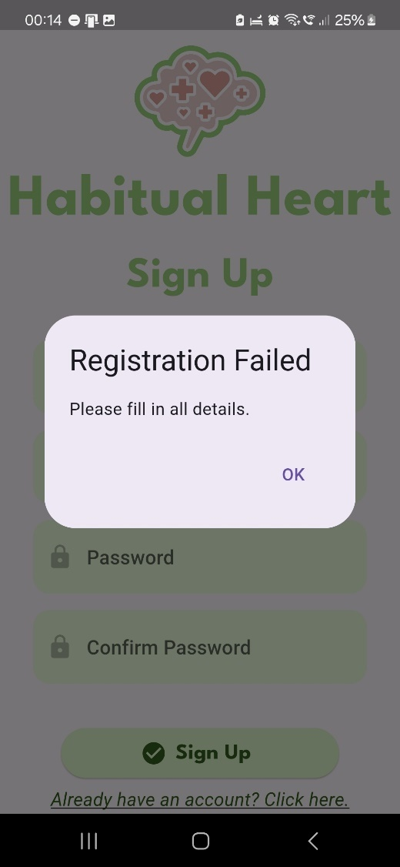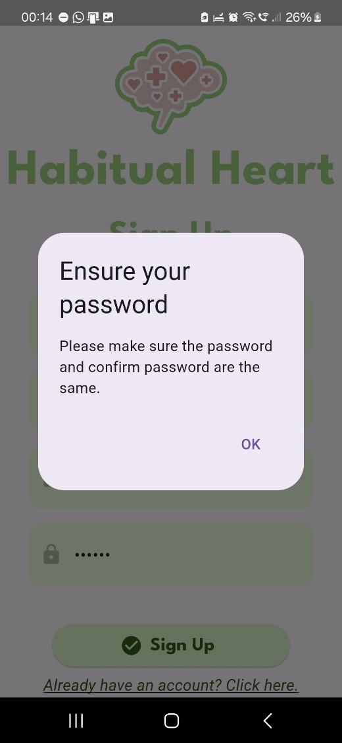

Figure 10 Error messages for the validation for account registration

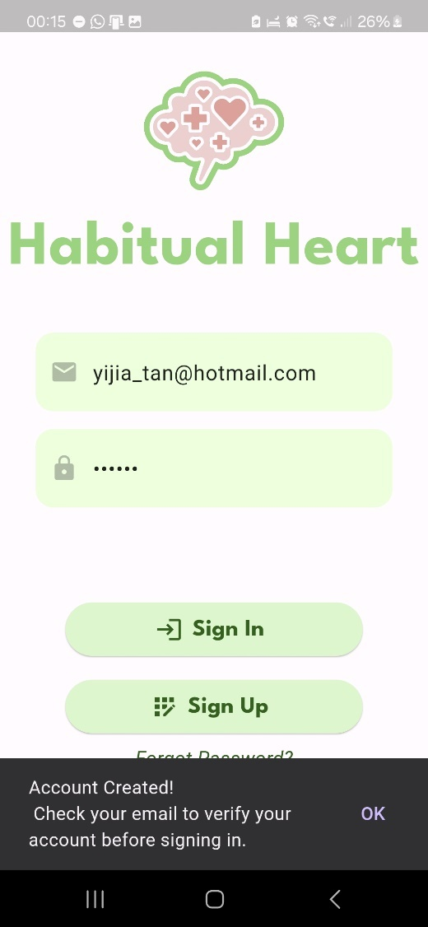

Figure 11 Account Created Message

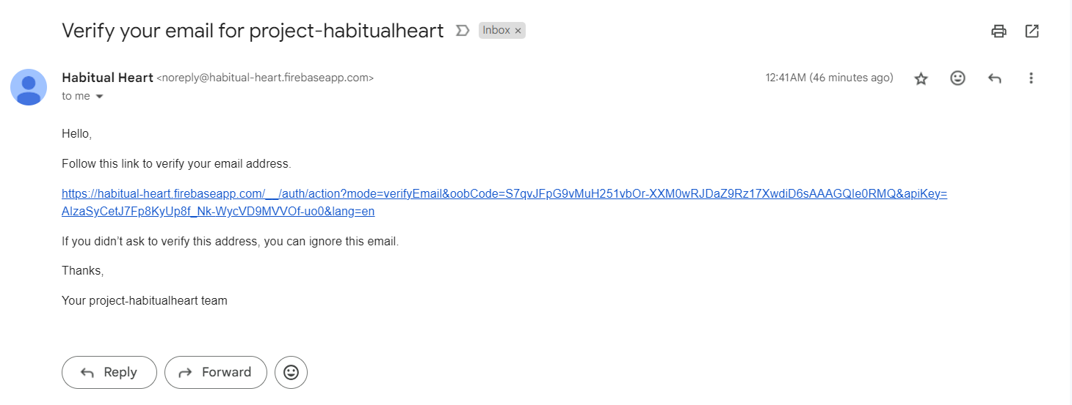

Figure 12 Confirmation Email to verify email existences

#### Home Page Module – Tan Yi Jia, Teh Ger Min

After signed in to the app, users are greeted with the current date and a display of their mood for the day, represented by an icon. If no mood has been recorded for today, users can select the icon and log their current mood in the Mood Creation Module – Tan Yi Jia. Below the mood section, the Habits List showcases a personalized list of habits, each indicating their current status and streaks, as illustrated Habit Module – Teh Ger Min.

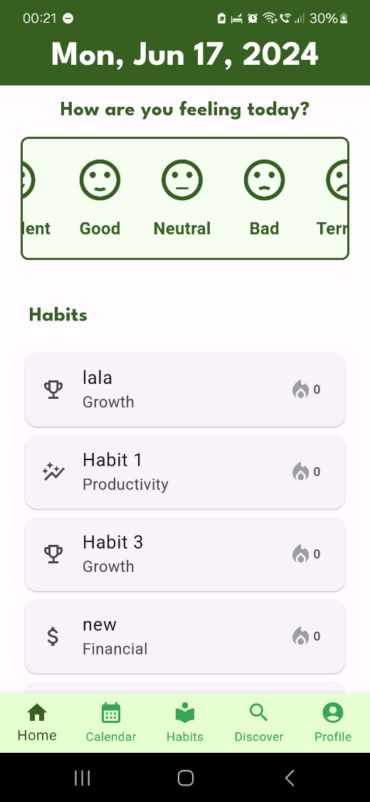 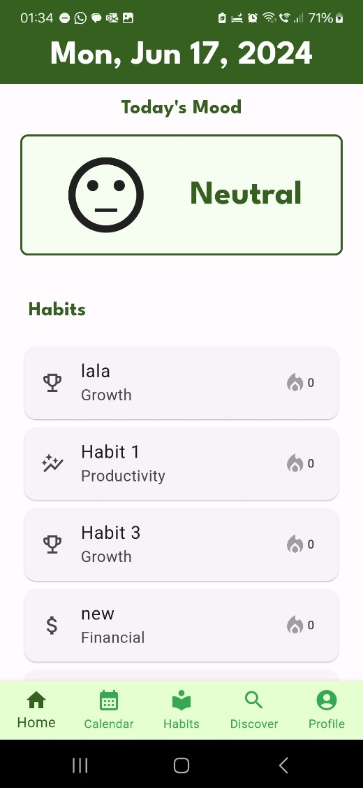

Figure 13 Home Page

#### Mood Creation Module – Tan Yi Jia

The mood creation module is to let users log their current mood and add descriptive details. Users can select their mood from predefined options (Excellent, Good, Neutral, Bad, Terrible), each associated with an icon. The user can pick the date and time for the mood entry using a date-time picker (Figure 15). They can also add a description to provide more context about their mood (Figure 14).

Upon saving, the mood data (including the selected mood, timestamp, and description) is stored in the Firestore database. The home page then displays the current day's mood with its corresponding icon and provides navigation to detailed mood entries as shown in Figure 16. In the mood details page, it displays the details of a specific mood entry, including the mood type, description, and timestamp, and provides options to edit or delete the entry.

When the user clicked edit button, it will proceed to a new page that allows users to update their mood records by selecting a new mood, modifying the description, and adjusting the timestamp (Figure 17). If the user clicked delete button, a confirmation message will pop out to confirm user wants to delete the mood entry (Figure 18).

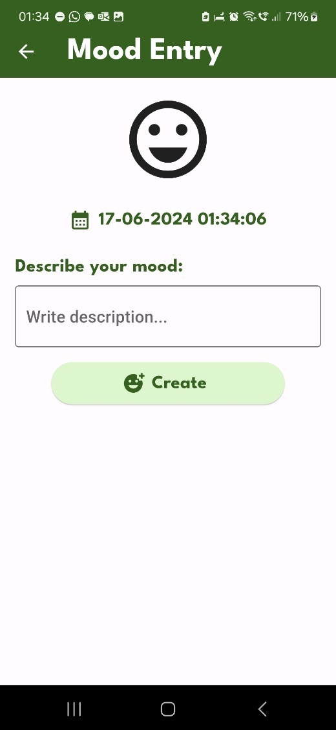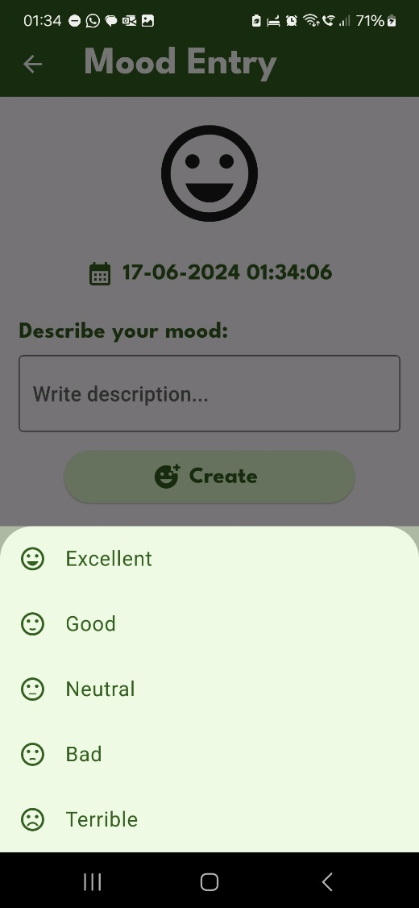

Figure 14 Mood Entry Creation

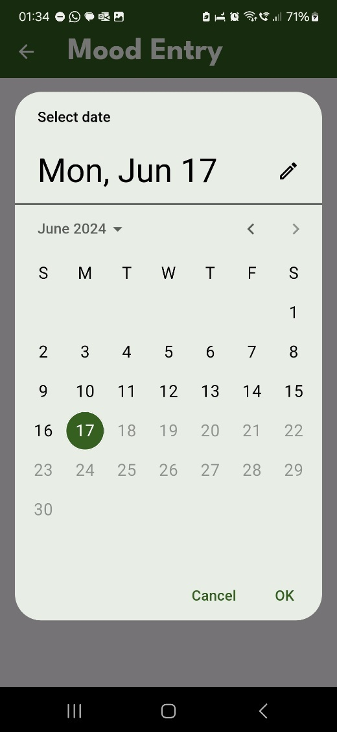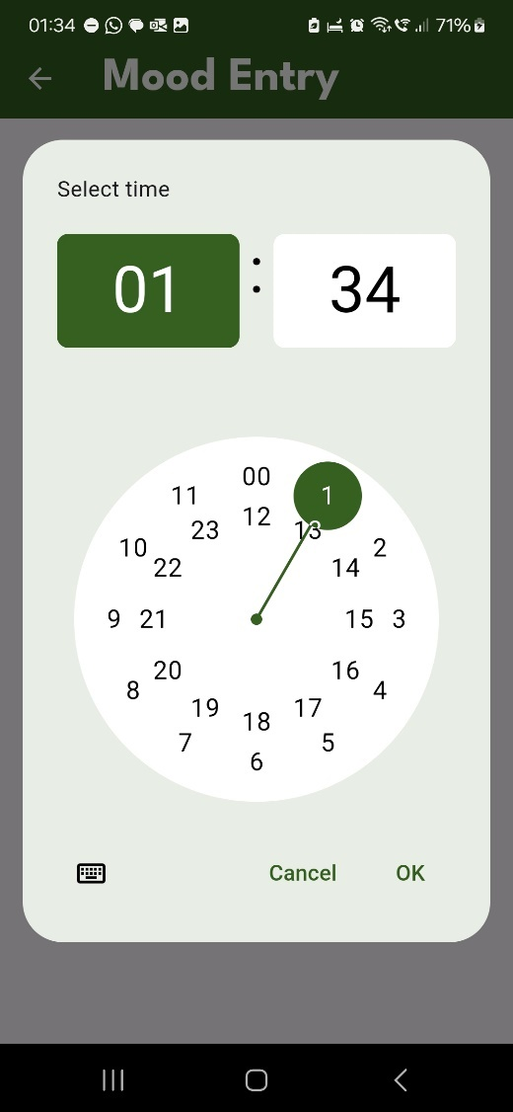

Figure 15 Mood’s Date and Time Entry

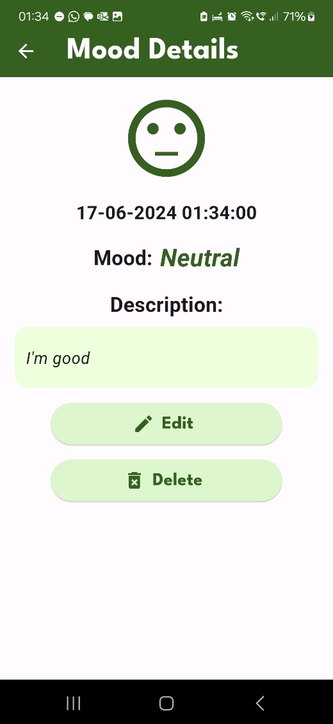

Figure 16 Mood Details

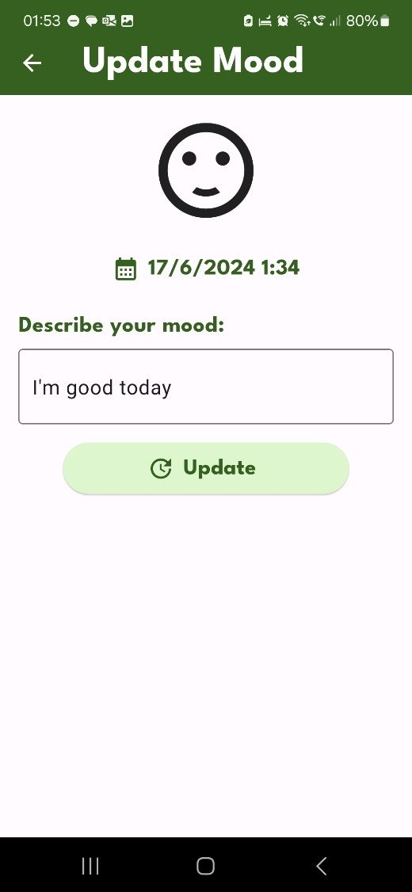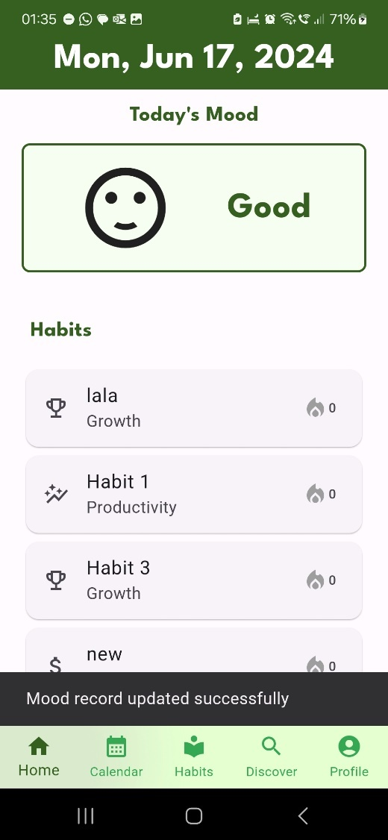

Figure 17 Edit Mood Entry

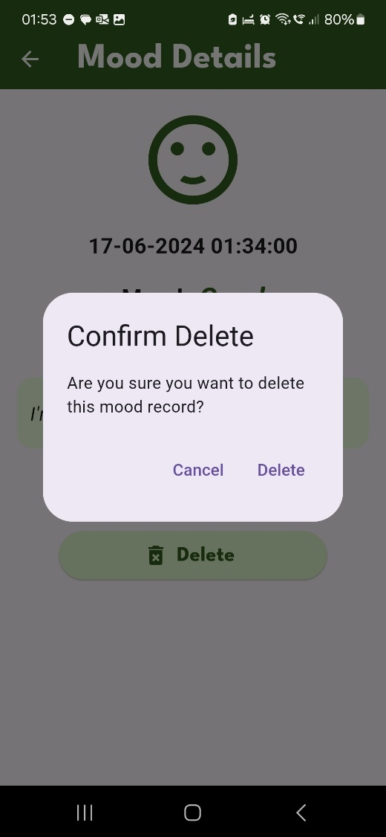

Figure 18 Delete Mood Entry

#### Calendar Module – Teh Ger Min

The calendar page lets users quickly review users’ mood entries (Figure 19). This page displays a calendar where each day is marked with the user's recorded mood, providing an overview of the emotional patterns over time. Additionally, users can select any specific date on the calendar to view a list of the associated habit check-ins for that day.

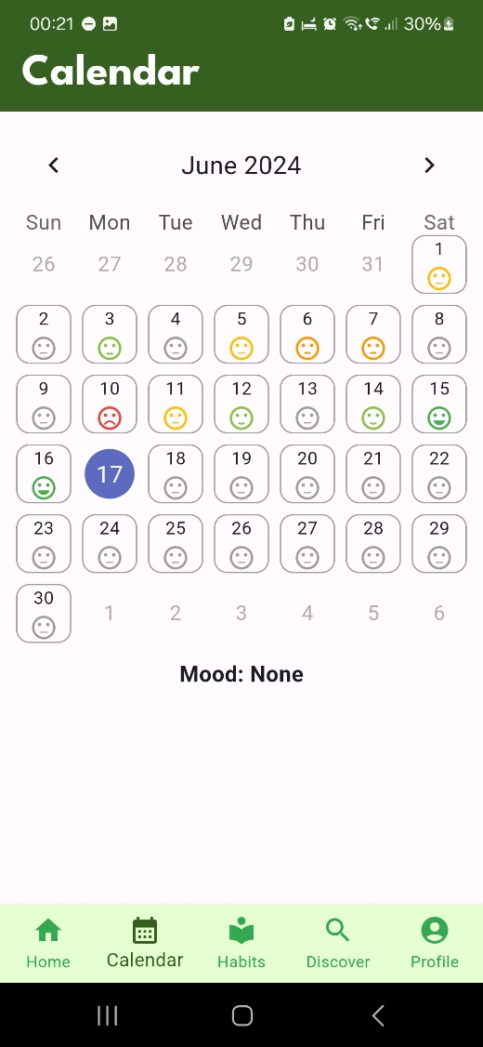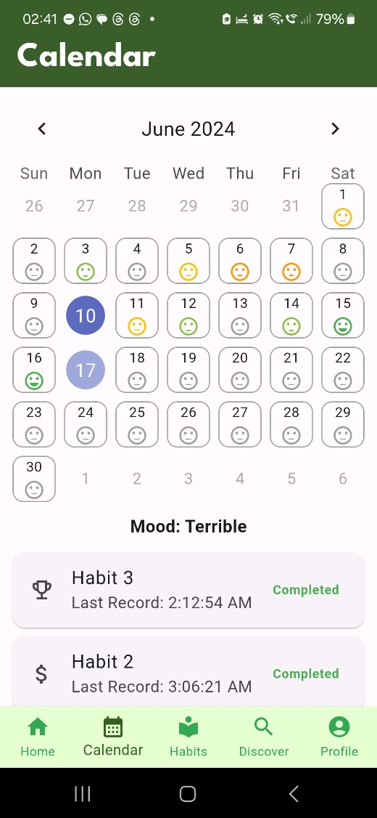

Figure 19 Calendar Module

#### Habits Module – Teh Ger Min

In this habits page, users can see the list of habits users have created before. Each habit is displayed with the habit’s name, category, status which is shown by a fire icon, and streak number. Users can filter the habits by category by clicking on the filter button at the top of the page, making user easier to manage and organize the habits. (Figure 20)

Users can slide a specific habit card to reveal options for editing or deleting the habit. This slidable feature provides quick access to these actions without navigating away from the main habits page, enhancing user experience and efficiency. (Figure 21)

After clicking on the Edit button, the system will navigate the user to the modify habit page. On this page, users can change the habit's name, description, category, or daily count. Once the user clicks on the Save changes button, the app will navigate back to the habits page, displaying the updated habit list with the newly modified habit details. (Figure 22)

After clicking on the Delete button, the system will display a confirmation dialog to ensure the user intended to delete the habit. This dialog also reminds the user that all associated habit records will be deleted. Upon confirming the deletion by clicking on the Delete button in the dialog, the system will remove the habit and all associated habit’s records and refresh the habits page to reflect the changes. (Figure 23)

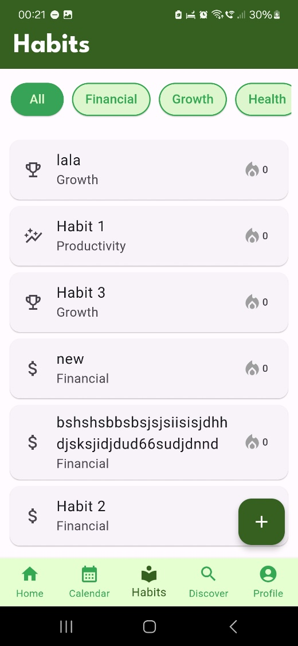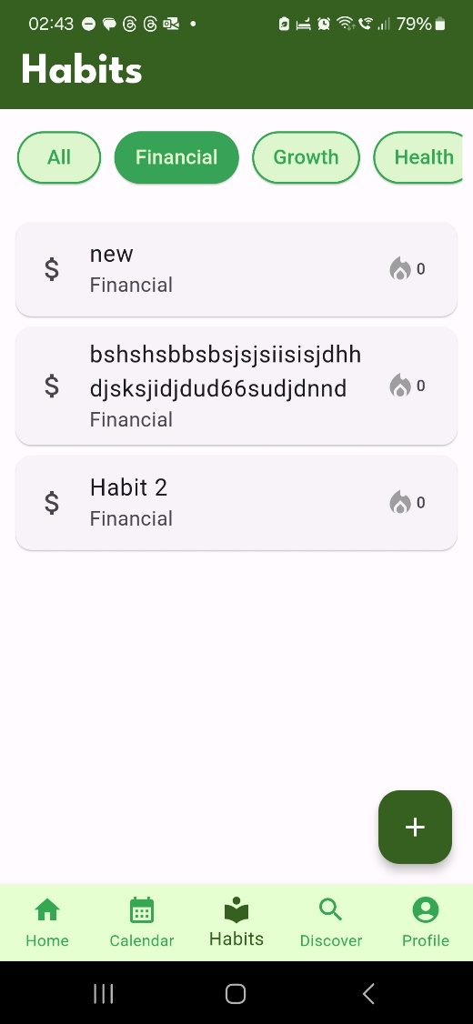

Figure 20 Habits Module

Figure 21 Slidable Habit Card

Figure 22 Edit Habit Entry

Figure 23 Delete Habit Entry

#### Habits Creation Module – Teh Ger Min

In the new habit page, users are required to fill in the habit's name, category, and daily count. The description field is optional, allowing users to provide additional details if user wish. Once all the necessary information is entered, users can click on the Submit button to add the new habit to the system. This enabling user to easily expand the habit list and begin tracking the habit progress.

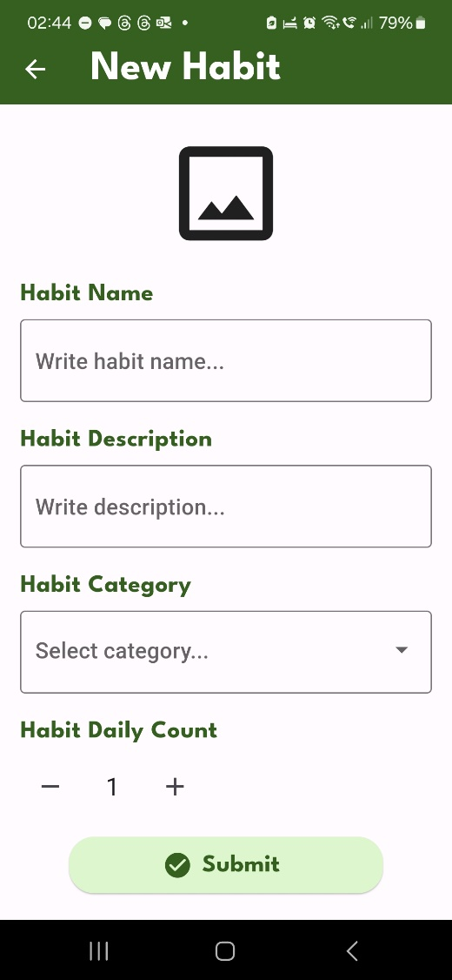

Figure 24 Habit Entry Creation

#### Habit Check in Module – Teh Ger Min

When users want to check in a specific habit, user need to click on the specific habit card. After clicking on the habit card, the app navigates users to the habit check-in page. On this page, users must click the submit button to check in one time for the habit, which saves one record for this habit. Users need to check in three times to complete this habit for the current day. Once the specific habit is completed for the current day, the habit's fire icon will light up, indicating the habit's completion status for the day. The number beside the fire icon represents the streak number, which will increase by 1 each time the specific habit is completed for the current day. This visual feedback helps users easily track users daily habit completion and streak progress.

Figure 25 Habit Check in Entry

#### Discover Module - Tan Yi Jia

The Discover module has three main sections. The first section displays a daily motivational quote retrieved from an API, featuring the quote and the author's name in a graceful design.

The second section is "Meditation Guides" which displaying various meditation tools in a grid layout. Users can tap to access detailed guides. The guides include the detailed instructions and audio guidance for deep breathing techniques (Figure 28), mindfulness meditation sessions with themed durations (Figure 27), and guided sleep meditation accompanied by soothing music (Figure 29).

The final section, "Meditation Videos," lists YouTube meditation videos, allowing users to launch and view them by tapping on the titles. Thus, the video’s link opens either in the YouTube app or a web browser (Figure 30).

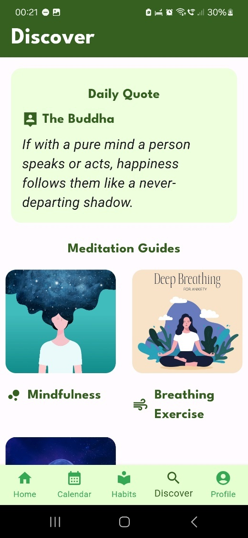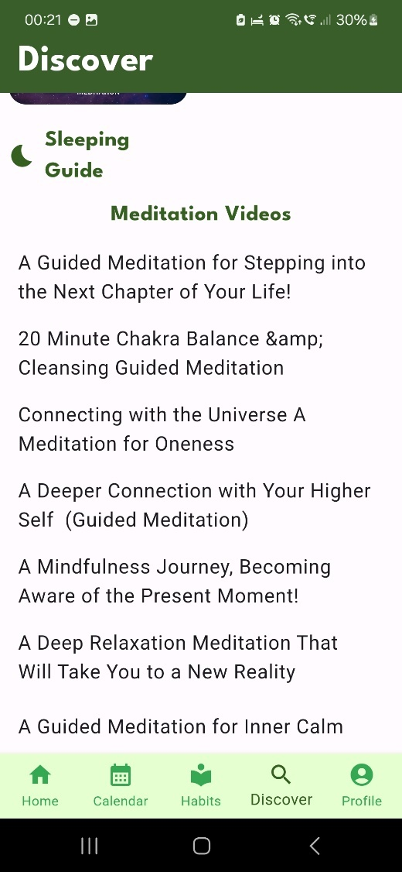

Figure 26 Discover Module

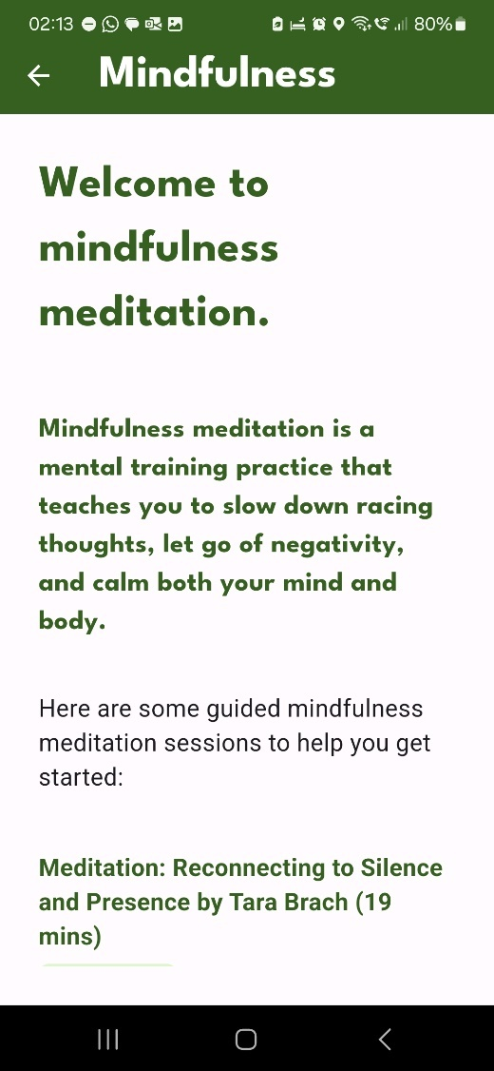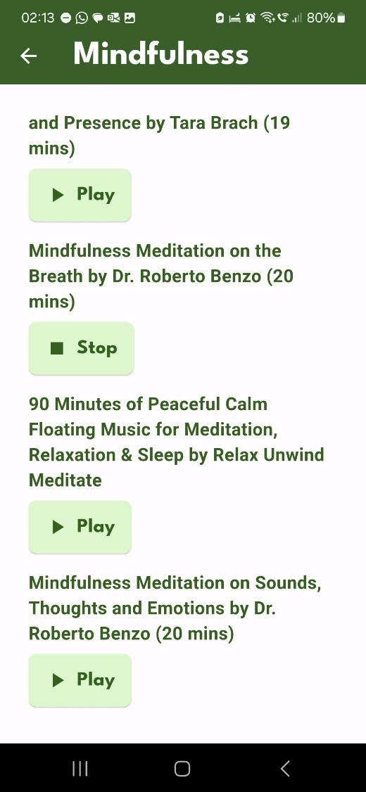

Figure 27 Discover Module - Meditation Guides (Mindfulness Meditation)

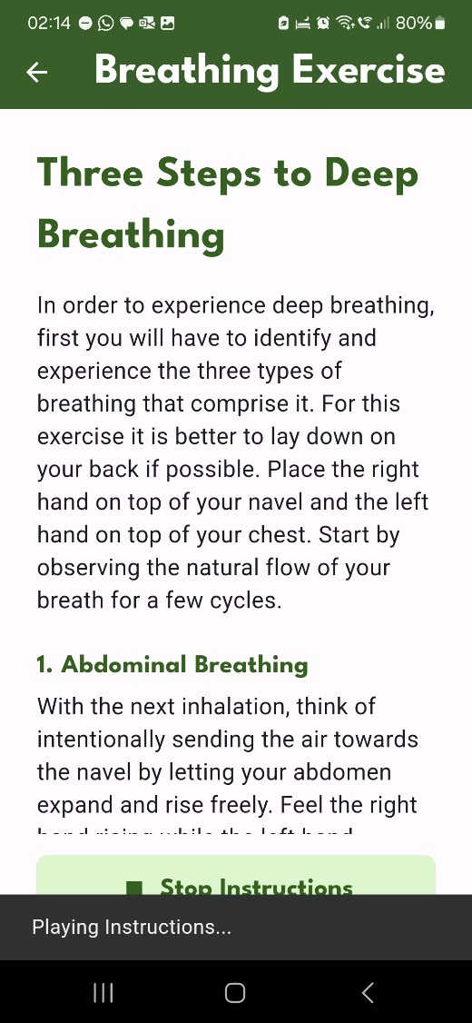

Figure 28 Discover Module - Meditation Guides (Breathing Exercise)

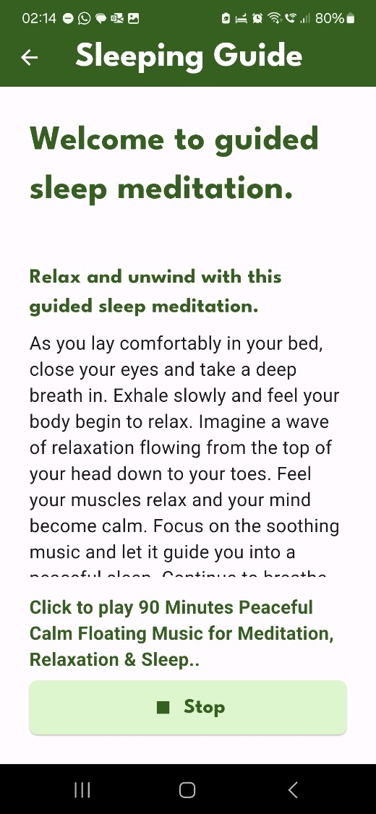

Figure 29 Discover Module - Meditation Guides (Sleeping Guide)

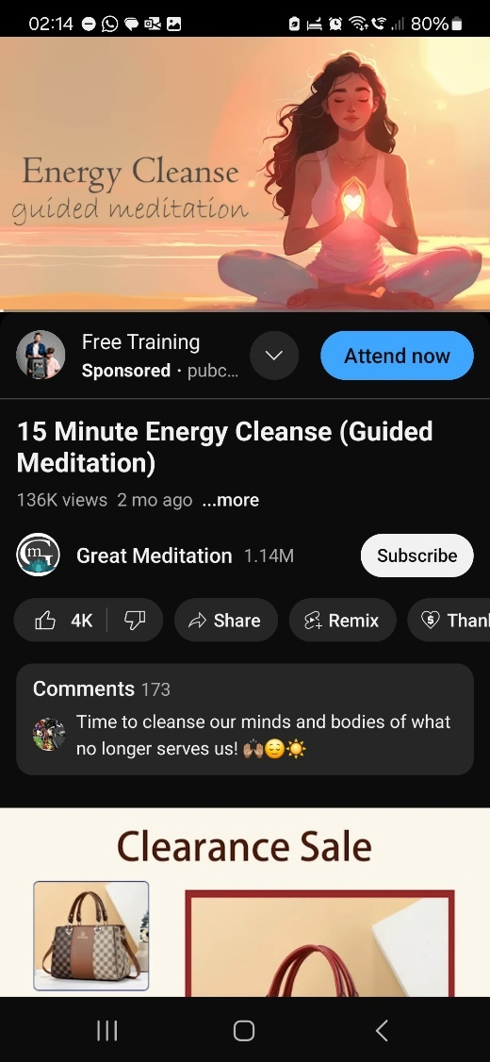

Figure 30 Discover Module - Play Meditation Videos in YouTube

#### User Profile Module – Tan Yi Jia

The User Profile module serves as a centralized hub for users to manage their account information and access various features related to their profile. The profile page displays the user's profile information: username. It fetches the user's data from the Firestore database and displays it prominently on the page. Besides that, users can edit their profile information by clicking the "Edit Profile" button. It will navigate the user to a dedicated page where they can modify their profile details, such as their username, or other personal information (Figure 32).

Next, users can enable or disable daily reminders for receiving the mood creation notification. User can also view the mood history through this module which allowing users to view and track their mood history or emotional well-being over time (Figure 33).

Next, this module includes sections for displaying legal information related to the application, such as the Privacy Policy and Terms and Conditions (Figure 34). Users can access these pages by tapping on the respective buttons or links. Finally, the module included a "Sign Out" button that allows users to securely sign out of the application, ending their current session with proceed back to the Sign In module.

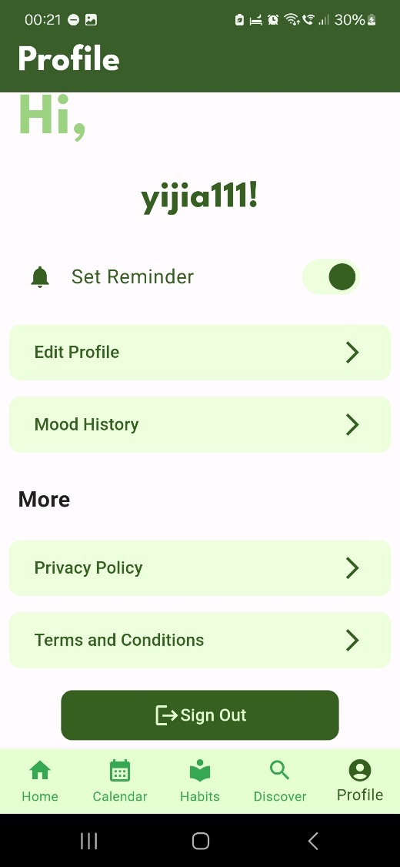

Figure 31 User Profile Module

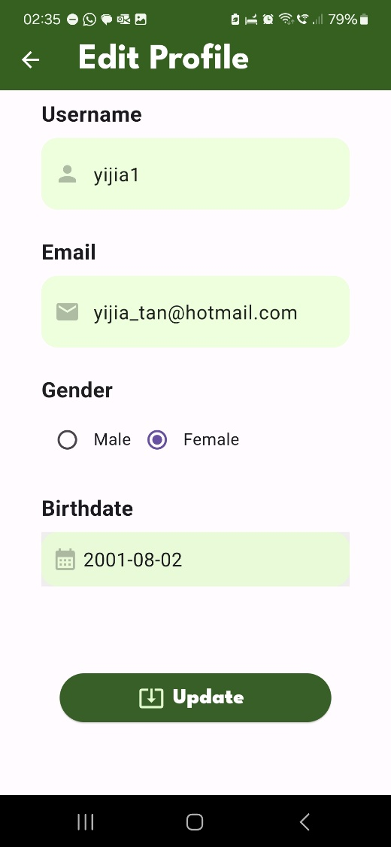

Figure 32 Update User Profile Information

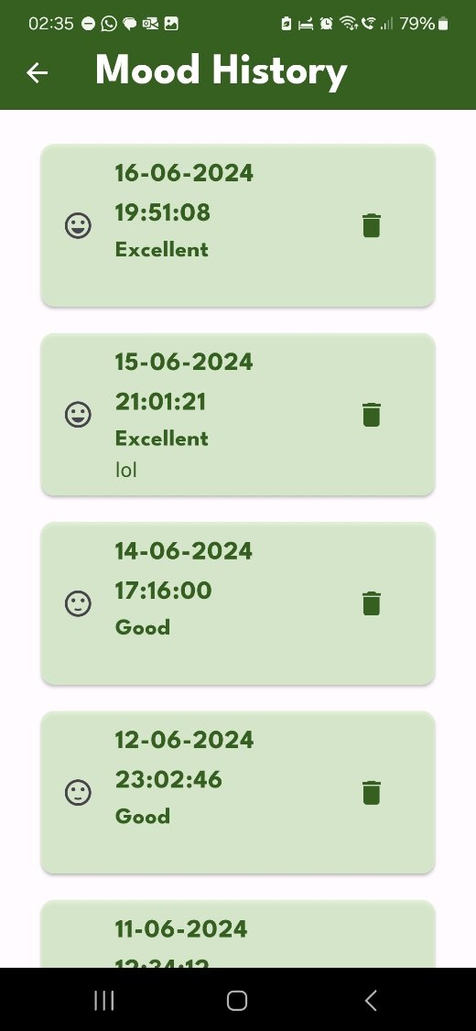

Figure 33 Mood History

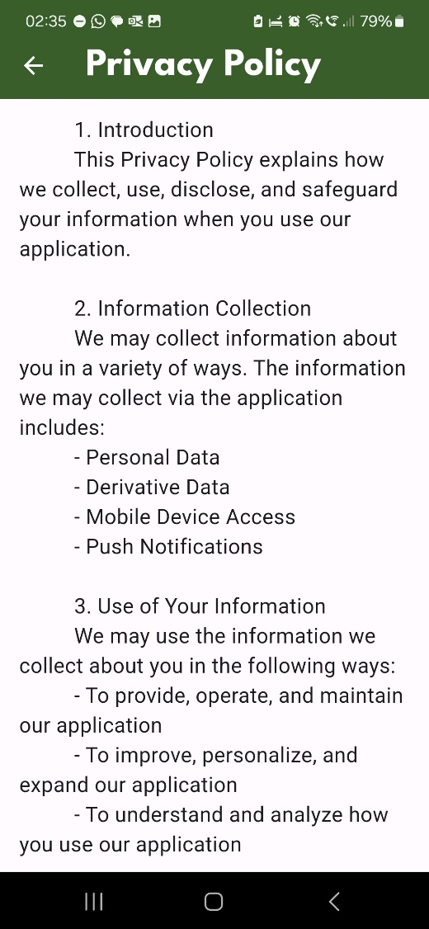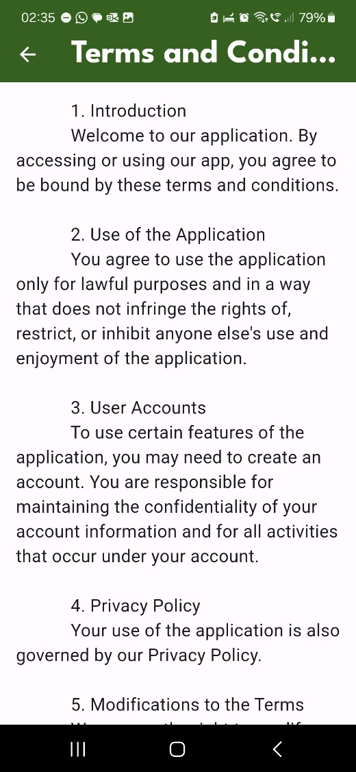

Figure 34 Privacy Policy, Terms & Conditions

## Strengths of the App

Firstly, the application offers a comprehensive suite of features that support both mood and habit management, allowing users to track and improve their emotional well-being and productivity simultaneously. These features include essential functionalities such as adding, editing, and deleting moods and habits, as well as viewing histories for both. Users can precisely track their progress and make the necessary routine modifications through this kind of detail. Additionally, the app incorporates motivational elements like daily quotes and meditation guides, which provide users with ongoing support and encouragement. The ability to manage personal profiles and view important policies directly within the app adds to its convenience and user-friendliness.

## Limitations of the App

Although the "Habitual Heart" application has many advantages, but also has several drawbacks. The lack of interaction with other wellness and productivity apps is a major disadvantage. This restriction may make the app less helpful ultimately for users who depend on this to handle different parts of daily lives across multiple apps. Furthermore, the app currently lacks strong analytics capabilities, which are essential for customers who want to do extensive statistical research on their data. Users may find it more difficult to understand their behaviour patterns and make wise selections if this is missing.

## Future Enhancements

Future improvements have been proposed to overcome those highlighted weaknesses and further improve the application. One key improvement is the introduction of detailed analytics. Providing users with advanced analytical tools is important for the app. This can offer deeper insights into the user's mood and habit data, which helps the user make more informed decisions. Besides that, expanding integrations with popular health and productivity apps is another crucial enhancement. This feature would allow users to seamlessly connect "Habitual Heart" with other tools they are currently using to create a more cohesive and comprehensive approach to personal well-being and productivity. Additionally, incorporating community features such as social sharing and progress tracking can foster a sense of community and provide users with additional motivation. Finally, adding gamification elements, such as rewards and challenges, can boost user engagement and make the process of habit and mood tracking more enjoyable. These enhancements aim to create a more robust, user-friendly, and engaging application that better meets the needs of its users.

## Reflections from the Group Members

### Tan Yi Jia

Throughout the development of the "Habitual Heart" application, I have gained invaluable experience and skills, particularly in areas where I previously had limited knowledge. One of the most significant learning experiences has been working with Flutter for the first time. Flutter is different from other UI frameworks I have used in the past. Flutter offers a unique approach to UI design by using a widget-based architecture, which allows for the creation of highly customizable and responsive interfaces. This was a departure from the traditional, component-based frameworks. The widget-centric design paradigm in Flutter promotes a more modular and reusable approach to UI components, which can enhance both development efficiency and code maintainability. Additionally, Flutter’s “hot reload” feature significantly sped up the development process by allowing real-time updates without needing to restart the application, thus making the iterative design and testing cycle much more efficient.

Another area where I have seen considerable growth is in my understanding and utilization of Firebase. Before embarking on this project, my experience with backend services was mostly centered around traditional server setups and SQL databases. Firebase introduced me to a different way of handling backend operations, emphasizing real-time data synchronization, and seamless user authentication with Firebase's various features. For example, Firestore is used for database management, and Firebase Authentication is used for user management. This has increased my perspective on backend development. This transition from a more conventional backend setup to a cloud-centric, real-time approach has not only enhanced my technical skill set but also provided me with insights into building modern, scalable applications. In conclusion, the process of developing the "Habitual Heart" application has been hard but enjoyable. This has improved my knowledge of Firebase and Flutter and made me realize how important flexibility and ongoing education are to software developers.

### Teh Ger Min

Working on the Habitual Heart project has been a transformative experience, enriching my development skills and broadening my technical horizons. This was my first time using the Flutter framework and Dart language, and I quickly realized the power and versatility they offer for front-end development. Flutter's ability to create beautiful, responsive interfaces with ease made the development process enjoyable and efficient.

I thoroughly enjoyed the development journey in this project. Creating a mobile app from scratch was both challenging and fun. I found immense satisfaction in seeing the app come to life, from designing the UI to implementing the functionality. The hands-on experience has been invaluable and has deepened my passion for mobile app development.

Through this project, I also learned about the Model-View-ViewModel (MVVM) architecture, which helped me understand the importance of a manageable and structured design. Implementing MVVM ensured that our codebase remained tidy and clear, making it easier to maintain and scale the app in the future.

Another significant learning experience was using Firebase, an online NoSQL database. This was my first exposure to a NoSQL database, and I was pleasantly surprised by its flexibility and ease of use. Firebase's support for real-time data synchronization and its scalable nature made it an excellent choice for our project, allowing us to store and manage data effortlessly.

Collaborating with my groupmate Yi Jia was a highlight of this project. We had a productive and enjoyable partnership, sharing ideas and solving problems together. This collaboration not only made the development process smoother but also enriched the overall experience, demonstrating the value of teamwork in software development.

I am also deeply thankful to our lecturer, Miss Karen. Her guidance and practical classes were instrumental in our success. She provided us with the knowledge and support needed to tackle the challenges we faced, and her encouragement kept us motivated throughout the project.

In conclusion, the Habitual Heart project has been a rewarding journey of learning and growth. It has equipped me with new skills, introduced me to powerful tools and frameworks, and highlighted the importance of collaboration and structured design. I look forward to applying these lessons in future projects and continuing to explore the exciting world of mobile app development.

## Appendix

### Appendix A – GitHub

GitHub link: <https://github.com/yjia28tan/HabitualHeart>

### Appendix B – Turnitin

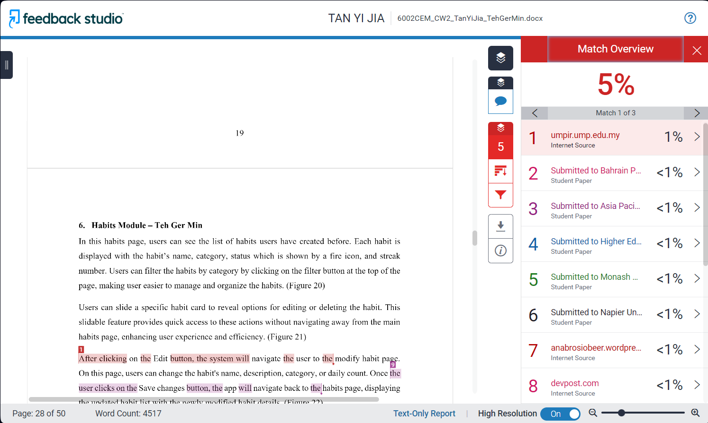

## References

José Antonio Ruiz-Hernández, Á. G. D. P. E. P.-L., 2022. Mental Health and Healthy Habits in University Students: A Comparative Associative Study. *European Journal of Investigation in Health, Psychology and Education,* 27 January, 12(2), pp. 114-126.

Waris Qidwai, I. A. K. U. S. S. A. H. H. K. N., 2016. FAST PACE OF LIFE AND ITS IMPACT ON HEALTH: RESULTS OF A STUDY FROM THE LARGEST CITY OF PAKISTAN. *Pakistan Journal of Public Health,* 1 December, 6(4), pp. 10-16.

### Code References

**Tan Yi Jia**

<https://github.com/lukePeavey/quotable>

<https://github.com/AkhmadRamadani/mood-journal>

<https://github.com/ruchidhar/flutter-hackathon-2023/tree/main?tab=readme-ov-file>

<https://www.bacancytechnology.com/qanda/flutter/login-logout-flutter-best-navigation>

<https://stackoverflow.com/questions/45079459/how-to-signout-a-user-in-flutter-with-firebase-authentication>

<https://firebase.flutter.dev/docs/firestore/usage/>

<https://swaroop-sambhayya.medium.com/how-to-access-and-get-the-youtube-data-through-api-in-flutter-ec61160b673f>

<https://www.youtube.com/watch?v=U7z5IeWuaLI>

<https://pub.dev/packages/assets_audio_player>

<https://www.fluttercampus.com/guide/101/how-to-get-current-formatted-date-and-time-on-flutter/>

**Teh Ger Min**

<https://github.com/ruchidhar/flutter-hackathon-2023/tree/main?tab=readme-ov-file>

<https://firebase.flutter.dev/docs/firestore/usage/>

<https://www.fluttercampus.com/guide/101/how-to-get-current-formatted-date-and-time-on-flutter/>

<https://api.flutter.dev/flutter/material/Icons-class.html>

<https://pub.dev/packages/table_calendar>

<https://stackoverflow.com/questions/75916474/custom-flutter-calendar>

<https://github.com/letsar/flutter_slidable>

<https://api.flutter.dev/flutter/material/AlertDialog-class.html>