Beatlock documentation

Yijun Jiang

11/04/2015

We use an ECDL (Toptica DL100) to do high-field imaging at ~900 G, which translates to a Zeeman shift of ~1.2 GHz.

The beatlock stabilizes the frequency of the ECDL at ~1 GHz redder than the Vortex laser, which is already locked. The rest of the frequency shift is done by an AOM.

The optical diagram of the beatlock is shown in Fig.1. The

Fig.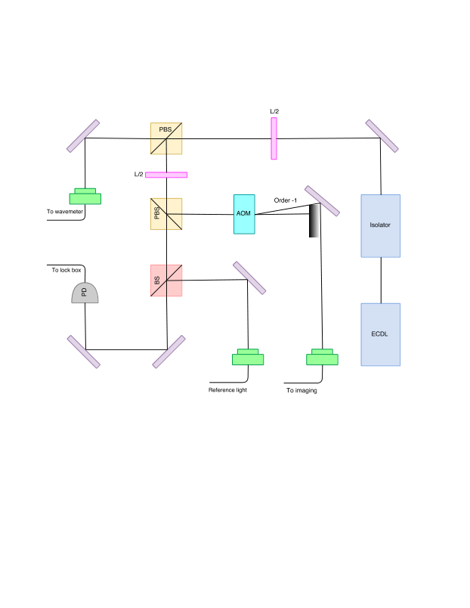1. Optical diagram of the beatlock setup.