缓存静态资源

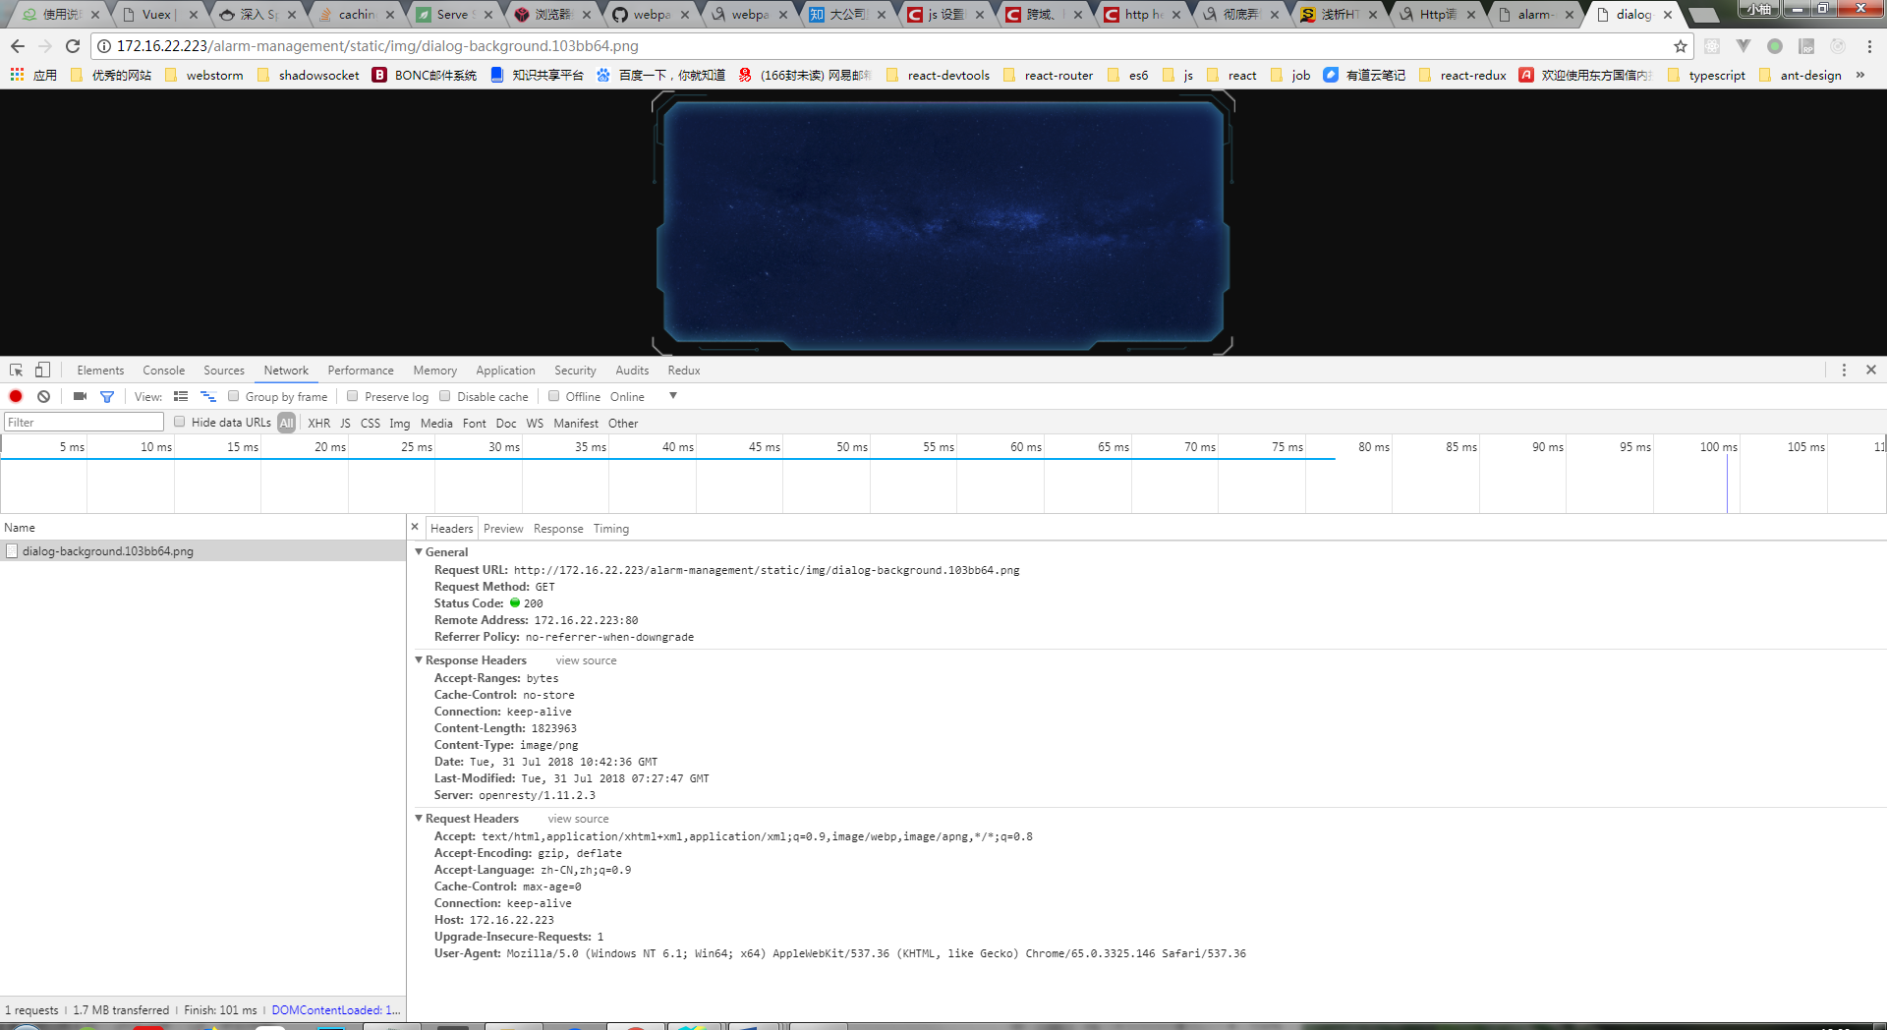

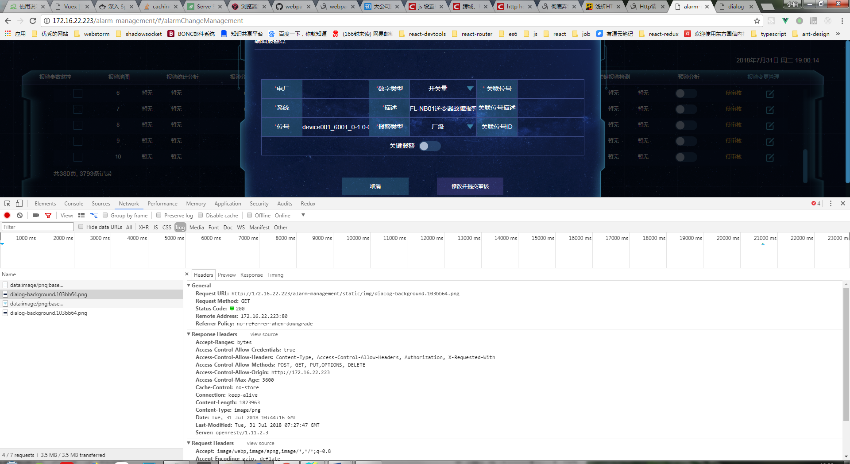

参考<https://www.cnblogs.com/wonyun/p/8146139.html>

<https://github.com/happylindz/blog/issues/7>

<http://tech.lede.com/2017/02/10/fe/cache/>

后端：https://blog.coding.net/blog/spring-static-resource-process