SMART EMPLOYEE ATTENDANCE FOR FLAG CEREMONIES WITH ENTRANCE AND EXIT ANALYTICS AT PLP

Information Assurance and Security I

Year/Section:
BSIT-3B

Group no:

List of Members:
Cogal, Daryl
Hulgado, Emmanuel
Ramirez, John Gabriel
Valdez, John Paul
Vergara, Joshua

- Objectives
- To develop a smart attendance monitoring system specifically for flag ceremonies.
- To automate the recording of employee entrance and exit during ceremonies.
- To provide accurate and real-time analytics of attendance data.
- To reduce manual attendance checking and human error.

- Specific Objectives
- To allow administrators to set the flag ceremony date and time.
- To implement employee registration including:
- Employee ID Number
- Full Name
- Department
- Other relevant employee details
- To configure a late threshold (e.g., 10 minutes after ceremony start time).
- To generate attendance reports and summaries.
- To track both entry and exit timestamps of employees.

- Functionality
- Notification
- Send SMS / Email / In-App notifications for:
- Time in
- Late time in
- Early time out
- Absent employees
- Reminder notification before the ceremony starts.
- Analytics
- Weekly analytics for:
- Total employees present
- Total employee late arrival
- Total employee early out
- Total employee absent

P.s use percentage
- Attendance percentage per department
- Use charts
- Export thru pdf or excel file
3. Role-Based Access
Admin - Full access of the system
HR - analytics of all
Employee - attendance portal (logs, history)
4.) Dashboard Features
Real-time attendance counter.
Late / Present / Absent indicators.
Live entrance and exit logs.
- Unique Feature
- RFID based time in system
- Ceremony-Aware Attendance Logic
- Automated Flag Ceremony Report Generator
- Department Discipline Ranking
- Send SMS / Email / In-App notifications for attendance

- Design (Wireframe/Prototype)

- LOGIN
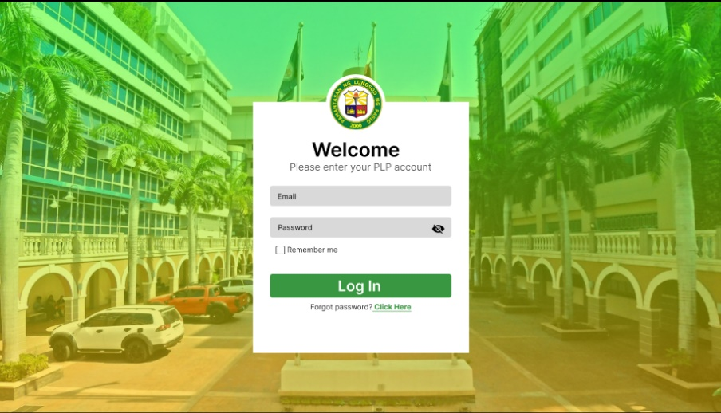

- DASHBOARD
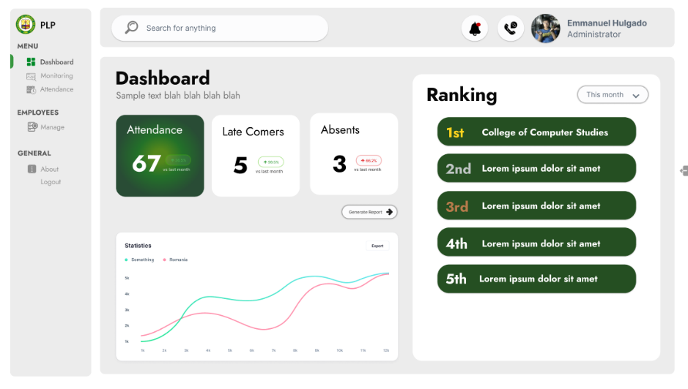

- SCHEDULER
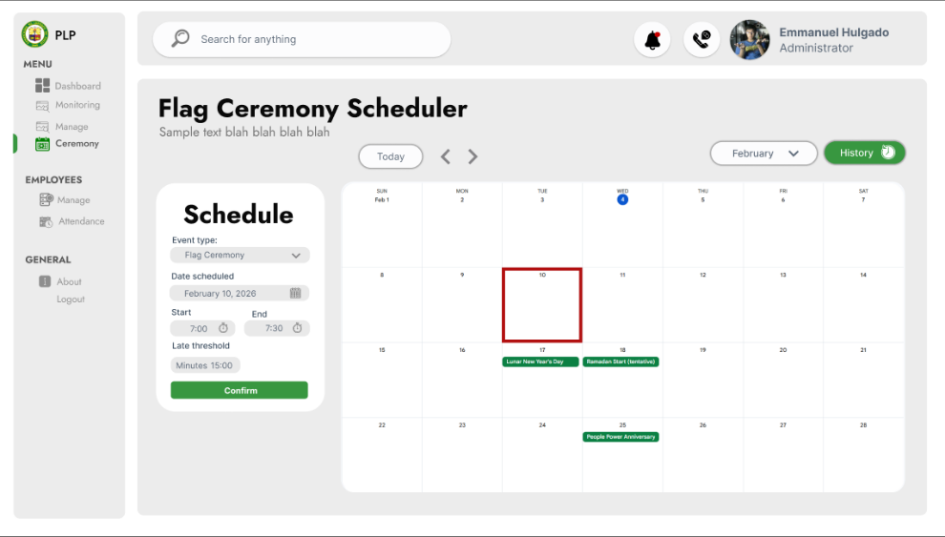

- CEREMONY HISTORY
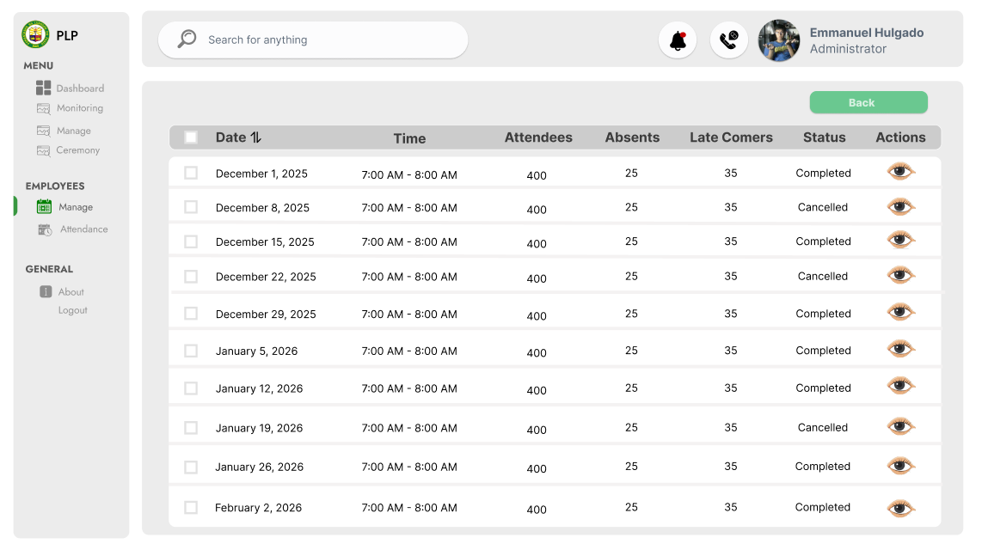

- EMPLOYEE MANAGEMENT
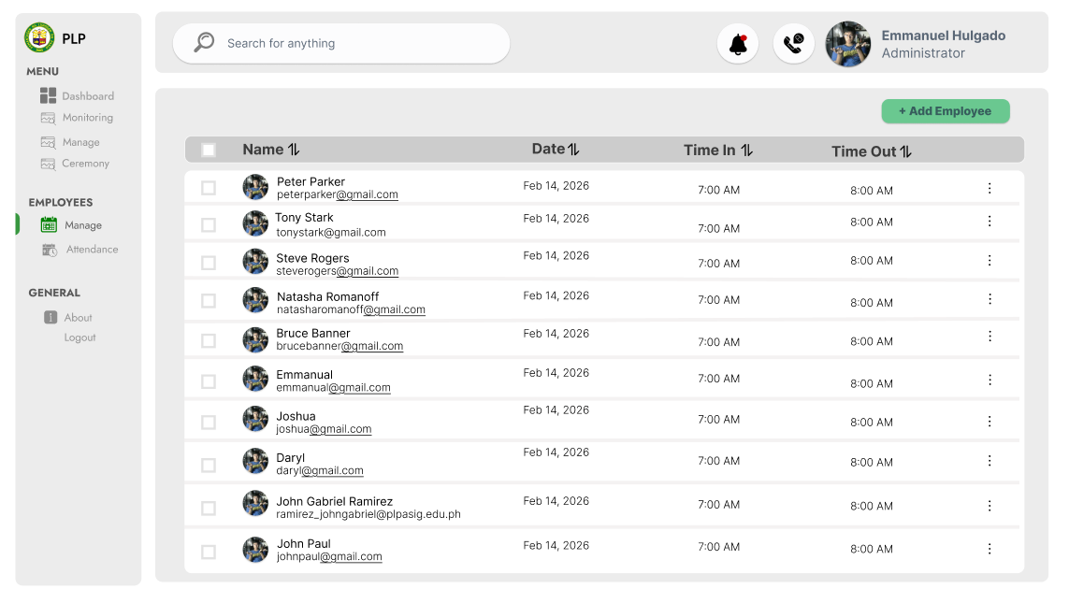

- Implementation Plan (Database and Programming Language)

