1. ER diagram

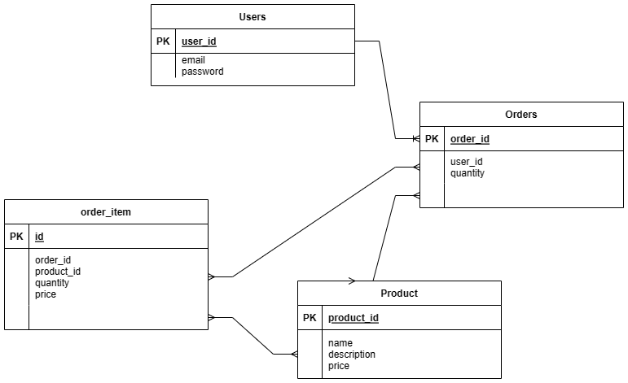

Explanation:

Users – Orders: one to many

Orders – Product: many to many

Orders – Order_Item: many to many

Products – Order_Item: many to many

1. 5 API endpoints

**User login:** /users/sign_in

**User sign up:** /users

**GET request responding with a collection of data:** /products

**GET request for retrieving details of a single element:** products/1

**GET request for retrieving details of another single element:** products/2

Explanation will be in the illustration video.

1. User is created with Devise with API provided

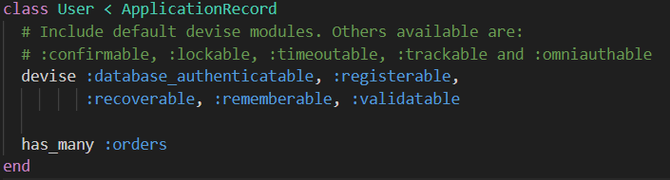

1. Seed data should be provided
2. Test account:

Email: [bbb@bbb.com](mailto:bbb@bbb.com)

Password: 123456

Email: [ccc@ccc.com](mailto:ccc@ccc.com)

Password: 123456

1. Heroku Link: