Name-Yash Jain

Course-B.Tech(H.)-CSE- 2nd Yr- III sem

Roll No-31

Q1. Count the total number of Students

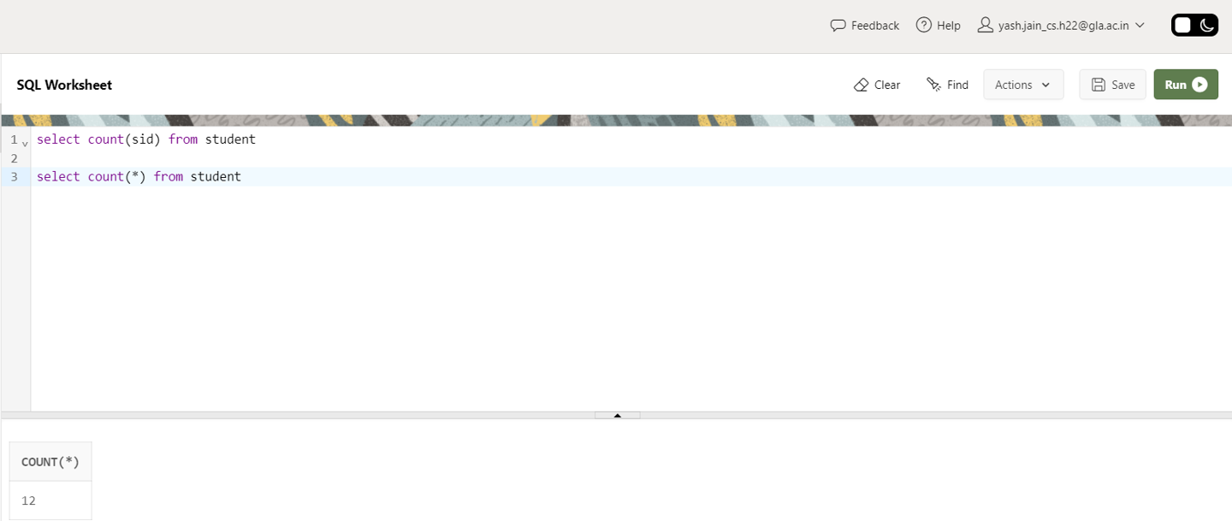

Q2. Calculate the average GPA of all Student.

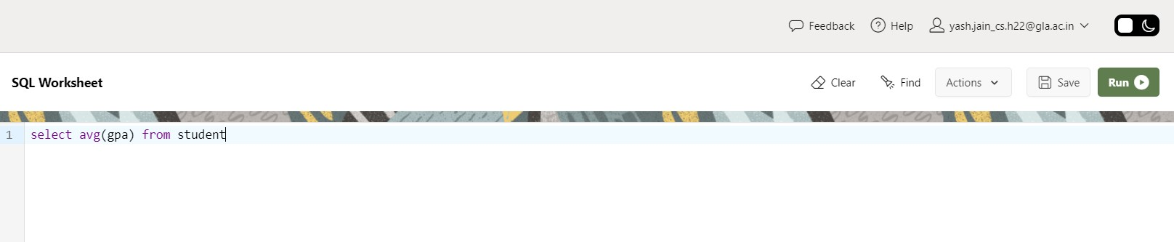

Q3. Determine the minimum and maximum GPA. Rename the titles as ‘max_GPA’ and ‘min_GPA’ respectively.

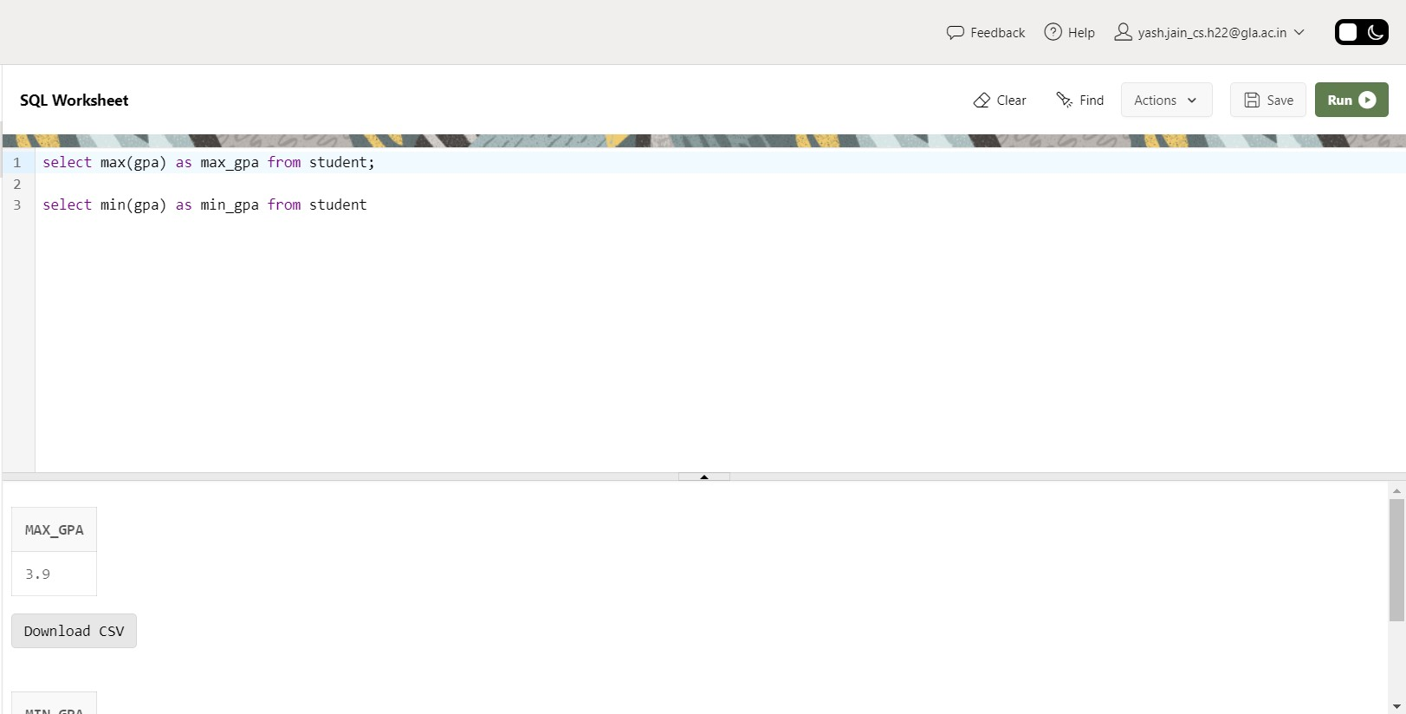

Q4. Count the number of students having GPA greater than or equal to 3.7.

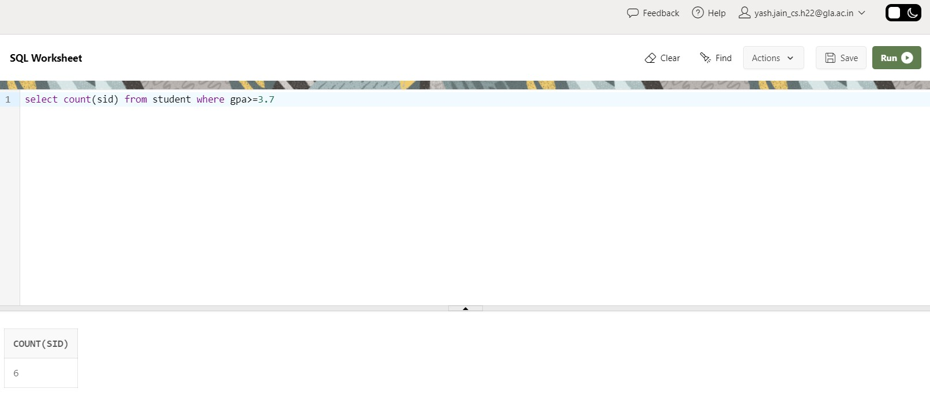

Q5. Find Maximum, Average, Minimum, total GPA of all student.

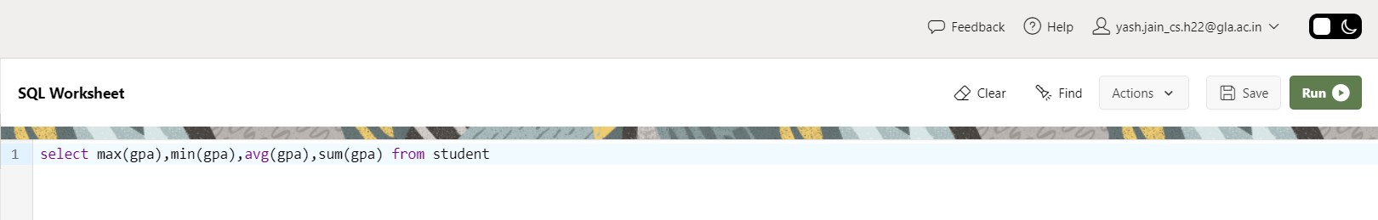

Q6. Find total number of colleges in our Application Database.

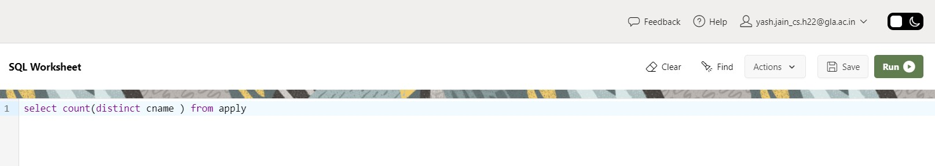

Q7. Find how many different majors student had applied in.

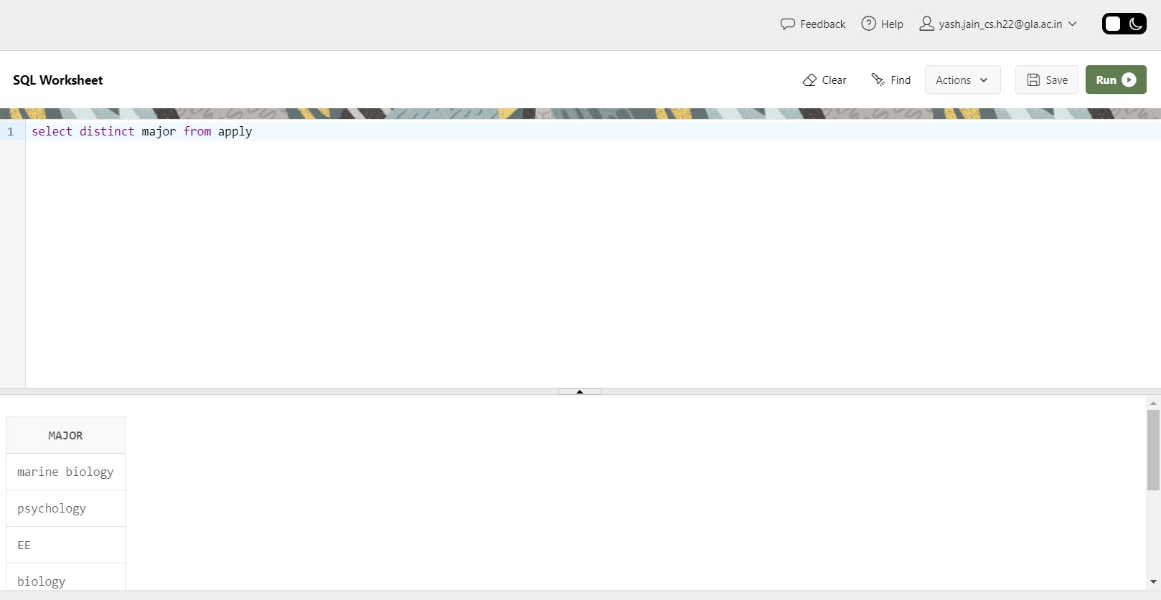

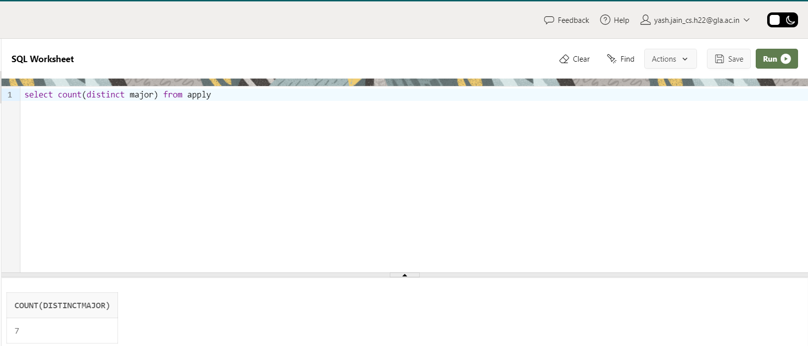

Q8. Find total no. of Applications in our Application System’s Database.

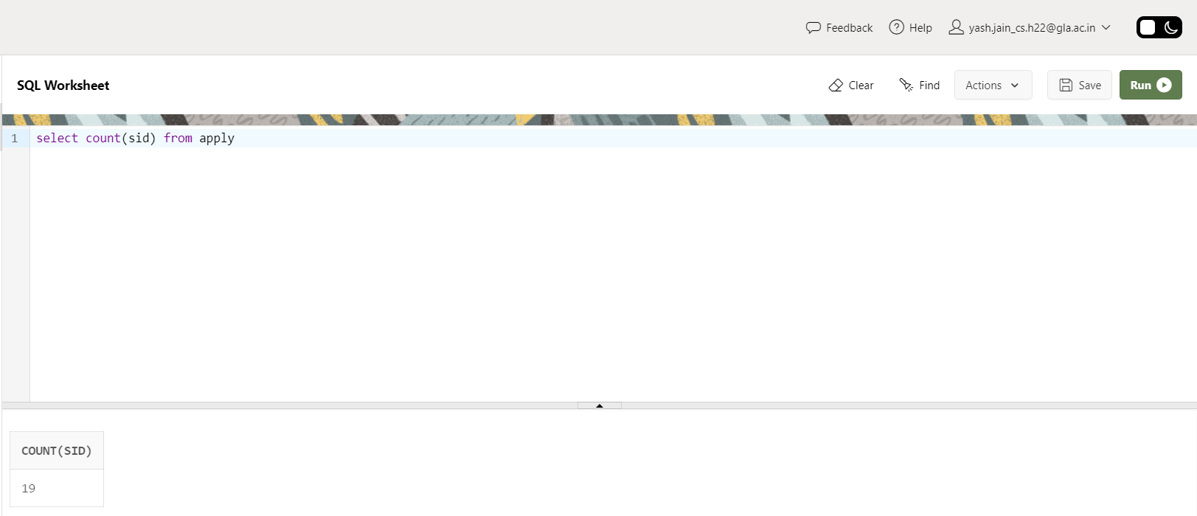

Q9. Find average of all distinct GPA.  
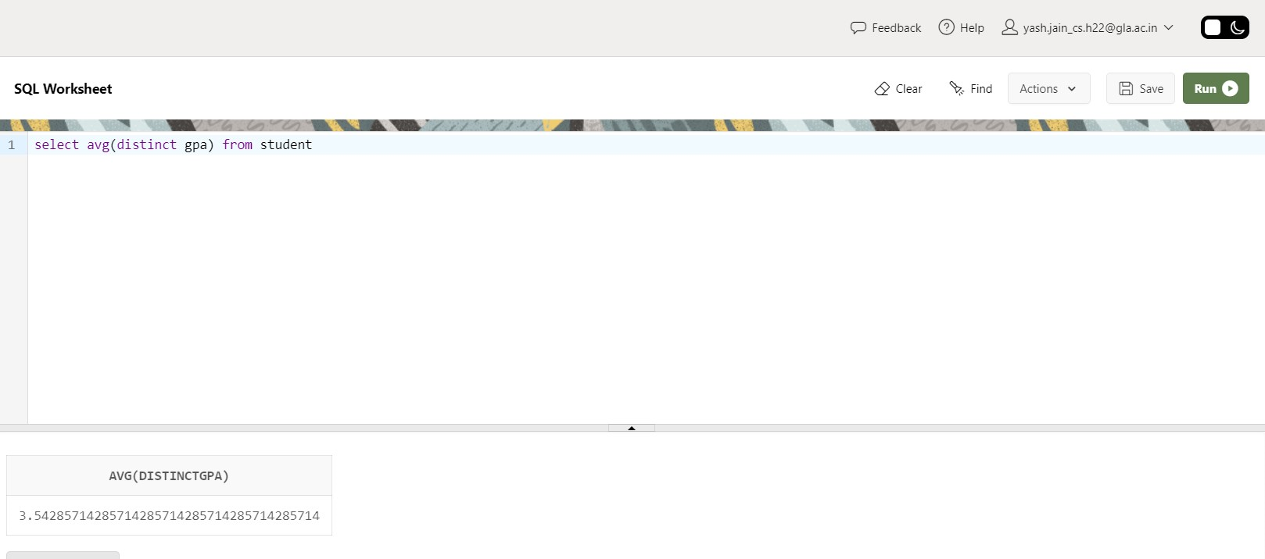

Q10. Display the total number of application accepted.

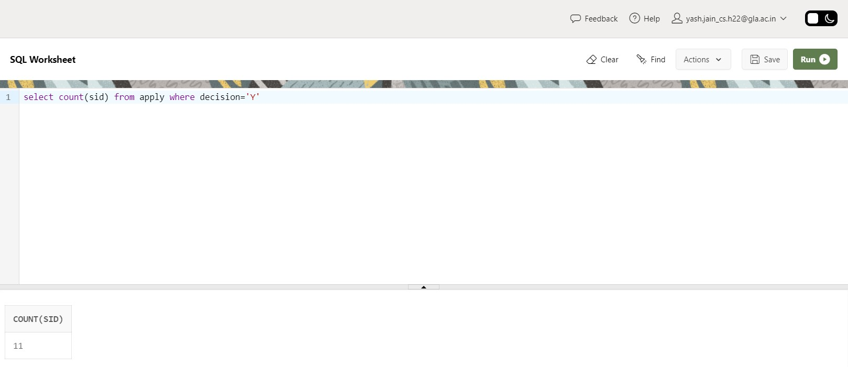

Q11. Find number of students having GPA>3.4 and coming from high school having size>1000.

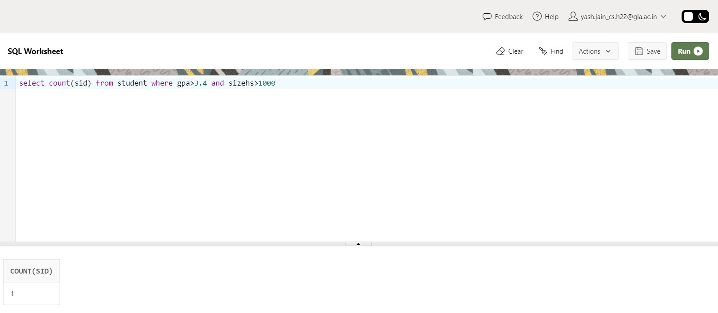

Q12. Find how many student applied to ‘marine biology’

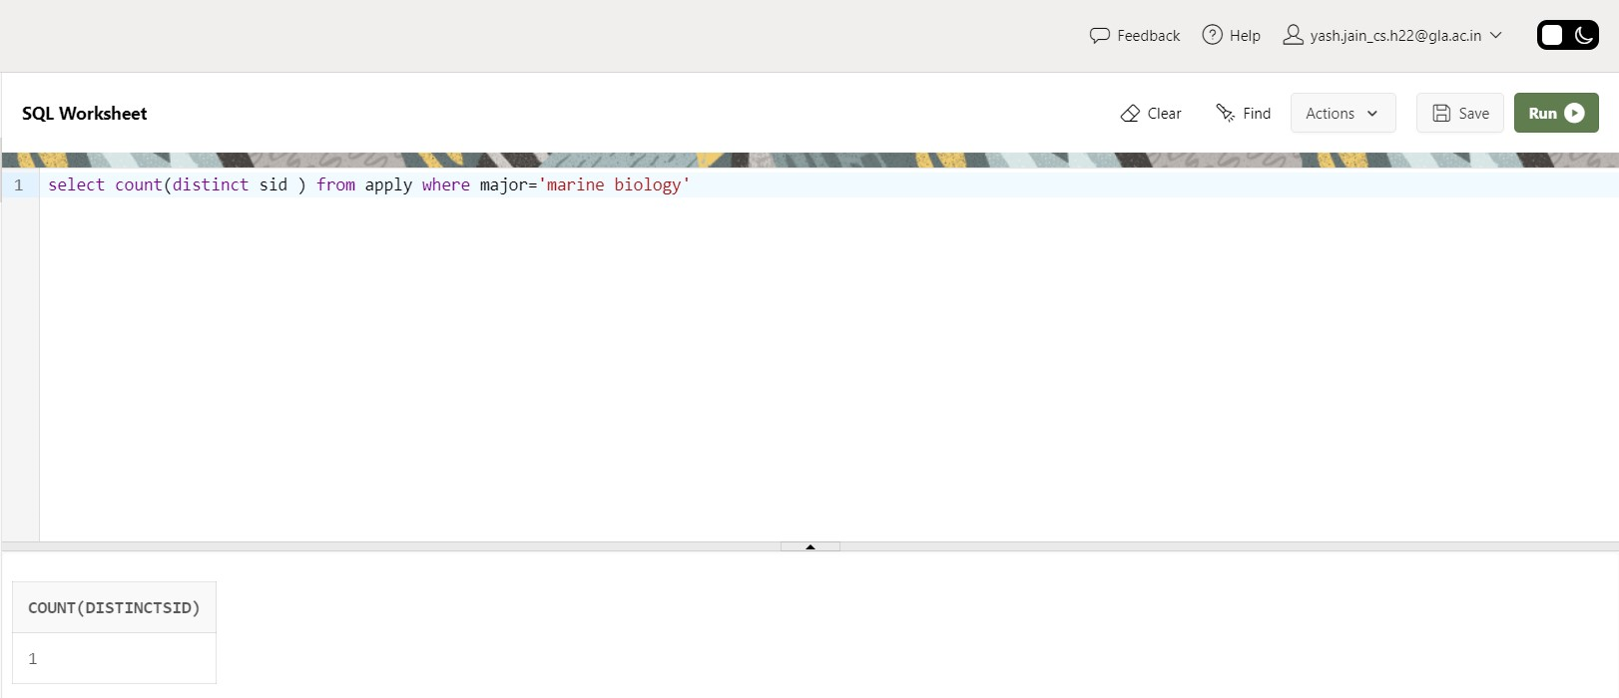

Q13. Find how many applications were rejected and accepted by the colleges.

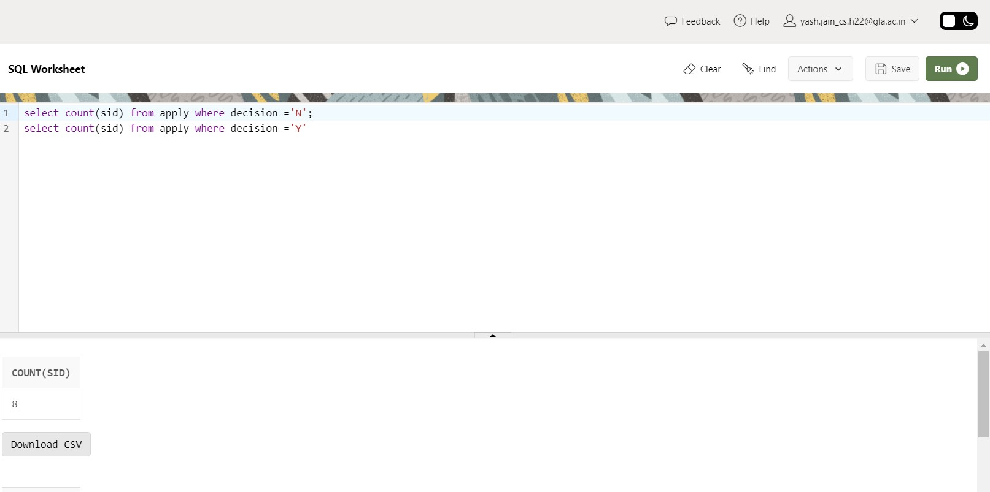

Q14. Find how many students applied to a particular major. (show count(sid) as No_of_applications).

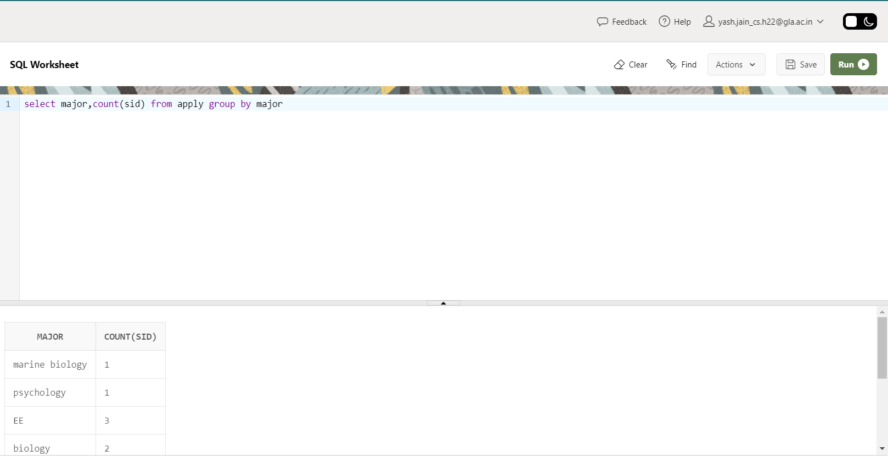

Q15. Find number of applications received by particular college.  
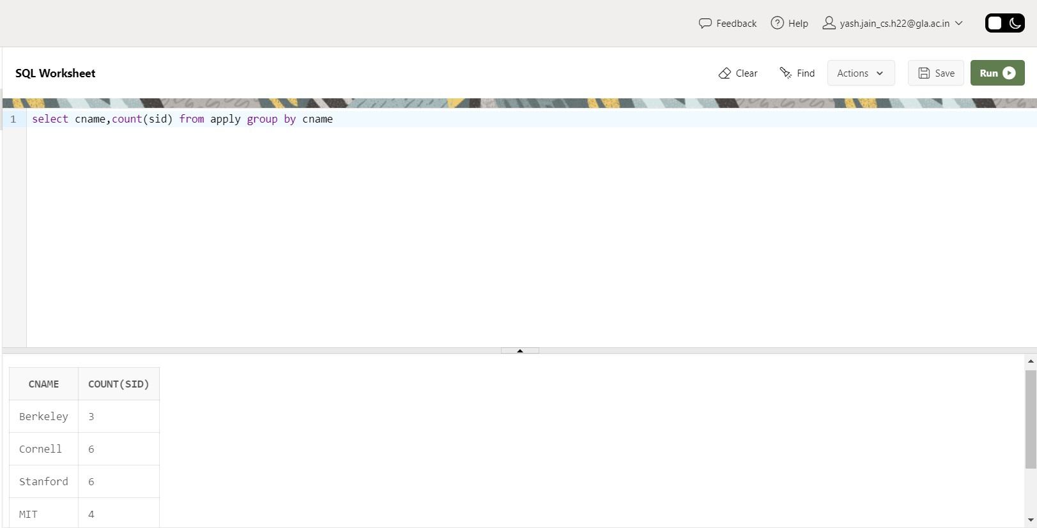

Q16. Find number of applications received in a particular major at a particular college.

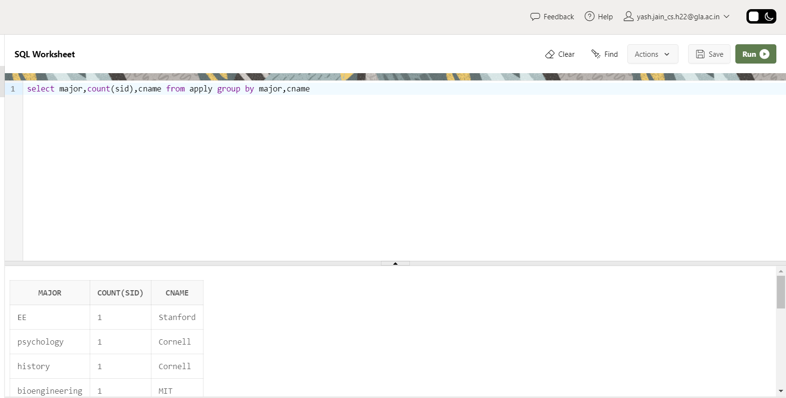

Q17. Give the college name and major, where number of applications received are greater than or equal to 2.

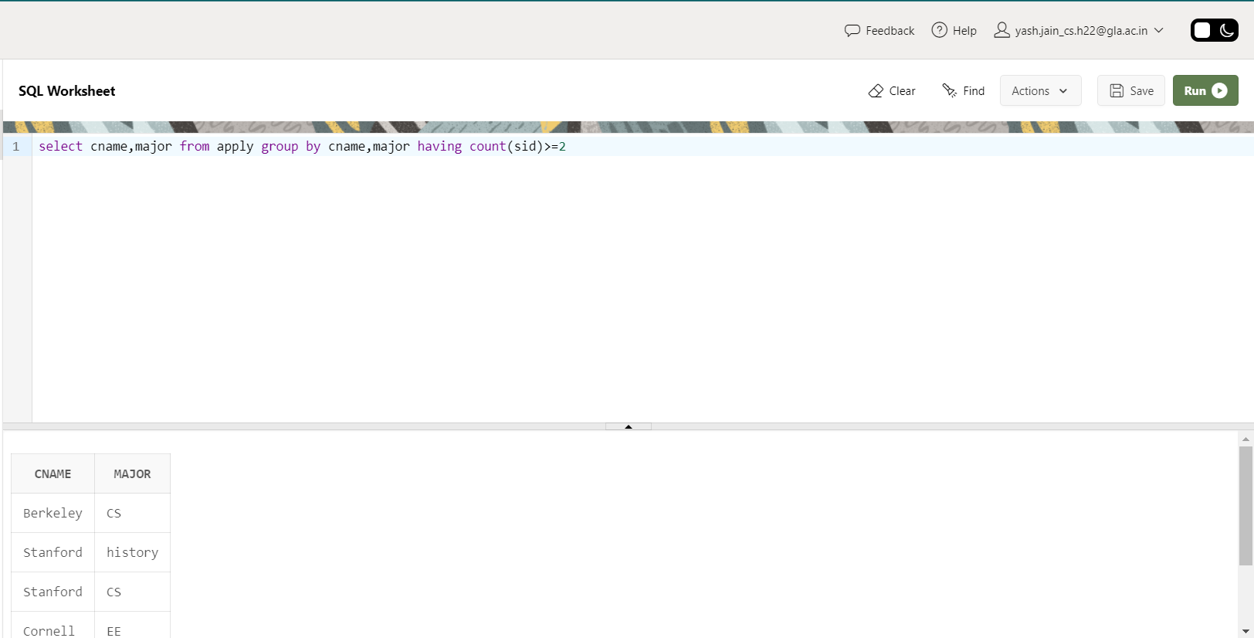

Q18. Give the name and no of applications of all those colleges which receives applications from 3 or more students.

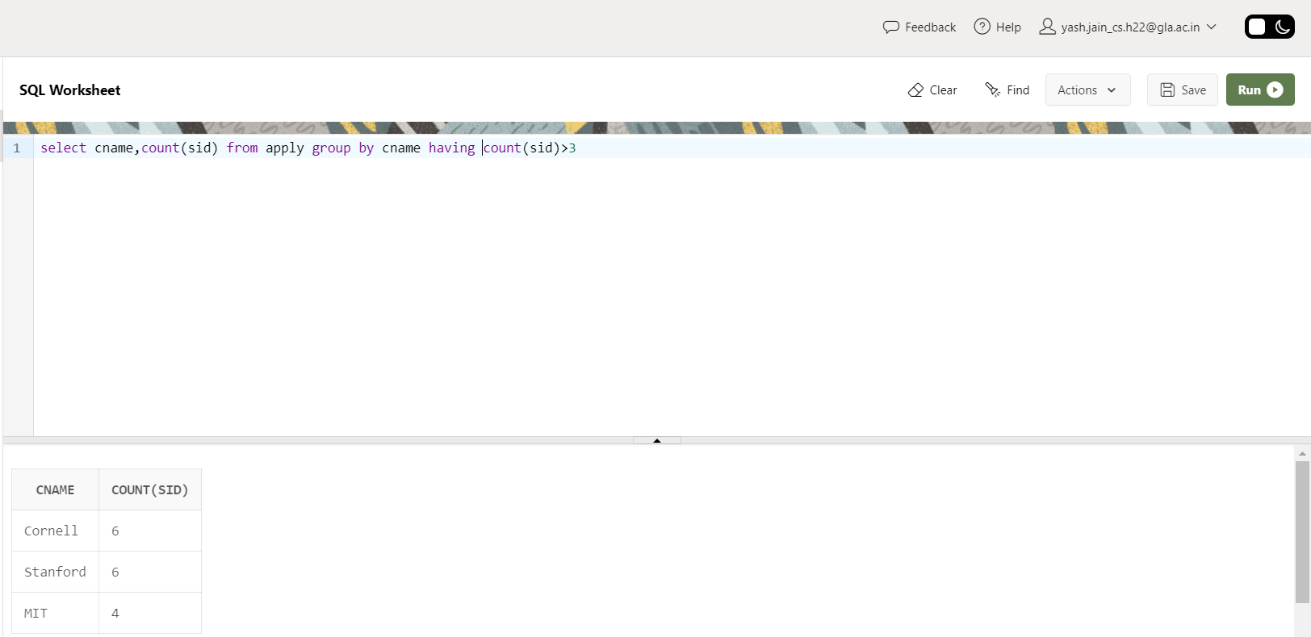

Q19. Give state and number of colleges of a state that has more than 1 college.

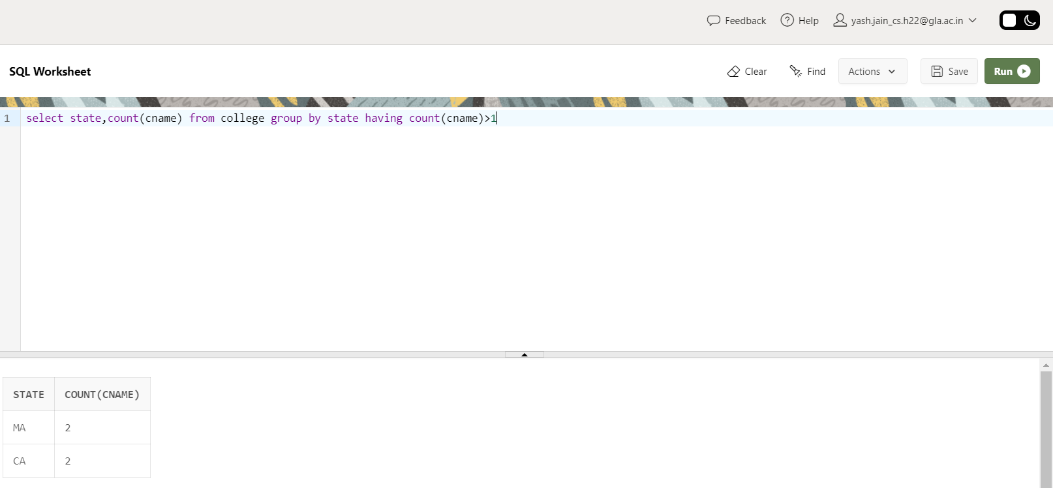

Q20. Find the name of students that are duplicate.

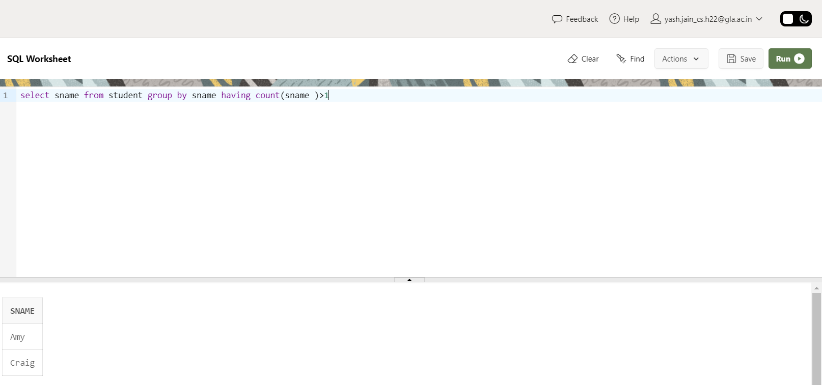

Q21. Find how many applications are filed by each student.

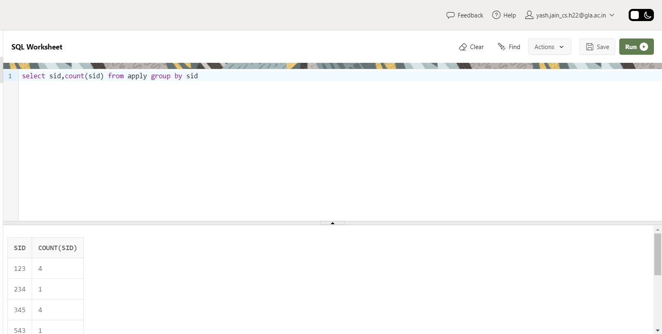

Q22. Provide name of students that file 3 or more applications.

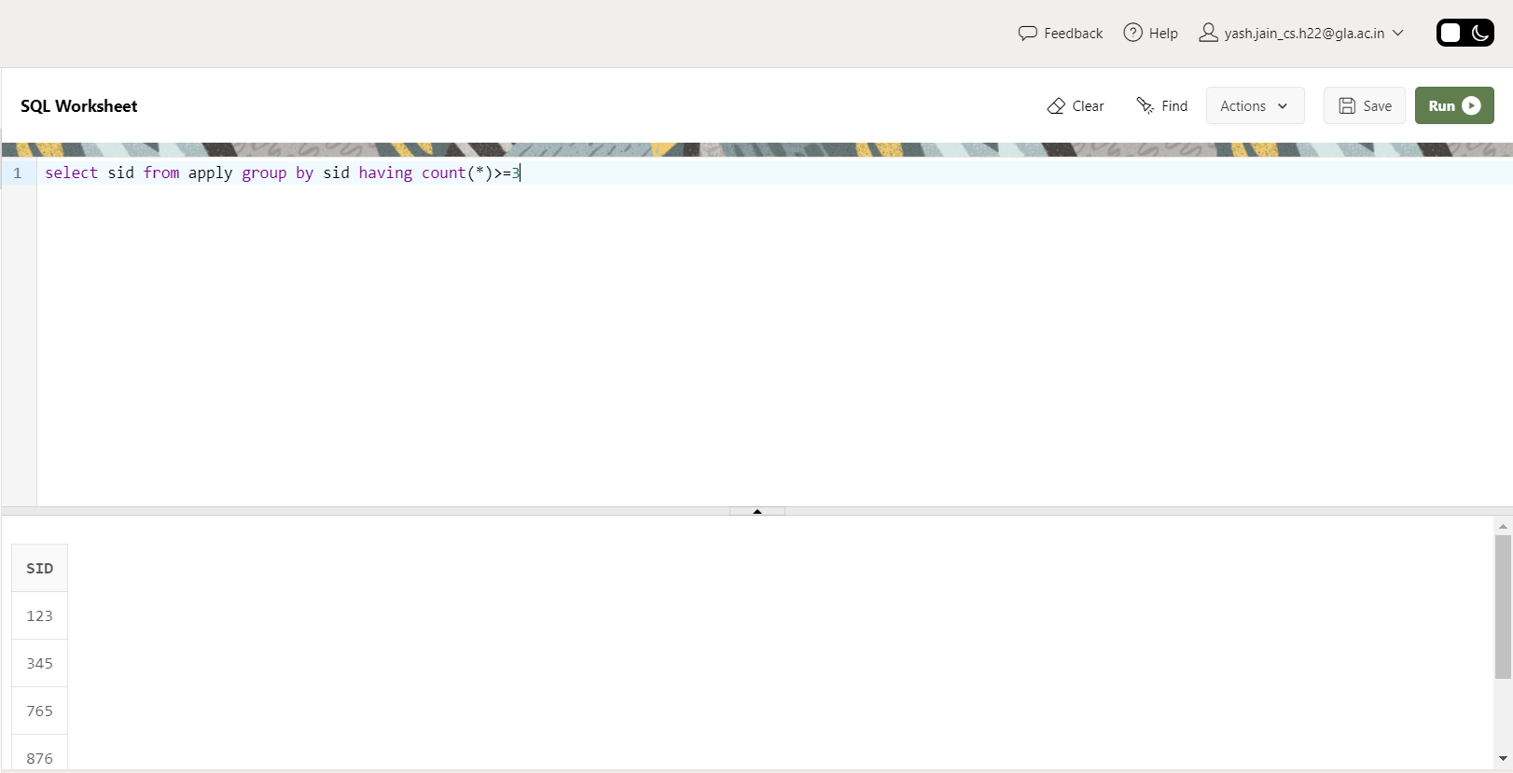

Q23. Provide name of student who have not applied to any college.

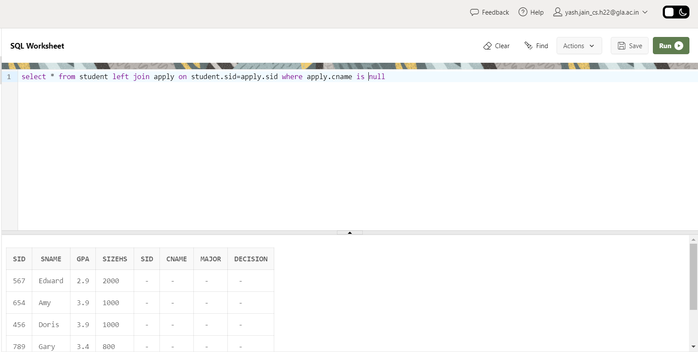

Q24. Find maximum GPA, Average GPA, and minimum GPA among applicants of each college. (i.e. say sID 123, 324 and 987 had applied to Berkley then compute and display max GPA among these three).

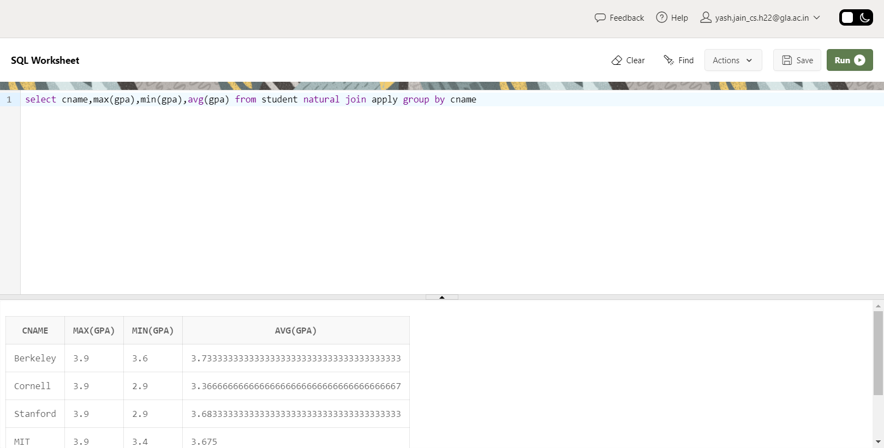

Q25. Find how many student have same GPA among all students. (provide this frequency in two column table as GPA 3.9 is 4 times, GPA 2.9 is 2 times )

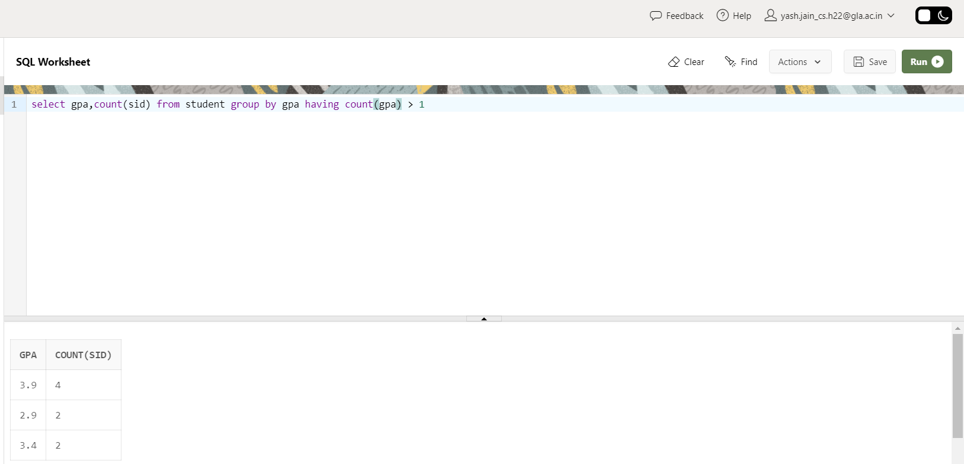

Q26. Find how many application of each major are rejected and accepted.