Name-Yash Jain

Course-B.Tech(H.)-CSE-2nd Yr

Roll No-31

1. IDs and names of students who have applied to major in CS at some college.

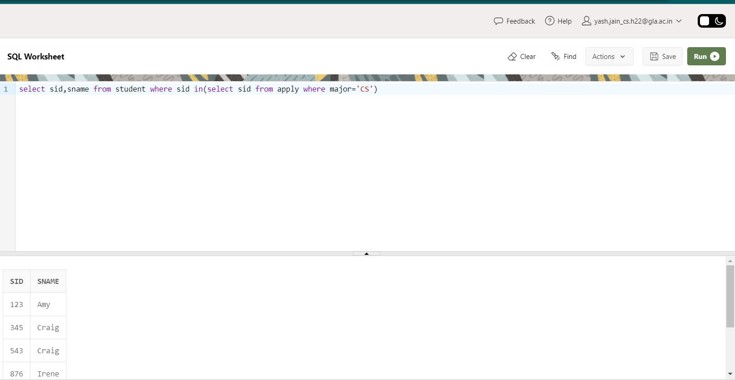

1. Find ID and name of student having same high school size as Jay.

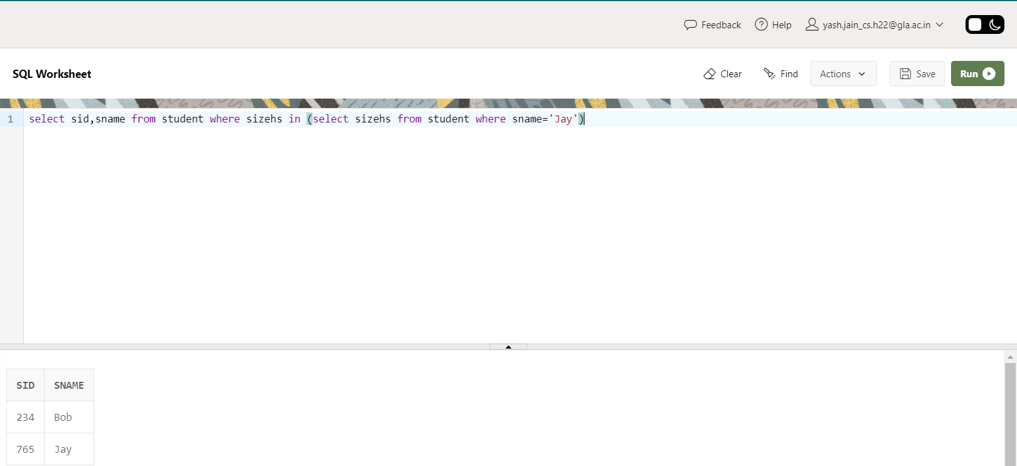

1. Find ID and name of student having same high school size as Jay but result should not include Jay.

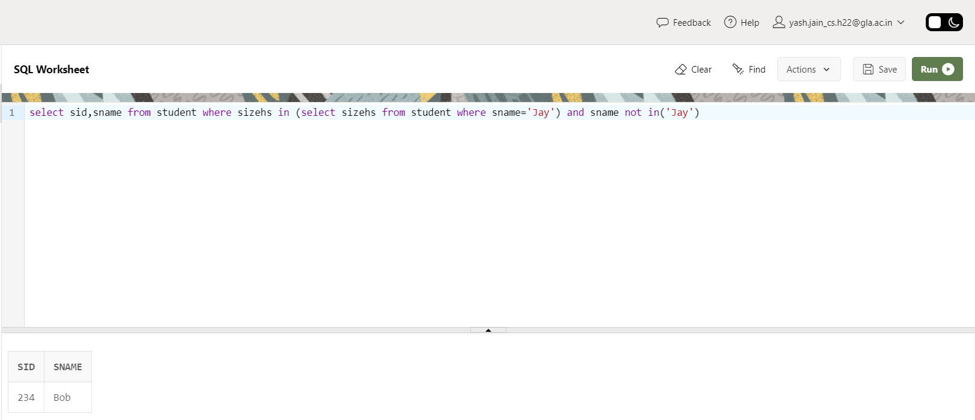

1. Find the name of student with their GPA and Sid whose GPA not equal to GPA of Irene?

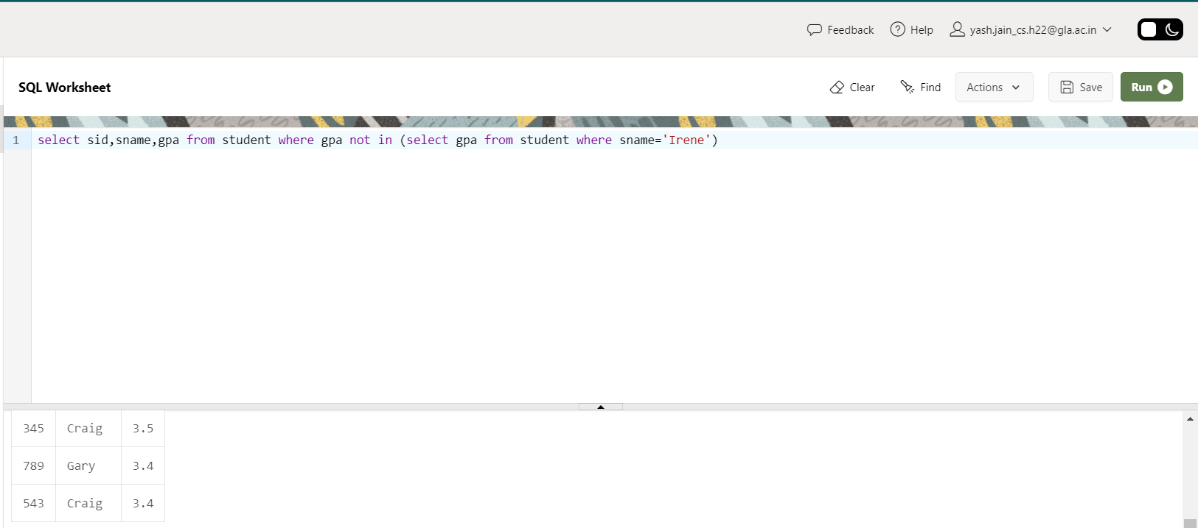

1. Find college where any student having their name started from J have applied?

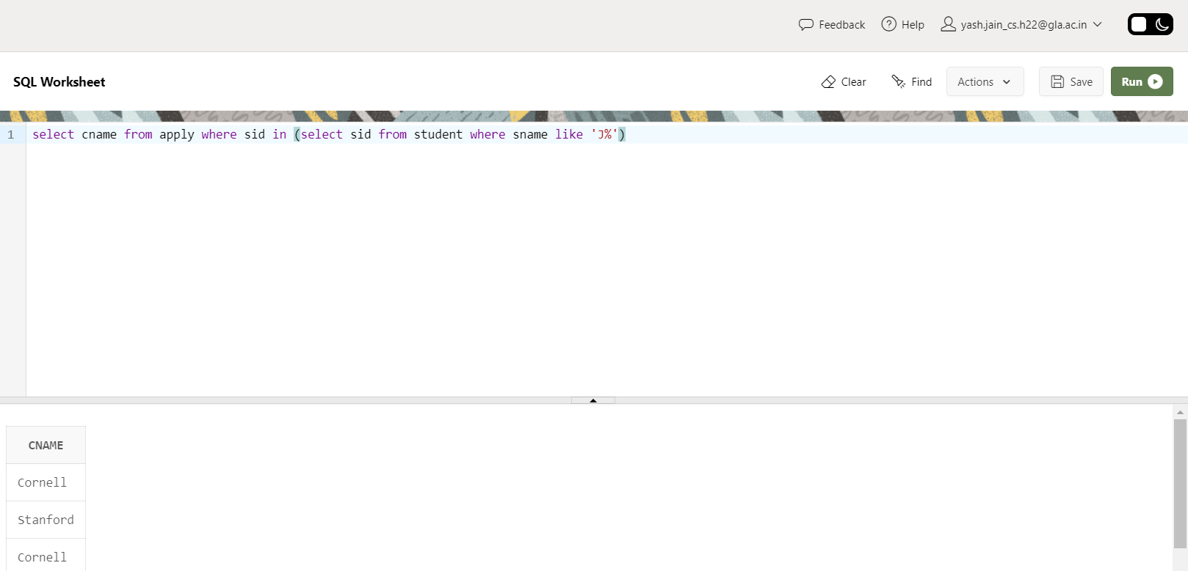

1. Find all different major where Irene has applied?

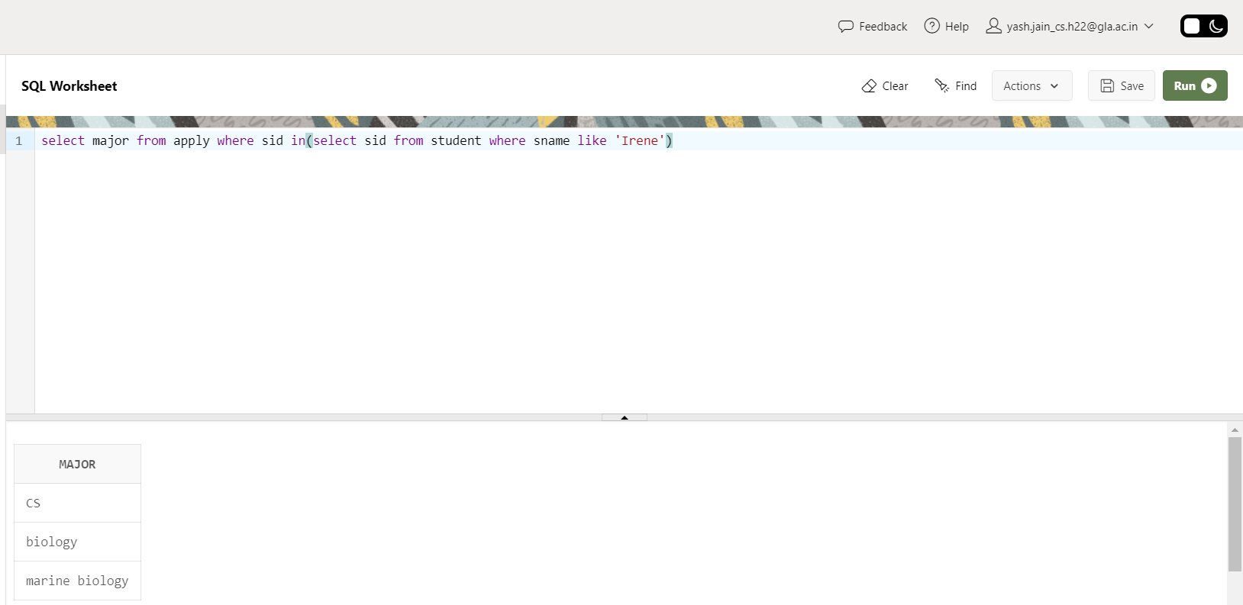

1. Find IDs of student and major who applied in any of major Irene had applied to?

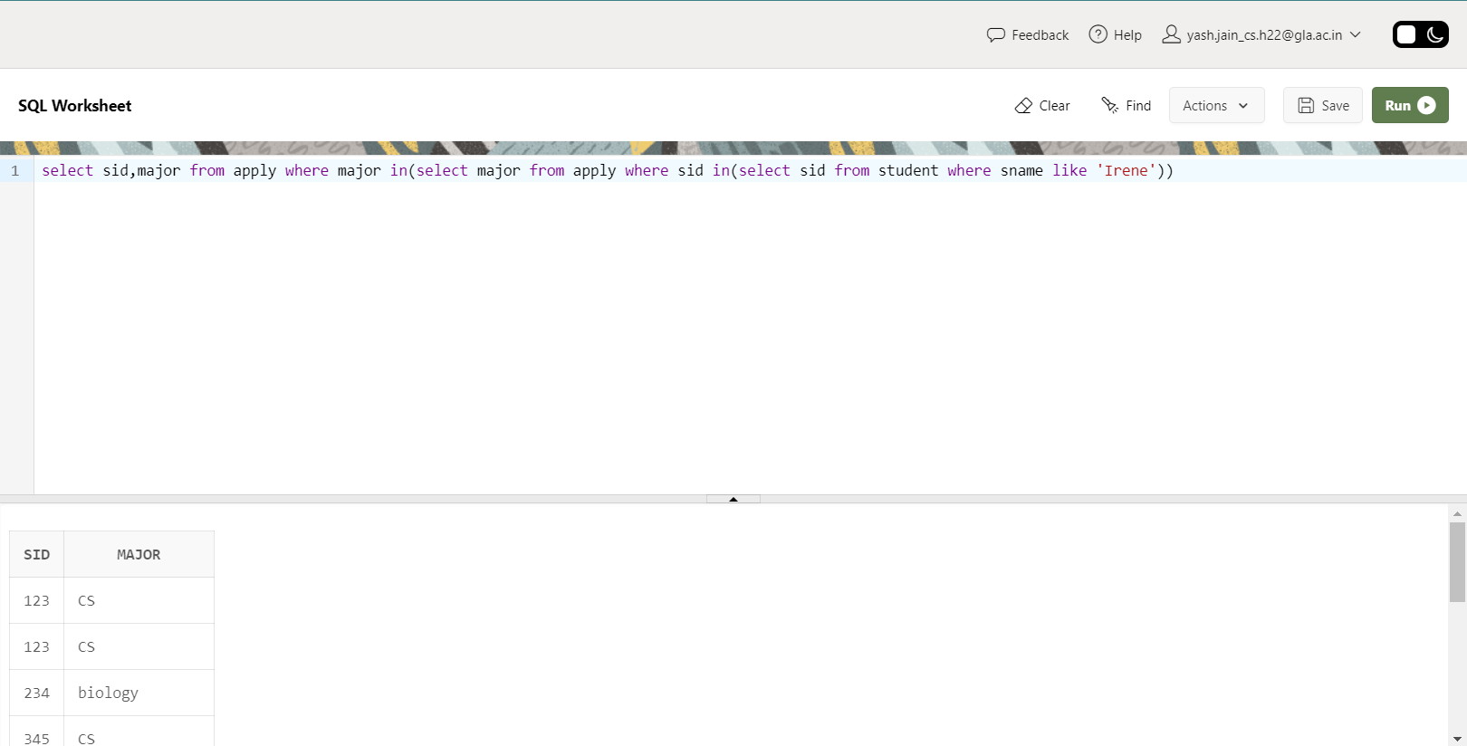

1. Find IDs of student and major who applied in any of major Irene had applied to? But this time exclude Irene sID from the list.

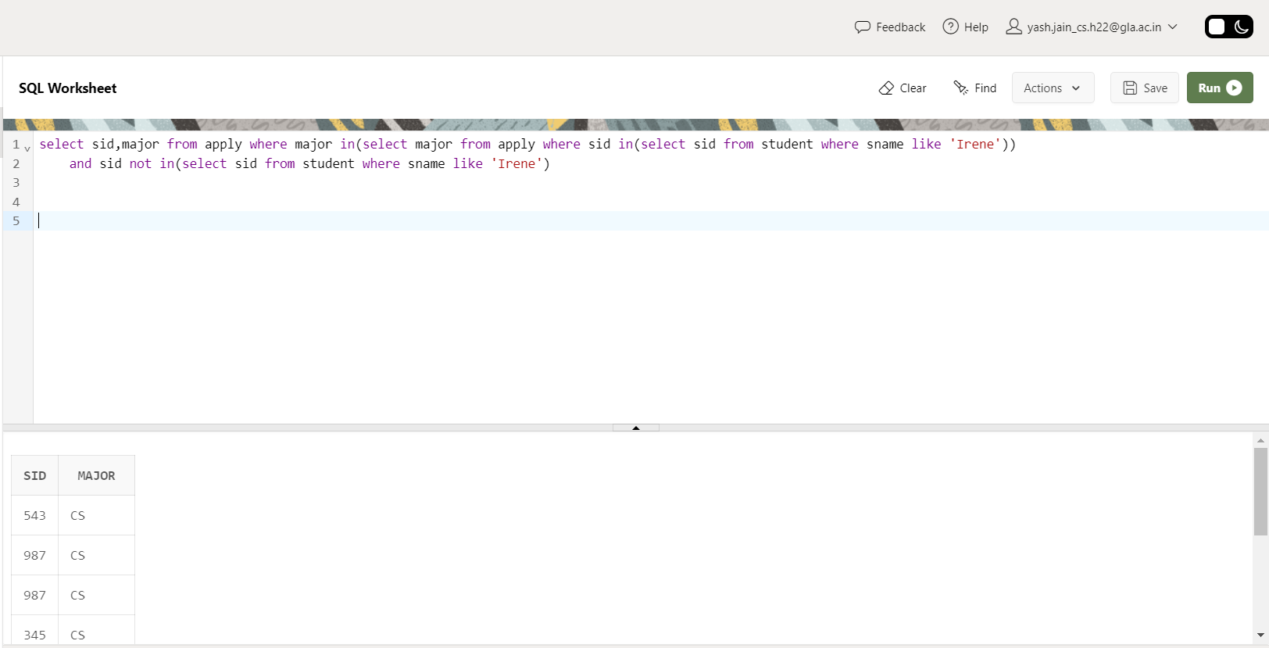

1. Give the number of colleges Jay applied to? (Remember count each college once no matter if he applied to same college twice with different major)

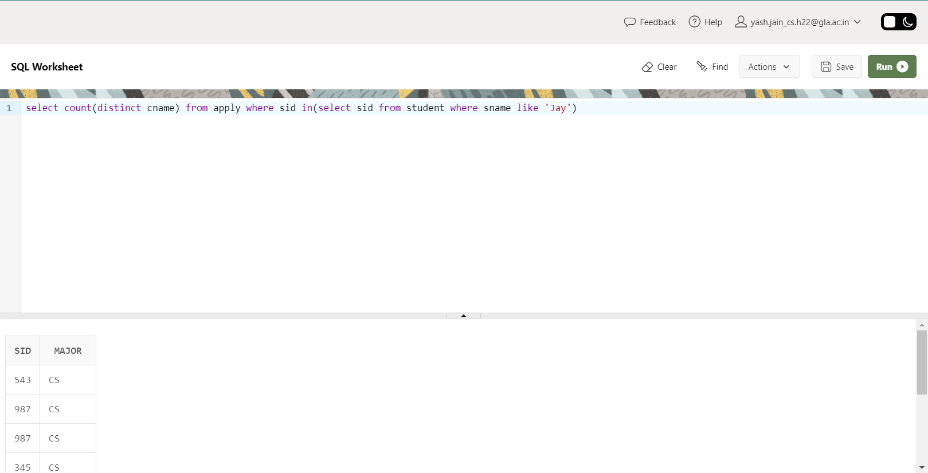

1. Find sID of student who applied to more or same number of college where Jay has applied?