Name: Yash Jain

Course : B.Tech(H.)-CS-2nd YR

Roll no – 31

University Roll No - 2215800033

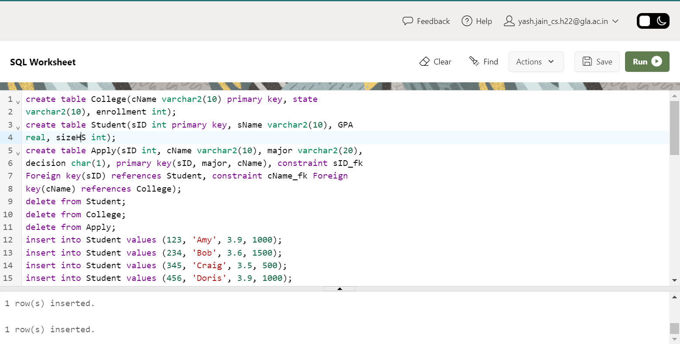

1. Create a new column DoB in Student table. (Datatype will be date).

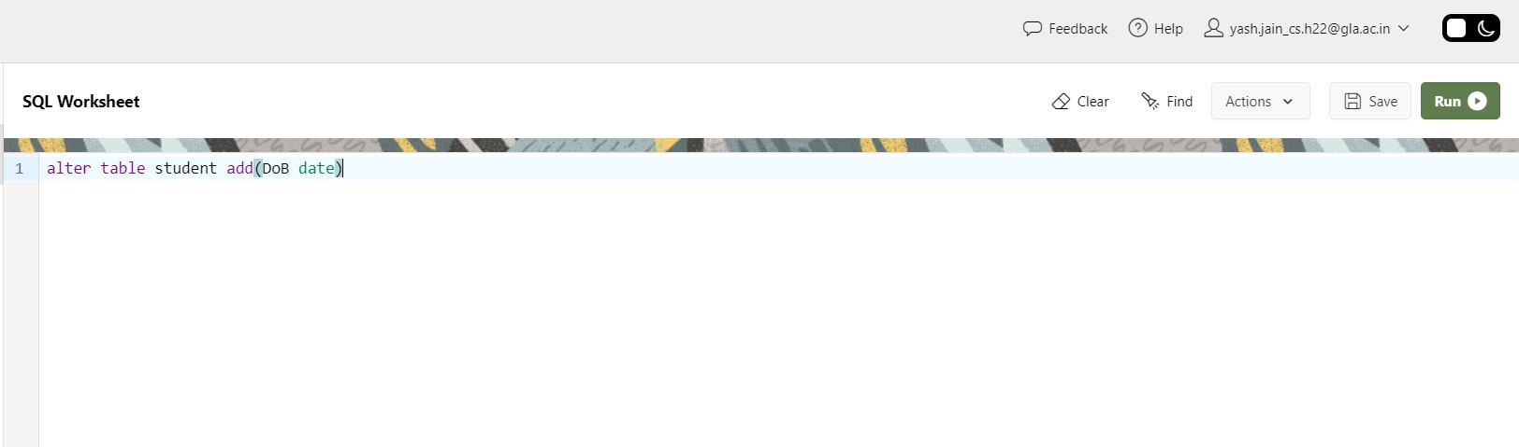

1. Insert DoB for each Student in corresponding table using above instance of Student table.

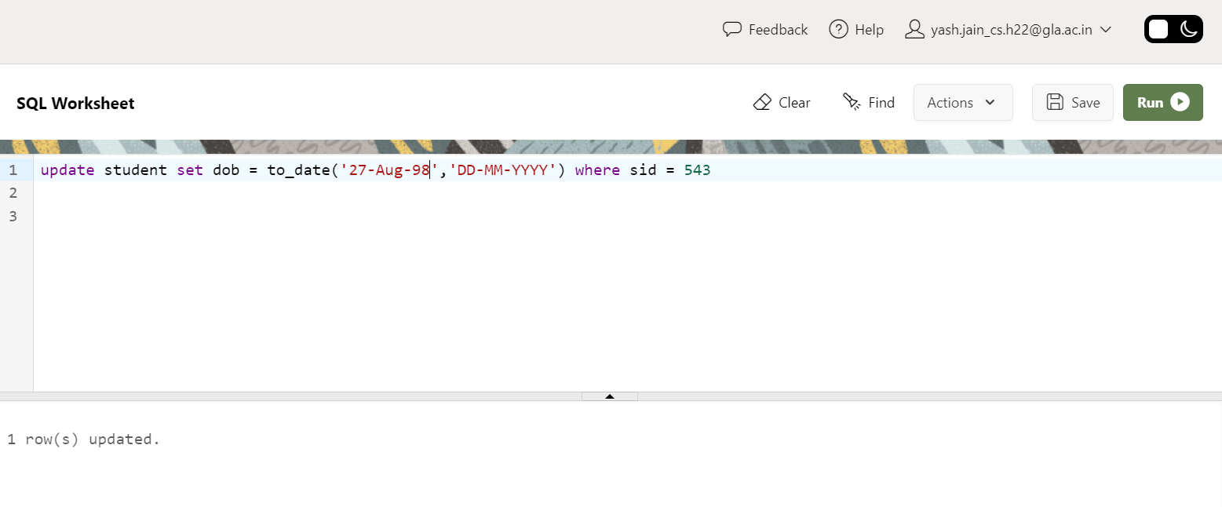

1. Find average of GPA round off to 2 decimal places.

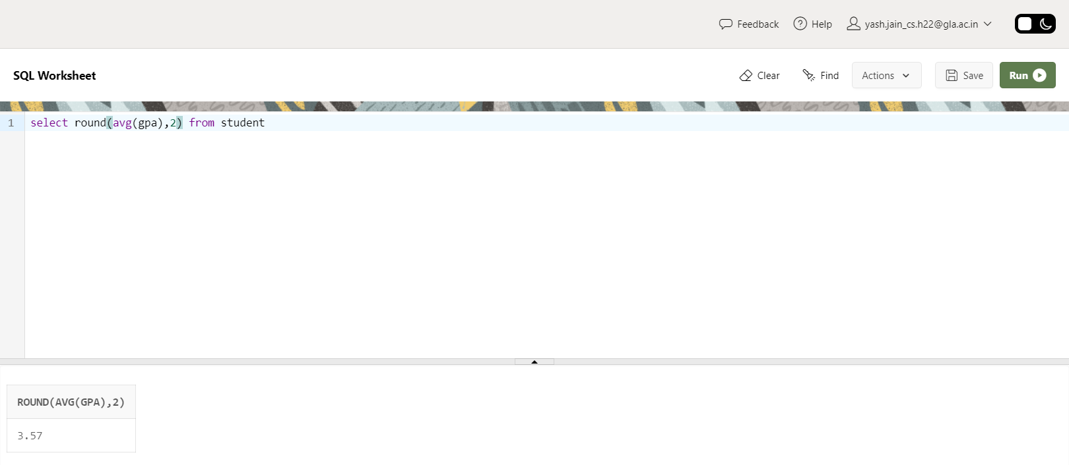

1. Find year of DoB of Student having less than 1000.

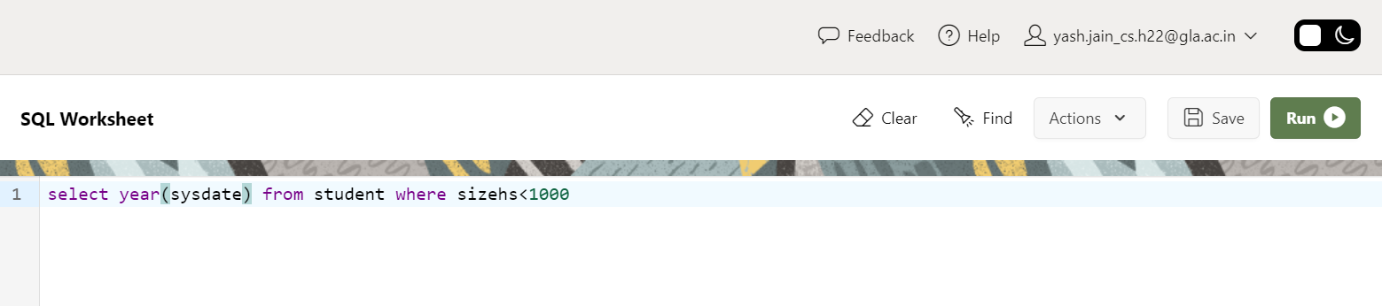

1. Compute Age of each student. (Hint: take difference between year of sysdate and Student’s DoB)
2. Display name of all Students in uppercase and name of college they applied in lower case.

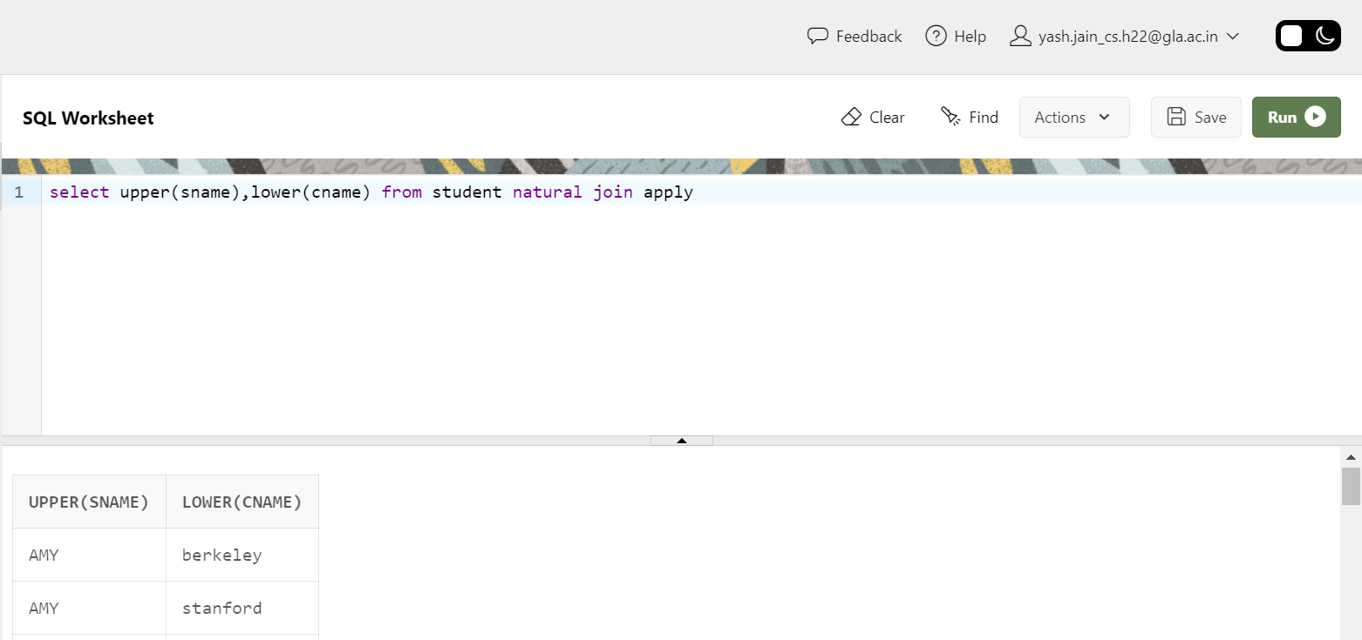

1. Find fourth alphabet of each student. (Hint: use substring).

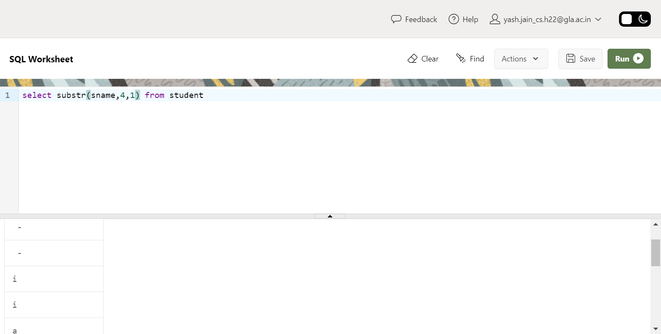

1. Find sID and sName of student whose sName has string length greater than 3.

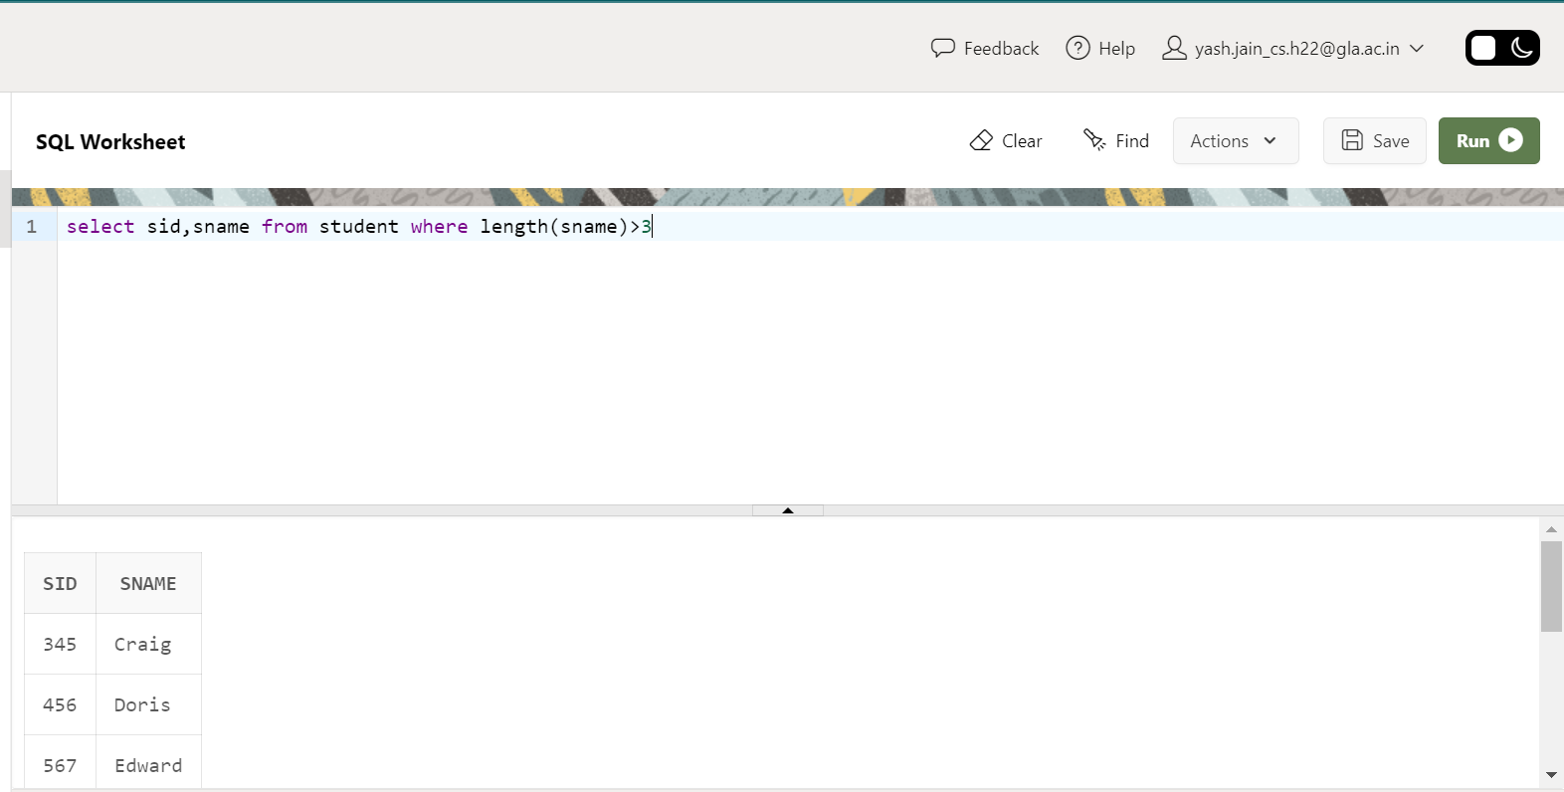

1. Find floor, ceiling and truncate (to one decimal place) value of average GPA.

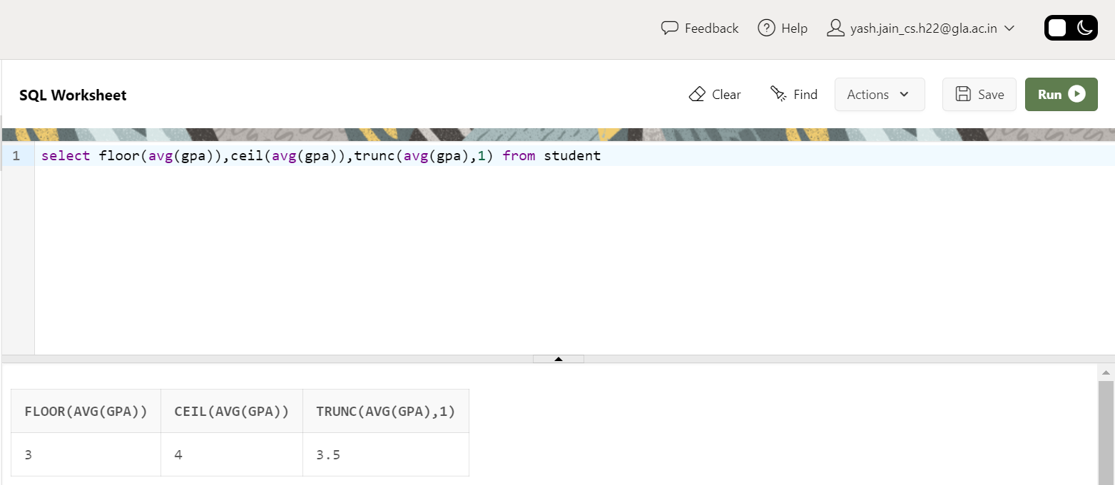

1. Display details of all students whose sID is even.

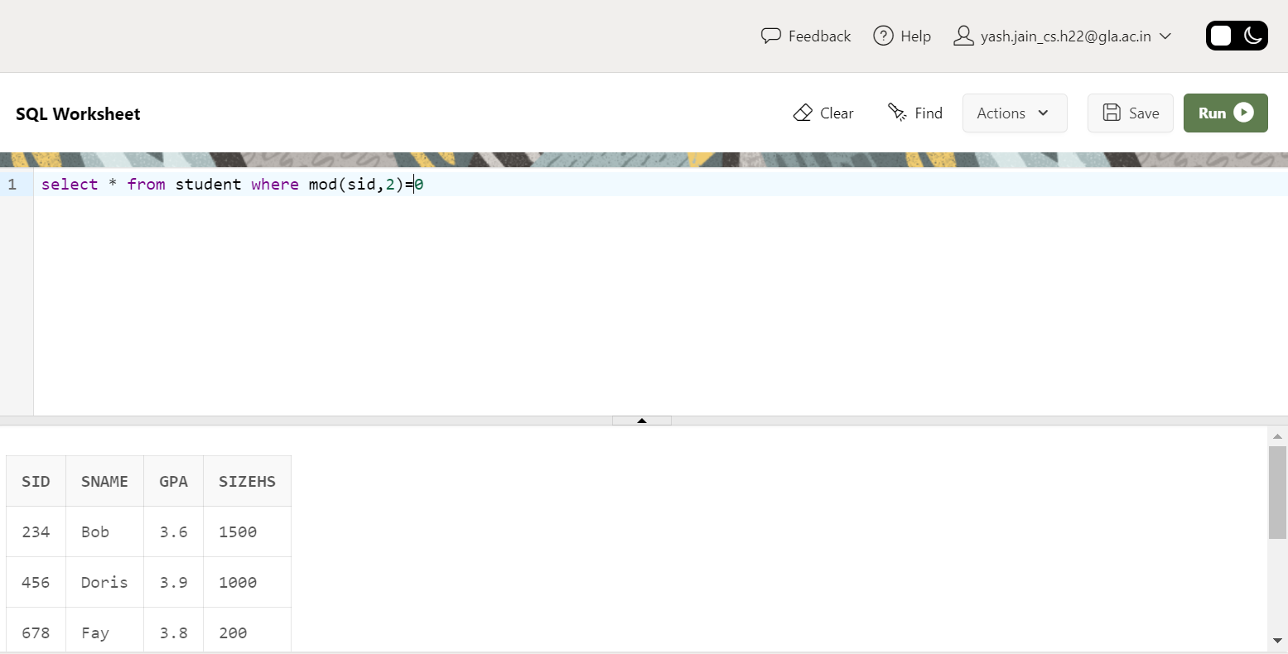

1. Compute Square Root of 900 and 247.

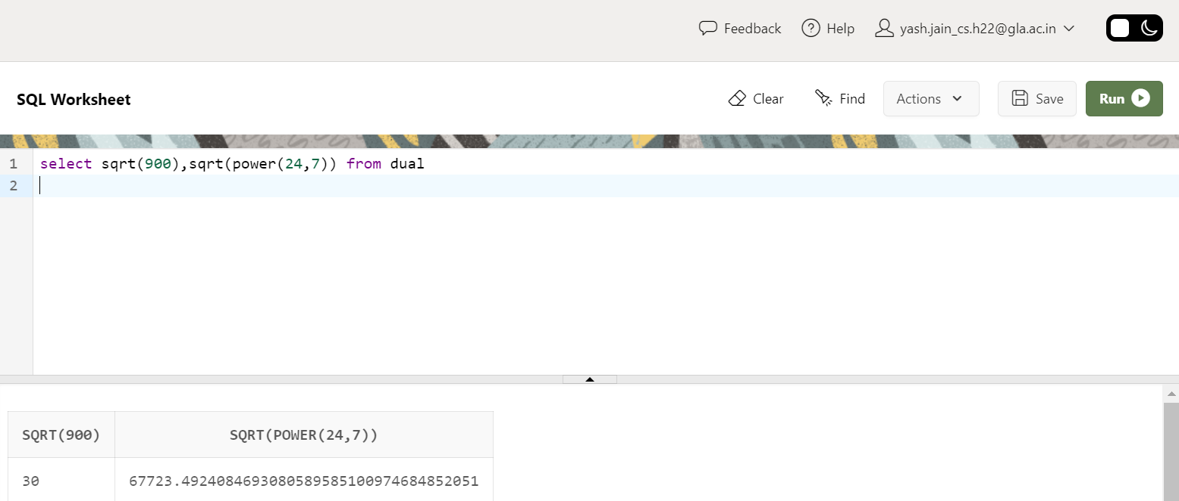

1. Consider the string “Peter Piper picked a peck of pickled peppers. A peck of pickled peppers Peter Piper picked. If Peter Piper picked a peck of pickled peppers, Where the peck of pickled peppers Peter Piper picked?” Find 6th occurrence of string ‘pick’. (Hint: use INSTR).

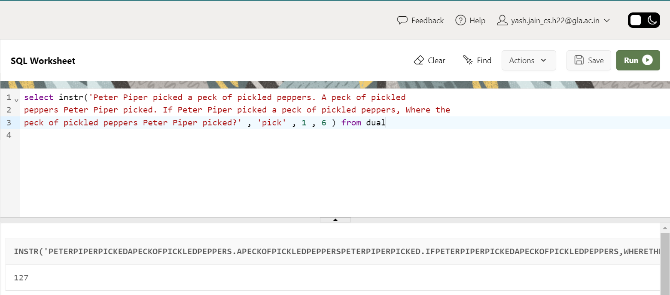

1. Consider String ‘Satya Nadella’ replace this using the key (Hint: use translate).

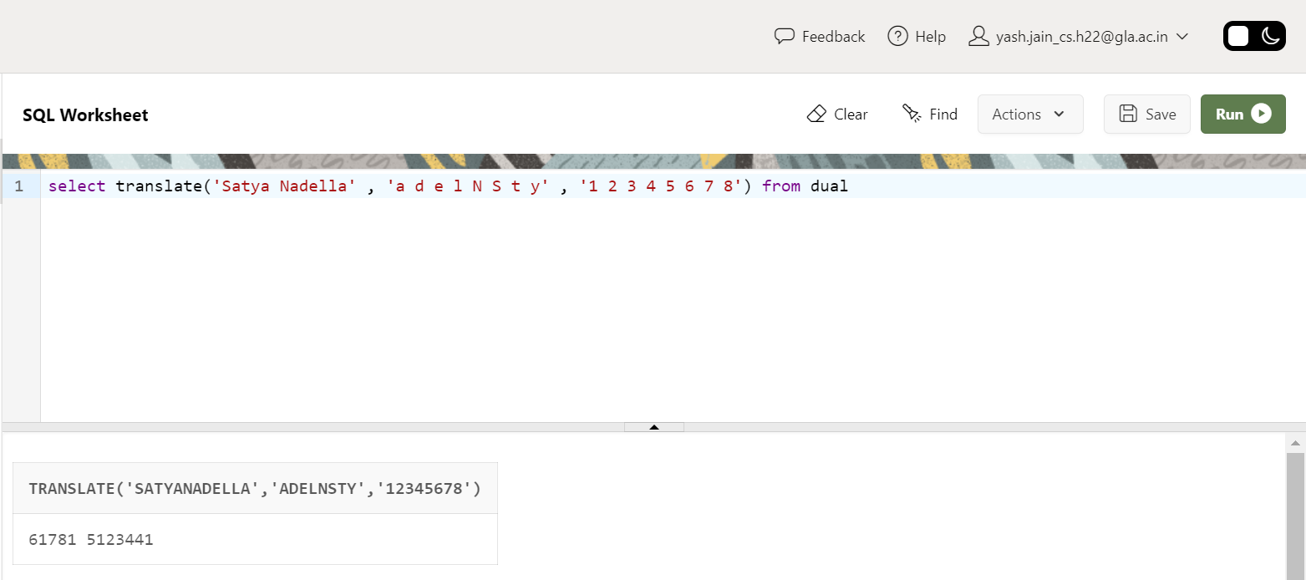

1. Display sID, sname and DoB in this format ‘February 26, 2014’

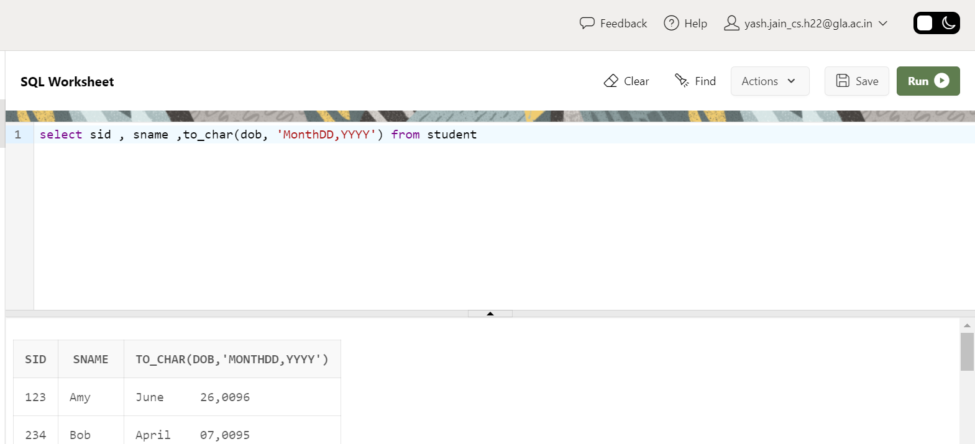

1. Convert the text ’26/02/2014’ to date.

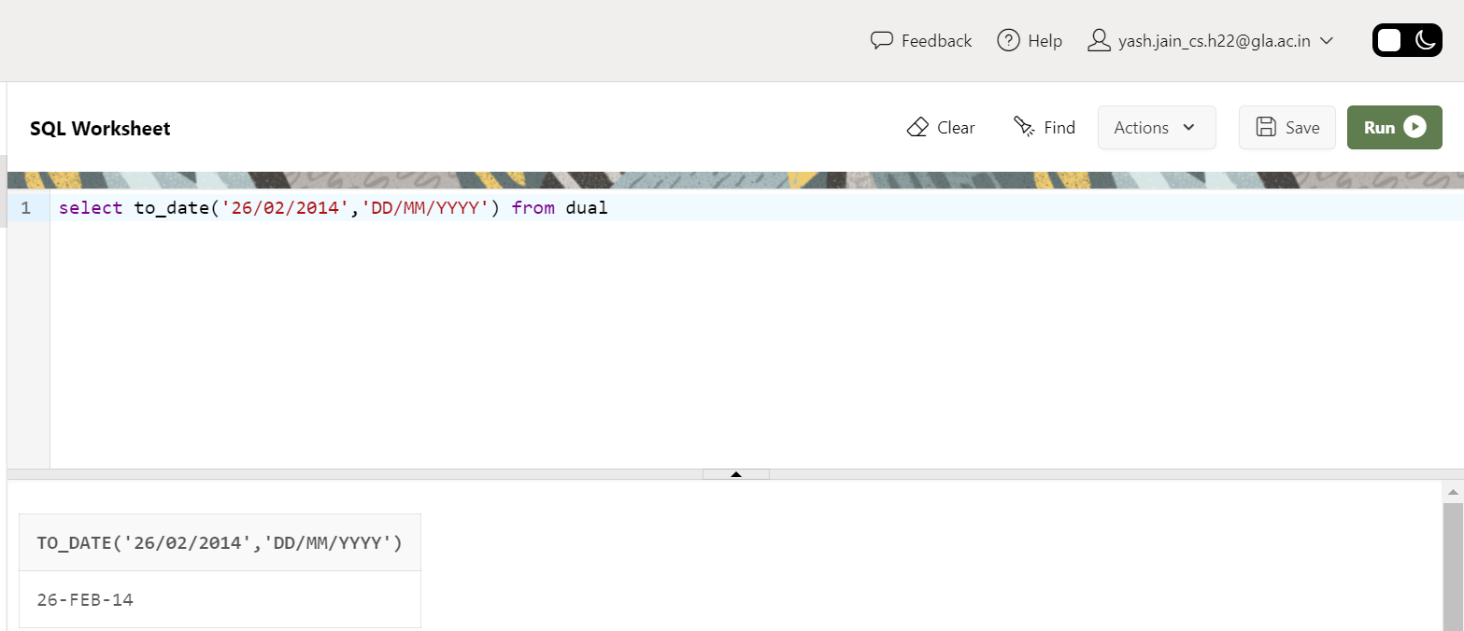

1. Compute on which date is next Saturday and last day of this month?

