CSC423-DATABASE SYSTEM

Project Report

HEYU YAO

C11885685

MAY 6, 2018

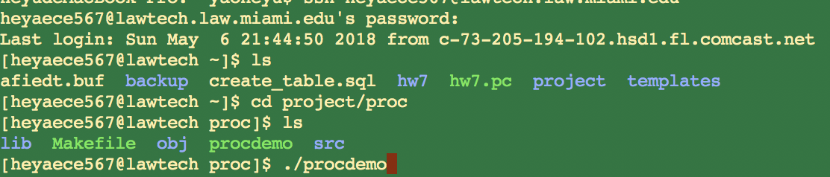

# How to Find My Project

* My project files is under ~/project/proc
* Main source file named procdemo.pc in ~/project/proc/src

# Conceptual Design EER Diagram

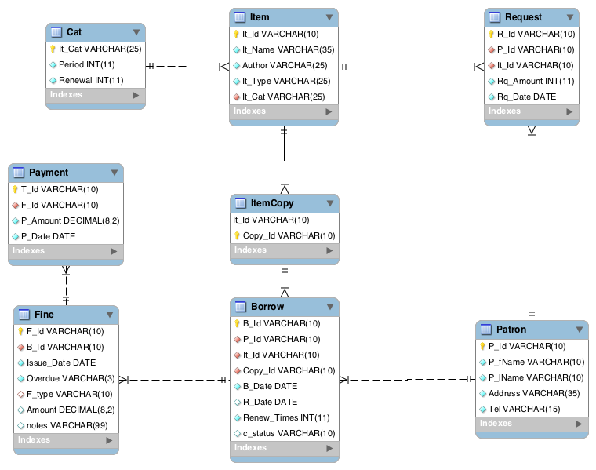

# Logical Design EER Diagram



# Table Information for Testing

### Cat:

|  |  |  |
| --- | --- | --- |
| It_Cat | Period | Renewal |
| Adult | 14 | 1 |
| Children | 30 | 1 |

### Item:

|  |  |  |  |  |
| --- | --- | --- | --- | --- |
| It_Id | It_Name | Author | It_Type | It_Cat |
| h001 | The Blue Dream | Kobe Bryant | Book | Children |
| h002 | The Red Dream | Ultraman | Magazine | Adult |
| h003 | The Blue Dream | The fisher | Movie | Children |

ItemCopy:

|  |  |
| --- | --- |
| It_Id | Copy_Id |
| h001 | c001 |
| h001 | c002 |
| h001 | c003 |
| h002 | c001 |
| h002 | c002 |
| h002 | c003 |
| h003 | c001 |
| h003 | c002 |
| h003 | c003 |
| h003 | c004 |

Patron:

|  |  |  |  |  |
| --- | --- | --- | --- | --- |
| P_Id | P_fName | P_lName | Address | Tel |
| p001 | John | West | 1345 guloh st | 7866208403 |
| p002 | James | Jones | 1234 blue st | 7866208404 |
| p003 | Lebron | James | 1234 red st | 7856208304 |

|  |  |  |  |  |  |  |  |
| --- | --- | --- | --- | --- | --- | --- | --- |
| B_Id | P_Id | It_Id | Copy_Id | B_Date | R_Date | Renew_Times | c_status |
| b001 | p001 | h001 | c001 | 2012-01-03 | 2012-03-03 | 0 | good |
| b002 | p001 | h001 | c002 | 2012-01-03 | 2012-03-03 | 0 | damage |
| b003 | p003 | h003 | c004 | 2012-01-23 |  | 0 | loss |
| b004 | p001 | h003 | c002 | 2018-01-03 | 2018-01-31 | 0 | good |
| b005 | p002 | h002 | c001 | 2018-01-03 |  | 1 | good |
| b006 | p003 | h003 | c001 | 2018-01-03 |  | 1 | loss |
| b007 | p001 | h002 | c003 | 2018-02-03 | 2018-02-10 | 0 | good |
| b008 | p003 | h003 | c003 | 2018-03-03 |  | 0 | good |
| b009 | p002 | h002 | c002 | 2018-04-03 |  | 0 | good |
| b010 | p002 | h002 | c003 | 2018-04-13 |  | 0 | good |

Borrow:

Fine:

|  |  |  |  |  |  |  |  |  |  |  |
| --- | --- | --- | --- | --- | --- | --- | --- | --- | --- | --- |
| F_Id | B_Id | Issue_Date | Overdue | F_type | Amount | | notes |  |  |  |
| f001 | b001 | 2012-03-03 | YES |  | 30 |  | |  |  |  |
| f002 | b002 | 2012-03-03 | YES | damage | 150 | overdued several days:30,  found item cover damaged:120 | | | | |
| f003 | b003 | 2012-03-21 | YES | loss | 223.89 | late report:23.89, item loss: 200 | | |  |  |
| f004 | b006 | 2018-04-06 | NO | loss | 178.99 |  | |  |  |  |

Payment:

|  |  |  |  |
| --- | --- | --- | --- |
| T_Id | F_Id | P_Amount | P_Date |
| t001 | f002 | 150 | 2012-03-06 |
| t002 | f003 | 120 | 2012-03-21 |
| t003 | f004 | 120 | 2018-04-10 |
| t004 | f004 | 50 | 2018-04-15 |

Request:

|  |  |  |  |  |
| --- | --- | --- | --- | --- |
| R_Id | P_Id | It_Id | Rq_Amount | Rq_Date |
| r001 | p001 | h001 | 2 | 2011-03-06 |
| r002 | p003 | h002 | 2 | 2018-05-06 |