Environment Setup
To use TensorFlow, you need to set up the environment correctly. TensorFlow is really picky, so it requires you to install different dependencies. This is a step by step guideline of how to go about doing this, and it is based on Brandon’s explanation and the website he recommended: http://www.python36.com/install-tensorflow141-gpu/
All the commands that you need to enter in the commandline are provided in this document.
Step 0. How this document is organized
- Unless specified otherwise, run the commands in the home directory. If you are unsure where you are, enter cd ~ in the commandline
- All the commands that are run in the commandline are highlighted in grey
Step 1. Updating and upgrading your system
sudo apt-get update
sudo apt-get upgrade
- Enter “y” for yes when you are asked the question “Do you want to continue?”
Step 2. Installing dependencies
sudo apt-get install build-essential
sudo apt-get install cmake git unzip zip
sudo apt-get install python2.7-dev pylint
- Notice that we are using the version python 2.7
Step 3. Installing Nvidia-384
- Now we have to install the graph card driver. Type the following in the commandline:
sudo apt install nvidia-384
Step 4. Checking that Nvidia-384 has been installed
- important: restart your computer to reboot it
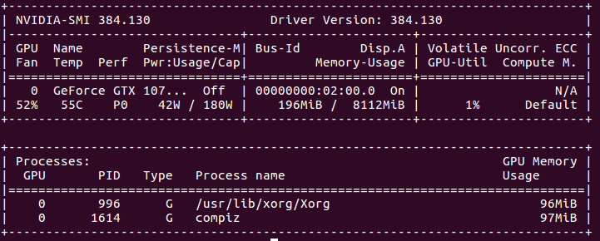
- To check that nvidia-384 has been correctly installed and running, type in the following in the commandline:
nvidia-smi
- You can be assured that it has successfully been installed if you see this:
Step 5. Downloading CUDA Toolkit 9.0
- Click on the following link, and you’ll see that the relevant options have already been selected for you: https://developer.nvidia.com/cuda-90-download-archive?target_os=Linux&target_arch=x86_64&target_distro=Ubuntu&target_version=1604&target_type=runfilelocal
Download every single one of the following by pressing the green buttons:
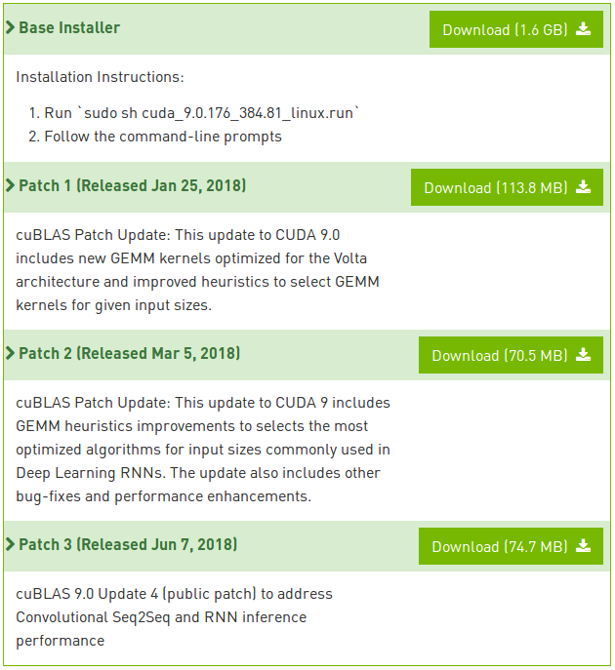
- when you’re in the Downloads folder, if you see duplicates of the downloaded files that end in “.part”, it means that they are still in the process of being downloaded.
- When you don’t see any files ending in “.part”, and if you see that not all of the files are colored in green, then run the following command: chmod 777 cuda_9.0.176*, which is a command that gives you the permission to run these files.

Step 6. Executing CUDA Toolkit 9.0
- Run the base installer using the command:
sudo ./cuda_9.0.176_384.81_linux.run
- Keep pressing the space key to scroll down. It will ask you a lot of questions, so please answer in the following way:
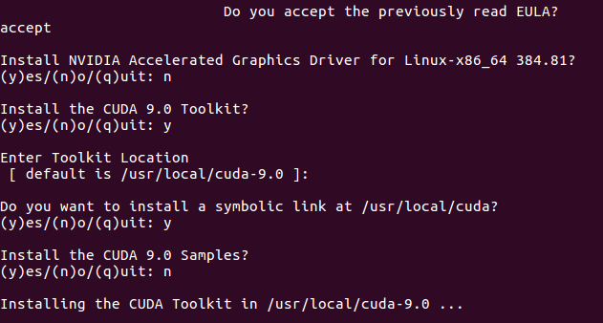

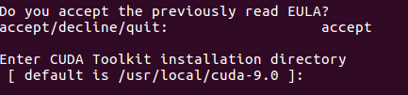
- Now, repeat the step above with the files that you downloaded for Patch 1, Patch 2, and Patch 3. Keep in mind that you need to always begin your command with “sudo”, and please answer the questions in the following way.

Step 7. Changing the path
- Enter the following command:
nano ~/.bashrc
- Then insert the following two lines at the end of the file:
export PATH=/usr/local/cuda-9.0/bin${PATH:+:${PATH}}
export LD_LIBRARY_PATH=/usr/local/cuda-9.0/lib64${LD_LIBRARY_PATH:+:${LD_LIBRARY_PATH}}
- Press “ctrl+x” and then press “y” for yes. Press the enter key to exit.
If you have been doing everything correctly so far, the following commands should work:
source ~/.bashrc
sudo ldconfig
nvidia-smi
Step 8. Downloading the cuDNN library
- Go to the following website: https://developer.nvidia.com/cudnn
- And then click on the “Download cuDNN” button. Then, click on “Join now” and then create a new account and fill in all the relevant information.
- Now, go back to this website: https://developer.nvidia.com/cudnn
- Click on the “Download cuDNN” button, and fill out the survey (if you’re told to do so by the website).
- Agree to the terms, and then click on the dropdown menu called “Download cuDNN v7.1.4 [May 16, 2018], for CUDA 9.0”.
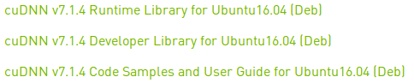
- Download the ones on the 5th, 6th, and 7th line:

Step 9. Checking that cuDNN has been properly installed
go to the Downloads folder, and enter the following commands:
sudo dpkg -i libcudnn7_7.1.4.18-1+cuda9.0_amd64.deb
sudo dpkg -i libcudnn7-dev_7.1.4.18-1+cuda9.0_amd64.deb
sudo dpkg -i libcudnn7-doc_7.1.4.18-1+cuda9.0_amd64.deb
Then, type in the following commands:
cp -r /usr/src/cudnn_samples_v7/ $HOME
cd $HOME/cudnn_samples_v7/mnistCUDNN
make clean && make
./mnistCUDNN
You will know that you have successfully installed cuDNN if you see the following message pop up at the end of a long script:

(You don’t need to do the below if you are going to build TensorFlow from source, which is recommended!)
Step 10. Installing TensorFlow
Run the following commands:
sudo apt install python-pip
pip install tensorflow-gpu
Step 11. Verifying Tensorflow installation
Enter the following commands in terminal:
python
import tensorflow as tf
hello = tf.constant(“Hello, TensorFlow!”)
sess = tf.Session()
print(sess.run(hello))
You have succeeded if you see the following message pop up:

