State Forecast Result Figures — Medicaid + CHIP

New York

Ny Enrollment Forecast Monthly
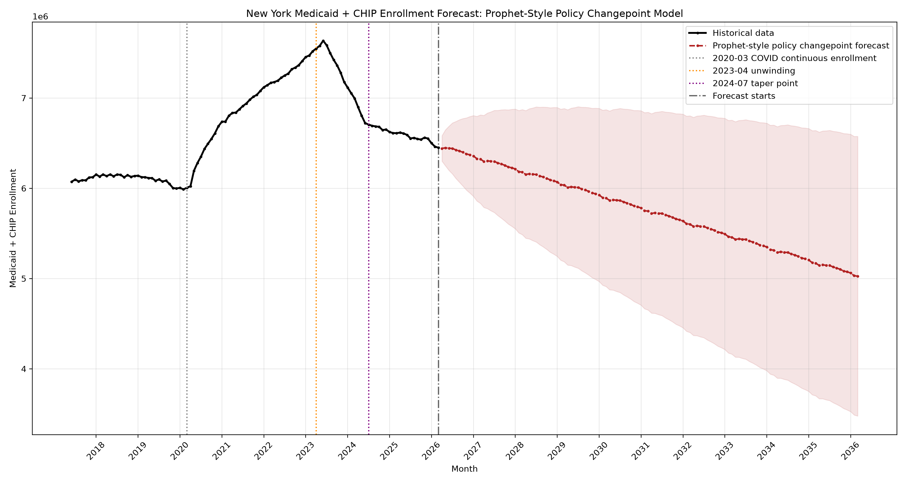
New_York/results/ny_enrollment_forecast_monthly.png

Ny Expenditure Forecast Annual
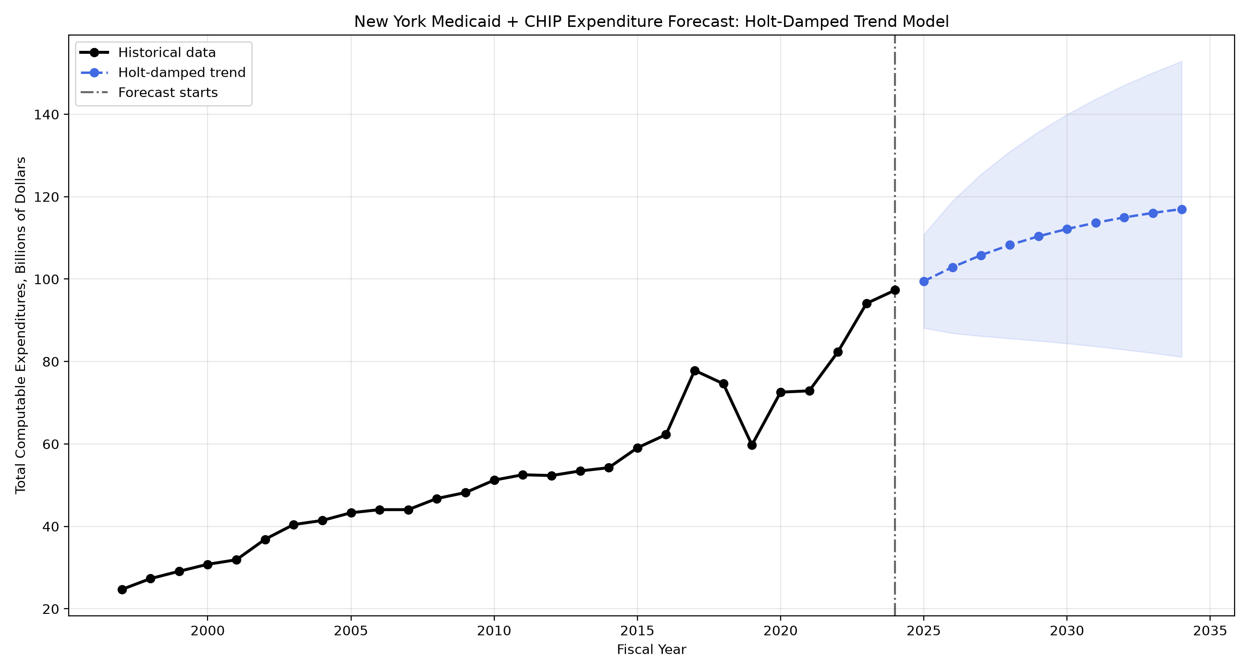
New_York/results/ny_expenditure_forecast_annual.png

Ny Per Enrollee Spending Annual
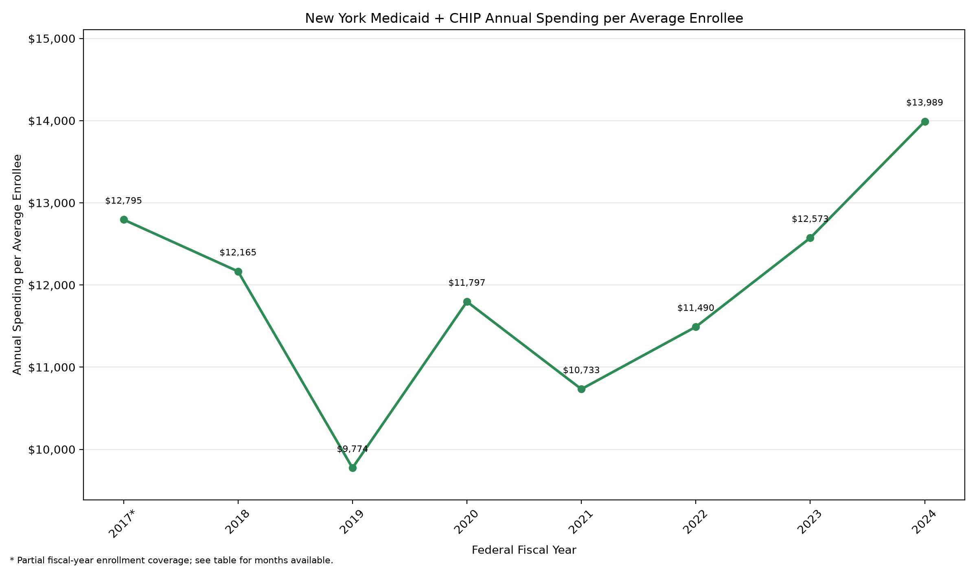
New_York/results/ny_per_enrollee_spending_annual.png

Illinois

Il Enrollment Forecast Monthly
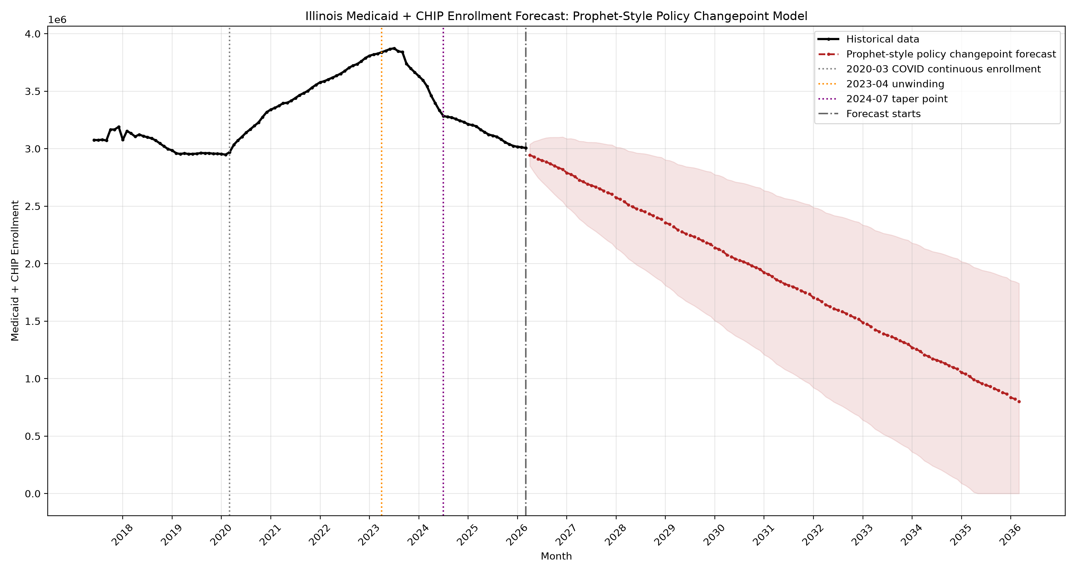
Illinois/results/il_enrollment_forecast_monthly.png

Il Expenditure Forecast Annual
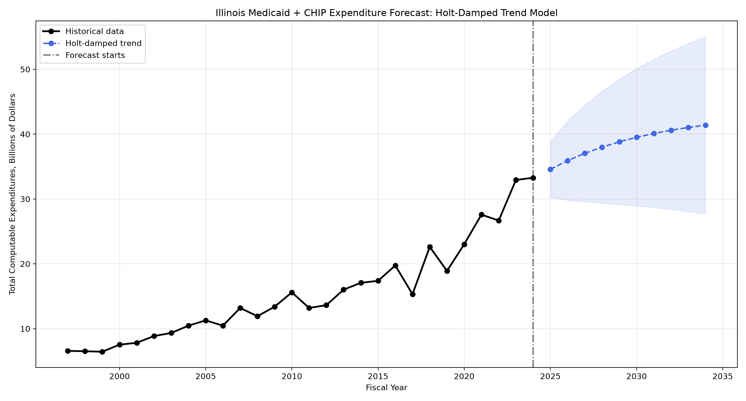
Illinois/results/il_expenditure_forecast_annual.png

Il Expenditure Policy Changepoint Forecast Annual
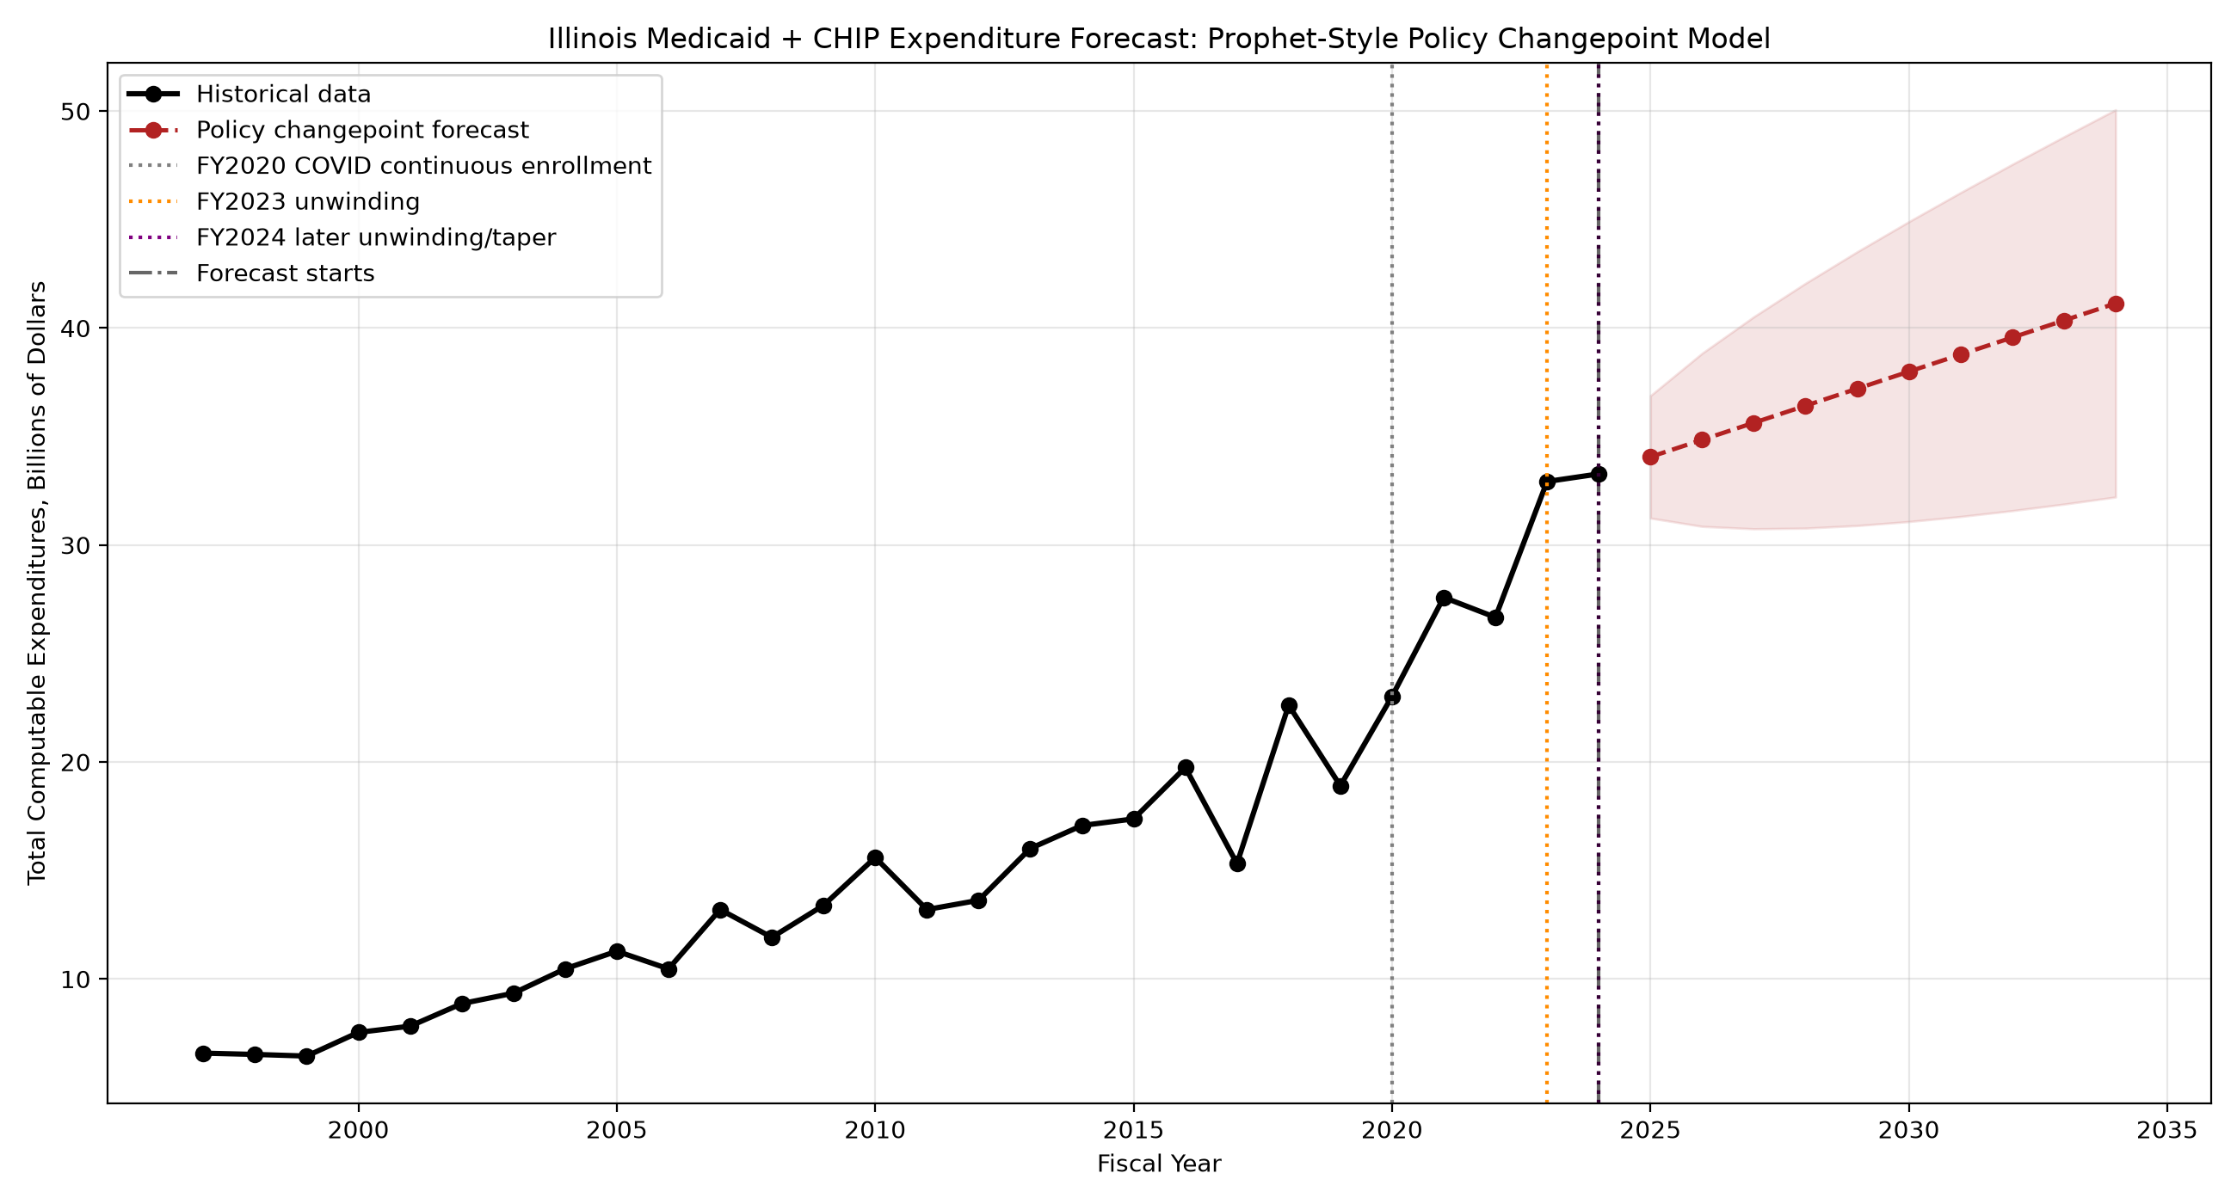
Illinois/results/il_expenditure_policy_changepoint_forecast_annual.png

Il Per Enrollee Spending Annual
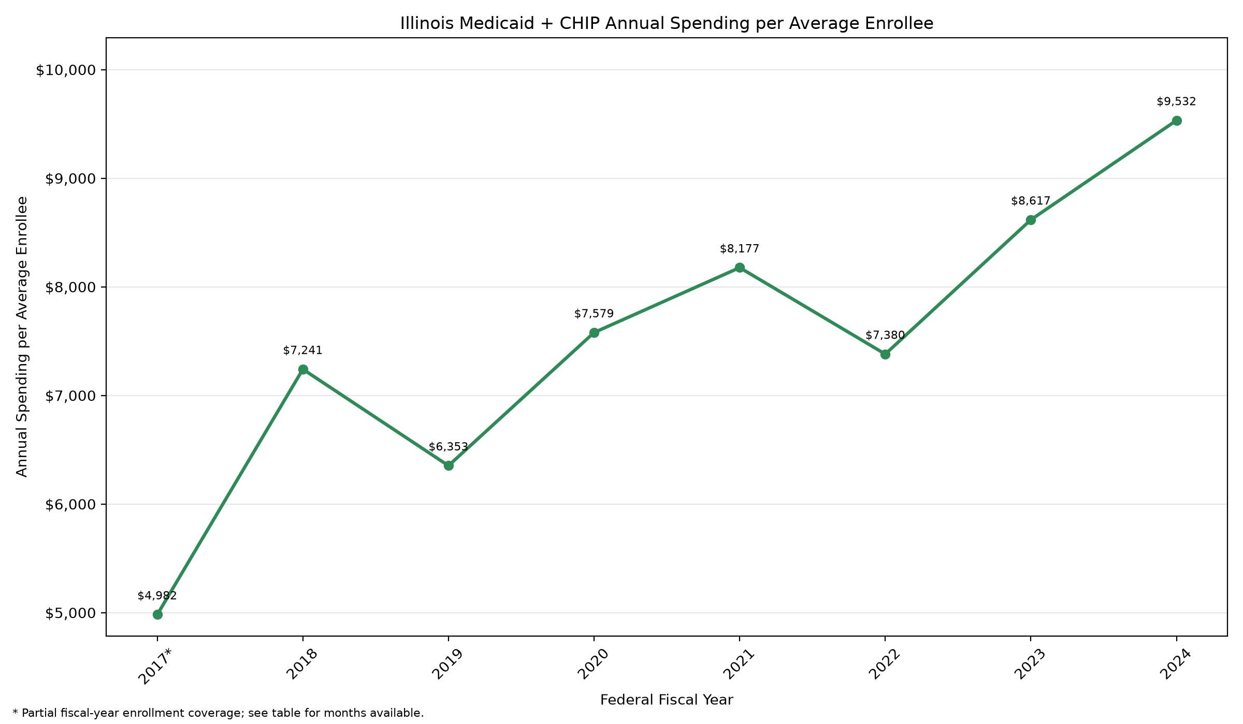
Illinois/results/il_per_enrollee_spending_annual.png

Washington

Wa Enrollment Forecast Monthly
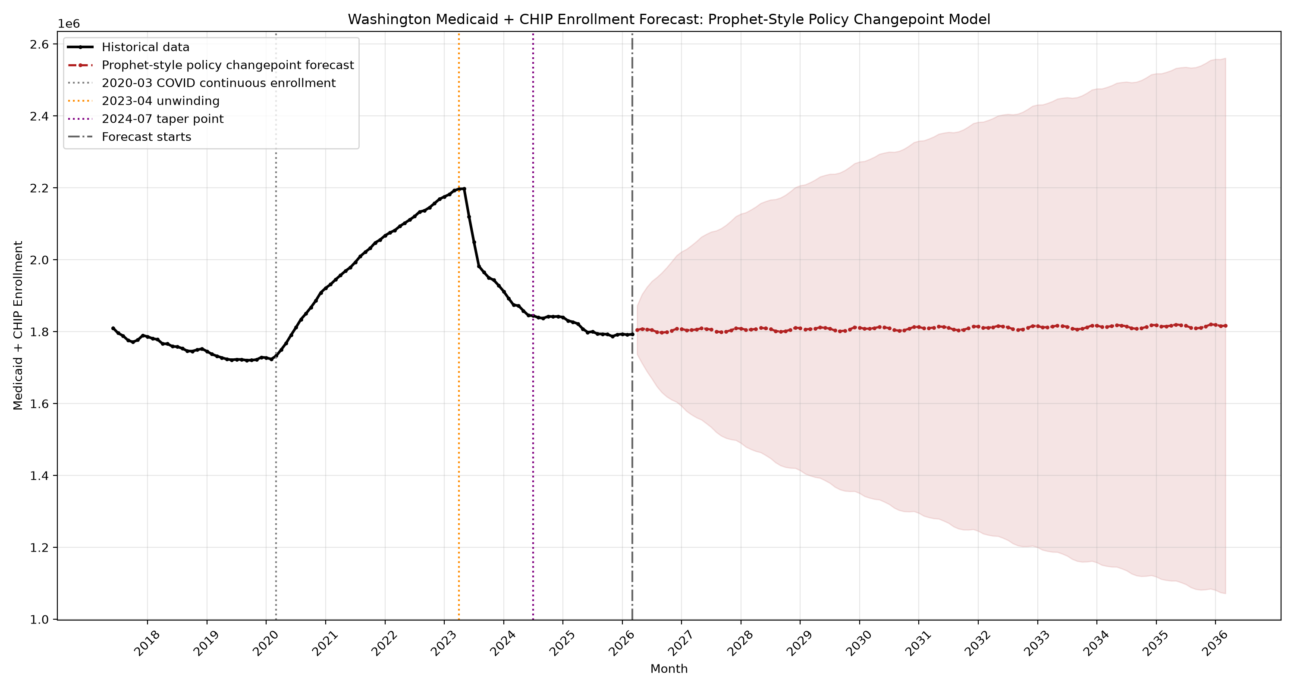
Washington/results/wa_enrollment_forecast_monthly.png

Wa Expenditure Forecast Annual
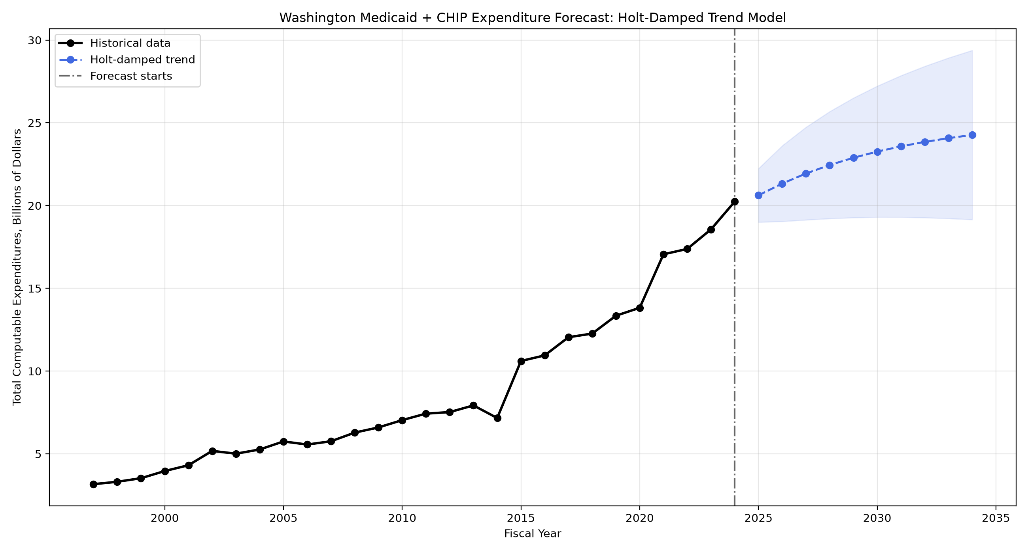
Washington/results/wa_expenditure_forecast_annual.png

Wa Expenditure Policy Changepoint Forecast Annual
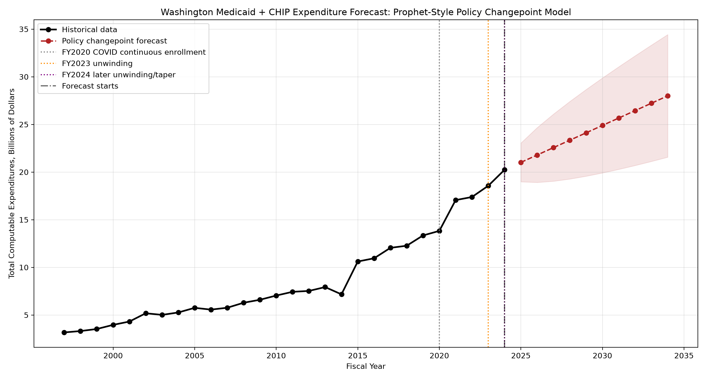
Washington/results/wa_expenditure_policy_changepoint_forecast_annual.png

Wa Per Enrollee Spending Annual
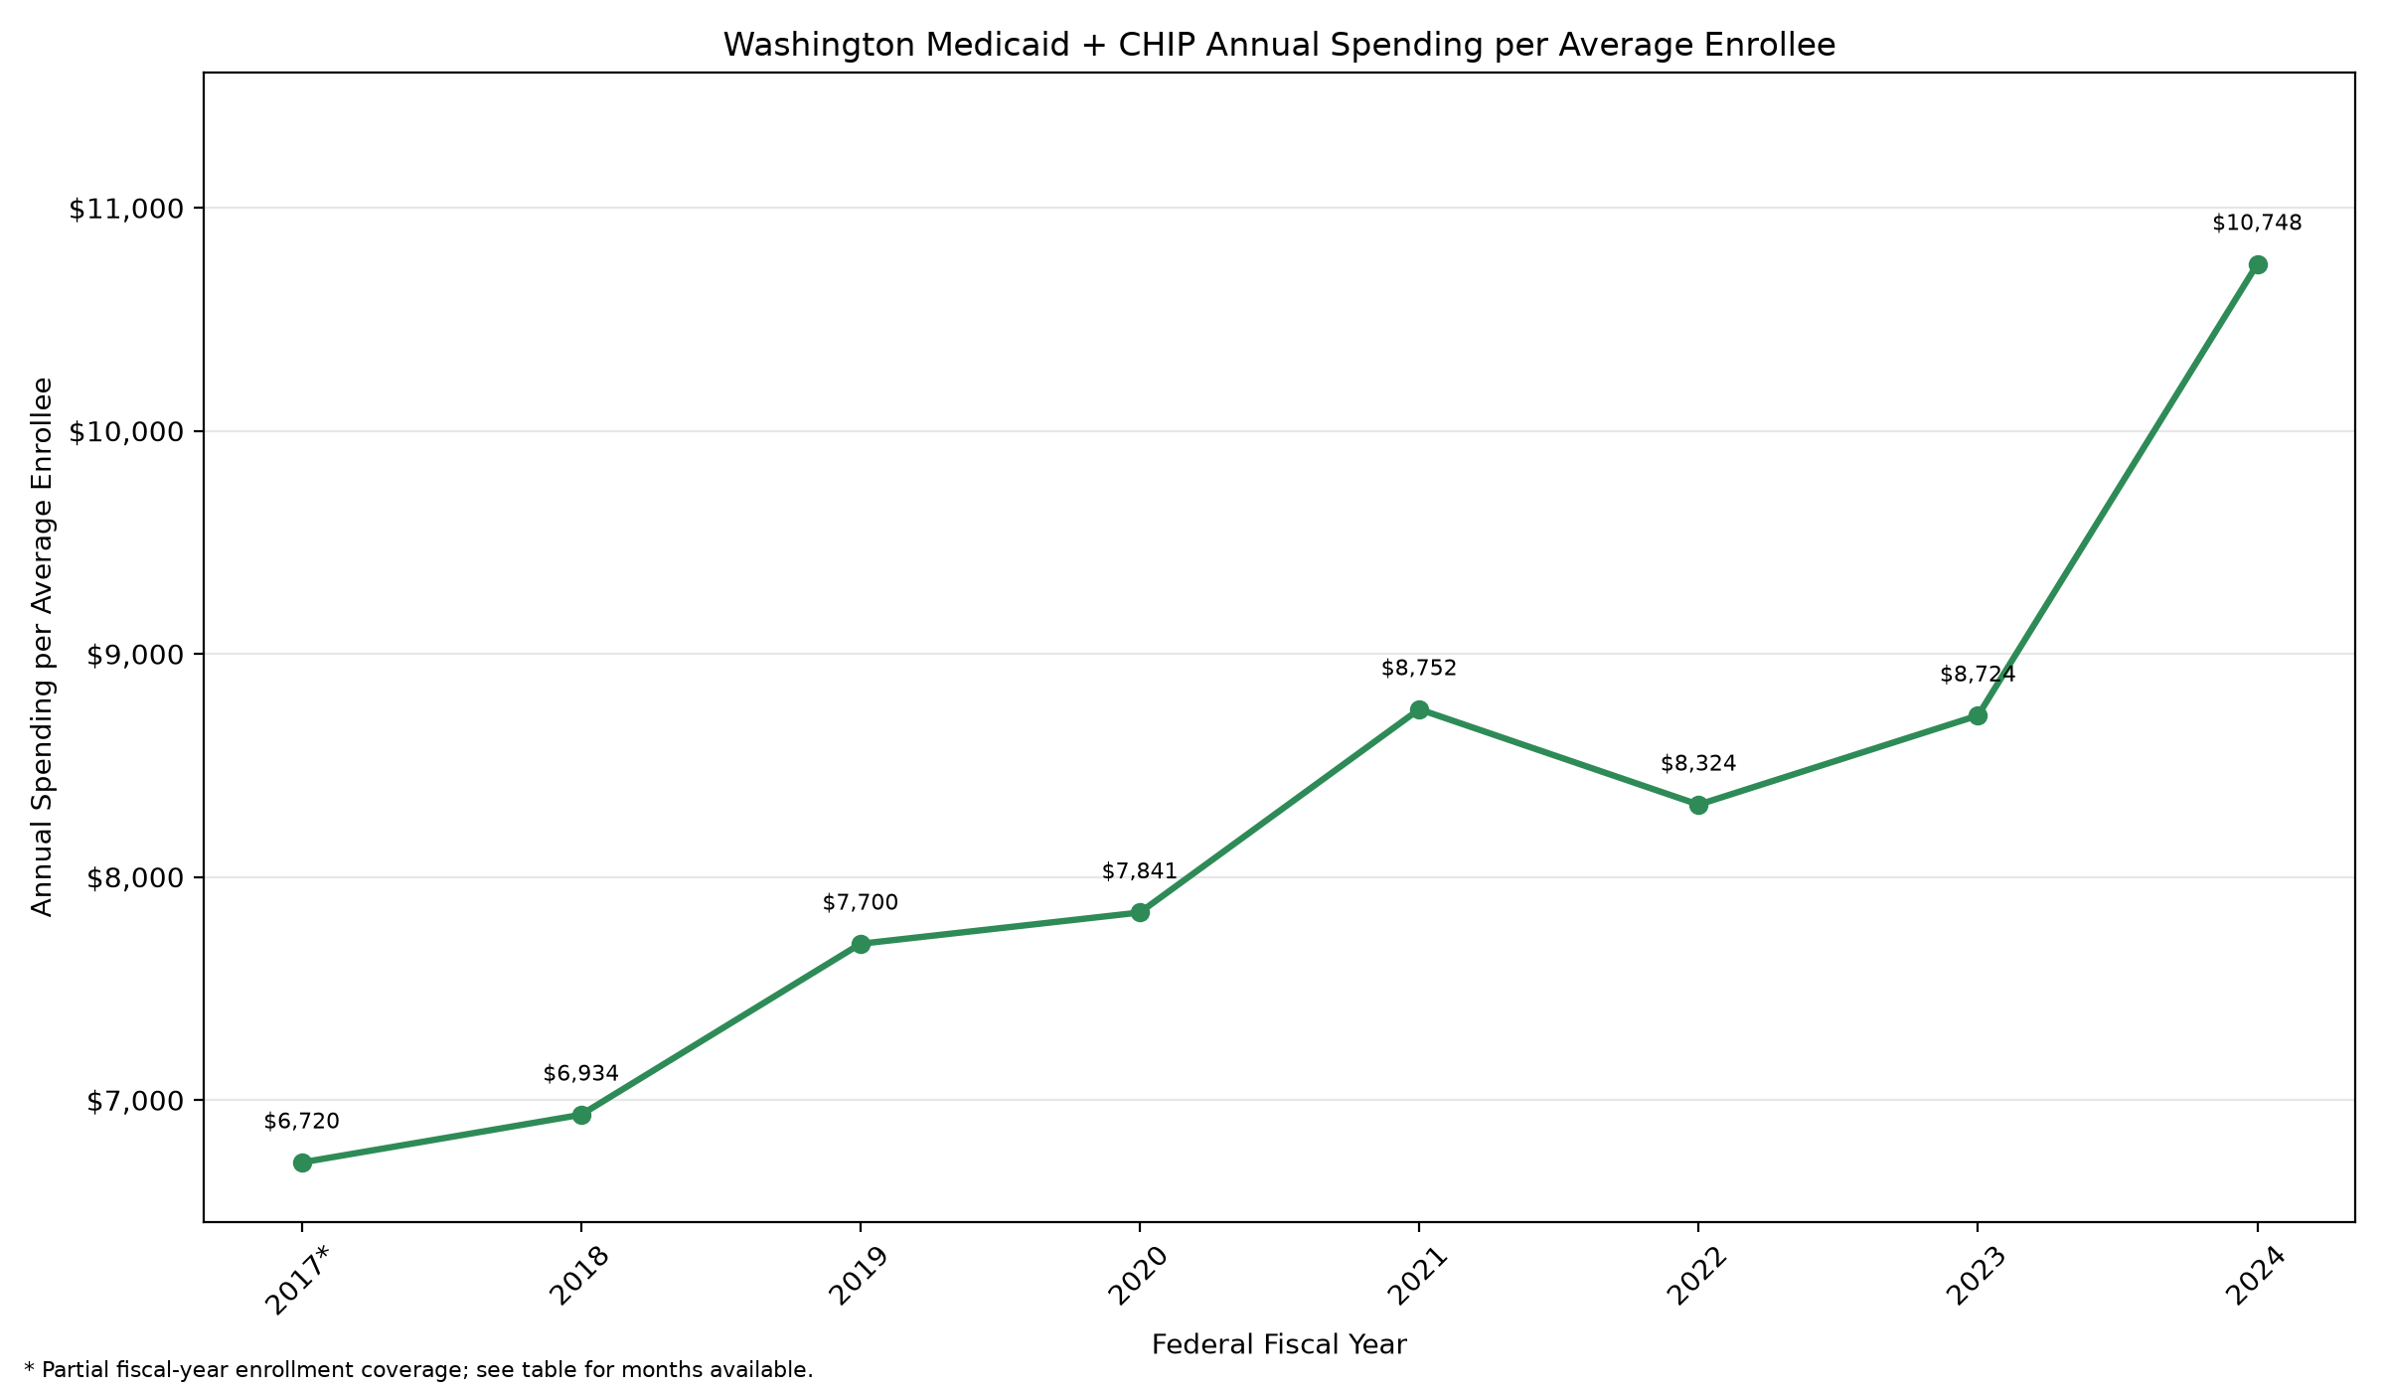
Washington/results/wa_per_enrollee_spending_annual.png

Pennsylvania

Pa Enrollment Forecast Monthly
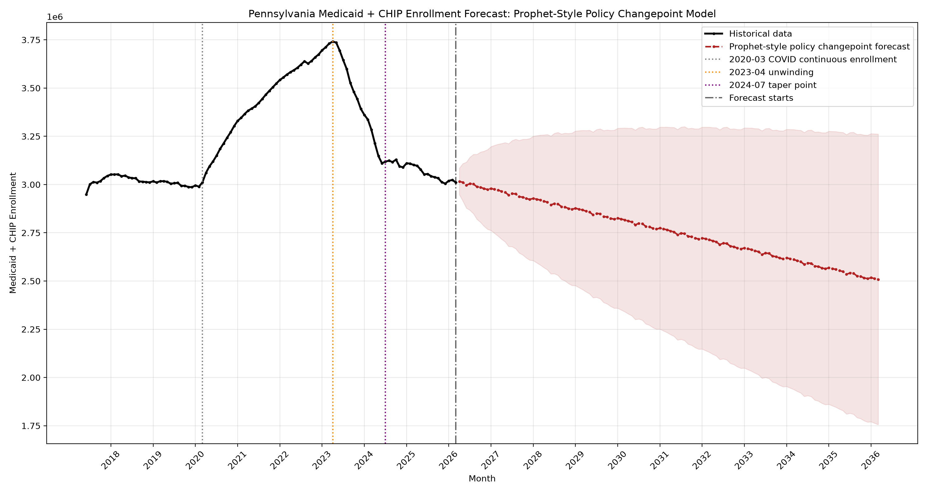
Pennsylvania/results/pa_enrollment_forecast_monthly.png

Pa Expenditure Forecast Annual
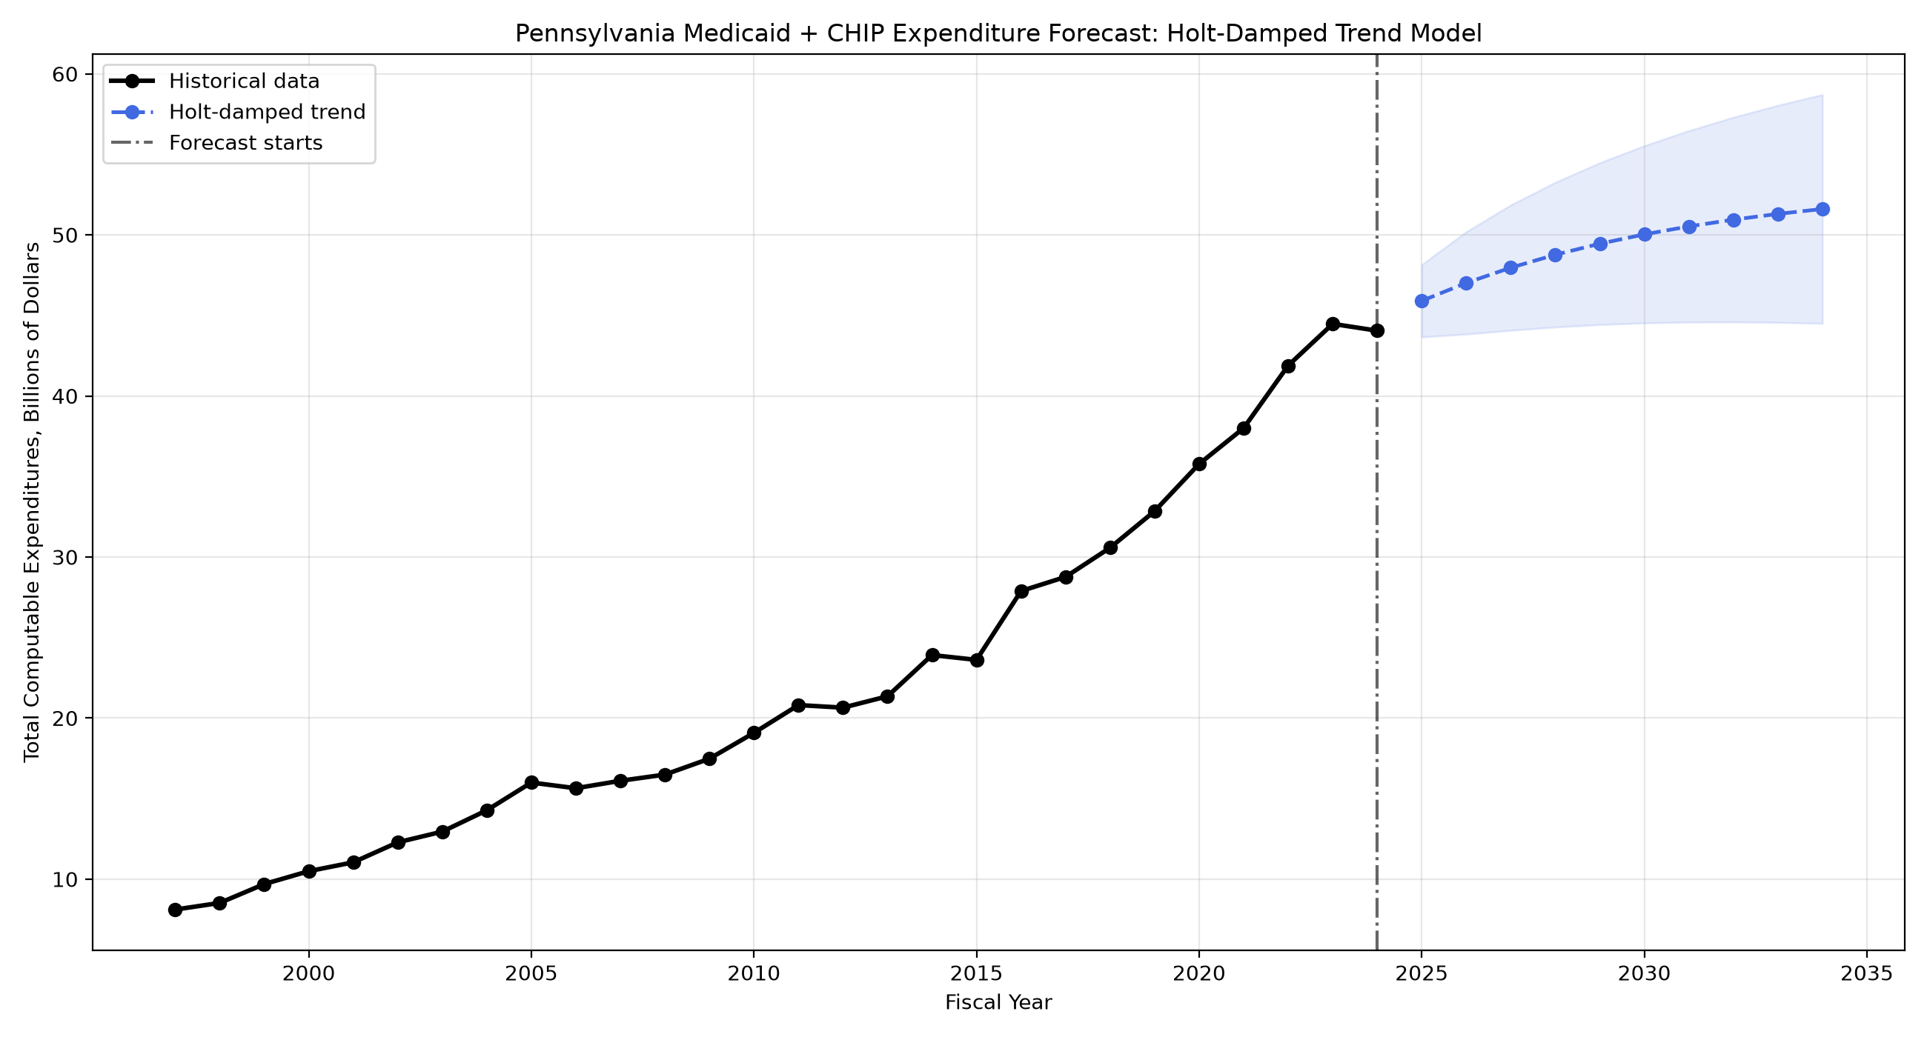
Pennsylvania/results/pa_expenditure_forecast_annual.png

Pa Expenditure Policy Changepoint Forecast Annual
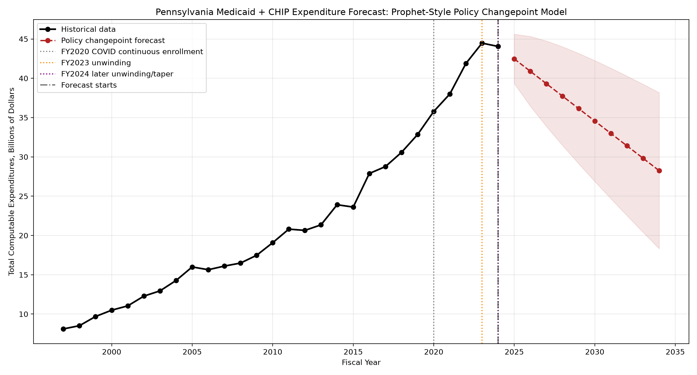
Pennsylvania/results/pa_expenditure_policy_changepoint_forecast_annual.png

Pa Per Enrollee Spending Annual
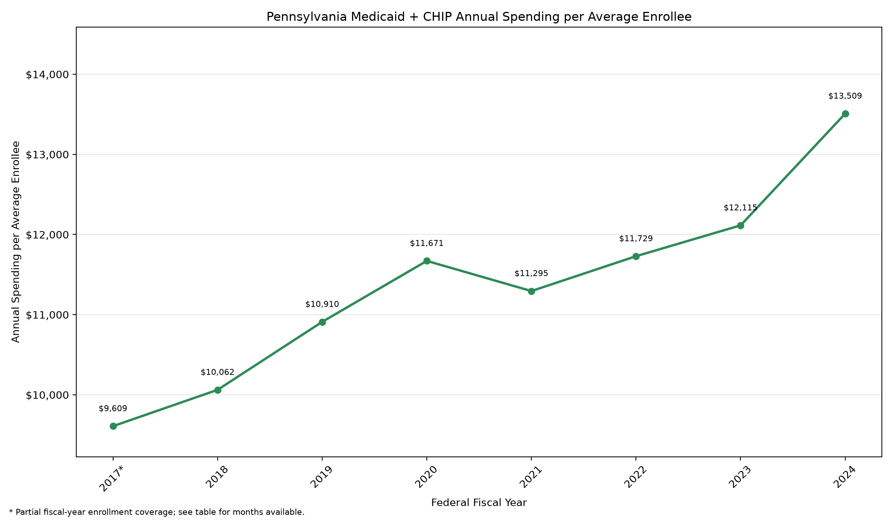
Pennsylvania/results/pa_per_enrollee_spending_annual.png

