Medicaid and CHIP: Fewer Enrollees, Continued Spending Pressure
By Yujie Zhu
When fewer people are enrolled in Medicaid and CHIP, spending might be expected to fall as well. But a shrinking enrollment count does not necessarily mean a smaller bill. As pandemic-era coverage protections ended and states resumed eligibility reviews, enrollment declined across New York, Illinois, Washington, and Pennsylvania. Spending per average enrollee, however, increased in all four states in fiscal year 2024.
What do these diverging trends mean for future spending? By examining recent enrollment and expenditure patterns alongside long-term forecasts, this article explores whether declining enrollment is likely to ease spending pressure across the four states.
The analysis draws on monthly Medicaid and CHIP enrollment data from June 2017 through March 2026 and annual expenditure data from federal fiscal years 1997 through 2024. It compares enrollment, total spending, and spending per average enrollee across the four states, then projects enrollment through March 2036 and spending through fiscal year 2034. Spending includes federal and nonfederal funding. Spending per average enrollee is calculated by dividing annual spending by average monthly enrollment in the same fiscal year; comparisons begin in fiscal year 2018, the first full year of enrollment data.
Enrollment forecasts account for seasonal patterns and shifts in trends around the pandemic and the resumption of eligibility reviews [1]. Spending forecasts use a damped-trend model, which extends historical growth while gradually slowing it, alongside an alternative model for Illinois, Washington, and Pennsylvania that allows trends to change at selected points. These forecasts illustrate how past patterns could develop over time; they do not establish what caused those patterns.

New York State
New York’s Medicaid and CHIP enrollment fell from a peak of 7.63 million in June 2023 to 6.45 million in March 2026. Spending, however, continued to rise. In fiscal year 2024, total expenditure reached $97.33 billion, up 3.4% from the previous year, even as average monthly enrollment fell 7.0%. Together, these changes pushed spending per average enrollee up 11.3%, to $13,989.
Some of that spending pressure may reflect changes in what the state pays for care. New York’s fiscal year 2024 budget included a 7.5% increase in hospital inpatient reimbursement, along with adjustments to personal care and Consumer Directed Personal Assistance Program payments to account for minimum wage increases [2,3]. These changes offer possible explanations for rising spending, although this analysis does not measure how much each contributed.
Looking ahead, the models project enrollment falling to 5.03 million by March 2036 and annual spending reaching $117.00 billion in fiscal year 2034 under the Holt damped-trend model. Those projections extend past trends rather than predict specific policy decisions. If the trends continue, New York could be covering fewer people while spending more overall.
Figure 1. Monthly enrollment forecast
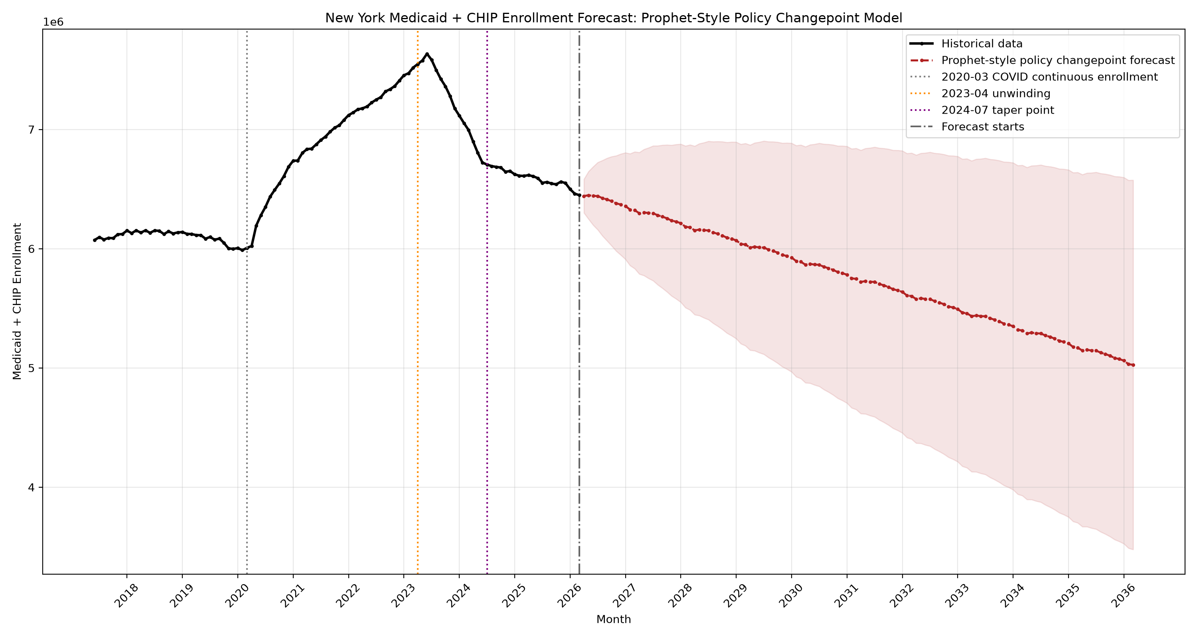
Figure 2. Annual expenditure forecast: Holt-damped model
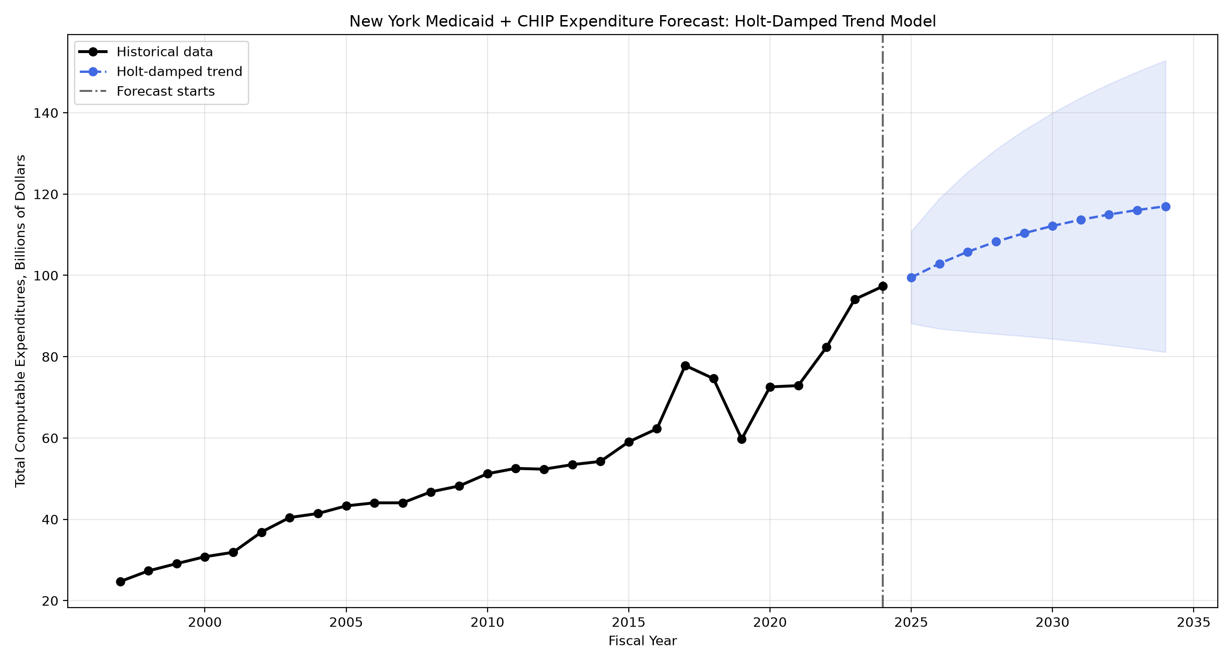
Figure 3. Historical spending per average enrollee
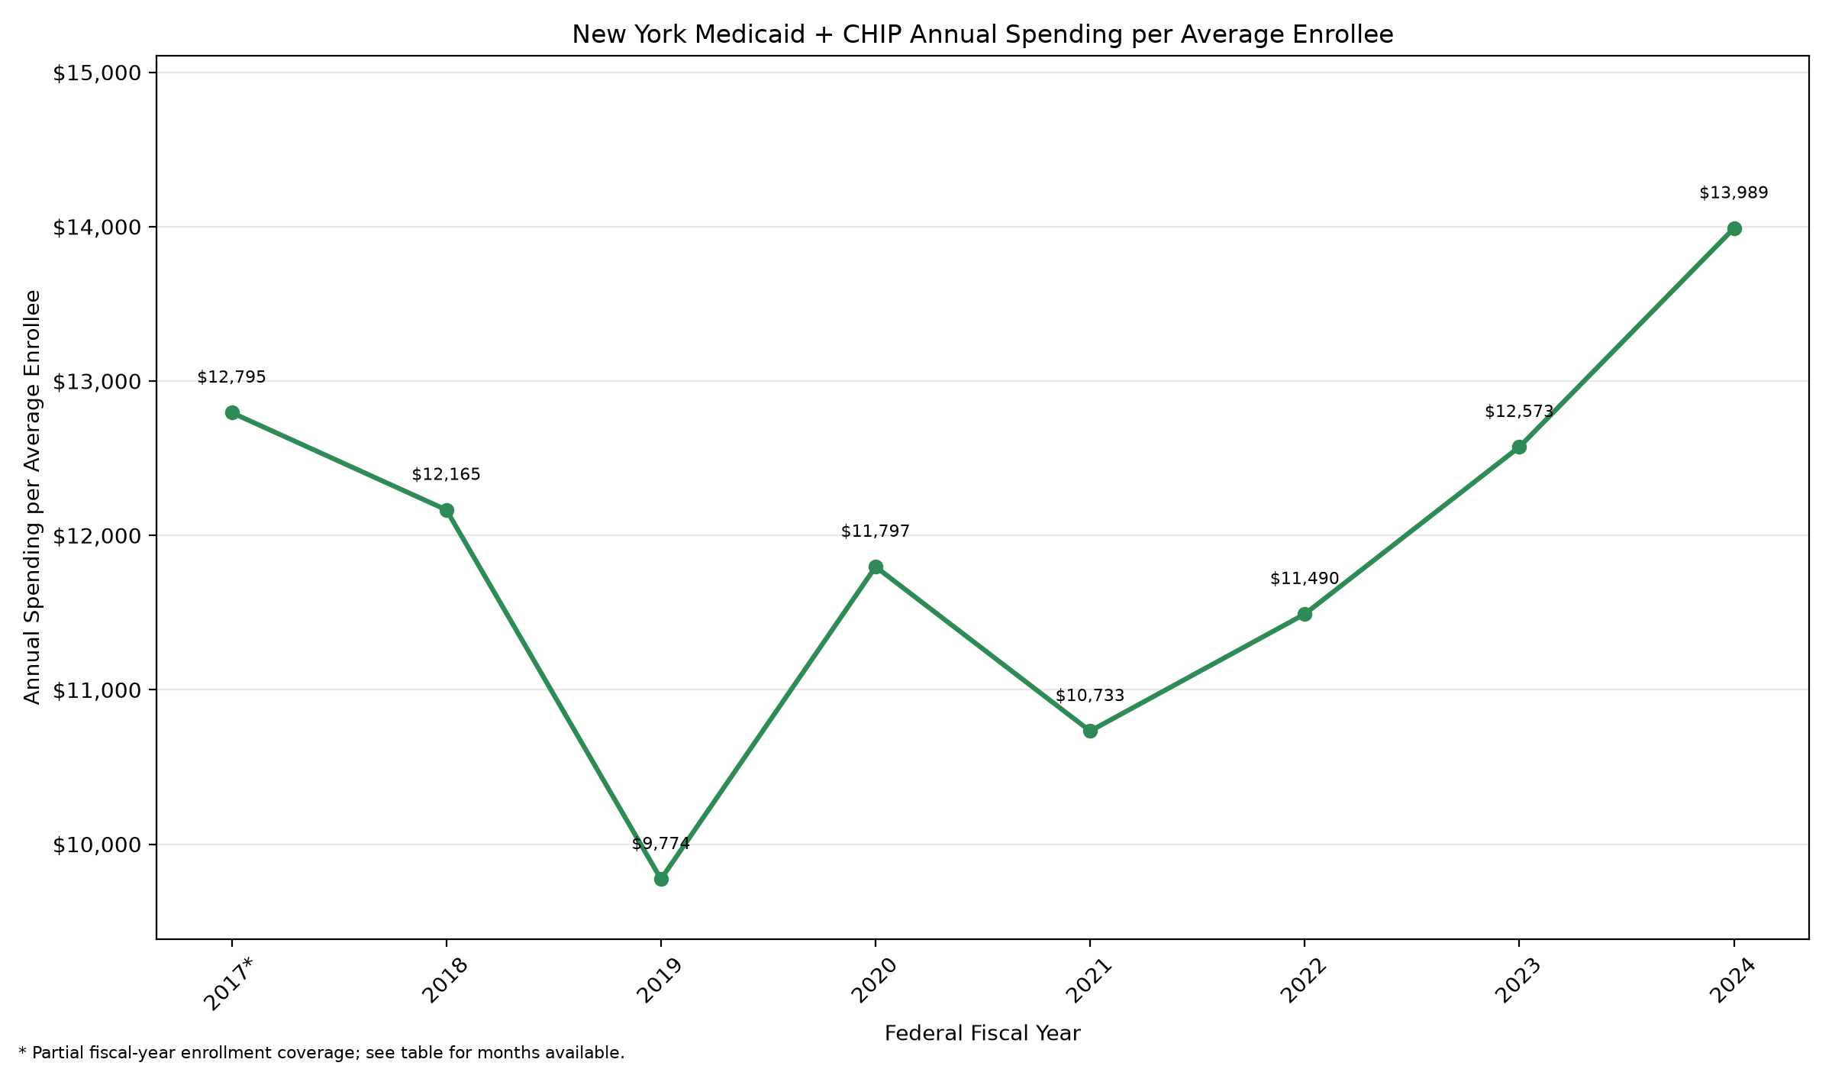

Illinois
Illinois’s Medicaid and CHIP enrollment fell from 3.87 million in July 2023 to 3.01 million in March 2026. As in New York, spending did not follow enrollment downward. In fiscal year 2024, average monthly enrollment dropped 8.6%, while total spending rose 1.1% to $33.28 billion. Spending per average enrollee reached $9,532, an increase of 10.6% from the previous year and 31.6% from fiscal year 2018.
The Illinois Department of Healthcare and Family Services identified greater medical needs among those who remained enrolled as one reason spending liabilities increased after eligibility reviews resumed [4]. This helps explain how spending can rise even when fewer people are covered. Hospital payment changes may also have contributed, although the state’s January 2024 notice said the fee-for-service rate changes were still awaiting federal approval [5]. This analysis does not measure the contribution of either factor.
Both spending models project annual expenditure reaching about $41 billion in fiscal year 2034: $41.39 billion under the Holt damped-trend model and $41.14 billion under the model with trend changes. Despite their different approaches, both extend an upward spending trend.
The enrollment forecast is harder to interpret. It projects a decline to 0.80 million by March 2036 by carrying the final fitted trend forward for ten years. If the recent losses mainly reflect the temporary effects of eligibility reviews, that approach could overstate the longer-term decline. The projection therefore needs to be checked against newer enrollment data before it is used for planning.
Figure 4. Monthly enrollment forecast
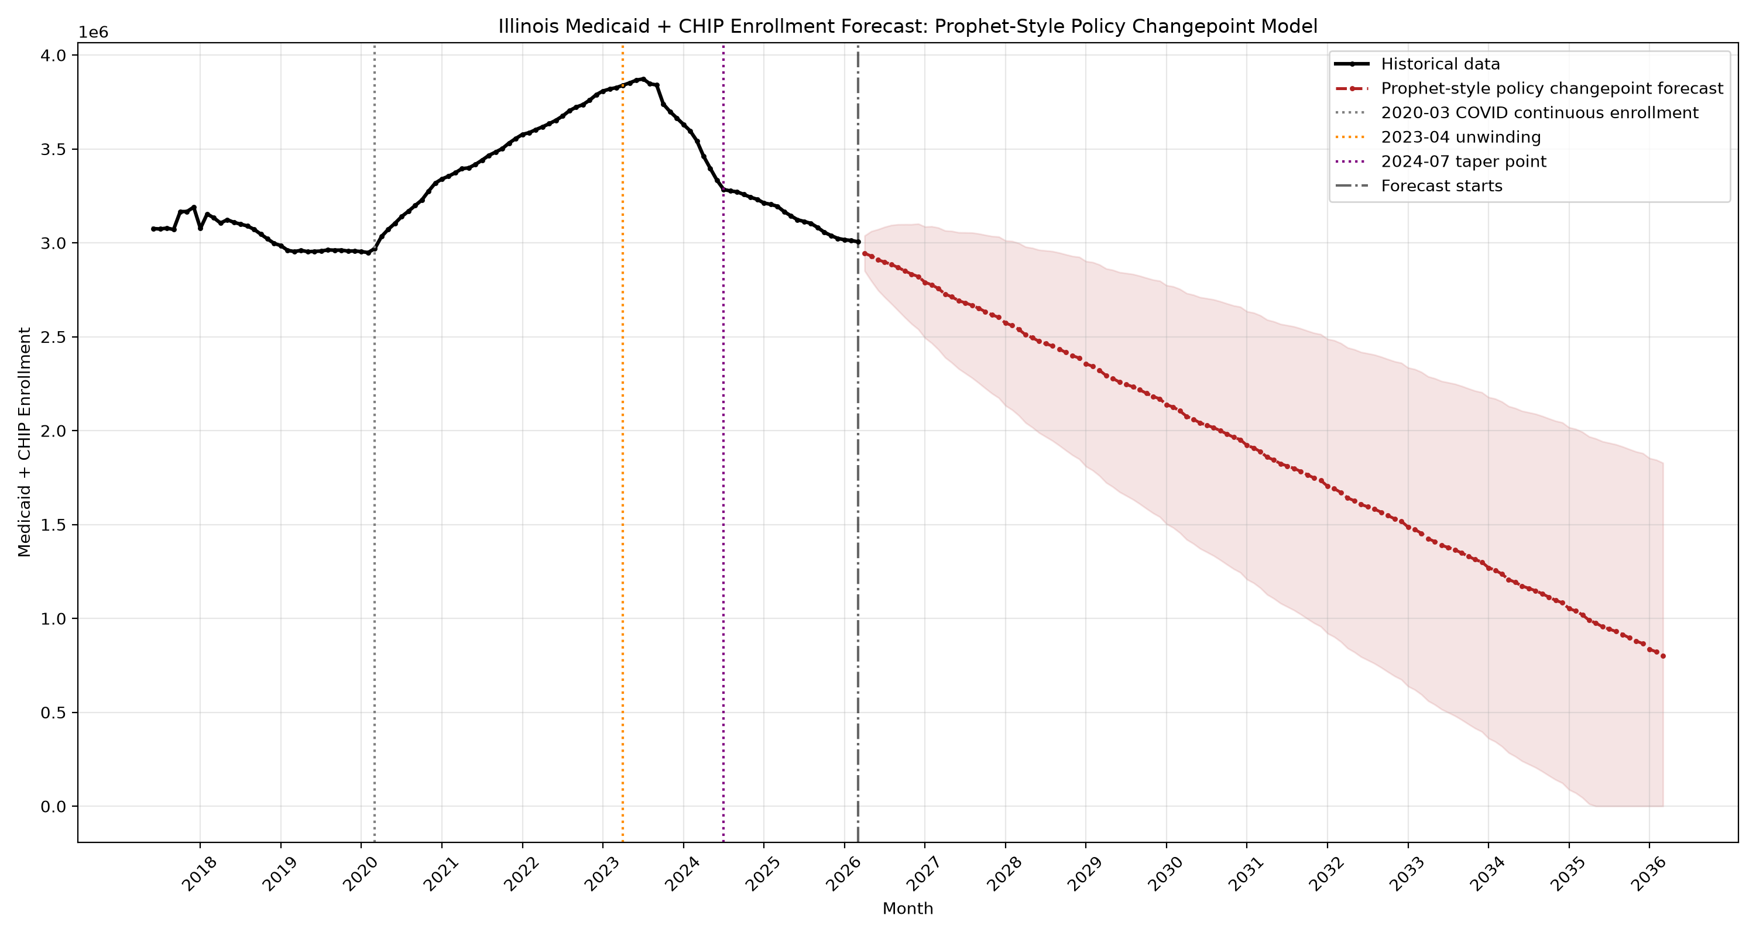
Figure 5. Annual expenditure forecast: Holt-damped model
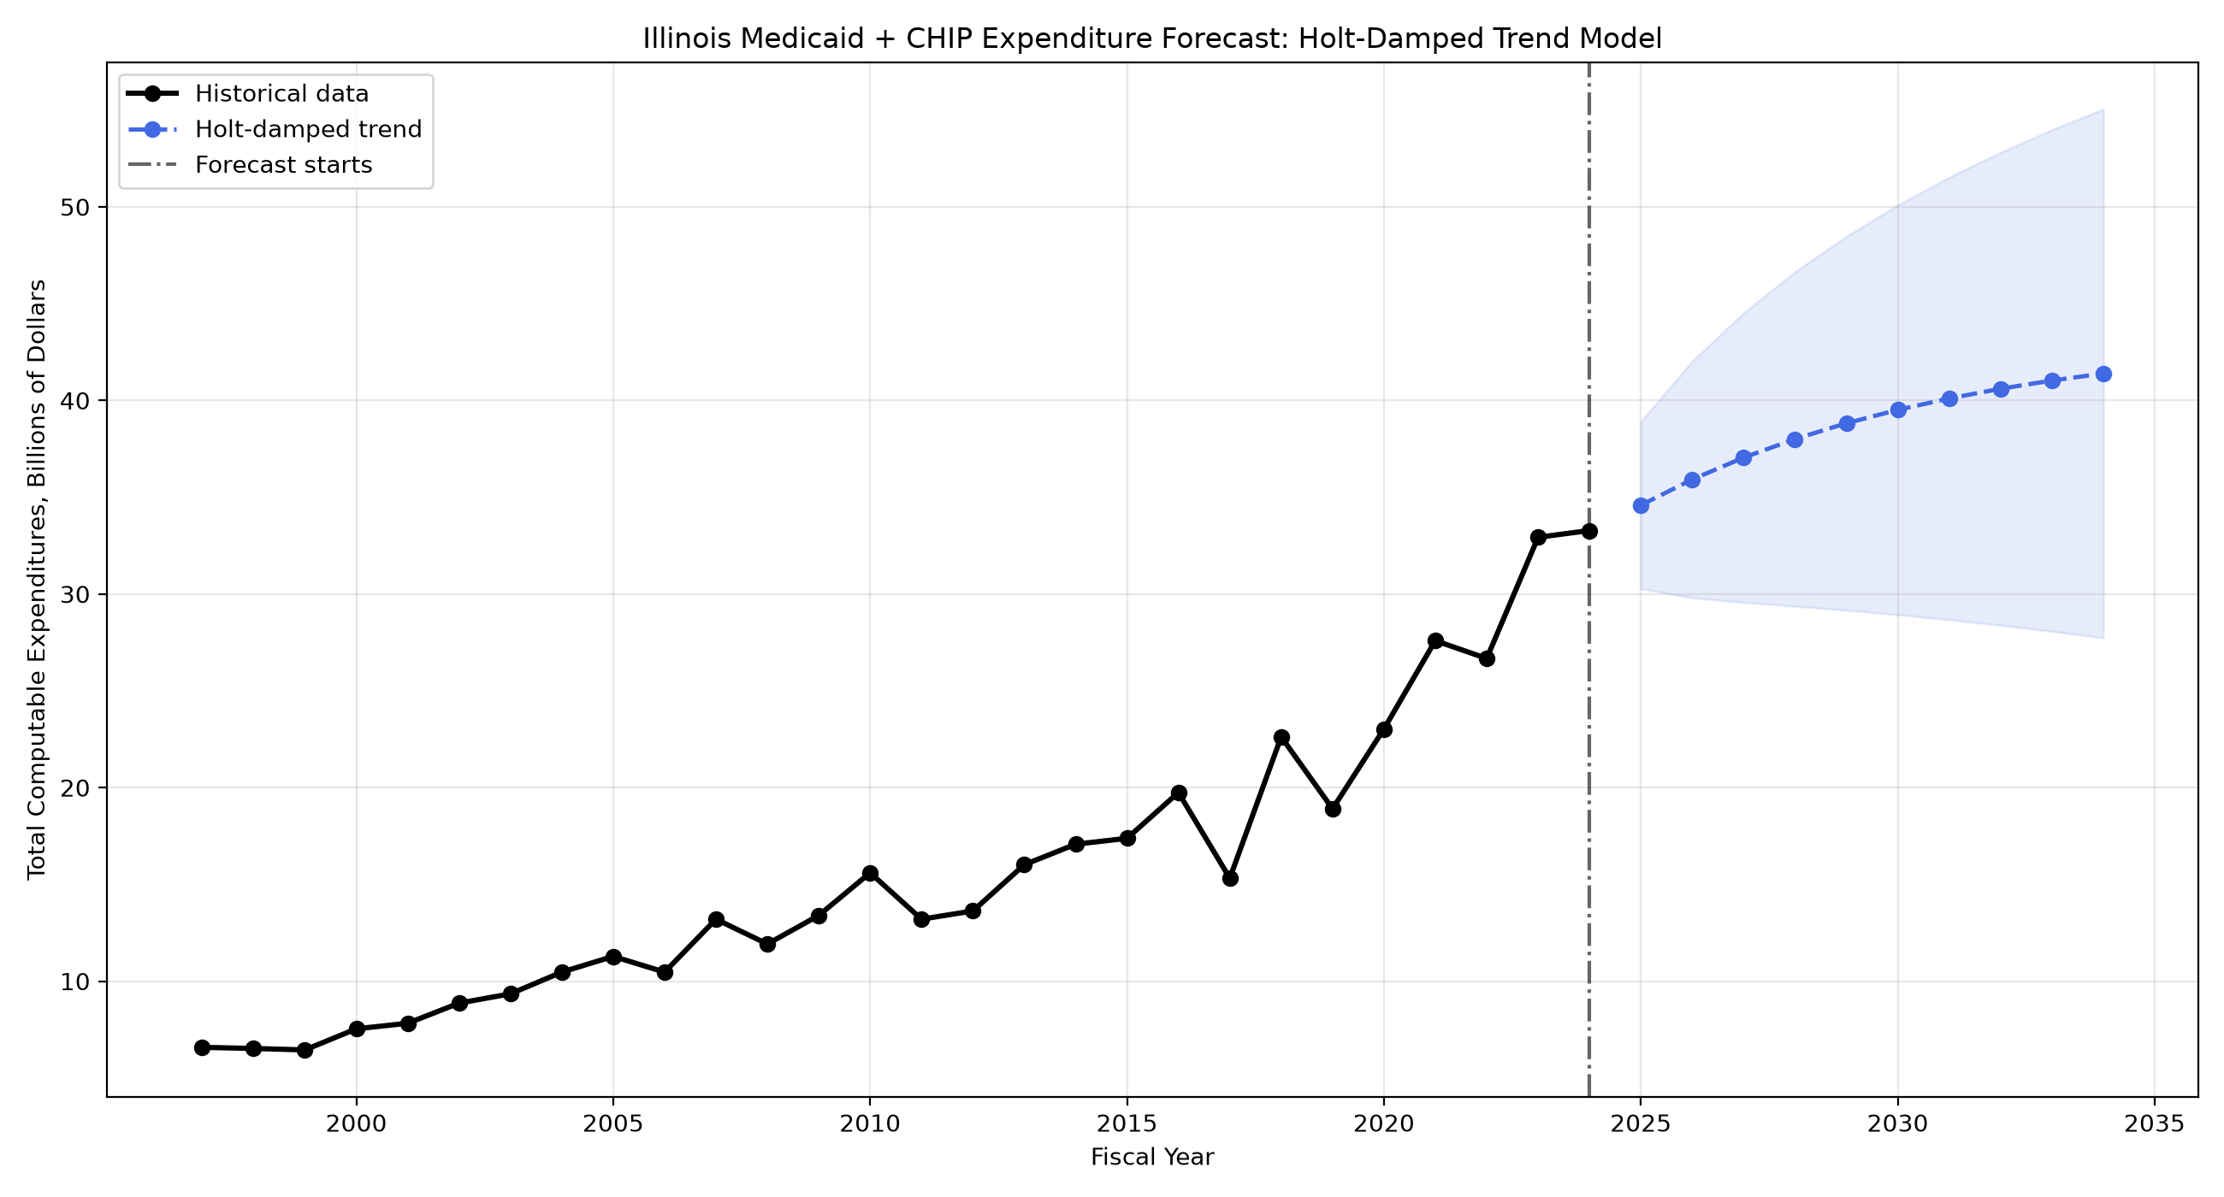
Figure 6. Annual expenditure forecast: policy changepoint model
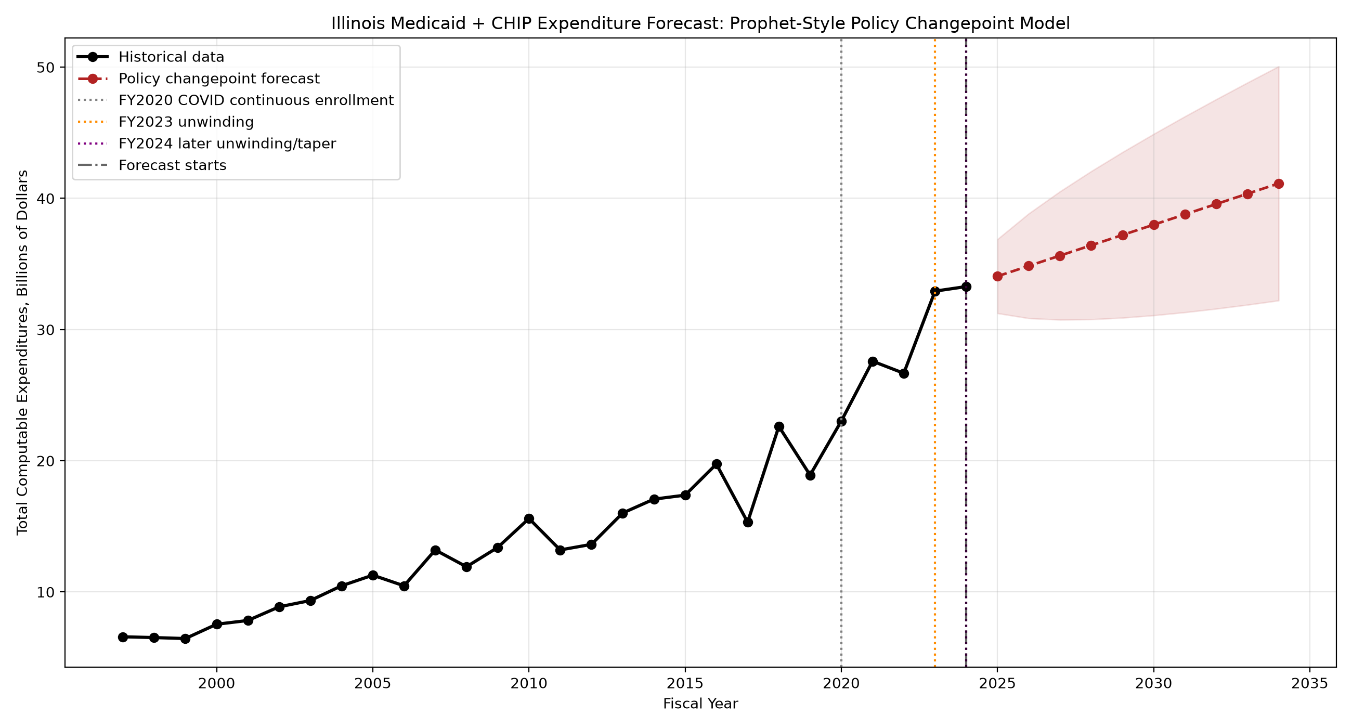
Figure 7. Historical spending per average enrollee
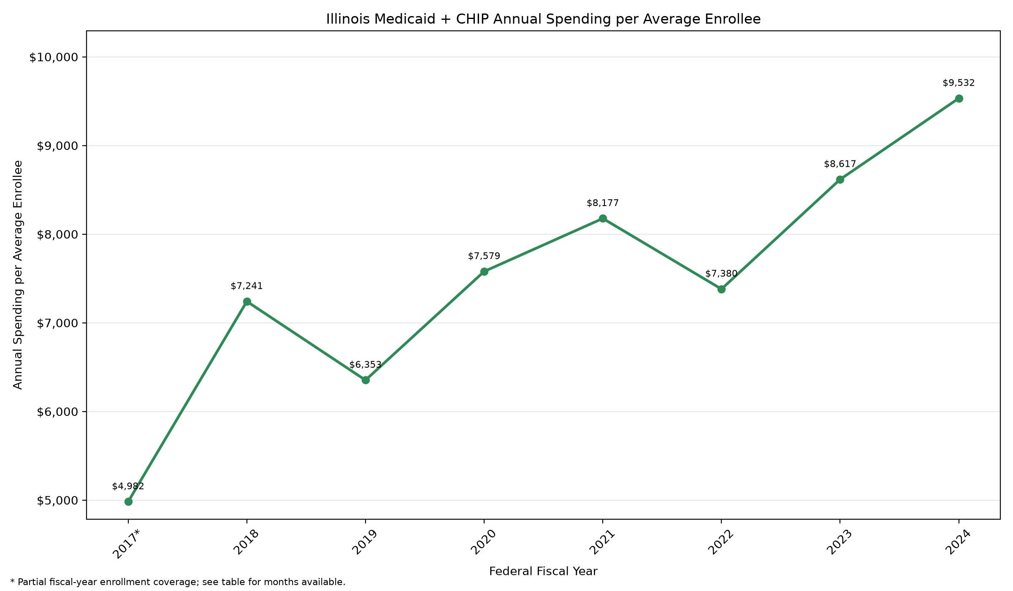

Washington State
Washington’s Medicaid and CHIP enrollment fell from a peak of 2.20 million in May 2023 to 1.79 million in March 2026. In fiscal year 2024, average monthly enrollment declined 11.5%, but total spending rose 9.0% to $20.24 billion. Spending per average enrollee increased 23.2% to $10,748—the largest increase among the four states that year. It was also 55.0% above its fiscal year 2018 level of $6,934.
Washington increased payments for several Medicaid behavioral health services during this period. Effective January 1, 2024, the state raised managed care payment rates for community behavioral health services by 15% and certain fee-for-service behavioral health rates by 22% [6]. With higher rates paid for these services, falling enrollment alone would not necessarily bring spending down. These changes provide context for the spending increase, though their share of the overall growth is not measured here.
The enrollment model projects little further change, reaching 1.82 million by March 2036. Both spending models, however, project continued increases: annual spending reaches $24.27 billion under the Holt damped-trend model and $28.00 billion under the model with trend changes in fiscal year 2034.
Figure 8. Monthly enrollment forecast
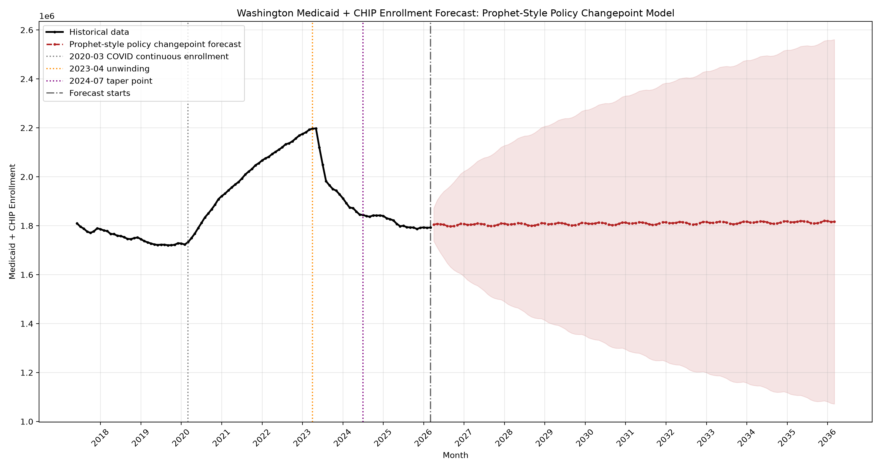
Figure 9. Annual expenditure forecast: Holt-damped model
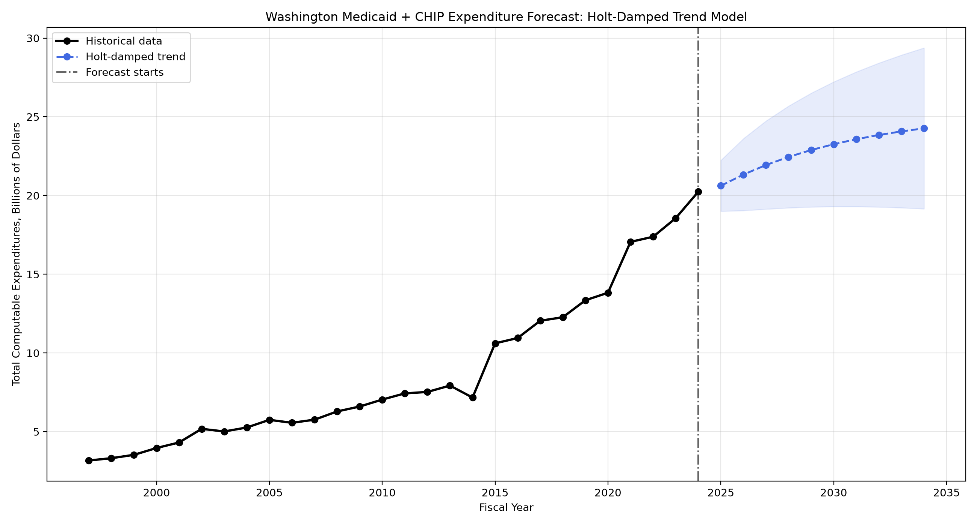
Figure 10. Annual expenditure forecast: policy changepoint model
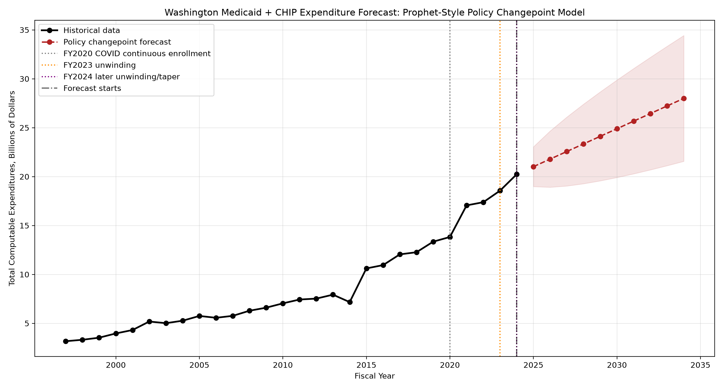
Figure 11. Historical spending per average enrollee
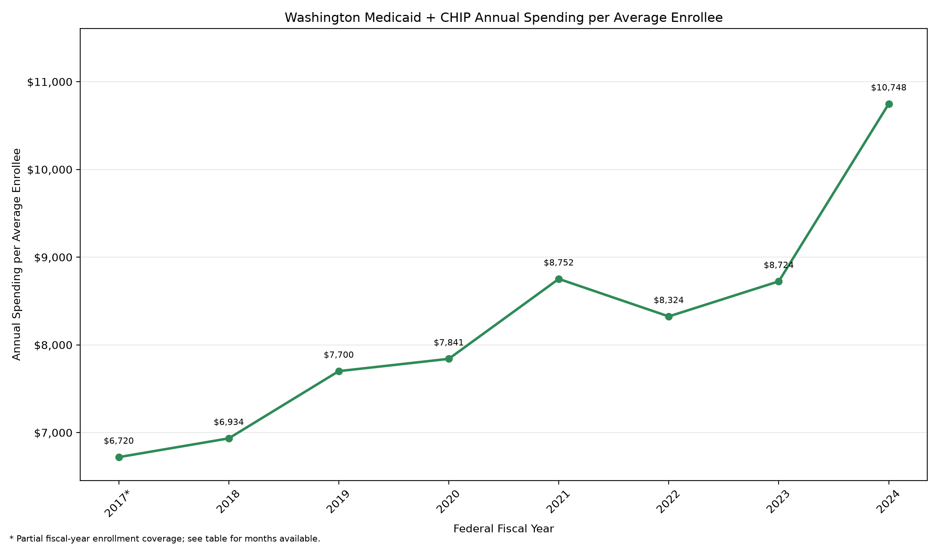

Pennsylvania
Pennsylvania’s Medicaid and CHIP enrollment fell from a peak of 3.74 million in April 2023 to 3.01 million in March 2026. This decline coincided with the return of eligibility reviews, during which people could lose coverage because they no longer qualified or did not complete the renewal process [7]. The enrollment model projects a slower decline over the next decade, reaching 2.51 million by March 2036, about 17% below the latest observed level.
Unlike the other three states, Pennsylvania recorded a small decrease in total spending in fiscal year 2024. Expenditure fell about 1.0% to $44.05 billion, while average monthly enrollment dropped 11.2%. Because enrollment fell much faster than spending, spending per average enrollee still rose 11.5% to $13,509. That was 34.3% above the fiscal year 2018 figure of $10,062.
Whether that spending decrease will continue is less clear. The Holt damped-trend model follows the longer-term upward pattern and projects annual spending of $51.60 billion in fiscal year 2034, about 17% above fiscal year 2024. The model with trend changes instead extends the recent decline, bringing spending to $28.24 billion, about 36% below fiscal year 2024.
The two forecasts leave a wide range of possible outcomes. Both reflect patterns in the historical data, but they give different weight to the recent spending decrease. Neither can tell us whether that decrease marks a lasting shift. For Pennsylvania, the projected decline in enrollment therefore offers little certainty about where total spending is headed.
Figure 12. Monthly enrollment forecast
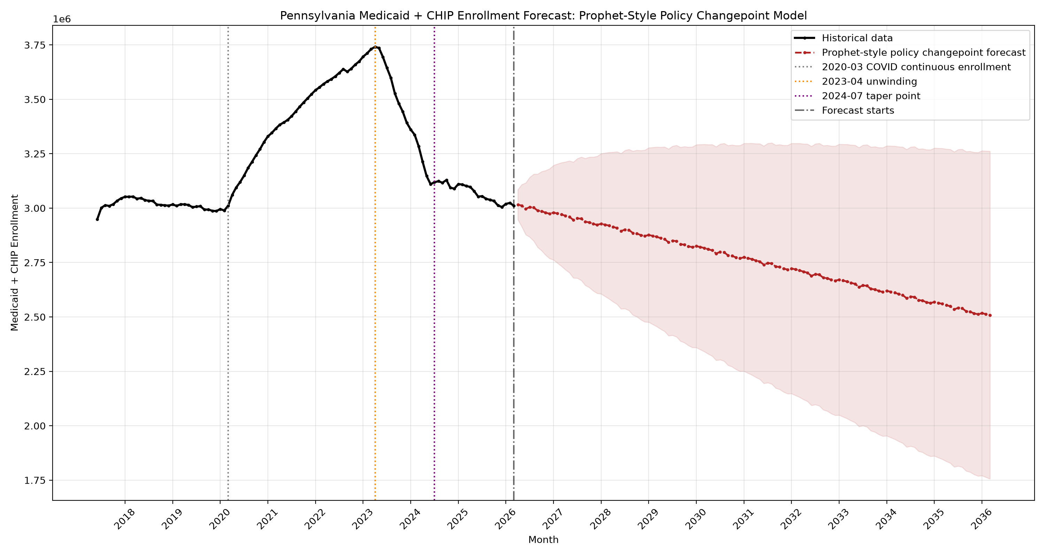
Figure 13. Annual expenditure forecast: Holt-damped model
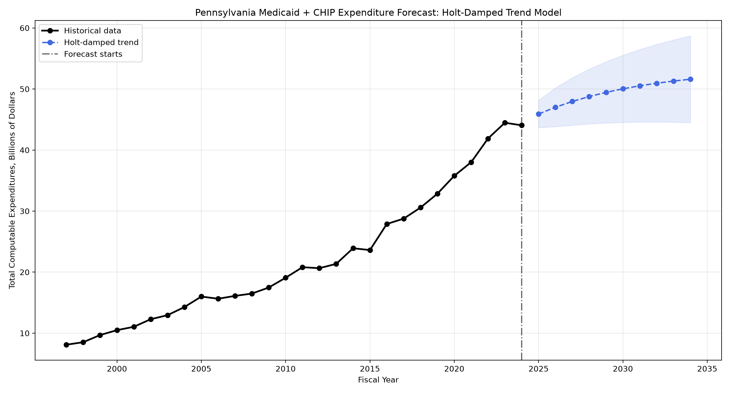
Figure 14. Annual expenditure forecast: policy changepoint model
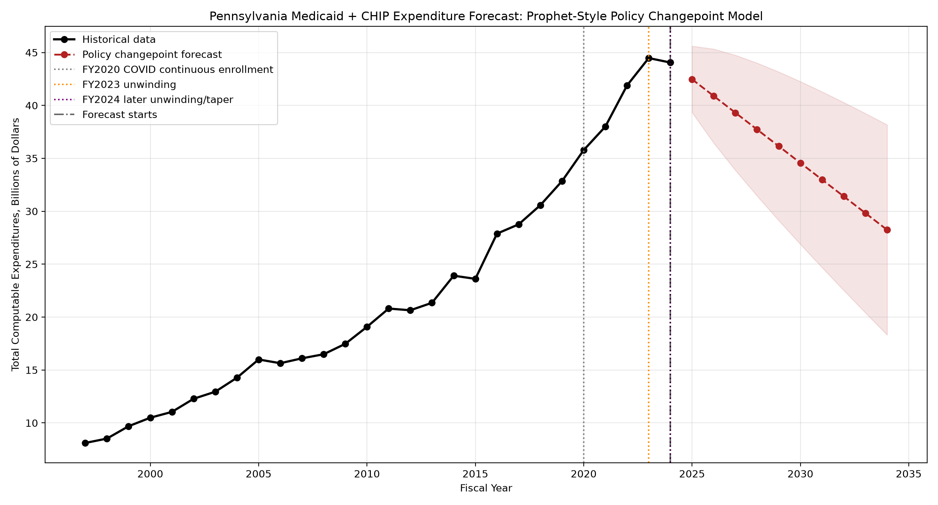
Figure 15. Historical spending per average enrollee
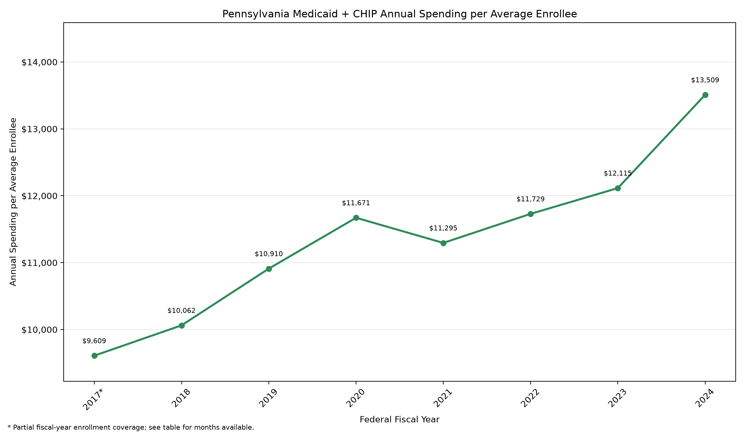
Across the four states, declining enrollment has not brought an equivalent decline in spending. In fiscal year 2024, spending per average enrollee rose in every state, even where total expenditure fell. The forecasts suggest that spending pressure could persist, although Pennsylvania’s contrasting projections show how much the outlook depends on which trends continue. Enrollment remains part of the budget picture, but payment rates and the care needs of those who remain covered also matter.

Model assumptions and limitations
The enrollment model places trend changes in March 2020, April 2023, and July 2024. The July 2024 point is a modeling choice intended to capture a possible slowdown in enrollment losses; it does not represent a policy event shared by all four states. The alternative spending model places trend changes in fiscal years 2020, 2023, and 2024. These choices affect which patterns the models carry forward. The projections do not account for future policy or economic changes and should be revisited as new data become available.

References
[1] CMS. Archived: Unwinding and Returning to Regular Operations after COVID-19. Source
[2] New York State Department of Health. 2024 Enacted Budget Medicaid Scorecard. Source
[3] New York State Department of Health. Dear Administrator Letter: Personal Care/CDPAP minimum wage reimbursement adjustments. March 22, 2024. Source
[4] Illinois HFS. FY2024 Annual Report, Overview, printed p. 7 (PDF page 7): FY2024 spending drivers. Source
[5] Illinois HFS. Hospital Rate Changes Effective January 1, 2024. January 19, 2024. Source
[6] Washington State Health Care Authority. Joint Legislative Executive Committee on Behavioral Health presentation. October 25, 2024. Behavioral Health Medicaid Rates. Source
[7] Pennsylvania DHS. PHE Unwinding Progress Tracker. Source

About the author
Yujie Zhu is a biomedical engineering major and an intern at EMRTS, aspiring to a career as a healthcare analyst. Yujie enjoys using data to understand past outcomes, uncover patterns and problems, and turn insights into better decisions and more effective processes.

