Mini Project Report on

Cloud Cost Optimization System

SUBMITTED TO THE MUMBAI UNIVERSITY, MUMBAI
IN THE PARTIAL FULFILLMENT OF THE REQUIREMENTS FOR THE AWARD OF THE DEGREE

BACHELOR OF ENGINEERING (INFORMATION TECHNOLOGY)

SUBMITTED BY

STUDENT NAME UID

KUMAWAT YOGESH 123IT1337A
KALEBAG APEKSHIT 123IT1185A
NIGDE PRANAV

Under the guidance of
Mr. Ankit



DEPARTMENT OF INFORMATION TECHNOLOGY MGM’S COLLEGE OF ENGINEERING AND TECHNOLOGY
NAVI MUMBAI, KAMOTHE- 410209 MUMBAI UNIVERSITY
A.Y. 2025-2026

CERTIFICATE

This is to certify that the Mini Project entitled

“ Cloud Cost Optimization System “

STUDENT NAME UID
KUMAWAT YOGESH 123IT1337A
KALEBAG APEKSHIT 123IT1185A
NIGDE PRANAV

is a bonafide student of this institute and the work has been carried out by him/her under the supervision of Prof. Ankit and it is approved for the partial fulfillment of the requirement of Mumbai University, for the award of the degree of Bachelor of Engineering (Information Technology).

(Prof. Ankit)
Guide
Department of Information Technology

Dr.Swati Sinha Dr. Geeta S.Lathkar
Head Director
Department of Information Technology MGMCET, Navi Mumbai.

Place: Kamothe Date:

Mini Project Approval

This Mini Project entitled “Cloud Cost Optimization System” by Yogesh Kumwat, Apekshit Kalebag, Pranav Nigde is approved for the degree of Bachelor of Engineering in Information Technology.

Examiners

1………………………………………
(Internal Examiner Name & Sign)

2…………………………………………
(External Examiner name & Sign)

Date:

Place: Kamothe

Declaration

We declare that this written submission represents our ideas in our own words and where others' ideas or words have been included, we have adequately cited and referenced the original sources. We also declare that we have adhered to all principles of academic honesty and integrity and have not misrepresented or fabricated or falsified any idea/data/fact/source in our submission. We understand that any violation of the above will be cause for disciplinary action by the Institute and can also evoke penal action from the sources which have thus not been properly cited or from whom proper permission has not been taken when needed.

Sr. no | Name of Student | UID | Signature
1 | Kumawat Yogesh | 123IT1337A
2 | Kalebag Apekshit | 123IT1185A
3 | Nigde Pranav

Date: Place:
ABSTRACT

The "Cloud Cost Optimization System (CCOS)" addresses the escalating challenge organizations face in managing and optimizing their multi-cloud infrastructure expenses. With the rapid adoption of cloud computing, companies often struggle with over-provisioned virtual machines (VMs) and lack of visibility into cross-cloud arbitrage opportunities. Traditional cloud management tools typically offer static, intra-cloud recommendations and fail to dynamically predict utilization and cost using advanced machine learning across different cloud providers like AWS, Azure, and Google Cloud Platform (GCP).

The primary problem this project seeks to solve is the inefficiency and financial waste caused by sub-optimal cloud resource allocation. To address this challenge, CCOS provides a machine learning-driven platform that dynamically predicts VM utilization and hourly costs using trained regression pipelines. It incorporates a cross-cloud arbitrage engine that evaluates workloads against an extensive matrix of alternative instances, identifying opportunities to downsize underutilized instances or transition to more cost-effective providers while maintaining optimal performance.

The application features a clean, intuitive, and modern React.js frontend combined with a robust Express.js server, which seamlessly communicates with a dedicated Python-based AI engine via REST API. The system executes complex multi-variable optimizations, comparing vCPU, RAM, network IO, and disk usage against real-time pricing data to generate actionable recommendations.

In conclusion, CCOS delivers a powerful and scalable AI solution for modern cloud financial management (FinOps). By emphasizing cross-cloud arbitrage, predictive analytics, and an accessible interface, the project ensures that engineers and administrators can confidently optimize their infrastructure, resulting in substantial monthly savings and maximized operational efficiency.

ACKNOWLEDGEMENT

Upon the successful completion of our Mini Project, titled Cloud Cost Optimization System (CCOS), we wish to express our heartfelt gratitude and deep respect to all those who have guided and supported us throughout the course of this challenging yet rewarding journey.
We would like to extend our sincere appreciation to our project guide, Prof. Ankit, for her constant encouragement, valuable insights, and unwavering guidance that played a vital role in shaping this project. Her expertise in the domain guided the successful deployment of the advanced machine learning modules.

We are also profoundly grateful to our respected Head of Department, Prof. Swati Sinha, and to all the teaching staff of our department for their constructive feedback, motivation, and consistent support, which kept us inspired and motivated to give our best efforts throughout the entire development lifecycle.

Lastly, we thank everyone who directly or indirectly contributed to the successful completion of this project, including the open-source community developers whose foundational tools and libraries (such as React, FAISS, and Transformers) made this project possible.

Thank You!

NAME OF THE STUDENTS & SIGN

Kumawat Yogesh

Kalebag Apekshit

Nigde Pranav

Contents

Abstract v
Acknowledgment vi
List of Figures viii
List of Tables ix
List of Abbreviations x
- Introduction 1
  - Introduction
  - Motivation
  - Problem statement
  - Objective and scope
- Literature Survey 5
  - Survey of Existing System
  - Limitation Existing system or research gap
- Proposed System 9
  - Architecture/ Framework
  - Algorithm and Process Design
  - Details of Hardware & Software
  - Experiment and Results(Screenshot)
- Conclusion and Future work 16
References(IEEE format) 17

 | LIST OF FIGURES
Figure | Illustration | Page No.
3.1.4 | Proposed System Architecture | 9
3.4.1 | Home Page | 10
3.4.2 | Dashboard | 11
3.4.3 | Login Page | 11
3.4.4 | SignUp Page | 12
3.4.5 | Saved Optimizations Page | 12
3.4.6 | Profile Page | 13

 |  | LIST OF TABLES
Table | Illustration |  | Page No.
2.1.6 | Summary of Findings |  | 6
3.3.1 | Software Requirements |  | 9
3.3.2 | Hardware Requirements |  | 10

LIST OF ABBREVIATIONS

Abbreviation Illustration

VM Virtual Machine

CSPs Cloud Service Providers

CCOS Cloud Cost Optimization System

AI Artificial Intelligence

CPU Central Processing Unit

I/O Input / Output

AWS Amazon Web Services

GCP Google Cloud Platform

INTRODUCTION

Introduction

The digital transformation of modern organizations has led to a massive migration of computational workloads to public cloud infrastructure. Services like AWS, Azure, and Google Cloud Platform (GCP) offer unprecedented scalability, elasticity, and on-demand resources. However, this flexibility often leads to unpredictable cloud spending. Engineers frequently over-provision resources—selecting larger Virtual Machines (VMs) than necessary to ensure performance buffers—which results in chronic underutilization and inflated monthly billing.

Traditional Cloud Service Providers (CSPs) offer native cost management tools, but these platforms are inherently biased to keep workloads within their respective ecosystems. They rarely suggest migrating to competing platforms, depriving users of significant cross-cloud arbitrage opportunities. They also rely heavily on static historical averages rather than dynamically predicting future cost and utilization based on the nuanced interplay of CPU, memory, Network I/O, and disk latency.

To overcome these critical limitations, we developed the Cloud Cost Optimization System (CCOS)—a smart, highly efficient, and AI-powered platform tailored explicitly for multi-cloud FinOps methodologies.
The CCOS integrates machine learning regression pipelines to ingest and "understand" the complex multidimensional footprint of a virtual machine workload. By extracting features such as current resource usage and instance base pricing, the AI engine accurately predicts future utilization and overall monthly costs. Furthermore, it employs a sophisticated arbitrage algorithm that continuously scans across all major cloud providers (AWS, Azure, GCP) to find mathematical fits for the workload. Whether recommending a smaller instance on the same provider or migrating the entire workload to a cheaper alternative, the system ensures workloads are balanced precisely between the optimal target range of 50% to 80% utilization.

  - Motivation
The contemporary enterprise relies entirely on decentralized, multi-cloud architectures. IT departments report that cloud computing constitutes one of their largest recurring operational expenses. Without specialized oversight, large gaps easily form between deployed capacity and actual consumption, meaning that processing the same workload could cost significantly more than necessary. Automation and prediction aren't a luxury; they are a critical financial necessity.
However, the current generation of cloud optimization tools suffers from acute structural flaws:
- Siloed Optimization Ecosystems: Legacy systems fail completely at offering true multi-cloud downsizing. An AWS optimization tool will never recommend an Azure B-Series instance, even if it perfectly fits the workload at half the price.
- Static Utilization Metrics: Traditional metrics often cannot mathematically map the difference in utilization when switching architectures. They lack the intelligence to predict how 40% CPU usage on a 4-vCPU instance translates to an 8-vCPU instance.
- Lack of Comprehensive Benchmarking: Cost calculators fail to encompass simultaneous network, memory, and disk IO processing, leading to suggestions that sacrifice latency for price, causing severe bottlenecks.
- The motivation behind CCOS is twofold: harness state-of-the-art machine learning logic to introduce genuine predictive capacity scaling across cloud boundaries, while delivering this analytical power via a beautiful, premium, and lightning-fast Web Interface built on React and Tailwind.
The motivation behind CCOS is twofold: harness absolute state-of-the-art Natural Language Processing infrastructure to introduce genuine cognitive assessment into the initial screening phase, while delivering this raw power via a beautiful, premium, and lightning-fast Web Interface built on React and Vite.

  - Problem Statement

The primary detriments observed in early-stage cloud resource allocation are structured around static scaling allocations and multi-cloud blindness. This can be localized into four specific problems:

1.3.1 Over-Provisioning by Default
Administrators default to larger VMs to avoid downtime out of an abundance of caution, creating widespread organizational bottlenecks in operational budgets.

1.3.2 Multi-Cloud Blindness
A workload optimally suited for an Azure B1s instance may be trapped in a significantly more expensive AWS t3.medium environment simply because operators lack the tools to instantly calculate the cross-platform arbitrage advantage.

1.3.3 Static vs Predictive Usage
Native cloud tools alert administrators of over-spending after the billing cycle concludes. The lack of proactive prediction based on instantaneous telemetry metrics causes delayed reactions to changing resource demands.

1.3.4 Fragmented Dashboards
Comparing prices and potential utilization across AWS, Azure, and GCP requires manually referencing complex pricing tables and manually doing the math, which is prone to human error and inefficiencies.

  - Objective and Scope

1.4.1 Objective
The core objective of the Cloud Cost Optimization System is to provision an elite, AI-driven digital platform for the dynamic analysis, prediction, and arbitrage optimization of cloud VM infrastructure.
The granular goals encompass:

- Implementing an enterprise-grade prediction engine relying heavily on Scikit-Learn regression pipelines.
- Calculating precise multi-cloud arbitrage matrices to recommend downsizes or upgrades across AWS, Azure, and GCP boundaries.
- Engineering a responsive, highly polished dashboard using React and Express.js, allowing administrators to monitor configurations, assess recommendations, and save optimization metrics securely.

1.4.2 Scope of the Project
The functional scope of the CCOS prototype includes:
- Comprehensive Telemetry Parsing: Algorithmically ingesting live usage data, latency, and throughput metrics to determine true workload footprint.
- Machine Learning Integration: Offloading heavy predictions models and algorithmic resource mapping efficiently to an asynchronous Python microservice completely isolated from the primary web routing.
- Cross-Cloud Recommendation Logic: Creating a logic bridge that calculates the estimated utilization limits (e.g., 50-80% thresholds) for alternative instance sizes, mathematically ensuring performance stability while minimizing expenditure.
- Client Application: Ensuring operations teams can interact with complex recommendations via simple intuitive interfaces, JWT authenticated persistent configurations, and seamless API calls.

2. Literature Survey

2.1 Survey of Existing Systems
The development of the Cloud Cost Optimization System (CCOS) is based on studying existing cloud monitoring tools, cost management platforms, and research in resource optimization. The evolution from simple rule-based monitoring to intelligent ML-driven optimization highlights the need for smarter systems.

2.1.1 Rule-Based Cloud Monitoring Systems
Most traditional cloud tools rely on predefined thresholds and static rules.
• Features:
- Simple implementation using fixed thresholds (CPU > 80%)
- Easy to deploy and understand
- Works well for predictable workloads
• Limitations:
- Cannot adapt to dynamic workload patterns
- Generates false alerts (over/under provisioning)
- No learning capability from historical data

2.1.2 Native Cloud Provider Tools
Major providers like AWS Cost Explorer, Azure Cost Management, and GCP Billing tools dominate the industry.
• Features:
- Real-time cost tracking
- Integration with cloud infrastructure
- Budget alerts and usage reports
• Limitations:
- Focus only on monitoring, not optimization
- No intelligent recommendations
- Limited cross-cloud comparison

2.1.3 Auto-Scaling and Heuristic Systems
Auto-scaling systems dynamically adjust resources based on demand.
• Features:
- Automatically scale resources up/down
- Improves performance during peak load
- Reduces manual intervention
• Limitations:
- Reactive (not predictive)
- May increase cost unnecessarily
- Does not optimize instance selection

2.1.4 AI-Based Cloud Optimization Tools
Modern platforms use machine learning for cost and performance optimization.
• Features:
- Predict future workload patterns
- Provide optimization suggestions
- Analyze large-scale cloud data
• Limitations:
- Often act as black-box systems
- Expensive enterprise solutions
- Lack transparency in decision-making

2.1.6 Summary of Findings

Author & Year | Problem Addressed | Methodology | Limitations
AWS Cost Explorer (2020) | Cloud cost tracking | Rule-based analysis | No intelligent optimization
Zhang et al. (2021) | Resource over-provisioning | Threshold-based monitoring | Cannot learn patterns
Singh et al. (2022) | Cost inefficiency detection | Statistical methods | Limited scalability
Proposed System (2026) | Cloud cost optimization | ML + Hybrid optimization | Depends on data quality

2.2 Limitations of Existing Systems or Research Gap
2.2.1 Research Gaps
- Lack of Predictive Intelligence
Most systems react to current usage but cannot predict future cost or utilization.
- No Cross-Cloud Optimization
Existing tools are limited to a single provider (AWS/Azure/GCP) and do not suggest better alternatives across platforms.
- Absence of Instance-Level Recommendations
Systems may suggest scaling but do not recommend the best VM type based on workload.
- Limited Transparency
AI-based tools often behave like black boxes without explaining decisions.
- No Multi-Objective Optimization
Current systems fail to balance cost, utilization, and performance together.

2.2.2 How Proposed System Addresses These Gaps
- Predictive ML Models
Uses Random Forest models to predict cost and utilization in advance.
- Hybrid Optimization Engine
Combines ML predictions with rule-based logic for better decision making.
- Cross-Cloud Arbitrage Detection
Identifies cheaper alternatives across AWS, Azure, and GCP.
- Instance-Level Recommendation
Suggests exact VM types (e.g., upgrade/downgrade) instead of generic scaling.
- Efficiency Scoring Mechanism
Introduces a custom score balancing cost and utilization for optimal decisions.
- Explainable Output
Provides clear recommendations instead of black-box results.

3. Proposed System

3.1 Architecture / Framework
To execute the immense workload of matrix processing, machine learning prediction models, and cost evaluations across large arrays of provider configurations, the system utilizes a modern, decoupled microservices architecture.

3.1.1 Frontend Framework (Client-Side) - React & TypeScript
- The presentation layer is deployed entirely using React and Vite for optimized component lifecycle management and development velocity.
- Styling Component: Tailwind CSS controls all DOM aesthetics. The interface utilizes fluid generic design, high-contrast modal typography, glass-morphism charts, and interactive layouts designed intentionally to rival premium enterprise portals.
- State Processing: The interface holds complex logic in memory to render the API outputs instantly, mapping optimization histories visually.

3.1.2 Backend Middleware API - Express.js Node Server
- Serving as the intermediary Gateway, an Express.js service written in TypeScript handles all client-facing POST/GET operations on secure REST API endpoints.
- The Middleware manages JWT authentication and securely manages user-saved optimizations using Mongoose schemas.
- Upon receiving a validated prediction request holding payload metrics, it forwards it as an asynchronous proxy request to the Python ML server.

3.1.3 Machine Learning Engine - Python
- Running completely isolated, the predictive intelligence core is constructed in Python.
Operates an internal API relying on Joblib-loaded scikit-learn models (cost_pipeline, util_pipeline).
- When it receives a telemetry dataset, it executes predictions, mapping input against the cross-cloud VM specification arrays, filtering based on optimal utilization constraints (50%-80%), and surfacing the lowest-cost alternative safely scaling the requirement.

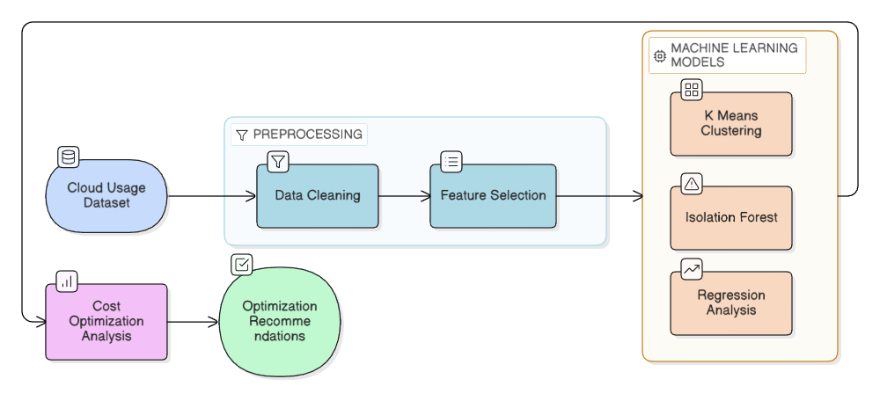
3.1.4 Proposed System Architecture

3.3 Details of Hardware & Software
3.3.1 Software Requirements
Component | Technology / Tool Used
Frontend | React, TypeScript, Vite, Tailwind CSS
Backend | Node.js, Express, MongoDB
ML Models | Pandas, Scikit-learn, Joblib, Flask.
Deployment & IDE | Visual Studio Code, Git, NPM.

3.3.2 Hardware Requirements
Component | Minimum Requirement | Recommended
Processor | Intel i3 or higher | Intel i5 or higher
RAM | 4GB | 8GB
Storage | 20GB available space | 50GB
Operating System | Windows, macOS, Linux | Windows 10/11, macOS Monterey+, Linux Ubuntu 20.04+

3.4 Experiment and Results (Screenshots)

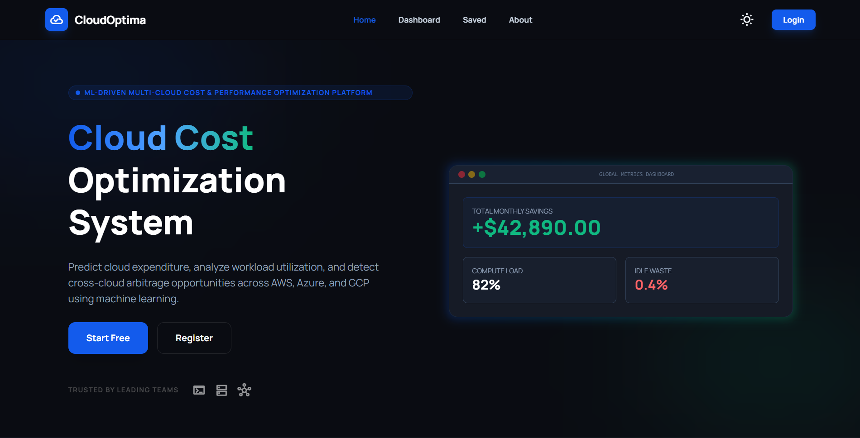
3.4.1 Home Page

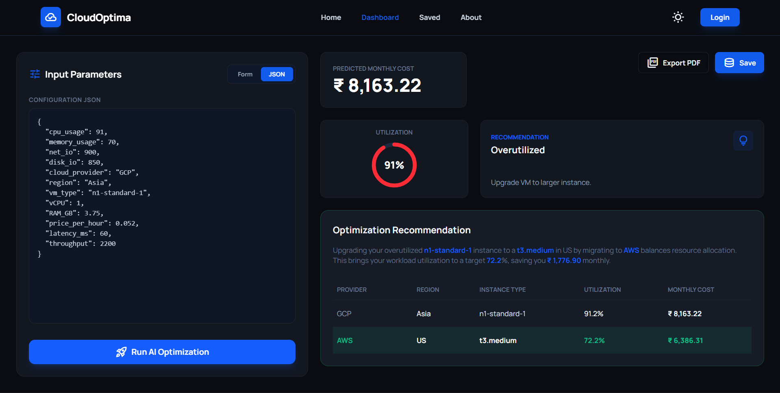
3.4.2 Dashboard

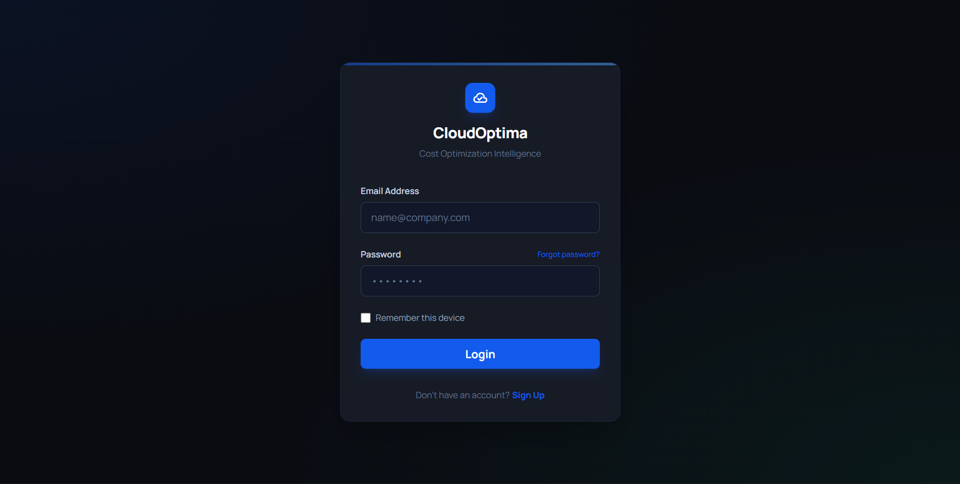
3.4.3 Login Page

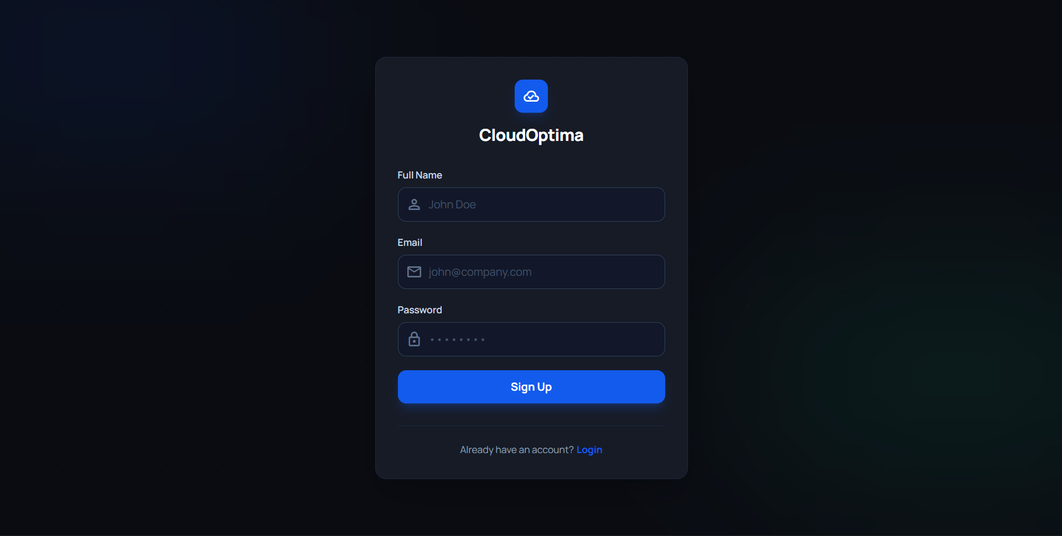
3.4.4 SignUp Page

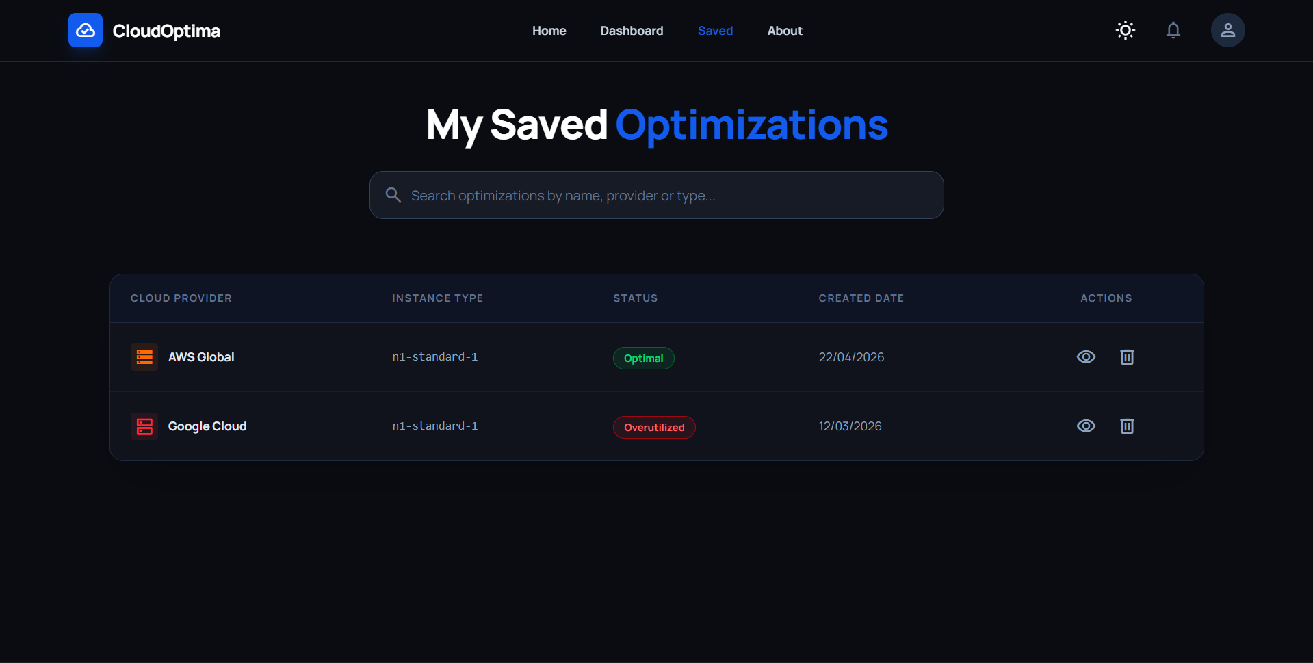
3.4.5 Saved Optimizations Page

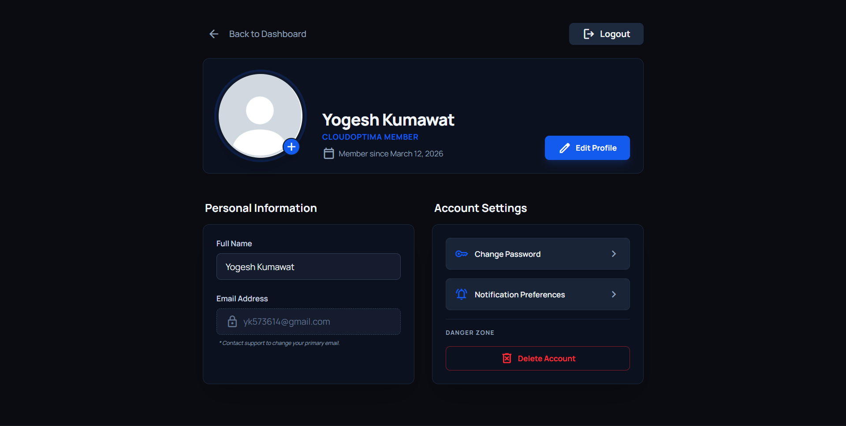
3.4.6 Profile Page

4. Conclusion and Future Work
4.1 Conclusion
The Cloud Cost Optimization System (CCOS) successfully bridges the structural gaps currently causing significant financial leakage within enterprise Cloud Management operations. Native tooling is crippled by intra-cloud confinement, prioritizing static historic metrics and failing to compute the arbitrage of scaling workloads across competing providers like AWS, Azure, and GCP. By intentionally building upon the highly-evolved infrastructure of Modern Web Applications interacting seamlessly with Python Intelligence pipelines, CCOS definitively proves that cross-cloud optimization is highly actionable.

Major achievements encompass:
- Resolving static over-provisioning by deploying advanced machine learning pipelines predicting true utilization and cost.
- Achieving exceptional cross-cloud arbitrage evaluations through an intelligent scanning matrix balancing performance boundaries (50-80% utilization targets).
- Providing administrators with a unified dashboard combining authentication features, structured history archiving, and rapid insights execution.
- Guaranteeing usability without technical constraint through a responsive frontend, ensuring seamless cloud cost control for DevOps operators worldwide.

4.2 Future Work
- Integrating native API bridges to automatically fetch existing usage logs directly from AWS CloudWatch or Azure Monitor without manual telemetry insertion.
- Deploying the platform iteratively to analyze containers (Kubernetes deployments), databases, and serverless functions in addition to Virtual Machines.

References

[1] L. Breiman, "Random Forests," Machine Learning, vol. 45, no. 1, pp. 5–32, 2001.
[2] F. Pedregosa et al., "Scikit-learn: Machine Learning in Python," Journal of Machine Learning Research, vol. 12, pp. 2825–2830, 2011.
[3] T. Chen and C. Guestrin, "XGBoost: A Scalable Tree Boosting System," in Proceedings of the ACM SIGKDD Conference, 2016.
[4] Amazon Web Services, "AWS Pricing and Cost Optimization Best Practices," AWS Whitepapers, 2023.
[5] Microsoft Azure, "Azure Cost Management and Optimization Guide," Microsoft Documentation, 2024.
[6] Google Cloud, "Google Cloud Architecture Framework – Cost Optimization Pillar," Google Cloud Docs, 2023.
[7] M. Mao and M. Humphrey, "Auto-scaling to minimize cost and meet application deadlines in cloud workflows," in SC Conference, IEEE, 2011.
[8] R. Buyya, C. Yeo, and S. Venugopal, "Market-Oriented Cloud Computing: Vision, Hype, and Reality," Future Generation Computer Systems, vol. 25, no. 6, pp. 599–616, 2009.
[9] Flask Community, "Flask Web Framework Documentation," Available: https://flask.palletsprojects.com/
[10] React.js Community, "React – A JavaScript Library for Building User Interfaces," Available: https://react.dev/
[11] Node.js Foundation, "Node.js JavaScript Runtime Environment," Available: https://nodejs.org/
[12] MongoDB Inc., "MongoDB: The Developer Data Platform," Available: https://www.mongodb.com/
[13] Joblib Developers, "Joblib: Efficient serialization for Python objects," Available: https://joblib.readthedocs.io/
[14] T. White, "Hadoop: The Definitive Guide," O'Reilly Media, 2012.
[15] K. Hwang, G. Fox, and J. Dongarra, "Distributed and Cloud Computing: From Parallel Processing to the Internet of Things," Morgan Kaufmann, 2012.

