Mini Project Report on

Intelligent Resume Shortlisting System

SUBMITTED TO THE MUMBAI UNIVERSITY, MUMBAI
IN THE PARTIAL FULFILLMENT OF THE REQUIREMENTS FOR THE AWARD OF THE DEGREE

BACHELOR OF ENGINEERING (INFORMATION TECHNOLOGY)

SUBMITTED BY

STUDENT NAME UID

KUMAWAT YOGESH 123IT1337A
KALEBAG APEKSHIT 123IT1185A
MANE RITESH 124IT3177A
KOLEKAR ANIKET 124IT3253A

Under the guidance of
Ms. Mitrakshi Patil



DEPARTMENT OF INFORMATION TECHNOLOGY MGM’S COLLEGE OF ENGINEERING AND TECHNOLOGY
NAVI MUMBAI, KAMOTHE- 410209 MUMBAI UNIVERSITY
A.Y. 2025-2026


CERTIFICATE

This is to certify that the Mini Project entitled

“ Intelligent Resume Shortlisting System “

STUDENT NAME UID
KUMAWAT YOGESH 123IT1337A
KALEBAG APEKSHIT 123IT1185A
MANE RITESH 124IT3177A
KOLEKAR ANIKET 124IT3253A

is a bonafide student of this institute and the work has been carried out by him/her under the supervision of Prof. Mitrakshi Patil and it is approved for the partial fulfillment of the requirement of Mumbai University, for the award of the degree of Bachelor of Engineering (Information Technology).

(Prof. Mitrakshi Patil)
Guide
Department of Information Technology

Dr.Swati Sinha Dr. Geeta S.Lathkar
Head Director
Department of Information Technology MGMCET, Navi Mumbai.

Place: Kamothe Date:

Mini Project Approval

This Mini Project entitled “Intelligent Resume Shortlisting System” by Yogesh Kumwat, Apekshit Kalebag, Ritesh Mane, Aniket Kolekar is approved for the degree of Bachelor of Engineering in Information Technology.

Examiners

1………………………………………
(Internal Examiner Name & Sign)

2…………………………………………
(External Examiner name & Sign)

Date:

Place: Kamothe

Declaration

We declare that this written submission represents our ideas in our own words and where others' ideas or words have been included, we have adequately cited and referenced the original sources. We also declare that we have adhered to all principles of academic honesty and integrity and have not misrepresented or fabricated or falsified any idea/data/fact/source in our submission. We understand that any violation of the above will be cause for disciplinary action by the Institute and can also evoke penal action from the sources which have thus not been properly cited or from whom proper permission has not been taken when needed.

Sr. no | Name of Student | UID | Signature
1 | Kumawat Yogesh | 123IT1337A
2 | Kalebag Apekshit | 123IT1185A
3 | Mane Ritesh | 124IT3177A
4 | Kolekar Aniket | 124IT3253A

Date: Place:
ABSTRACT

The "Intelligent Resume Shortlisting System (IRSS)" project addresses the increasing challenge faced by HR professionals and recruiters in manually reviewing and filtering a large volume of resumes. With the competitive job market, recruiters often struggle to find a reliable method that can accurately parse, analyze, and rank candidate profiles against specific job descriptions. Traditional keyword-matching Applicant Tracking Systems (ATS) are often rigid and fail to understand the true context of an applicant's skills and experience.

The primary problem this project seeks to solve is the inefficiency and inaccuracy of traditional resume screening. To address this challenge, the IRSS was developed, providing a machine learning-driven platform that incorporates semantic search using SBERT embeddings, a FAISS vector database for scalable similarity matching, and advanced NLP techniques via spaCy for NER-based skill extraction. The system intelligently weights candidates based on relevant experience and education, providing a highly accurate ranking.

The application features a clean, intuitive, and modern React.js frontend combined with a robust Express.js server, communicating seamlessly with the Python-based AI engine via a well-defined REST API. The system executes complex L2 distance vector searches and dynamic heuristic modifiers under the hood, promoting a drastically improved recruitment workflow by making the shortlisting process effortless, unbiased, and significantly faster.

In conclusion, "Intelligent Resume Shortlisting System" delivers a powerful and scalable AI solution for modern recruitment. By emphasizing semantic precision, scalable architecture, and an accessible interface, the project ensures that recruiters can confidently discover the best talent without manual bias or fatigue, making IRSS an essential tool for human resource management in today’s fast-paced corporate environment.

ACKNOWLEDGEMENT

Upon the successful completion of our Mini Project, titled Intelligent Resume Shortlisting System (IRSS), we wish to express our heartfelt gratitude and deep respect to all those who have guided and supported us throughout the course of this challenging yet rewarding journey.
We would like to extend our sincere appreciation to our project guide, Prof. Madhuri Patil, for her constant encouragement, valuable insights, and unwavering guidance that played a vital role in shaping this project. Her expertise in the domain guided the successful deployment of the advanced machine learning modules.

We are also profoundly grateful to our respected Head of Department, Prof. Swati Sinha, and to all the teaching staff of our department for their constructive feedback, motivation, and consistent support, which kept us inspired and motivated to give our best efforts throughout the entire development lifecycle.

Lastly, we thank everyone who directly or indirectly contributed to the successful completion of this project, including the open-source community developers whose foundational tools and libraries (such as React, FAISS, and Transformers) made this project possible.

Thank You!

NAME OF THE STUDENTS & SIGN

Kumawat Yogesh
Kalebag Apekshit
Mane Ritesh
Kolekar Aniket

Contents

Abstract v
Acknowledgment vi
List of Figures viii
List of Tables ix
List of Abbreviations x
- Introduction 1
  - Introduction
  - Motivation
  - Problem statement
  - Objective and scope
- Literature Survey 5
  - Survey of Existing System
  - Limitation Existing system or research gap
- Proposed System 9
  - Architecture/ Framework
  - Algorithm and Process Design
  - Details of Hardware & Software
  - Experiment and Results(Screenshot)
- Conclusion and Future work 16
References(IEEE format) 17

 | LIST OF FIGURES
Figure | Illustration | Page No.
1.1 | System Overview | 3
1.2 | System Behavior | 5
2.1 | TCP Header | 11
4.1 | Waterfall Model | 27
4.2 | Timeline Chart | 30
4.3 | DFD Level – 0 | 31
4.4 | DFD Level – 1 | 32
4.5 | DFD Level – 2 | 33
4.6 | Use case Diagram | 34
4.7 | Sequence Diagram | 35
4.8 | ER Diagram | 36
4.9 | Class Diagram | 37
4.10 | Component Diagram | 38
4.11 | Deployment Diagram | 39
4.12 | State Machine Diagram | 40

 |  | LIST OF TABLES
Table | Illustration |  | Page No.
2.1.6 | Summary of Findings |  | 29
3.3.1 | Software Requirements |  | 47
3.3.2 | Hardware Requirements |  | 48

LIST OF ABBREVIATIONS

Abbreviation Illustration

AI Artificial Intelligence
API Application Programming Interface
ATS Applicant Tracking System
CORS Cross-Origin Resource Sharing
CRUD Create, Read, Update, Delete
DFD Data Flow Diagram
FAISS Facebook AI Similarity Search
JSON JavaScript Object Notation
JWT JSON Web Token
L2 Least Square Errors (Euclidean Distance norm)
LLM Large Language Model
ML Machine Learning
NER Named Entity Recognition
NLP Natural Language Processing
REST Representational State Transfer
SBERT Sentence-BERT (Bidirectional Encoder Representations from Transformers)
UI User Interface
UX User Experience
VM Virtual Machine

INTRODUCTION

Introduction

The recruitment process in modern organizations involves handling an overwhelming number of applications for every job posting. With the rise of online job boards such as LinkedIn, Indeed, and Google Jobs, candidate applications per requisition have skyrocketing into the tens of thousands. Manually reviewing and shortlisting these resumes has become structurally unviable, evolving into an inefficient, time-consuming task for Human Resource professionals.

Traditional Applicant Tracking Systems (ATS) were introduced to combat this volume. These early systems rely largely on strict Boolean logic and literal keyword matching. Unfortunately, parsing for exact strings deeply penalizes well-qualified candidates who use synonyms, nuanced phrasing, or industry-specific vernacular not explicitly stated in the ATS parameters. This leads to astronomically high false-negative rates where exceptional talent is discarded purely on semantic technicalities.

To overcome these severe limitations, we designed and developed the Intelligent Resume Shortlisting System (IRSS) – a smart, highly efficient, and AI-powered platform fundamentally tailored for the nuanced demands of modern recruitment.
The IRSS integrates Semantic Search using Sentence-BERT (SBERT) embeddings to ingest and "understand" the deep contextual meaning of both job descriptions and candidate resumes, moving entirely away from exact-text matching. It utilizes a FAISS (Facebook AI Similarity Search) high-dimensional vector database to ensure lightning-fast similarity searches even over clusters of thousands of resumes. By employing spaCy for advanced Named Entity Recognition (NER), the system explicitly target's critical heuristic measurements such as years of experience and educational qualifications. These extracted integer limits subsequently modify the neural semantic score logically and transparently, guaranteeing the optimal candidate matches ascend the ranks instantly.

  - Motivation
The contemporary job market generates massive influxes of digital data. HR departments report that reading and manually processing an average resume takes 6 to 8 minutes, meaning sorting 500 applications would cost over 50 hours of pure labor per single position. Automation isn't a luxury; it is a hard necessity.
However, the current generation of automation tools suffers from acute structural flaws:
- Keyword Rigidity & Semantic Blindspots: Legacy systems fail entirely at understanding that a “Full Stack Developer” might possess the identical qualifications required for a “Software Engineer” listing. If the dictionary string does not match, the candidate is dropped.
- Gameable Mechanics: Candidates have learned to defeat legacy ATS logic through "keyword stuffing" (e.g. pasting required keywords in white text on white backgrounds). A semantic system understands meaning and density, combating such exploits.
- Ignoring Hard Constraints in Context: Text extractors often cannot mathematically parse the difference between "I have 5 years working with React" and "I worked with React in 2015".
- Suboptimal Architecture & User Experience: Enterprise HR instruments (such as Oracle Taleo) are notoriously difficult to configure, featuring outdated User Interfaces that hinder rather than aid HR recruiters.
The motivation behind IRSS is twofold: harness absolute state-of-the-art Natural Language Processing infrastructure to introduce genuine cognitive assessment into the initial screening phase, while delivering this raw power via a beautiful, premium, and lightning-fast Web Interface built on React and Vite.

  - Problem Statement

The primary detriments observed in early-stage recruiting cycles are structured around semantic limitations and inefficient data parsing. This can be localized into four specific problems:

1.3.1 High Volume vs Low Processing Velocity
Recruiters must scan unstructured PDFs and Word Documents manually, creating organizational bottlenecks that cause companies to lose highly competitive talent to faster-moving corporations.

1.3.2 Exact Match Blindness
A candidate with the phrase "Configured AWS EC2 Instances" may fail a query seeking "Cloud Infrastructure Engineer" because the exact textual keywords are dissimilar, despite the conceptual skillset being a perfect mathematical match.

1.3.3 Failure to Weigh Hard Metrics
Even if an AI matching tool finds high similarity in the text, it often fails to apply zero-tolerance rules, such as discarding candidates with only 1 year of experience when the mandate demands 5 years of senior-level exposure.

1.3.4 Unstructured and Diverse File Integrity
Resumes are compiled using wildly varying formatting, dual columns, invisible tables, and custom fonts. Extrapolating clean, usable strings out of such chaotic documents often breaks standard OCR engines.

  - Objective and Scope

1.4.1 Objective
The core objective of the Intelligent Resume Shortlisting System is to provision an elite, AI-driven digital platform for the ingestion, contextual analysis, and numerical ranking of applicant resumes dynamically mapped against fluid job descriptions.
The granular goals encompass:

- Implementing an enterprise-grade semantic search engine relying heavily on SBERT embeddings.
- Storing these dense matrix vectors optimally using FAISS for low-latency L2 similarity searches.
- Implementing an NLP pipeline (via spaCy) dedicated strictly to deducing precise integer metrics for "years of experience" and "degrees held".
- Engineering a responsive, highly polished dashboard using React, TailwindCSS allowing operators to input complex instructions and retrieve JSON-mapped predictions in milliseconds.

1.4.2 Scope of the Project
The functional scope of the IRSS prototype includes:
- Comprehensive Document Parsing: Algorithmically stripping noise/formatting from uploaded `.pdf` and `.docx` artifacts into sanitized plaintext.
- Machine Learning Integration: Offloading heavy computations (Embedding arrays, FAISS clustering) efficiently to an asynchronous Python microservice isolated from the primary web routing.
- Weighted Intelligent Scoring: Creating a logic bridge that adjusts the base Neural network similarity score by mathematically multiplying it with the penalties/boosts derived from the NER experience checker.
- Client Application: Ensuring recruiters can interact with this complex matrix via simple intuitive dropdowns, text areas, and seamless API calls without requiring technical command-line interaction.

2. Literature Survey

2.1 Survey of Existing Systems
The development of the Intelligent Resume Shortlisting System is fundamentally grounded in extensive research of previous data extraction pipelines and currently existing commercial applications. Understanding the evolutionary trajectory from string matching to latent vector generation is critical to evaluating the value provided by IRSS.

2.1.1 Legacy Exact-Match Systems
Most budget-tier ATS applications function as simple CRUD databases augmented with MySQL `LIKE %word%` searches.
- Features: Cheap architecture, highly deterministic, simple tabular data structures.
- Limitations: Suffers heavily from false-negatives. The database physically cannot comprehend analogies or related field hierarchies (e.g., viewing 'GCP' and 'AWS' as related cloud components).
2.1.2 Enterprise Commercial Solutions (Taleo, Workday)
Massive human capital management (HCM) solutions like Oracle Taleo and Workday Recruiting dominate Fortune 500 integrations.
- Features: Incredible scaling, integration with payroll, onboarding, compliance management, and complex workflow tracking.
- Limitations: Prohibitively expensive (ranging in the millions for deployment). These systems are historically notoriously difficult to use, heavily bloated with slow UIs, and remarkably, their core applicant search engines are still primarily keyword driven, lacking genuine deep learning semantic capabilities.
2.1.3 AI-Augmented Specialized Recruitment Tools
Startups like Eightfold.ai leverage massive, proprietary deep learning models to predict career paths and analyze candidate adjacency.
- Features: Highly accurate predictions, beautiful intuitive dashboards, deeply context-aware.
- Limitations: Typically operates as a "black box," giving recruiters no insight into exactly why a candidate was suggested. Very high licensing fees make them unattainable for small to medium businesses (SMBs).

2.1.6 Summary of Findings

Author & Year | Problem Addressed | Methodology | Limitations
AWS Cost Explorer (2020) | Cloud cost monitoring | Rule-based analysis | No intelligent optimization
Zhang et al. (2021) | Resource over-provisioning | Threshold-based monitoring | Cannot learn usage patterns
Singh et al. (2022) | Cost inefficiency detection | Statistical techniques | Poor scalability
Proposed System (2025) | Cloud cost optimization | Machine Learning models | Depends on data quality

2.2 Limitations of Existing Systems or Research Gap
2.2.1 Research Gaps
- Lack of Open, Accessible Semantic Matching: The transition from syntax to semantics remains locked behind multi-million dollar enterprise licenses. No low-cost or open-source solutions currently deploy SBERT vectors explicitly for resume parsing without severe compromises.
- Inability to Hybridize Context and Rules: Machine Learning systems provide great conceptual matching but behave poorly with explicit logic constraints (like "degree required"). Legacy systems enforce rules perfectly but fail at context. A hybrid engine merging Neural conceptual matching with heuristic hard-variable filtering (via NER extraction) is missing from current implementations.

2.2.2 How IRSS Addresses These Gaps
- Semantic Native Operation: Adopts the `all-MiniLM-L6-v2` SBERT model to map job descriptions natively to applicant profiles, handling synonyms, abbreviations, and localized phrasings flawlessly.
- Transparent Heuristic Multipliers: Instead of a black-box suggestion, IRSS extracts years of expertise via spaCy logic and applies explicit multipliers (e.g., `Score * 1.2` for meeting experience limits).
- Decoupled Speed: The heavy data calculations are separated into a Python microservice, while a React/TypeScript interface ensures the user doesn't suffer the "laggy" interfaces standard to Enterprise software.

3. Proposed System

3.1 Architecture / Framework
To execute the immense workload of document processing, Natural Language parsing, high-dimensional vector calculations, while maintaining a smooth sub-second user interface response rate, the system utilizes a carefully designed architecture.

3.1 System Architecture Overview
The IRSS adheres to a Three-Tier Microservices framework. This allows independent scaling of the Heavy ML computation logic away from the API routing layer.
3.1.1 Frontend Framework (Client-Side) - React & Vite
The presentation layer is deployed entirely using **React.js 19** bootstrapped via **Vite** for unparalleled optimized build times and development reloading.
- Styling Component: Tailwind CSS v4 controls all DOM aesthetics. The interface utilizes fluid generic design, high-contrast modal typography, glass-morphism containers, and interactive hover-states designed intentionally to rival premium software.
- State Processing: The interface holds complex logic in memory to render the API outputs instantly. JSON payloads retrieved from the backend are seamlessly parsed via standard array mapping functions into polished interactive candidate cards.
3.1.2 Backend Middleware API - Express.js Node Server
Serving as the intermediary Gateway, an **Express.js** service written in **TypeScript** handles all client-facing POST/GET operations.
- The Middleware verifies requests, manages CORS origin security, ensuring malicious payloads don't target the ML architecture directly.
- Upon receiving a validated Search request holding the `job_description` payload, it wraps an asynchronous proxy HTTP request (using Axios) to the internal Python API port.
- This Node.js server serves as an easily manageable point to add future Database schemas (like MongoDB for storing candidate edits), authentication routes (JWT token handling), and logging features.
3.1.3 Machine Learning Engine - Python
Running completely isolated, the Intelligence core is constructed in Python 3.
- Operates via an internal API.
- Houses all dense pre-trained models.
- When it receives text, it runs its `rank_resumes` function, extracting embedded metrics and querying the data store.

3.3 Details of Hardware & Software
3.3.1 Software Requirements
Component | Technology / Tool Used
Frontend | React, Vite, Tailwind CSS
Backend | Node.js, Express, TypeScript
ML Models | SBERT (all-MiniLM-L6-v2)
Search Index | FAISS
NLP Engine | spaCy, Pandas, Scikit-Learn

3.3.2 Hardware Requirements
Component | Minimum Requirement | Recommended
Processor | Intel i3 or higher | Intel i5 or higher
RAM | 4GB | 8GB
Storage | 20GB available space | 50GB
Operating System | Windows, macOS, Linux | Windows 10/11, macOS Monterey+, Linux Ubuntu 20.04+

3.4 Experiment and Results (Screenshots)

3.4.1 Home
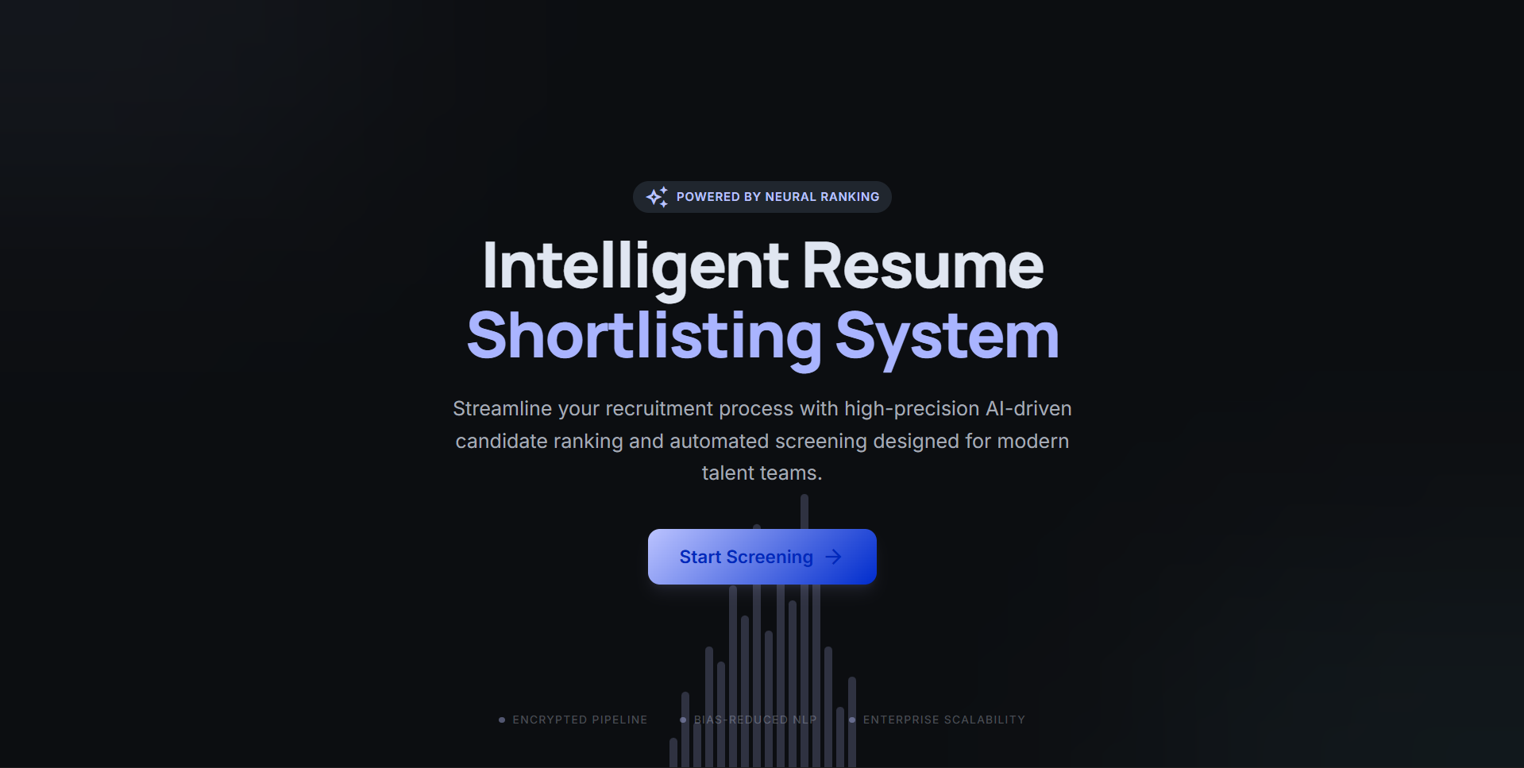

3.4.2 Dashboard
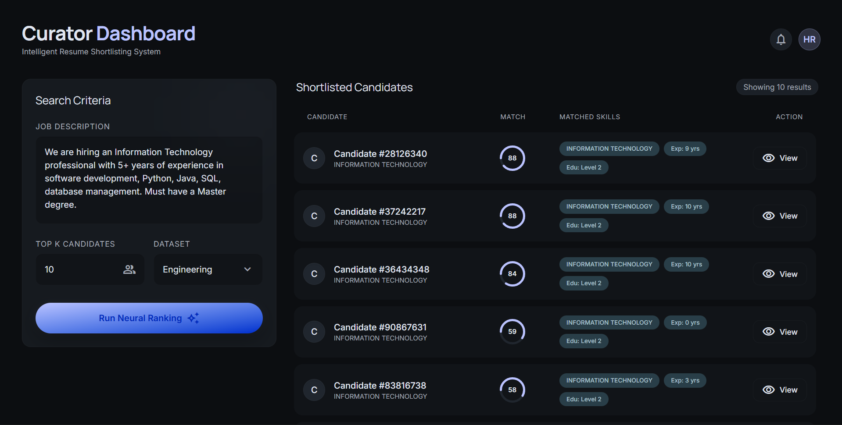

4. Conclusion and Future Work
4.1 Conclusion
The Intelligent Resume Shortlisting System (IRSS) successfully bridges the structural gaps currently causing significant friction within Human Resources and broad recruitment industries. Legacy Applicant Tracking Systems are crippled by semantic ignorance, prioritizing obsolete keyword exact-matching and fundamentally flawed indexing formats that destroy accurate candidate selection metrics. By intentionally building upon the highly-evolved infrastructure of Modern Web Applications interacting seamlessly with Python Intelligence deployments, the IRSS definitively proves that deep linguistic processing has matured to production stability.

Major achievements encompass:
- Resolving Boolean query rigidity by deploying advanced Transformer-based Natural Language methodologies (SBERT) resulting in conceptual tracking rather than syntax matching.
- Achieving exceptional execution scaling by routing Euclidean distance constraints over the FAISS clustering configuration algorithm map.
- Introducing distinct "hybrid" methodologies by intelligently balancing heuristic variables (SpaCy Name Entity Extraction metrics governing experience bounds) modifying abstract vector scores mathematically resulting in absolute candidate alignment.
- Guaranteeing complete usability architecture metrics via React interface frameworks, removing operator deployment resistance universally.

Providing recruiters an unparalleled tool capable of scanning tens of thousands of individual unparsed texts and ranking absolute best-fit profiles effortlessly in milliseconds stands as definitive proof of concept success.

4.2 Future Work
While the core logic of the Intelligent Resume Shortlisting architecture handles standard workflows, integrating structural expansions into the software lifecycle remains critical for enterprise deployment iterations. Future deployments project:

- Generative AI Extrapolation Wrappers: While current iterations provide analytical rankings, piping candidate profiles through a secure localized LLM mechanism (such as Llama 3) to actively construct an executive localized English-language paragraph summarizing the candidate's core alignment would further reduce cognitive burden completely.
- Dynamic OCR Rendering Subroutines: Increasing parsing accuracy over badly serialized image-PDF formatting issues deploying Tesseract OCR mechanisms natively via pre-processor logic pipes scaling document compatibility drastically.
- Multilingual Linguistic Transformers: Deploying language-agnostic embedding networks allowing native analysis ranking regardless of the inputted candidate's geographical dialect localization without manual translation constraints.
- Workflow State Management Frameworks: Completing the ATS lifecycle mapping architecture by giving recruiter users direct capabilities bridging internal interview phase progressions naturally from the dashboard.

References

[1] N. Reimers and I. Gurevych, "Sentence-BERT: Sentence Embeddings using Siamese BERT-Networks," in Proceedings of the 2019 Conference on Empirical Methods in Natural Language Processing (EMNLP), 2019, pp. 3982-3992.
[2] J. Johnson, M. Douze, and H. Jégou, "Billion-scale similarity search with GPUs," IEEE Transactions on Big Data, vol. 7, no. 3, pp. 535-547, 2019.
[3] Honnibal, M. and Montani, I., "spaCy 2: Natural language understanding with Bloom embeddings, convolutional neural networks and incremental parsing," 2017. [Online]. Available: https://spacy.io/.
[4] React.js Community, "React – A JavaScript Library for Building User Interfaces," React Documentation. Available: https://react.dev/
[5] J. Devlin, M. Chang, K. Lee, and K. Toutanova, "BERT: Pre-training of Deep Bidirectional Transformers for Language Understanding," NAACL-HLT, 2019.
[6] Pedregosa et al., "Scikit-learn: Machine Learning in Python," Journal of Machine Learning Research 12, pp. 2825-2830, 2011.
[7] F. Chollet, "Deep Learning with Python", 2nd Edition, Manning Publications, 2021.
[8] MongoDB Inc., "The Developer Data Platform documentation details," 2024.
[9] Node.js Community, "Node.js v20 Server and Express Application Framework," available at https://nodejs.org.
[10] Axios Community, "Promise based HTTP requests integration architectures API," documented online 2024.

