静态爬虫：
import requests
from bs4 import BeautifulSoup
def get_movies():
headers = {
'user-agent': 'Mozilla/5.0 (Windows NT6.1; Win64; x64)AppleWebKit/537.36 (KHTML,like Gecko) Chrome/52.0.2743.82 Safari/537.36',
'Host': 'movie.douban.com'
}
movie_list = []
ls=[]
lm=[]
for i in range(0,250,25):
link = 'https://movie.douban.com/top250?start=%s'%i
r = requests.get(link, headers=headers, timeout=10)
soup = BeautifulSoup(r.text, "lxml")
div_list = soup.find_all('div', class_='hd')
div_de=soup.find_all('div',class_='bd')
div_img=soup.find_all('div',class_='pic')
for each in div_list:
movie = each.a.span.text.strip()
movie_list.append(movie)
for i in div_de:
k=i.p.text
ls.append(k)
for i in div_img:
k=i.a.img['src']
lm.append(k)
return movie_list,ls,lm
movies,l1,l2 = get_movies()
for i in range(len(movies)):
print(movies[i])
print(l1[i])
print(l2[i])

Django框架
• url：
from django.contrib import admin
from django.urls import path
from act.views import act_detail
urlpatterns = [
path('admin/', admin.site.urls),
path("",act_detail)
]
• views：
from django.shortcuts import render
from django.http import HttpResponse,Http404
from .models import act
# Create your views here.
def act_detail(requst):
return render(requst,"act_detail.html")
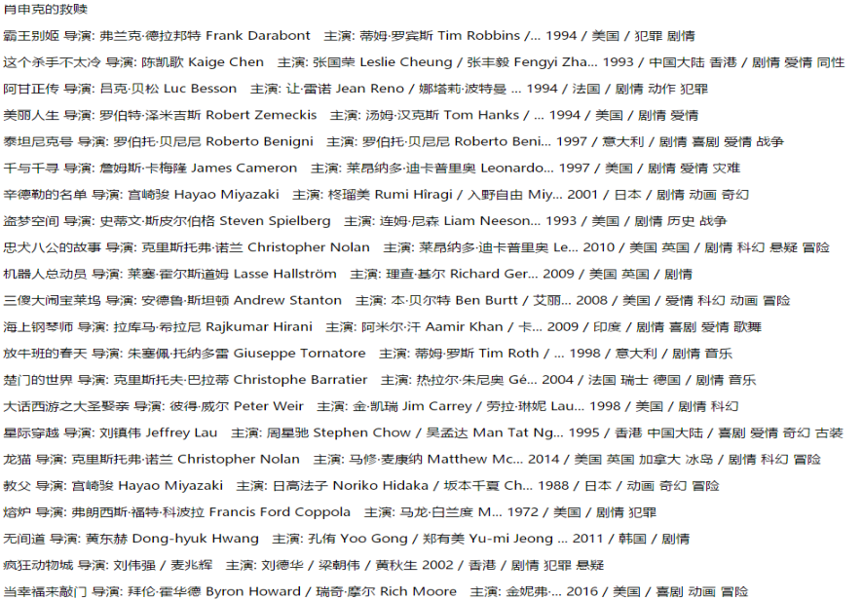

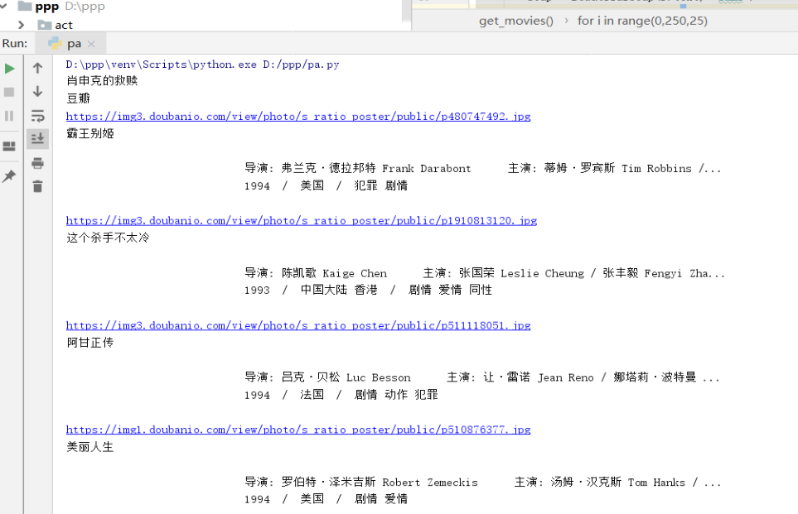

12306爬虫
import base64
import requests
import re
import config
def get_point(index):
index = index.split(',')
loc = {
'1': '43,45',
'2': '106,45',
'3': '167,45',
'4': '259,45',
'5': '42,120',
'6': '106,120',
'7': '167,120',
'8': '259,120',
}
answer = []
for t in index:
answer.append(loc[t])
return ','.join(answer)
# 首先做好伪装,伪装成浏览器
# 实例化一个session
session = requests.Session() # 自动的处理cookie
headers = {
'User-Agent': 'Mozilla/5.0 (Linux; Android 6.0; Nexus 5 Build/MRA58N) AppleWebKit/537.36 (KHTML, like Gecko) Chrome/70.0.3538.77 Mobile Safari/537.36'
}
# 伪装成浏览器
session.headers.update(headers)
# 访问登陆界面
cookie_url = 'https://kyfw.12306.cn/otn/login.html/conf'
session.get(cookie_url)
# 下载验证码
response = session.get('https://kyfw.12306.cn/passport/captcha/captcha-image64?login_site=E&module=login&rand=sjrand&1541760606034&callback=jQuery19106311375523623572_1541759333476&_=1541759333479')
img_base64 = re.findall(r'"image":"(.*?)"', response.text)[0]
img_byte = base64.b64decode(img_base64)
with open('test.jpg', 'wb') as f:
f.write(img_byte)
check_captcha = 'https://kyfw.12306.cn/passport/captcha/captcha-check?callback=jQuery19106311375523623572_1541759333476&rand=sjrand&login_site=E&_=1541759333484'
answer = get_point(input('请输入正确的序号:'))
response = session.get(check_captcha, params={'answer': answer})
code = re.findall(r'"result_code":"(.*?)"', response.text)[0]
if code == '4':
print("验证码验证成功")
# 验证用户名与密码
login_url = 'https://kyfw.12306.cn/passport/web/login'
Form_Data = {
'username': config.username,
'password': config.password,
'appid': 'otn',
'answer': answer
}
response = session.post(login_url, data=Form_Data)
res = response.json()
if res['result_code'] == 0:
print('用户名密码验证正确')
uamtk_url = 'https://kyfw.12306.cn/passport/web/auth/uamtk'
response = session.post(uamtk_url, data={'appid': 'otn'})
res = response.json()
if res['result_code'] == 0:
print('获取token成功')
check_token_url = 'https://kyfw.12306.cn/otn/uamauthclient'
response = session.post(check_token_url, data={'tk': res['newapptk']})
res = response.json()
if res['result_code'] == 0:
print('验证token通过')
print('登陆成功')
else:
print('用户名或密码错误')
else:
print('验证码错误')
