CLASSIFICATION REPORT

In this report, I’ll detail how I aimed to evaluate the effectiveness of 3 different methods - Decision Tree Classifier, a Random Forests ensemble classifier for decision trees, and a Support Vector machine on separating images from CIFAR-10 dataset into different groups.
These were PCA reduced to 200 features to reduce training time while still providing enough features to train a model.
To help find the optimal hyperparameters for each classifier I split training data using 3-fold cross validation, and then iterated over every combination of my specified hyperparameter values exhaustively to find which ones resulted in the best model – I used the GridSearchCV method for this. I initially started with 5-fold validation but I found it almost redundant and training time ballooned especially for the more complex models.

Report Task 3: Hyperparameter selection and training

Decision Tree
I chose the hyperparameters of maximum tree depth,
I kept the criterion to gini because on early test runs of testing it against entropy it didn’t make a noticeable difference to performance compared to entropy and if anything was consistently worse – they are similar metrics
Main ones I evaluated were max depth of the tree, the minimum samples needed in a split, min samples leaf. These are all important parameters that are related to managing how a tree overfits, and the final list of values i iterated over are detailed below

Ranges and how you evaluated overfitting? During experimentation, I initially started with higher values for the max depth of the tree, but then got a difference of around 0.4 between my training and test set. I reduced the depth and increased the minimum samples neaded for both leaves and split, so that tree split less aggressively which led to less overfitting of data

Best parameters; {'max_depth': 10, 'min_samples_leaf': 10, 'min_samples_split': 50}

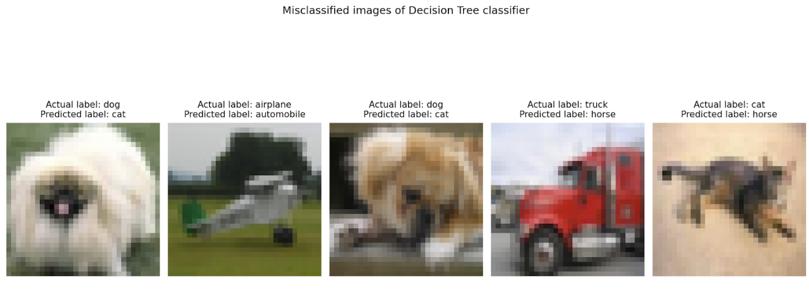
Fig 1: 5 images misclassified by single Decision Tree method

When trying to evaluate failure modes of a single decision tree, we can see there is definitely a pattern of general features being identified by the decision tree. Common failure modes include confusing animals which have similar limbs and such, as well as vehicles which have been PCA reduced to the point where the shapes are distorted and the tree is not deep enough to learn the pattern

Random Forests ensemble method for decisiontree
Decided on Random Forests (what are they) as they were a good ensemble method involving _, and they cut down on the training time because they use multiple shallower decision trees. The prime huperparameters I found were

During my hyperparam exploration experiments I had to cut down on the n estimators in order to cut down on training time, maximum 200 took over 10 minutes for one draw and my device could not physically compute that many estimators even though it led to a higher overall fitting.. Potentially overfitting however as we did get a large training accuracy with more than that for very little increase in test accuracy

What did you ry
Stuff specific to random forests ease we experimented with setting max depth high but we got large training accuracy with more than that for very little increase in test accuracy. Max features sqrt was by far the better thing to do. Tried going beyond 200 estimators but it took far too long to train.

Best parameters{'max_depth': 10, 'max_features': 'sqrt', 'min_samples_split': 10, 'n_estimators': 200}

Although the score is higher than a single decision tree, we are stil prone to overfitting if depth of trees and as such have this rubbish to deal with so not a hugely notabe improvement if we look at the test score

SVM classifier
The loss function for an SVM classifier is measured with the formula as below. Note the values C (a penalty term for misclassification) as well as
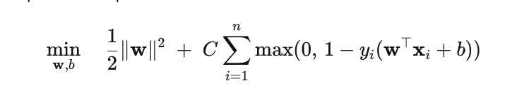
Figure 2: the formula for the loss function on an SVM, note the regularisation param C
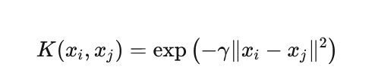

Figure 3: the representation of an rbf kernel, which is influenced by parameter gamma

As such I based most of my parameters off what could be tuned to minimise the loss function most important part was the regularisation parameter which penalises misclassifications to different scales. Tried C of 10 but it gave me 90+ training score and only 50s for test

The kernel type between linear and the rbf kernel, which required gamma as another parameter to the thing for the rbf kernel (make sure to incldue scale at some point too. when i tried linear kernel so i went for the rbf and poly kernels which can fit features err better, which is much better for image data. Gamma had stuff

Features are not linearly separable and thus taking the margins can lead to overfitting

Best params: 'C': 5, 'gamma': 'scale', 'kernel': 'rbf'}

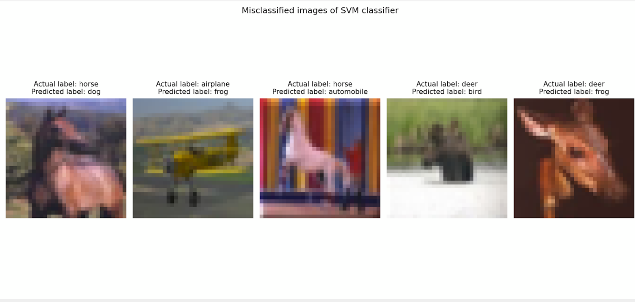
Figure 4: 5 images misclassified by the SVM

Although the misclassifcation of other images as frogs still persists (presumebly because of overfitting on the colour), the other failure modes are based on PCA reducing the shape so much that image is ambiguous even for an SVM - at a distance the horse looks similar to its misclassified label and the bird is indistinguishable. This fits well with a correct classification rate of 55%

Report Task 4: Comparing classifier performance
Discuss and explain the differences in performance between
the three classifiers on the test set. Your explanation should relate dif-
ferences in accuracy to model properties such as model complexity, bias–
variance behaviour, suitability for high-dimensional image data, and com-
putational constraints. You may refer to insights from your failure-case vi-
sualisation where relevant.

Test accuracy was calculated and is shown below for all 3 models
Model | Score
Decision Tree Classifier | 0.3096
Ensemble (Random Forests) for Decision Tree Classifier | 0.474
SVM | 0.5645

Fig 4: Model scores/test accuracy on the test set for all 3 models(table)

Best performing model on the PCA reduced CIFAR data was SVM, second best was boosted trees, third best was a simple decision tree.

For single decision trees, increased depth led to low bias but has incredibly high variance to the point of massively overfitting training data which is computationally intensive?, while shallow trees have low bias but really high variance -> underfitting. However computationally it is faster but not reliable for classification in normal circumstances. The failure case clearly displayed the misclassification on objects with similar combinations of features(e.g. cat or dog) or else images that had been PCA reduced so much that it was hard to identify any features, even with little overfitting
Random Forests as an ensemble method expands on creating lots of low depth boosted trees, which is more effective than a single decision tree classifier as it uses multiple weak learners and so returns a better model score on average as a whole with less overfitting so long as number of estimators isnt too high and they arent deep themselves – don’t see patterns. Captures patterns even from PCA reducted better because it uses multiple shallow boosted trees at the same time WHY IDK if this is right. However the error is only ever so better because as an ensemble method forests still depend on weaknesses of trees

SVM is best suited to high dimensional image data compared to the other stuff using a kernel because it can fit higher dimensional data better and images are such that even smaller things make a difference so its better for image data especially when using the rbf kernel which could notice the patterns so much better. Observing the failure cases it is clear

How do failure cases misclassifcation patterns relate to how well model performs/the stuff mentioned prior?
Decision trees - misclassifcation on classes with same broad features
PCA - other than the overfitting leading to some very interesting cases

