CLUSTERING REPORT

Introduction
In this report, I will detail my findings of utilising two main methods of clustering data for classifying the MNIST image dataset. The two methods I am investigating are K-Means clustering (which creates harder spherical assignments) and Gaussian Mean Models (GMM) – assessing probabilities of data being in different clusters
The MNIST set is a database of images which are classed in any of digits 0-9, albeit drawn in different fashions as illustrated below:
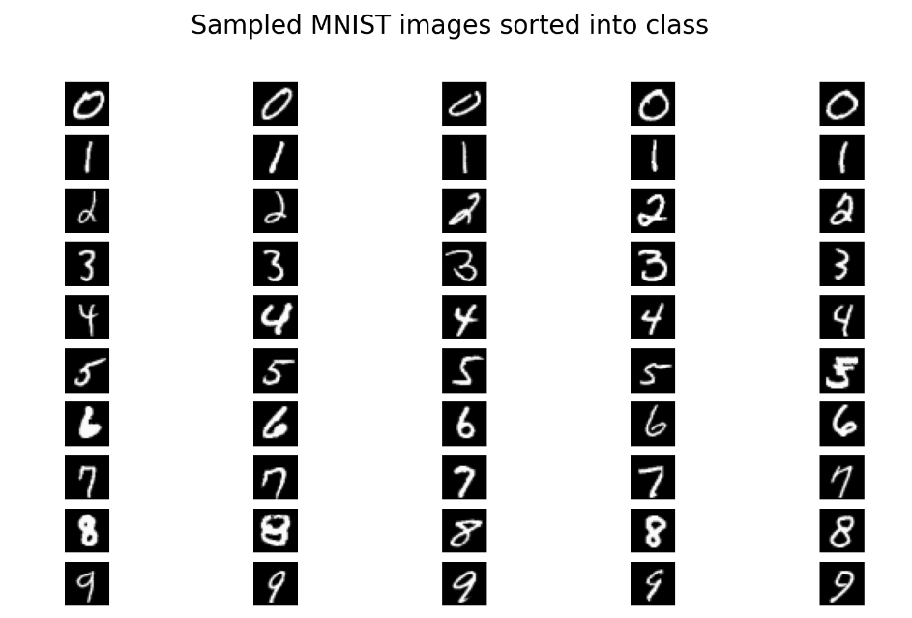
Figure 1: Visualising samples from the MNIST dataset sorted into their respective classes

Methodology and hyperparameter
Despite looking like simple numerical representations, each MNIST image has about _ features. It was not practical to train on this many features because of _ and _, so I decided to reduce the dataset via PCA to 80 features, which I believed would be more than enough for a good clustering model to classify images properly while not being impractical to train.
I had to account that despite clustering not being a supervised learning method, I still needed to find hyperparameters so to split the data I used KFold method, defined hyperparameters and then iterated through every combination of them. This was done until I found the combinations which gave the model that returned the highest of an internal distance metric after fitted with training data, as labels weren’t present
Out of all the metrics, I evaluated silhouette score as the best metric because
As for the hyperparameters explored, number of clusters or components for both models of course, had to be fixed at 10 to comply with the requirements of MNIST classification. With Kmeans, I felt like the most important factors were the number of maximum iterations until convergence to give the thing a chance to
After running entire cycles of hyperparameter search, within my boundaries these are the values I got;
Best KMeans params: {'n_clusters': 10, 'max_iter': 300, 'n_init': 20}

Best GMM params: {'n_components': 10, 'covariance_type': 'full', 'n_init': 5}

Finally, we needed a way. As methods like exhaustive GridSearch weren’t suited for unsupervised clustering as there was no test data to compare to, we instead used clustering

Evaluating clustering experiment results

We evaluated clustering performance on our test data using some numerical measures which check Rand Index, Mutual information and again, the silhouette score.
Table!!

 | Adjusted Rand Index | Adjusted Mutual Info | Silhouette Score
K means | 0.366 | 0.499 | 0.075
GMM | 0.371 | 0.535 | 0.027

Figure 2: A table of the summaries of the performance

Both models have a very similar value for the Adjusted Rand Index, which measures, suggesting that on this particular thing they were both um…something. Adjusted mutual info is higher for GMM which shows that as a model it is the best , and both are around the same kind of thing. Both models had lowish silhouette scores

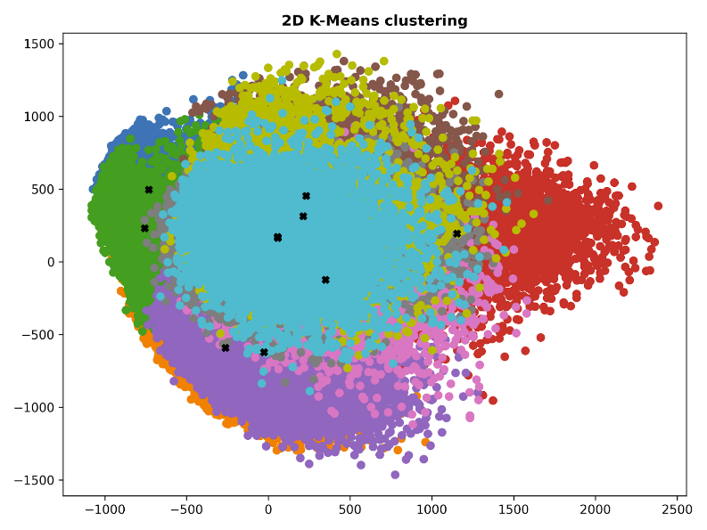
Figure 3: KMeans clustering in 2D

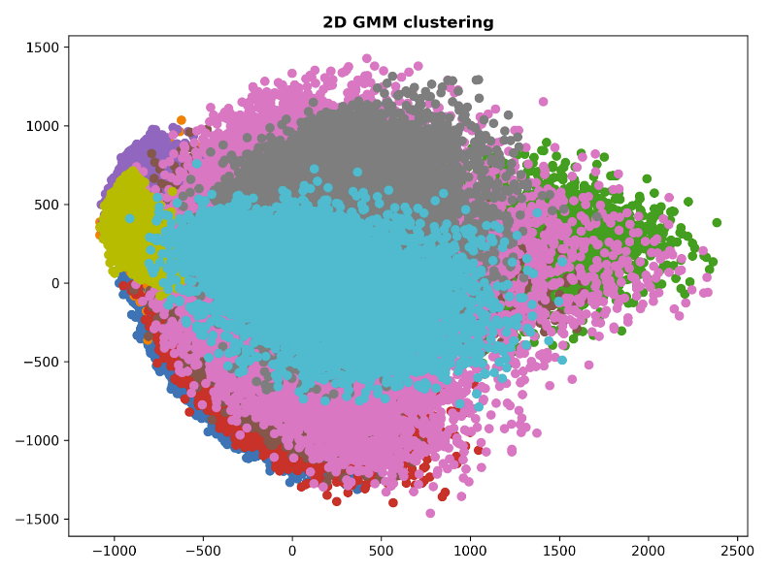
Figure 4: GMM clustering in 2D

What do these show? The Kmeans circular shapes and spherical shapes can be seen, while GMMs glexibility and lack of overlap is also shown

The model with the best average silhouette score was chosen as the best performing model, which in this case happens to be Kmeans. Below we can see 5 samples from each of its 10 clusters.
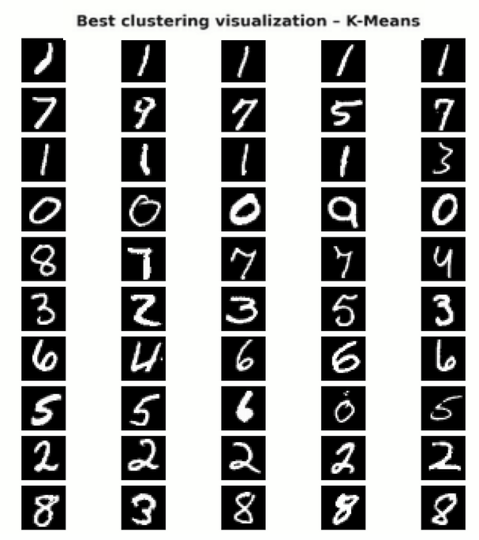

Fig: Visualization of clustering results on image classification using the optimised K-Means method

In general, despite the bad theoretical indications from the silhouette score and other measurement metrics, the model performs quite well at clustering considering that its input data was PCA reduced to 80 features. The failures of this model seem to fall on numbers which have partial, halfway similarities with each other (e.g.). How does this re

Why did Kmeans perform better than GMM? Well there are a m

Conclusion
In conclusion, it has been shown that Kmeans can indeed be a reasonably good classifier for MNIST image data when reduced, as well as PCA reduction leading to less correlated features. Owing to limits on time and hardware that the clustering models were trained on, this was the extent of my results, and perhaps if those two were different we would’ve seen the best

