REGRESSION REPORT

This report summarises how I evaluated the charges section of a larger insurance dataset using regression to try and predict costs from input data by learning parameters, I trained 3 regression models which were trained on the insurance chargers dataset: linear regression, a simple two layer neural network, and a Bayesian regression model.

Report Task 1: E

After using the data to train a linear regression model, each feature had a specific learned coefficient. These are displayed in the table below.

Feature name | Learned coefficient(3dp)
sex_male | -18.592
smoker_yes | 23651.129
region_northwest | -370.677
region_southeast | -657.864
region_southwest | -809.799
age | 3614.975
bmi | 2036.228
children | 516.890

Figure 1: Learned coefficients for each feature

RMSE error between the predicted and actual values of charges was used as the error to evaluate the quality of the trained linear regression model both on the training and the test set. The values are as follows:
LinReg RMSE train: 6105.545160099847
LinReg RMSE test: 5796.284659276263

The below plot shows the relationship between predicted and actual charge values
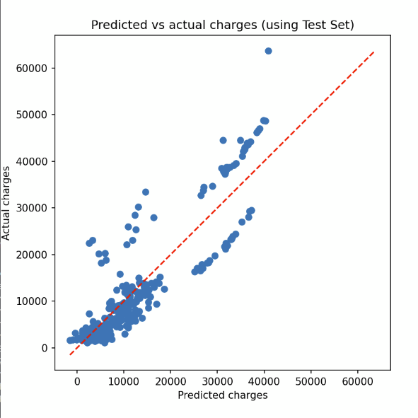
Figure 2 - Comparing the predicted charges from linear regression against the actual charges

The neural network model, which I trained using Pytorch, differs in its prediction accuracy to linear regression. Once trained over a few hundred epochs it returned the following RMSE values:

Neural Net RMSE train:4296.827638565884
Neural Net RMSE test: 4338.340938945062
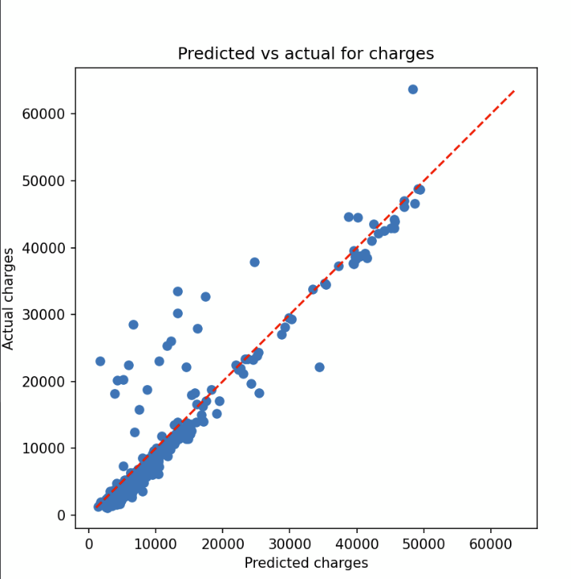

Figure 3 - Comparing the charges predicted by the neural network against the actual charges

I used the Bayesian linear regression model as another approach to estimate the posterior coefficients via a form of Monte-Carlo sampling which I did using PyMC. I recorded a noise value of 20.0 and the learned coefficients were as follows:
Feature name | Learned coefficient(3dp)
sex_male | 6.160
smoker_yes | 23523.936
region_northwest | -332.984
region_southeast | -608.515
region_southwest | -768.792
age | 3609.295
bmi | 2030.844
children | 517.267

The sign and magnitude of each coefficient is similar to the linear regression model other than sex_male showing that this method yields similar results.
:

Report Task 2: Comparing the performance of the linear regression model and neural network on the test data.

The RMSE of the neural network on the data is smaller than that of the linear regression model, by about 20% with ~4000 compared to ~5000.
A reason for this is that the neural network is a far more complex model, as it introduces nonlinearity into training by passing inputs or input vectors through a sigmoid at every node, and has multiple layers and weights between each of them. In addition, the neural network goes through multiple iterations of backpropagation to learn parameters via gradient descent. Linear regression is simply written as a weighted sum of inputs and, as such, is easier to interpret.
Overall, the neural network model performs far better on unseen data, as indicated by the lower RMSE value on test data, which interestingly is incredibly close to the training RMSE, showing that it has not been overfitted. This is because parameters of the model are updated via gradient descent over thousands of iterations with an adjustable learning rate, allowing for better fitting. Meanwhile, the linear regression parameters are only fitted once.

