SEQUENTIAL DATA REPORT

Report Task 5: A first look at posterior predictions
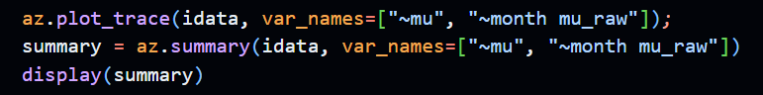
Figure 1: Code used to generate summary of posterior parameters
The regression values of Rhat for all posteriors listed is consistently 1.0. This is an important value to to assess MCMC convergence – all have values below 1.01 which indicates good convergence to a stable solution and more reliable posterior values.

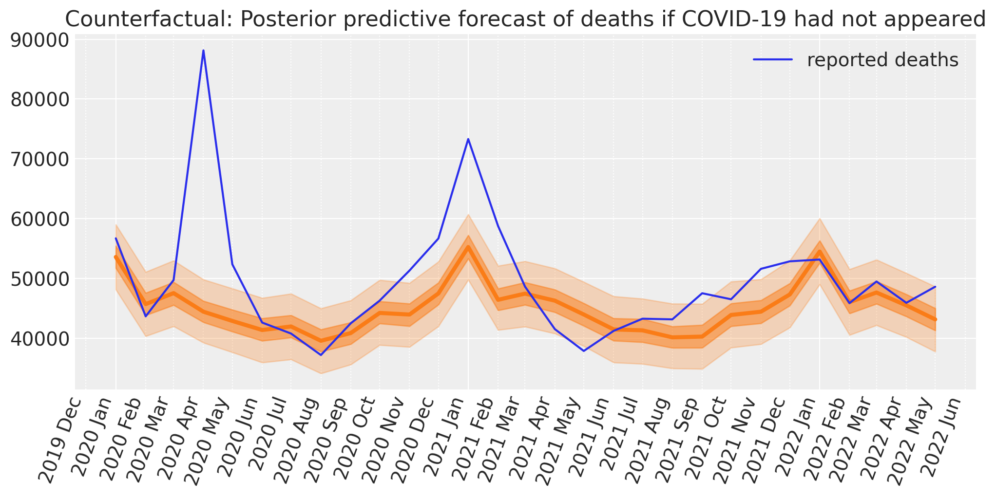
Figure 2: The posterior predictive forecast for post-2020 deaths
There is a large error between forecasted and reported deaths. The reason is the sharp magnitude and unprecedented nature of COVID deaths would be beyond the model’s capabilities, as its pre-2020 training data would not have included similar spikes - evidenced by how other than two outbreak peaks in 2020 and 2021, recorded deaths fall in line with the model.

Report Task 6: Comparing posteriors trained with different year splits
By varying the split year for our data, our trained posteriors vary. Below are two posterior summary tables showing 2010 and 2020 split.
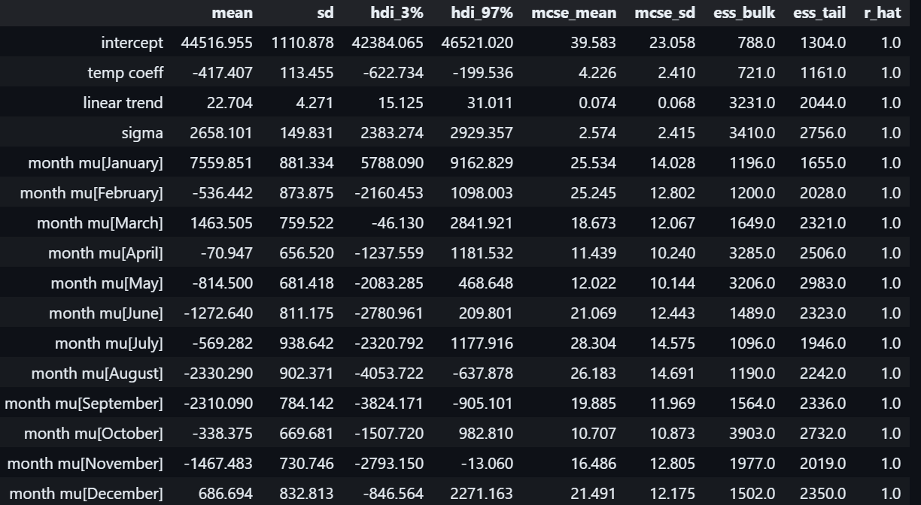
Figure 3: Posterior distribution summary of training with 2020 as split year

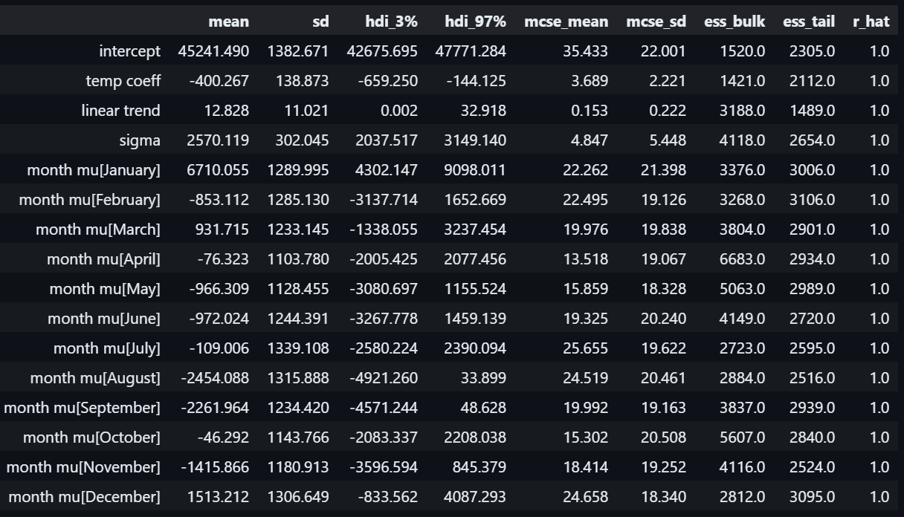
Figure 4: Posterior distribution summary of training with 2010 as split year
50 words: The differences in the value of posterior distribution values between months varies much more sharply with the 2020s split because of the. The magnitude of the 2020 split posterior summary values also swings much more because

Report Task 7 – Excluding variables from the posterior model
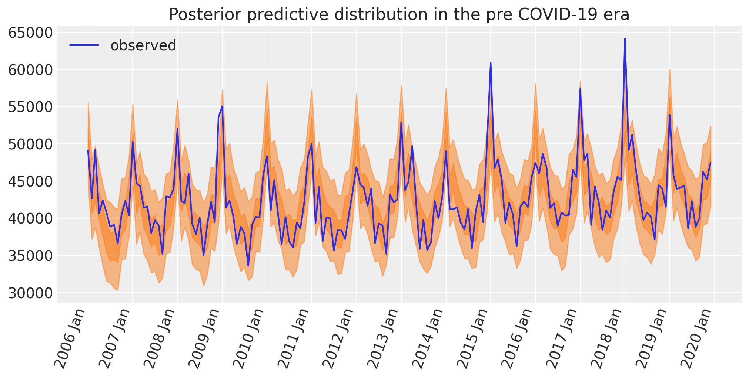
Figure 5: Plotting the posterior predictive distribution using full model

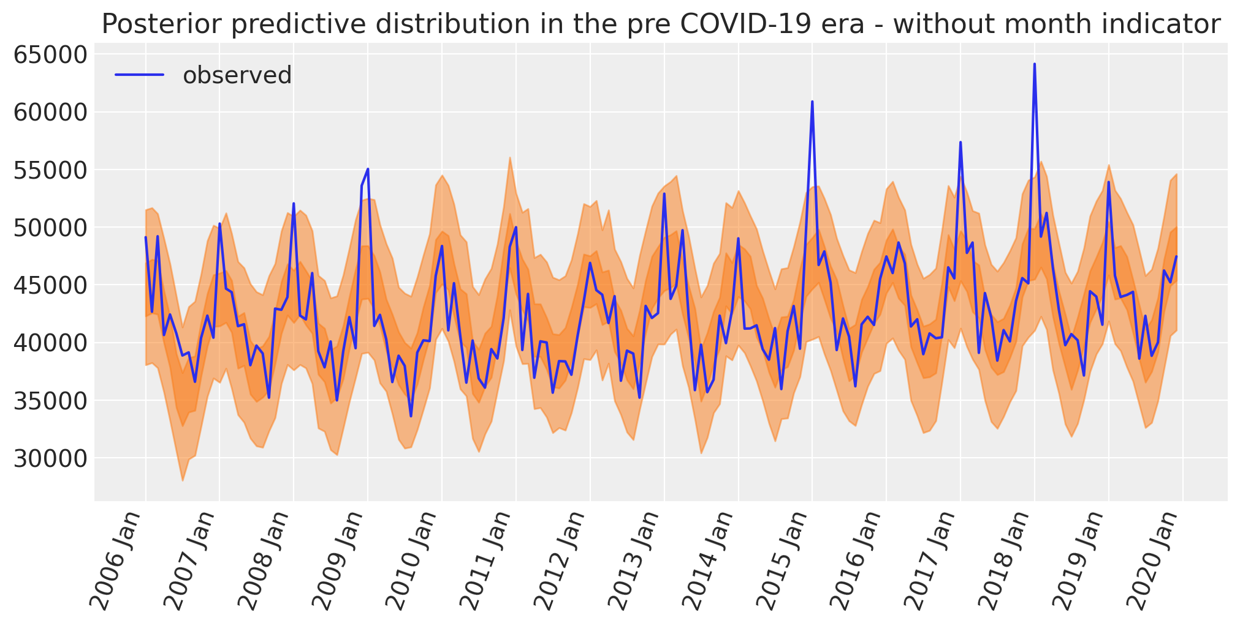
Figure 6: Plot excluding month indicators.

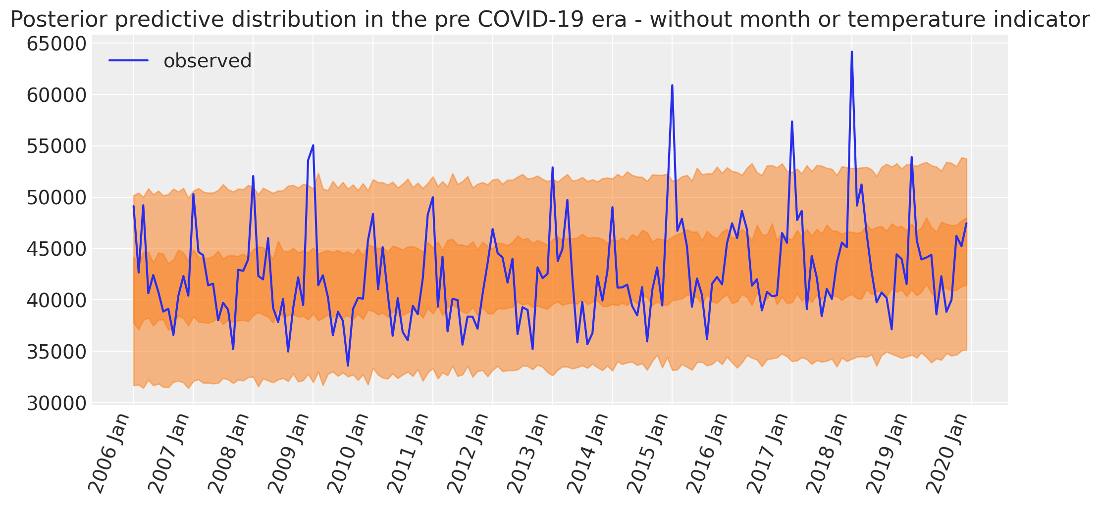
Figure 7: Plot excluding both months and temperature indicators.

Compared to the full model, excluding month indicators leads to sharp spikes smoothing as winter seasonal death is ignored. When month and temperature indicators are excluded, then we get a relatively flat, slowly rising prediction over the years because model doesn’t consider effect of winter season and temperature deaths, only the general rising trend.

Report Task 8 – Comparing two different HMM outputs to actual data

I created two hidden Markov Models, one created manually and one using the hmmlearn library and sampled from them to get output of deaths. To see how this compared to actual (discretised) death data and their qualithy, we can first visualise the values at each month:

Figure 8: Bar chart of discretised sequence of deaths visualised

We can plot the predicted values against each other and see what kind of linear correlation they have(idk if this is needed for discretised deaths)

Figure 9: HMM1 plotted against real sequence

Figure 10: HMM2 outputs plotted against real sequence

