# Laser GUI Help and Documentation

## Overview

## How to start

1. **Double click laserGUI.bat in “Laser” file.** A command prompt will appear, followed by the Laser Control GUI shortly after.
2. **DONE!** You’ve successfully opened the GUI. It should look like Figure 1 below, but without the entries.

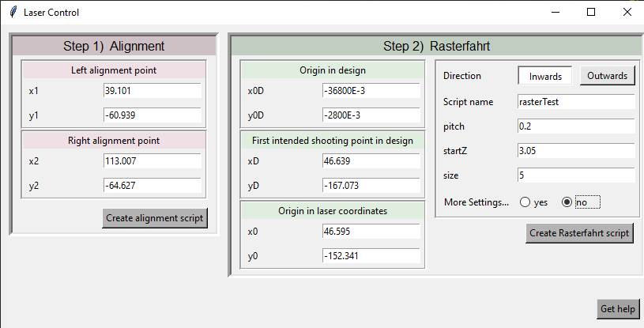

Figure 1: Laser GUI with example values. E-3 -> if you want to write micrometers and convert into millimeters

## NOTES:

1. All distance or coordinate values are in **millimeters**!
2. This guide assumes you know how to use the laser already.

## Step 1: Alignment

Sections [Left alignment point] and [Right alignment point]:

1. **Choose 2 alignment marks on your design.** Those 2 points will be leveled along the x-axis.
2. Move to the corresponding alignment marks using the jog sheet.
3. Each time, enter the x and y coordinates in **mm** **with a decimal point**. (e.g. 0.2 for 0.2 mm)
4. **Press the button** [Create alignment script]. If successful, a info pop-up will appear (fig 2)
5. “**alignment.vbs**” will be saved into “Skripte” folder. Will be overwritten every time alignment is executed.
6. Load this script into your 3Dmicromac application and execute.
7. Check if successful. Correct manually if needed.

|  |  |
| --- | --- |
| TIPS: | * The further away those 2 points are from each other, the better the alignment. |
|  | * No need to move to the Laser Site for entering the coordinates, as the offset of the coordinates seen through the microscope to the Laser Site stays constant for both points. |
|  | * First use the microscope with a small magnification to move to the alignment marks. Then use the largest magnification and z-axis to focus on them. The alignment vastly depends on the accuracy of the coordinates! |

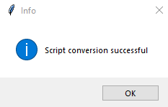

Figure 2: Successful! Script saved into "Skripte" folder

## Step 2: rasterfahrt

## TroubleShoot

ValueError: could not convert string to float:

Most probably empty column

Or used decimal comma instead of decimal point 1,3 instead of 1.3