Report Generated by Test Manager

Title: | Electronic Throttle Control Tests
Author: | MathWorks Training
Date: | 09-Mar-2019 14:51:17

Test Environment
Platform: | PCWIN64
MATLAB: | (R2019a)

Summary
Name | Outcome | Duration (Seconds)
Results: 2019-Mar-09 14:43:24 | 5 | 32
etcTests | 5 | 32
PWM Conversion | 2 | 23
SIL Equivalence Test |  | 21
Scripted_Iteration1 |  | 21
Zero Input Test |  | 2
Iteration1 |  | 2
PI Controller | 3 | 8
Windup Test |  | 2
Parameter Tunability Test | 2 | 6
Iteration1 |  | 3
Iteration2 |  | 3

Results: 2019-Mar-09 14:43:24
Result Type: | Result Set
Parent: | None
Start Time: | 09-Mar-2019 14:43:26
End Time: | 09-Mar-2019 14:43:58
Outcome: | Total: 5, Passed: 5

Aggregated Coverage Results
Analyzed Model | Sim Mode | Complexity | Decision | Function | Function call | Execution
pwmCnv | Normal | 5 | 100% | -- | -- | 100%
piCtrl | Normal | 3 | 100% | -- | -- | 100%
pwmCnv | SIL | 5 | 100% | 100% | 100% | 100%
Back to Report Summary

etcTests

Test Result Information
Result Type: | Test File Result
Parent: | Results: 2019-Mar-09 14:43:24
Start Time: | 09-Mar-2019 14:43:26
End Time: | 09-Mar-2019 14:43:58
Outcome: | Total: 5, Passed: 5

Test Suite Information
Name: | etcTests
Back to Report Summary

PWM Conversion

Test Result Information
Result Type: | Test Suite Result
Parent: | etcTests
Start Time: | 09-Mar-2019 14:43:26
End Time: | 09-Mar-2019 14:43:49
Outcome: | Total: 2, Passed: 2

Test Suite Information
Name: | PWM Conversion
Back to Report Summary

SIL Equivalence Test

Test Result Information
Result Type: | Test Case Result
Parent: | PWM Conversion
Start Time: | 09-Mar-2019 14:43:26
End Time: | 09-Mar-2019 14:43:47
Outcome: | Passed
Description:

Compares the PWM conversion algorithm in Normal and Software-in-the-Loop (SIL) modes.

Test Case Information
Name: | SIL Equivalence Test
Type: | Equivalence Test
Test Case Requirements
Description: | pwm_5: Normal simulation and software-i... (throttleReqs#30)
Document: | throttleReqs.slreqx

Scripted_Iteration1

Test Result Information
Result Type: | Test Iteration Result
Parent: | SIL Equivalence Test
Start Time: | 09-Mar-2019 14:43:26
End Time: | 09-Mar-2019 14:43:47
Outcome: | Passed

Test Case Information
Name: | Scripted_Iteration1
Type: | Equivalence Test
Iteration Settings
Test Overrides
Parameter Name | Value | Simulation Index
ExternalInput | C:\Perforce\sandbox\english\slvv\files\ch5\withTestSuite\tests\pwmTestData.mat | 1

Equivalence Comparison
Name | Abs Tol | Rel Tol | Lead Tol | Lag Tol | Max Diff | Data Type 1 | Units 1 | Sample Time 1 | Data Type 2 | Units 2 | Sample Time 2 | Interp | Sync | Link to Plot
motor_inputs.duty | 0 | 0 | 0 | 0 | 0 | double |  | 0.01 | double |  | 0.01 | linear | union | Link
motor_inputs.direction | 0 | 0 | 0 | 0 | 0 | double |  | 0.01 | double |  | 0.01 | linear | union | Link

Name | Abs Tol | Rel Tol | Lead Tol | Lag Tol | Max Diff | Data Type 1 | Units 1 | Sample Time 1 | Data Type 2 | Units 2 | Sample Time 2 | Interp | Sync
motor_inputs.duty | 0 | 0 | 0 | 0 | 0 | double |  | 0.01 | double |  | 0.01 | linear | union
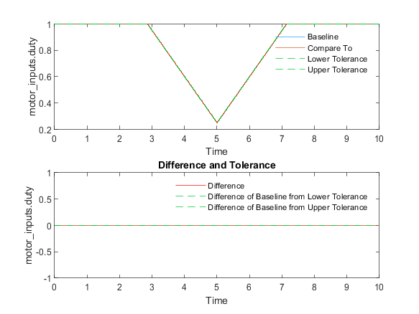
Back to Report Summary | Back to Criteria Results

Name | Abs Tol | Rel Tol | Lead Tol | Lag Tol | Max Diff | Data Type 1 | Units 1 | Sample Time 1 | Data Type 2 | Units 2 | Sample Time 2 | Interp | Sync
motor_inputs.direction | 0 | 0 | 0 | 0 | 0 | double |  | 0.01 | double |  | 0.01 | linear | union
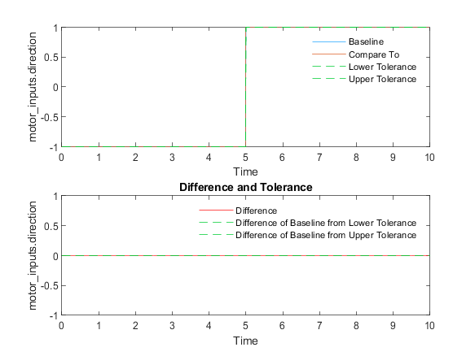
Back to Report Summary | Back to Criteria Results

Simulation 1
System Under Test Information
Model: | pwmCnv
Simulation Mode: | software-in-the-loop (sil)
Configuration Set: | Configuration1
External Input Name: | pwmTestData.mat
External Input File: | C:\Perforce\sandbox\english\slvv\files\ch5\withTestSuite\tests\pwmTestData.mat
Start Time: | 0
Stop Time: | 10
Checksum: | 3422217998 2983377753 621514607 2584637770
Simulink Version: | 9.3
Model Version: | 1.185
Model Author: | bneiswan
Date: | Mon Mar 04 16:16:37 2019
User ID: | bneiswan
Model Path: | C:\Perforce\sandbox\english\slvv\files\ch5\withTestSuite\models\pwmCnv.slx
Machine Name: | AH-BNEISWAN
Solver Name: | FixedStepDiscrete
Solver Type: | Fixed-Step
Fixed Step Size: | 0.01
Simulation Start Time: | 2019-03-09 14:43:26
Simulation Stop Time: | 2019-03-09 14:43:44
Platform: | PCWIN64

Simulation Output
Name | Data Type | Units | Sample Time | Interp | Sync | Link to Plot
motor_inputs.duty | double |  | 0.01 | linear | union | Link
motor_inputs.direction | double |  | 0.01 | linear | union | Link

Name | Data Type | Units | Sample Time | Interp | Sync
motor_inputs.duty | double |  | 0.01 | linear | union
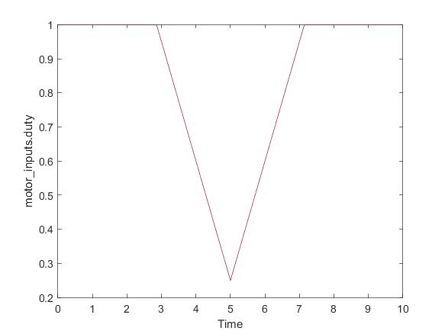
Back to Report Summary | Back to Signal Summary

Name | Data Type | Units | Sample Time | Interp | Sync
motor_inputs.direction | double |  | 0.01 | linear | union
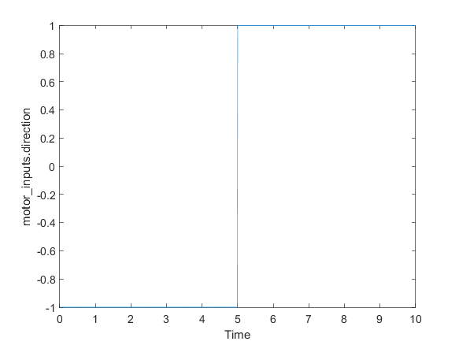
Back to Report Summary | Back to Signal Summary

Simulation 2
System Under Test Information
Model: | pwmCnv
Simulation Mode: | normal
Configuration Set: | Configuration1
External Input Name: | pwmTestData.mat
External Input File: | C:\Perforce\sandbox\english\slvv\files\ch5\withTestSuite\tests\pwmTestData.mat
Start Time: | 0
Stop Time: | 10
Checksum: | 2998922239 2108830796 4045941144 3011785138
Simulink Version: | 9.3
Model Version: | 1.185
Model Author: | bneiswan
Date: | Mon Mar 04 16:16:37 2019
User ID: | bneiswan
Model Path: | C:\Perforce\sandbox\english\slvv\files\ch5\withTestSuite\models\pwmCnv.slx
Machine Name: | AH-BNEISWAN
Solver Name: | FixedStepDiscrete
Solver Type: | Fixed-Step
Fixed Step Size: | 0.01
Simulation Start Time: | 2019-03-09 14:43:45
Simulation Stop Time: | 2019-03-09 14:43:46
Platform: | PCWIN64

Simulation Output
Name | Data Type | Units | Sample Time | Interp | Sync | Link to Plot
motor_inputs.duty | double |  | 0.01 | zoh | union | Link
motor_inputs.direction | double |  | 0.01 | zoh | union | Link

Name | Data Type | Units | Sample Time | Interp | Sync
motor_inputs.duty | double |  | 0.01 | zoh | union
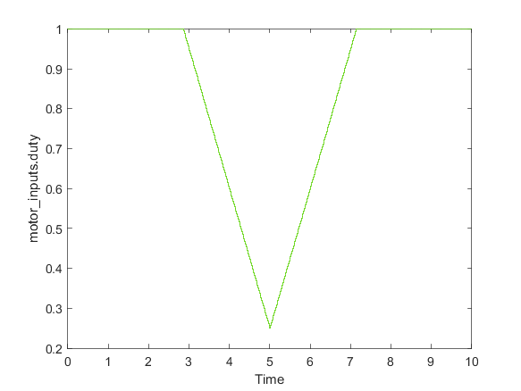
Back to Report Summary | Back to Signal Summary

Name | Data Type | Units | Sample Time | Interp | Sync
motor_inputs.direction | double |  | 0.01 | zoh | union
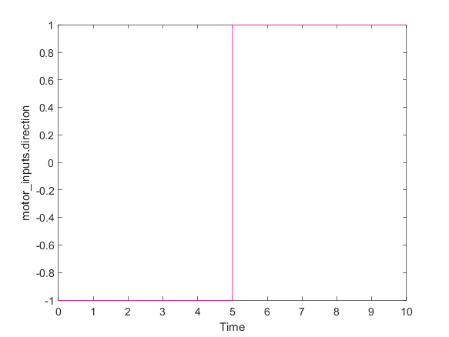
Back to Report Summary | Back to Signal Summary

Zero Input Test

Test Result Information
Result Type: | Test Case Result
Parent: | PWM Conversion
Start Time: | 09-Mar-2019 14:43:47
End Time: | 09-Mar-2019 14:43:49
Outcome: | Passed

Test Case Information
Name: | Zero Input Test
Type: | Simulation Test

Iteration1

Test Result Information
Result Type: | Test Iteration Result
Parent: | Zero Input Test
Start Time: | 09-Mar-2019 14:43:47
End Time: | 09-Mar-2019 14:43:49
Outcome: | Passed

Test Case Information
Name: | Iteration1
Type: | Simulation Test
Iteration Settings
Test Overrides
Parameter Name | Value
ExternalInput | C:\Perforce\sandbox\english\slvv\files\ch5\withTestSuite\sldv_output\pwmCnv\pwmCnv_sldvdata1.mat : Test Case:1

Simulation
System Under Test Information
Model: | pwmCnv
Simulation Mode: | normal
Configuration Set: | Configuration1
External Input Name: | Test Case:1
External Input File: | C:\Perforce\sandbox\english\slvv\files\ch5\withTestSuite\sldv_output\pwmCnv\pwmCnv_sldvdata1.mat : Test Case:1
Start Time: | 0
Stop Time: | 0
Checksum: | 3391865571 2550012242 1423758845 2288482349
Simulink Version: | 9.3
Model Version: | 1.185
Model Author: | bneiswan
Date: | Mon Mar 04 16:16:37 2019
User ID: | bneiswan
Model Path: | C:\Perforce\sandbox\english\slvv\files\ch5\withTestSuite\models\pwmCnv.slx
Machine Name: | AH-BNEISWAN
Solver Name: | FixedStepDiscrete
Solver Type: | Fixed-Step
Fixed Step Size: | 0.01
Simulation Start Time: | 2019-03-09 14:43:48
Simulation Stop Time: | 2019-03-09 14:43:48
Platform: | PCWIN64

Simulation Output
Name | Data Type | Units | Sample Time | Interp | Sync | Link to Plot
motor_inputs.duty | double |  | 0.01 | zoh | union | Link
motor_inputs.direction | double |  | 0.01 | zoh | union | Link

Name | Data Type | Units | Sample Time | Interp | Sync
motor_inputs.duty | double |  | 0.01 | zoh | union
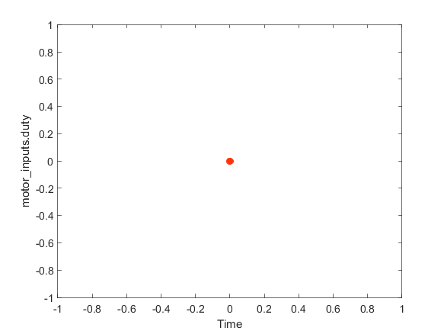
Back to Report Summary | Back to Signal Summary

Name | Data Type | Units | Sample Time | Interp | Sync
motor_inputs.direction | double |  | 0.01 | zoh | union
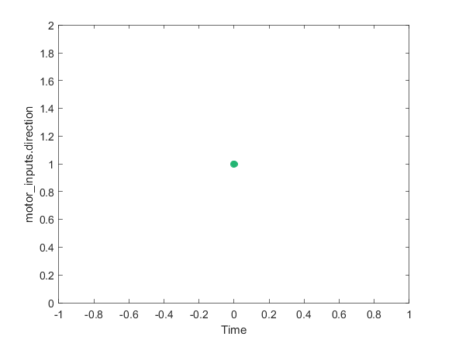
Back to Report Summary | Back to Signal Summary

PI Controller

Test Result Information
Result Type: | Test Suite Result
Parent: | etcTests
Start Time: | 09-Mar-2019 14:43:50
End Time: | 09-Mar-2019 14:43:58
Outcome: | Total: 3, Passed: 3

Test Suite Information
Name: | PI Controller
Back to Report Summary

Windup Test

Test Result Information
Result Type: | Test Case Result
Parent: | PI Controller
Start Time: | 09-Mar-2019 14:43:50
End Time: | 09-Mar-2019 14:43:52
Outcome: | Passed
Description:

Simulate the PI controller model to test for integrator windup.

Test Case Information
Name: | Windup Test
Type: | Simulation Test
Test Case Requirements
Description: | pi_ctrl_3: Maximum value of integral state ... (throttleReqs#8)
Document: | throttleReqs.doc

Verify Result
Name | Link to Plot
Test Sequence (Assessment)/.../Windup:verify(controller_output < (1 - Kp)) | Link

Name
Test Sequence (Assessment)/.../Windup:verify(controller_output < (1 - Kp))
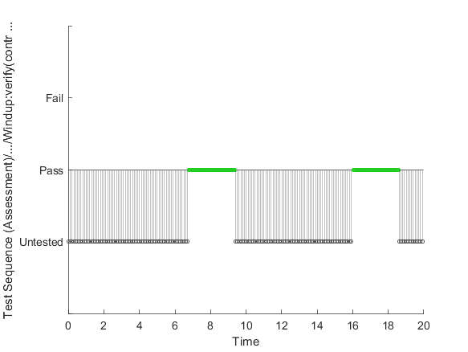
Back to Report Summary | Back to Signal Summary

Simulation
System Under Test Information
Model: | piCtrl
Harness: | piCtrl_Logic
Harness Owner: | piCtrl
Simulation Mode: | normal
Configuration Set: | Configuration1
Start Time: | 0
Stop Time: | 20
Checksum: | 806252472 2402241606 2662739934 1985461667
Simulink Version: | 9.3
Model Version: | 1.11
Model Author: | bneiswan
Date: | Sat Mar 09 13:12:36 2019
User ID: | bneiswan
Model Path: | C:\Perforce\sandbox\english\slvv\files\ch5\withTestSuite\models\piCtrl.slx
Machine Name: | AH-BNEISWAN
Solver Name: | FixedStepDiscrete
Solver Type: | Fixed-Step
Fixed Step Size: | 0.01
Simulation Start Time: | 2019-03-09 14:43:50
Simulation Stop Time: | 2019-03-09 14:43:51
Platform: | PCWIN64

Simulation Output
Name | Data Type | Units | Sample Time | Interp | Sync | Link to Plot
a2d_scaled.pedal_scaled | double |  | 0.01 | zoh | union | Link
a2d_scaled.angle_scaled | double |  | 0.01 | zoh | union | Link
Test Sequence:2 | boolean |  | 0.01 | zoh | union | Link
controller_output | double |  | 0.01 | zoh | union | Link

Name | Data Type | Units | Sample Time | Interp | Sync
a2d_scaled.pedal_scaled | double |  | 0.01 | zoh | union
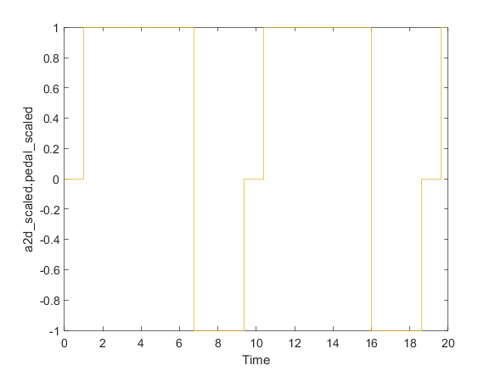
Back to Report Summary | Back to Signal Summary

Name | Data Type | Units | Sample Time | Interp | Sync
a2d_scaled.angle_scaled | double |  | 0.01 | zoh | union
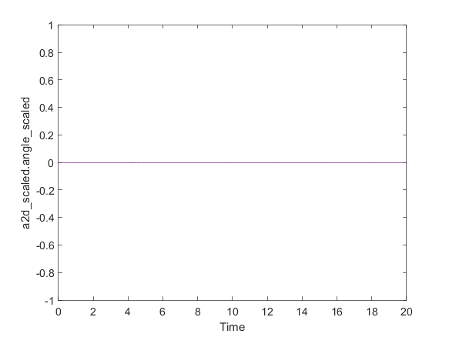
Back to Report Summary | Back to Signal Summary

Name | Data Type | Units | Sample Time | Interp | Sync
Test Sequence:2 | boolean |  | 0.01 | zoh | union
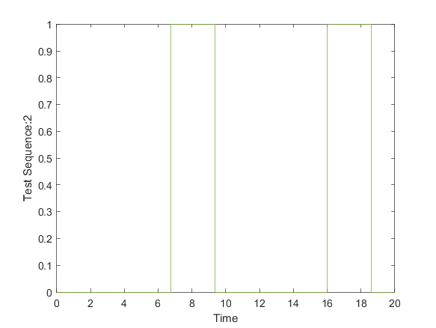
Back to Report Summary | Back to Signal Summary

Name | Data Type | Units | Sample Time | Interp | Sync
controller_output | double |  | 0.01 | zoh | union
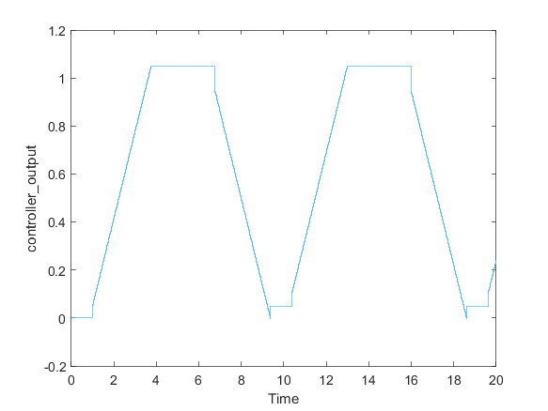
Back to Report Summary | Back to Signal Summary

Parameter Tunability Test

Test Result Information
Result Type: | Test Case Result
Parent: | PI Controller
Start Time: | 09-Mar-2019 14:43:52
End Time: | 09-Mar-2019 14:43:58
Outcome: | Passed
Description:

Simulate the PI controller model with parameter overrides and compare it to expected outputs.

Test Case Information
Name: | Parameter Tunability Test
Type: | Baseline Test
Test Case Requirements
Description: | Proportional and integral gains should be adjustable and tunable.
Document: | ..\documents\throttleReqs.doc

Iteration1

Test Result Information
Result Type: | Test Iteration Result
Parent: | Parameter Tunability Test
Start Time: | 09-Mar-2019 14:43:52
End Time: | 09-Mar-2019 14:43:55
Outcome: | Passed

Test Case Information
Name: | Iteration1
Type: | Baseline Test
Baseline Name: | piExpectedOutput1.mat
Baseline File: | C:\Perforce\sandbox\english\slvv\files\ch5\withTestSuite\tests\piExpectedOutput1.mat
Iteration Settings
Test Overrides
Parameter Name | Value
SignalBuilderGroup | PI Test 1
Baseline | C:\Perforce\sandbox\english\slvv\files\ch5\withTestSuite\tests\piExpectedOutput1.mat

Baseline Comparison
Name | Abs Tol | Rel Tol | Lead Tol | Lag Tol | Max Diff | Data Type 1 | Units 1 | Sample Time 1 | Data Type 2 | Units 2 | Sample Time 2 | Interp | Sync | Link to Plot
a2d_scaled.pedal_scaled | 0.01 | 0.05 | 0 | 0 | 0 | double |  | 0.01 | double |  | 0.01 | zoh | union | Link
a2d_scaled.angle_scaled | 0.01 | 0.05 | 0 | 0 | 0 | double |  | 0.01 | double |  | 0.01 | zoh | union | Link
controller_output | 0.01 | 0.05 | 0 | 0 | 0 | double |  | 0.01 | double |  | 0.01 | zoh | union | Link

Name | Abs Tol | Rel Tol | Lead Tol | Lag Tol | Max Diff | Data Type 1 | Units 1 | Sample Time 1 | Data Type 2 | Units 2 | Sample Time 2 | Interp | Sync
a2d_scaled.pedal_scaled | 0.01 | 0.05 | 0 | 0 | 0 | double |  | 0.01 | double |  | 0.01 | zoh | union
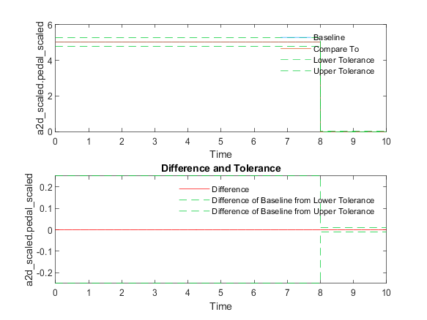
Back to Report Summary | Back to Criteria Results

Name | Abs Tol | Rel Tol | Lead Tol | Lag Tol | Max Diff | Data Type 1 | Units 1 | Sample Time 1 | Data Type 2 | Units 2 | Sample Time 2 | Interp | Sync
a2d_scaled.angle_scaled | 0.01 | 0.05 | 0 | 0 | 0 | double |  | 0.01 | double |  | 0.01 | zoh | union
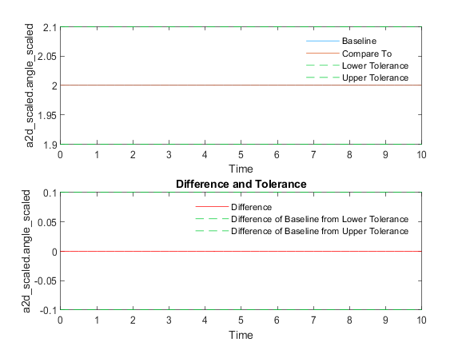
Back to Report Summary | Back to Criteria Results

Name | Abs Tol | Rel Tol | Lead Tol | Lag Tol | Max Diff | Data Type 1 | Units 1 | Sample Time 1 | Data Type 2 | Units 2 | Sample Time 2 | Interp | Sync
controller_output | 0.01 | 0.05 | 0 | 0 | 0 | double |  | 0.01 | double |  | 0.01 | zoh | union
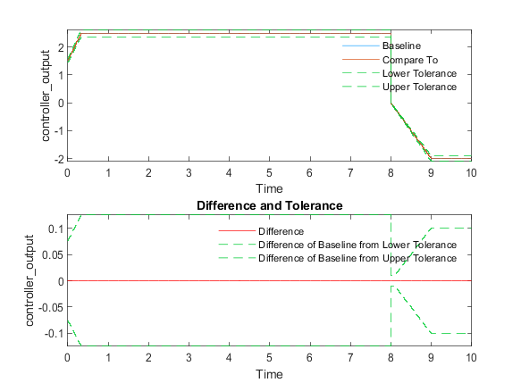
Back to Report Summary | Back to Criteria Results

Simulation
System Under Test Information
Model: | piCtrl
Harness: | piCtrl_Harness
Harness Owner: | piCtrl
Simulation Mode: | normal
Configuration Set: | Configuration1
Signal Builder Block: | piCtrl_Harness/Harness Inputs
Signal Builder Group: | PI Test 1
Start Time: | 0
Stop Time: | 10
Checksum: | 139475585 3713416244 2408504657 787736295
Simulink Version: | 9.3
Model Version: | 1.9
Model Author: | bneiswan
Date: | Sat Mar 09 13:12:36 2019
User ID: | bneiswan
Model Path: | C:\Perforce\sandbox\english\slvv\files\ch5\withTestSuite\models\piCtrl.slx
Machine Name: | AH-BNEISWAN
Solver Name: | FixedStepDiscrete
Solver Type: | Fixed-Step
Fixed Step Size: | 0.01
Simulation Start Time: | 2019-03-09 14:43:53
Simulation Stop Time: | 2019-03-09 14:43:53
Platform: | PCWIN64

Parameter Overrides
Workspace Variable | Value | Source | Model Element
Parameter Set 1
Ki | 1 | base workspace | piCtrl_Harness/piCtrl
Kp | 0.5 | base workspace | piCtrl_Harness/piCtrl

Simulation Output
Name | Data Type | Units | Sample Time | Interp | Sync | Link to Plot
a2d_scaled.pedal_scaled | double |  | 0.01 | zoh | union | Link
a2d_scaled.angle_scaled | double |  | 0.01 | zoh | union | Link
controller_output | double |  | 0.01 | zoh | union | Link

Name | Data Type | Units | Sample Time | Interp | Sync
a2d_scaled.pedal_scaled | double |  | 0.01 | zoh | union
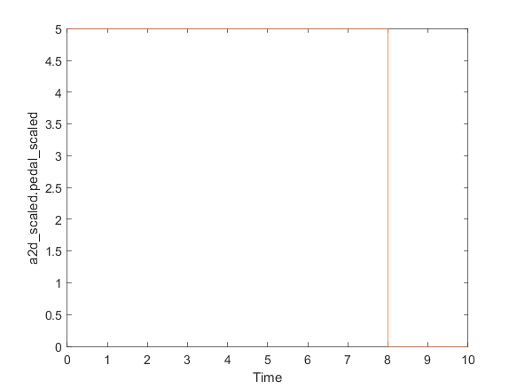
Back to Report Summary | Back to Signal Summary

Name | Data Type | Units | Sample Time | Interp | Sync
a2d_scaled.angle_scaled | double |  | 0.01 | zoh | union
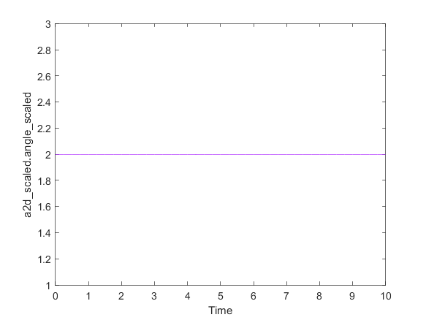
Back to Report Summary | Back to Signal Summary

Name | Data Type | Units | Sample Time | Interp | Sync
controller_output | double |  | 0.01 | zoh | union
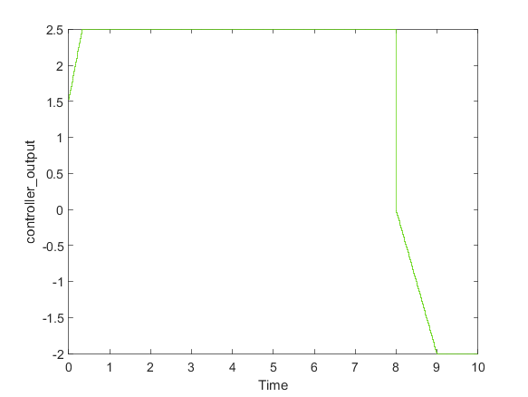
Back to Report Summary | Back to Signal Summary

Iteration2

Test Result Information
Result Type: | Test Iteration Result
Parent: | Parameter Tunability Test
Start Time: | 09-Mar-2019 14:43:55
End Time: | 09-Mar-2019 14:43:58
Outcome: | Passed

Test Case Information
Name: | Iteration2
Type: | Baseline Test
Baseline Name: | piExpectedOutput2.mat
Baseline File: | C:\Perforce\sandbox\english\slvv\files\ch5\withTestSuite\tests\piExpectedOutput2.mat
Iteration Settings
Test Overrides
Parameter Name | Value
SignalBuilderGroup | PI Test 2
Baseline | C:\Perforce\sandbox\english\slvv\files\ch5\withTestSuite\tests\piExpectedOutput2.mat

Baseline Comparison
Name | Abs Tol | Rel Tol | Lead Tol | Lag Tol | Max Diff | Data Type 1 | Units 1 | Sample Time 1 | Data Type 2 | Units 2 | Sample Time 2 | Interp | Sync | Link to Plot
a2d_scaled.pedal_scaled | 0.01 | 0.05 | 0 | 0 | 0 | double |  | 0.01 | double |  | 0.01 | zoh | union | Link
a2d_scaled.angle_scaled | 0.01 | 0.05 | 0 | 0 | 0 | double |  | 0.01 | double |  | 0.01 | zoh | union | Link
controller_output | 0.01 | 0.05 | 0 | 0 | 0 | double |  | 0.01 | double |  | 0.01 | zoh | union | Link

Name | Abs Tol | Rel Tol | Lead Tol | Lag Tol | Max Diff | Data Type 1 | Units 1 | Sample Time 1 | Data Type 2 | Units 2 | Sample Time 2 | Interp | Sync
a2d_scaled.pedal_scaled | 0.01 | 0.05 | 0 | 0 | 0 | double |  | 0.01 | double |  | 0.01 | zoh | union
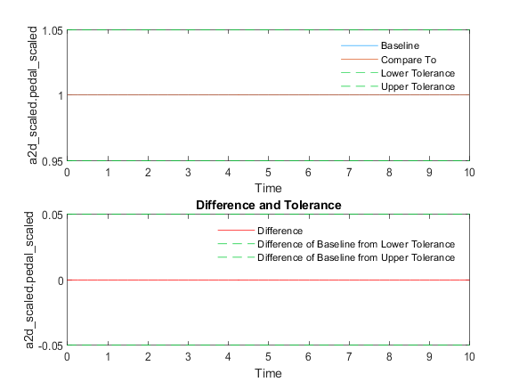
Back to Report Summary | Back to Criteria Results

Name | Abs Tol | Rel Tol | Lead Tol | Lag Tol | Max Diff | Data Type 1 | Units 1 | Sample Time 1 | Data Type 2 | Units 2 | Sample Time 2 | Interp | Sync
a2d_scaled.angle_scaled | 0.01 | 0.05 | 0 | 0 | 0 | double |  | 0.01 | double |  | 0.01 | zoh | union
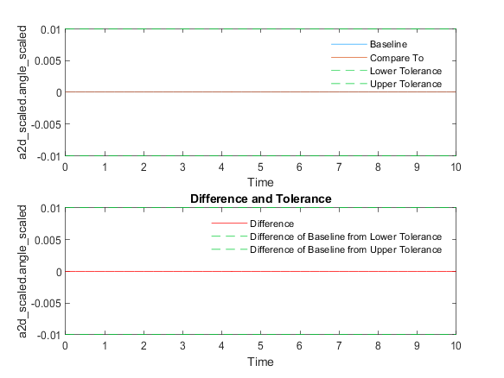
Back to Report Summary | Back to Criteria Results

Name | Abs Tol | Rel Tol | Lead Tol | Lag Tol | Max Diff | Data Type 1 | Units 1 | Sample Time 1 | Data Type 2 | Units 2 | Sample Time 2 | Interp | Sync
controller_output | 0.01 | 0.05 | 0 | 0 | 0 | double |  | 0.01 | double |  | 0.01 | zoh | union
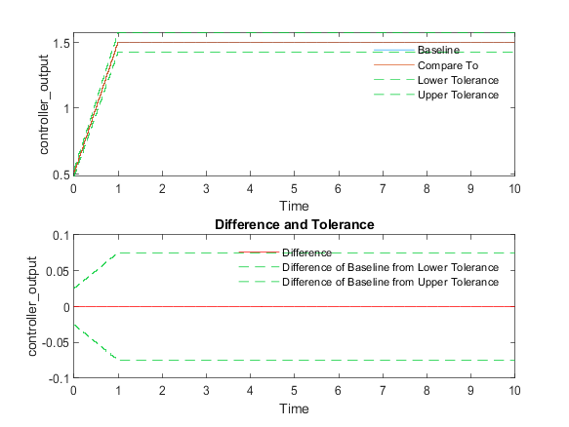
Back to Report Summary | Back to Criteria Results

Simulation
System Under Test Information
Model: | piCtrl
Harness: | piCtrl_Harness
Harness Owner: | piCtrl
Simulation Mode: | normal
Configuration Set: | Configuration1
Signal Builder Block: | piCtrl_Harness/Harness Inputs
Signal Builder Group: | PI Test 2
Start Time: | 0
Stop Time: | 10
Checksum: | 139475585 3713416244 2408504657 787736295
Simulink Version: | 9.3
Model Version: | 1.9
Model Author: | bneiswan
Date: | Sat Mar 09 13:12:36 2019
User ID: | bneiswan
Model Path: | C:\Perforce\sandbox\english\slvv\files\ch5\withTestSuite\models\piCtrl.slx
Machine Name: | AH-BNEISWAN
Solver Name: | FixedStepDiscrete
Solver Type: | Fixed-Step
Fixed Step Size: | 0.01
Simulation Start Time: | 2019-03-09 14:43:56
Simulation Stop Time: | 2019-03-09 14:43:56
Platform: | PCWIN64

Parameter Overrides
Workspace Variable | Value | Source | Model Element
Parameter Set 1
Ki | 1 | base workspace | piCtrl_Harness/piCtrl
Kp | 0.5 | base workspace | piCtrl_Harness/piCtrl

Simulation Output
Name | Data Type | Units | Sample Time | Interp | Sync | Link to Plot
a2d_scaled.pedal_scaled | double |  | 0.01 | zoh | union | Link
a2d_scaled.angle_scaled | double |  | 0.01 | zoh | union | Link
controller_output | double |  | 0.01 | zoh | union | Link

Name | Data Type | Units | Sample Time | Interp | Sync
a2d_scaled.pedal_scaled | double |  | 0.01 | zoh | union
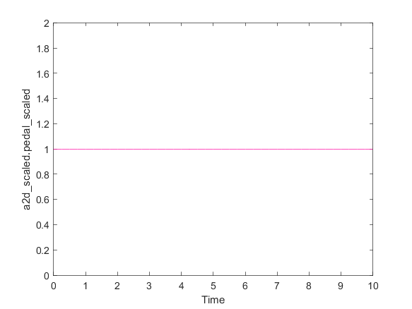
Back to Report Summary | Back to Signal Summary

Name | Data Type | Units | Sample Time | Interp | Sync
a2d_scaled.angle_scaled | double |  | 0.01 | zoh | union
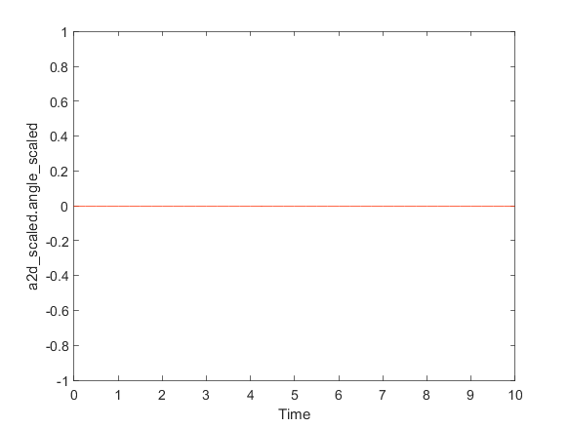
Back to Report Summary | Back to Signal Summary

Name | Data Type | Units | Sample Time | Interp | Sync
controller_output | double |  | 0.01 | zoh | union
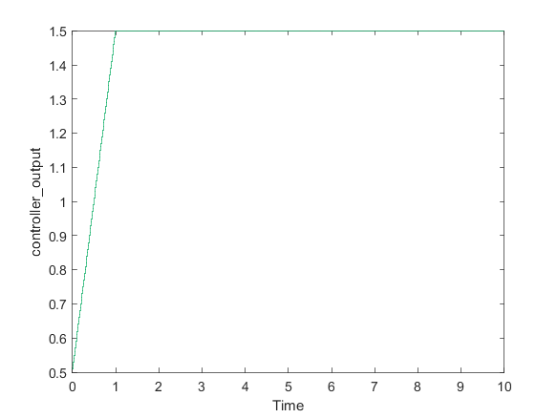
Back to Report Summary | Back to Signal Summary

