**Report Generated by Test Manager**

|  |  |
| --- | --- |
| **Title:** | **Electronic Throttle Control Tests** |
| **Author:** | **MathWorks Training** |
| **Date:** | **09-Mar-2019 14:51:17** |

|  |  |
| --- | --- |
| **Test Environment** | |
| Platform: | PCWIN64 |
| MATLAB: | (R2019a) |

|  |  |  |
| --- | --- | --- |
| **Summary** | | |
| **Name** | **Outcome** | **Duration (Seconds)** |
| Results: 2019-Mar-09 14:43:24 | 5 | 32 |
| etcTests | 5 | 32 |
| PWM Conversion | 2 | 23 |
| SIL Equivalence Test |  | 21 |
| Scripted_Iteration1 |  | 21 |
| Zero Input Test |  | 2 |
| Iteration1 |  | 2 |
| PI Controller | 3 | 8 |
| Windup Test |  | 2 |
| Parameter Tunability Test | 2 | 6 |
| Iteration1 |  | 3 |
| Iteration2 |  | 3 |

**Results: 2019-Mar-09 14:43:24**

|  |  |
| --- | --- |
| Result Type: | Result Set |
| Parent: | None |
| Start Time: | 09-Mar-2019 14:43:26 |
| End Time: | 09-Mar-2019 14:43:58 |
| Outcome: | Total: 5, Passed: 5 |

**Aggregated Coverage Results**

|  |  |  |  |  |  |  |
| --- | --- | --- | --- | --- | --- | --- |
| **Analyzed Model** | **Sim Mode** | **Complexity** | **Decision** | **Function** | **Function call** | **Execution** |
| [pwmCnv](./newReport/tpe4dc752e_64d7_437b_bd8a_6a131198d44a.html) | Normal | 5 | 100% | -- | -- | 100% |
| [piCtrl](./newReport/tp374c0109_ef7d_4574_b17b_594a7dd76a7f.html) | Normal | 3 | 100% | -- | -- | 100% |
| [pwmCnv](./newReport/tpb4ee688b_a868_4242_ad28_836201d97269.html) | SIL | 5 | 100% | 100% | 100% | 100% |

Back to Report Summary

|  |
| --- |
| **etcTests** |

|  |  |
| --- | --- |
| **Test Result Information** | |
| Result Type: | Test File Result |
| Parent: | Results: 2019-Mar-09 14:43:24 |
| Start Time: | 09-Mar-2019 14:43:26 |
| End Time: | 09-Mar-2019 14:43:58 |
| Outcome: | Total: 5, Passed: 5 |

|  |  |
| --- | --- |
| **Test Suite Information** | |
| Name: | etcTests |

Back to Report Summary

|  |
| --- |
| **PWM Conversion** |

|  |  |
| --- | --- |
| **Test Result Information** | |
| Result Type: | Test Suite Result |
| Parent: | etcTests |
| Start Time: | 09-Mar-2019 14:43:26 |
| End Time: | 09-Mar-2019 14:43:49 |
| Outcome: | Total: 2, Passed: 2 |

|  |  |
| --- | --- |
| **Test Suite Information** | |
| Name: | PWM Conversion |

Back to Report Summary

|  |
| --- |
| **SIL Equivalence Test** |

|  |  |
| --- | --- |
| **Test Result Information** | |
| Result Type: | Test Case Result |
| Parent: | PWM Conversion |
| Start Time: | 09-Mar-2019 14:43:26 |
| End Time: | 09-Mar-2019 14:43:47 |
| Outcome: | Passed |
| Description: |  |

Compares the PWM conversion algorithm in Normal and Software-in-the-Loop (SIL) modes.

|  |  |
| --- | --- |
| **Test Case Information** | |
| Name: | SIL Equivalence Test |
| Type: | Equivalence Test |
| **Test Case Requirements** | | |
| Description: | pwm_5: Normal simulation and software-i... (throttleReqs#30) | |
| Document: | [throttleReqs.slreqx](http://localhost:31415/matlab/feval/rmi.navigate?arguments=%5b%22linktype_rmi_slreq%22,%22throttleReqs.slreqx%22,%2230%22,%22C:%5C%5CPerforce%5C%5Csandbox%5C%5Cenglish%5C%5Cslvv%5C%5Cfiles%5C%5Cch5%5C%5CwithTestSuite%5C%5Ctests%5C%5CetcTests.mldatx%22%5d) | |

|  |
| --- |
| **Scripted_Iteration1** |

|  |  |
| --- | --- |
| **Test Result Information** | |
| Result Type: | Test Iteration Result |
| Parent: | SIL Equivalence Test |
| Start Time: | 09-Mar-2019 14:43:26 |
| End Time: | 09-Mar-2019 14:43:47 |
| Outcome: | Passed |

|  |  |
| --- | --- |
| **Test Case Information** | |
| Name: | Scripted_Iteration1 |
| Type: | Equivalence Test |

**Iteration Settings**

**Test Overrides**

|  |  |  |
| --- | --- | --- |
| **Parameter Name** | **Value** | **Simulation Index** |
| ExternalInput | C:\Perforce\sandbox\english\slvv\files\ch5\withTestSuite\tests\pwmTestData.mat | 1 |

**Equivalence Comparison**

|  |  |  |  |  |  |  |  |  |  |  |  |  |  |  |
| --- | --- | --- | --- | --- | --- | --- | --- | --- | --- | --- | --- | --- | --- | --- |
| **Name** | **Abs Tol** | **Rel Tol** | **Lead Tol** | **Lag Tol** | **Max Diff** | **Data Type 1** | **Units 1** | **Sample Time 1** | **Data Type 2** | **Units 2** | **Sample Time 2** | **Interp** | **Sync** | **Link to Plot** |
| motor_inputs.duty | 0 | 0 | 0 | 0 | 0 | double |  | 0.01 | double |  | 0.01 | linear | union | Link |
| motor_inputs.direction | 0 | 0 | 0 | 0 | 0 | double |  | 0.01 | double |  | 0.01 | linear | union | Link |

|  |  |  |  |  |  |  |  |  |  |  |  |  |  |
| --- | --- | --- | --- | --- | --- | --- | --- | --- | --- | --- | --- | --- | --- |
| **Name** | **Abs Tol** | **Rel Tol** | **Lead Tol** | **Lag Tol** | **Max Diff** | **Data Type 1** | **Units 1** | **Sample Time 1** | **Data Type 2** | **Units 2** | **Sample Time 2** | **Interp** | **Sync** |
| motor_inputs.duty | 0 | 0 | 0 | 0 | 0 | double |  | 0.01 | double |  | 0.01 | linear | union |

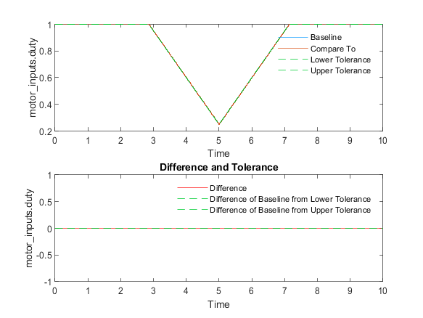

|  |  |
| --- | --- |
| Back to Report Summary | Back to Criteria Results |

|  |  |  |  |  |  |  |  |  |  |  |  |  |  |
| --- | --- | --- | --- | --- | --- | --- | --- | --- | --- | --- | --- | --- | --- |
| **Name** | **Abs Tol** | **Rel Tol** | **Lead Tol** | **Lag Tol** | **Max Diff** | **Data Type 1** | **Units 1** | **Sample Time 1** | **Data Type 2** | **Units 2** | **Sample Time 2** | **Interp** | **Sync** |
| motor_inputs.direction | 0 | 0 | 0 | 0 | 0 | double |  | 0.01 | double |  | 0.01 | linear | union |

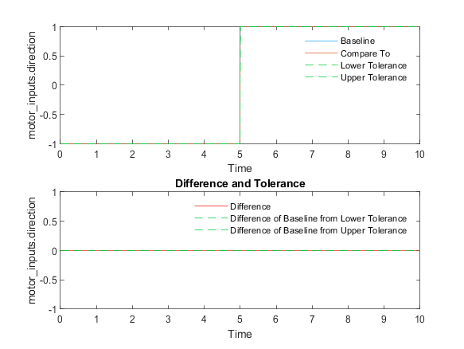

|  |  |
| --- | --- |
| Back to Report Summary | Back to Criteria Results |

**Simulation 1**

|  |  |
| --- | --- |
| **System Under Test Information** | |
| Model: | pwmCnv |
| Simulation Mode: | software-in-the-loop (sil) |
| Configuration Set: | Configuration1 |
| External Input Name: | pwmTestData.mat |
| External Input File: | C:\Perforce\sandbox\english\slvv\files\ch5\withTestSuite\tests\pwmTestData.mat |
| Start Time: | 0 |
| Stop Time: | 10 |
| Checksum: | 3422217998 2983377753 621514607 2584637770 |
| Simulink Version: | 9.3 |
| Model Version: | 1.185 |
| Model Author: | bneiswan |
| Date: | Mon Mar 04 16:16:37 2019 |
| User ID: | bneiswan |
| Model Path: | C:\Perforce\sandbox\english\slvv\files\ch5\withTestSuite\models\pwmCnv.slx |
| Machine Name: | AH-BNEISWAN |
| Solver Name: | FixedStepDiscrete |
| Solver Type: | Fixed-Step |
| Fixed Step Size: | 0.01 |
| Simulation Start Time: | 2019-03-09 14:43:26 |
| Simulation Stop Time: | 2019-03-09 14:43:44 |
| Platform: | PCWIN64 |

**Simulation Output**

|  |  |  |  |  |  |  |
| --- | --- | --- | --- | --- | --- | --- |
| **Name** | **Data Type** | **Units** | **Sample Time** | **Interp** | **Sync** | **Link to Plot** |
| motor_inputs.duty | double |  | 0.01 | linear | union | Link |
| motor_inputs.direction | double |  | 0.01 | linear | union | Link |

|  |  |  |  |  |  |
| --- | --- | --- | --- | --- | --- |
| **Name** | **Data Type** | **Units** | **Sample Time** | **Interp** | **Sync** |
| motor_inputs.duty | double |  | 0.01 | linear | union |

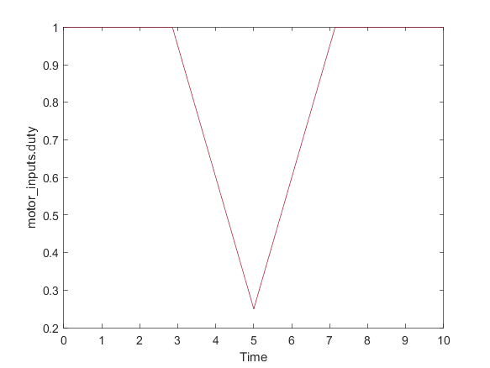

|  |  |
| --- | --- |
| Back to Report Summary | Back to Signal Summary |

|  |  |  |  |  |  |
| --- | --- | --- | --- | --- | --- |
| **Name** | **Data Type** | **Units** | **Sample Time** | **Interp** | **Sync** |
| motor_inputs.direction | double |  | 0.01 | linear | union |

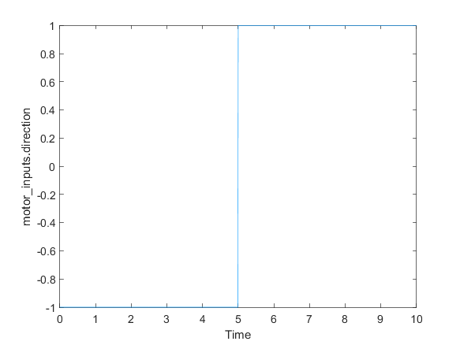

|  |  |
| --- | --- |
| Back to Report Summary | Back to Signal Summary |

**Simulation 2**

|  |  |
| --- | --- |
| **System Under Test Information** | |
| Model: | pwmCnv |
| Simulation Mode: | normal |
| Configuration Set: | Configuration1 |
| External Input Name: | pwmTestData.mat |
| External Input File: | C:\Perforce\sandbox\english\slvv\files\ch5\withTestSuite\tests\pwmTestData.mat |
| Start Time: | 0 |
| Stop Time: | 10 |
| Checksum: | 2998922239 2108830796 4045941144 3011785138 |
| Simulink Version: | 9.3 |
| Model Version: | 1.185 |
| Model Author: | bneiswan |
| Date: | Mon Mar 04 16:16:37 2019 |
| User ID: | bneiswan |
| Model Path: | C:\Perforce\sandbox\english\slvv\files\ch5\withTestSuite\models\pwmCnv.slx |
| Machine Name: | AH-BNEISWAN |
| Solver Name: | FixedStepDiscrete |
| Solver Type: | Fixed-Step |
| Fixed Step Size: | 0.01 |
| Simulation Start Time: | 2019-03-09 14:43:45 |
| Simulation Stop Time: | 2019-03-09 14:43:46 |
| Platform: | PCWIN64 |

**Simulation Output**

|  |  |  |  |  |  |  |
| --- | --- | --- | --- | --- | --- | --- |
| **Name** | **Data Type** | **Units** | **Sample Time** | **Interp** | **Sync** | **Link to Plot** |
| motor_inputs.duty | double |  | 0.01 | zoh | union | Link |
| motor_inputs.direction | double |  | 0.01 | zoh | union | Link |

|  |  |  |  |  |  |
| --- | --- | --- | --- | --- | --- |
| **Name** | **Data Type** | **Units** | **Sample Time** | **Interp** | **Sync** |
| motor_inputs.duty | double |  | 0.01 | zoh | union |

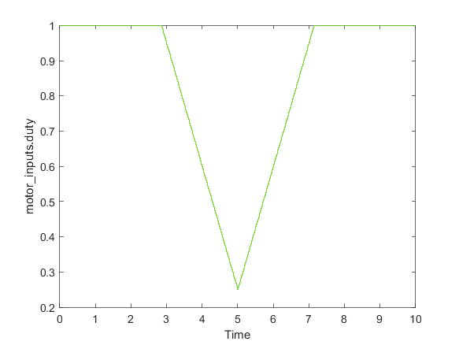

|  |  |
| --- | --- |
| Back to Report Summary | Back to Signal Summary |

|  |  |  |  |  |  |
| --- | --- | --- | --- | --- | --- |
| **Name** | **Data Type** | **Units** | **Sample Time** | **Interp** | **Sync** |
| motor_inputs.direction | double |  | 0.01 | zoh | union |

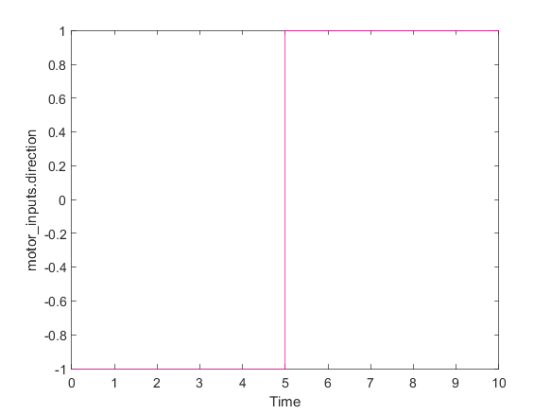

|  |  |
| --- | --- |
| Back to Report Summary | Back to Signal Summary |

|  |
| --- |
| **Zero Input Test** |

|  |  |
| --- | --- |
| **Test Result Information** | |
| Result Type: | Test Case Result |
| Parent: | PWM Conversion |
| Start Time: | 09-Mar-2019 14:43:47 |
| End Time: | 09-Mar-2019 14:43:49 |
| Outcome: | Passed |

|  |  |
| --- | --- |
| **Test Case Information** | |
| Name: | Zero Input Test |
| Type: | Simulation Test |

|  |
| --- |
| **Iteration1** |

|  |  |
| --- | --- |
| **Test Result Information** | |
| Result Type: | Test Iteration Result |
| Parent: | Zero Input Test |
| Start Time: | 09-Mar-2019 14:43:47 |
| End Time: | 09-Mar-2019 14:43:49 |
| Outcome: | Passed |

|  |  |
| --- | --- |
| **Test Case Information** | |
| Name: | Iteration1 |
| Type: | Simulation Test |

**Iteration Settings**

**Test Overrides**

|  |  |
| --- | --- |
| **Parameter Name** | **Value** |
| ExternalInput | C:\Perforce\sandbox\english\slvv\files\ch5\withTestSuite\sldv_output\pwmCnv\pwmCnv_sldvdata1.mat : Test Case:1 |

**Simulation**

|  |  |
| --- | --- |
| **System Under Test Information** | |
| Model: | pwmCnv |
| Simulation Mode: | normal |
| Configuration Set: | Configuration1 |
| External Input Name: | Test Case:1 |
| External Input File: | C:\Perforce\sandbox\english\slvv\files\ch5\withTestSuite\sldv_output\pwmCnv\pwmCnv_sldvdata1.mat : Test Case:1 |
| Start Time: | 0 |
| Stop Time: | 0 |
| Checksum: | 3391865571 2550012242 1423758845 2288482349 |
| Simulink Version: | 9.3 |
| Model Version: | 1.185 |
| Model Author: | bneiswan |
| Date: | Mon Mar 04 16:16:37 2019 |
| User ID: | bneiswan |
| Model Path: | C:\Perforce\sandbox\english\slvv\files\ch5\withTestSuite\models\pwmCnv.slx |
| Machine Name: | AH-BNEISWAN |
| Solver Name: | FixedStepDiscrete |
| Solver Type: | Fixed-Step |
| Fixed Step Size: | 0.01 |
| Simulation Start Time: | 2019-03-09 14:43:48 |
| Simulation Stop Time: | 2019-03-09 14:43:48 |
| Platform: | PCWIN64 |

**Simulation Output**

|  |  |  |  |  |  |  |
| --- | --- | --- | --- | --- | --- | --- |
| **Name** | **Data Type** | **Units** | **Sample Time** | **Interp** | **Sync** | **Link to Plot** |
| motor_inputs.duty | double |  | 0.01 | zoh | union | Link |
| motor_inputs.direction | double |  | 0.01 | zoh | union | Link |

|  |  |  |  |  |  |
| --- | --- | --- | --- | --- | --- |
| **Name** | **Data Type** | **Units** | **Sample Time** | **Interp** | **Sync** |
| motor_inputs.duty | double |  | 0.01 | zoh | union |

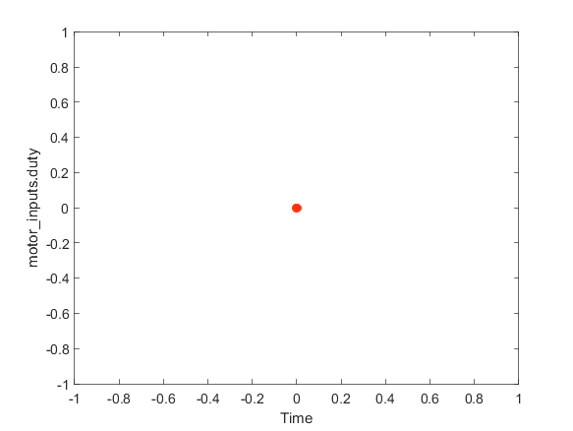

|  |  |
| --- | --- |
| Back to Report Summary | Back to Signal Summary |

|  |  |  |  |  |  |
| --- | --- | --- | --- | --- | --- |
| **Name** | **Data Type** | **Units** | **Sample Time** | **Interp** | **Sync** |
| motor_inputs.direction | double |  | 0.01 | zoh | union |

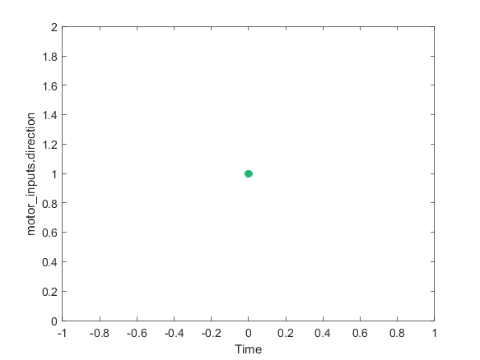

|  |  |
| --- | --- |
| Back to Report Summary | Back to Signal Summary |

|  |
| --- |
| **PI Controller** |

|  |  |
| --- | --- |
| **Test Result Information** | |
| Result Type: | Test Suite Result |
| Parent: | etcTests |
| Start Time: | 09-Mar-2019 14:43:50 |
| End Time: | 09-Mar-2019 14:43:58 |
| Outcome: | Total: 3, Passed: 3 |

|  |  |
| --- | --- |
| **Test Suite Information** | |
| Name: | PI Controller |

Back to Report Summary

|  |
| --- |
| **Windup Test** |

|  |  |
| --- | --- |
| **Test Result Information** | |
| Result Type: | Test Case Result |
| Parent: | PI Controller |
| Start Time: | 09-Mar-2019 14:43:50 |
| End Time: | 09-Mar-2019 14:43:52 |
| Outcome: | Passed |
| Description: |  |

Simulate the PI controller model to test for integrator windup.

|  |  |
| --- | --- |
| **Test Case Information** | |
| Name: | Windup Test |
| Type: | Simulation Test |
| **Test Case Requirements** | | |
| Description: | pi_ctrl_3: Maximum value of integral state ... (throttleReqs#8) | |
| Document: | [throttleReqs.doc](./documents/throttleReqs.doc) | |

**Verify Result**

|  |  |
| --- | --- |
| **Name** | **Link to Plot** |
| Test Sequence (Assessment)/.../Windup:verify(controller_output < (1 - Kp)) | Link |

|  |
| --- |
| **Name** |
| Test Sequence (Assessment)/.../Windup:verify(controller_output < (1 - Kp)) |

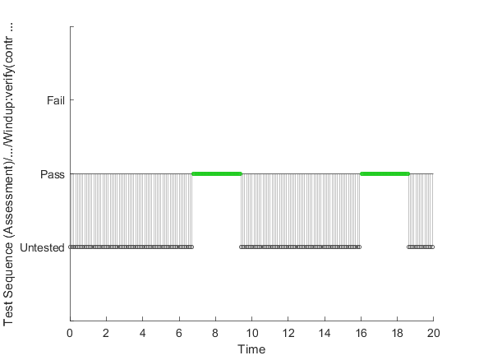

|  |  |
| --- | --- |
| Back to Report Summary | Back to Signal Summary |

**Simulation**

|  |  |
| --- | --- |
| **System Under Test Information** | |
| Model: | piCtrl |
| Harness: | piCtrl_Logic |
| Harness Owner: | piCtrl |
| Simulation Mode: | normal |
| Configuration Set: | Configuration1 |
| Start Time: | 0 |
| Stop Time: | 20 |
| Checksum: | 806252472 2402241606 2662739934 1985461667 |
| Simulink Version: | 9.3 |
| Model Version: | 1.11 |
| Model Author: | bneiswan |
| Date: | Sat Mar 09 13:12:36 2019 |
| User ID: | bneiswan |
| Model Path: | C:\Perforce\sandbox\english\slvv\files\ch5\withTestSuite\models\piCtrl.slx |
| Machine Name: | AH-BNEISWAN |
| Solver Name: | FixedStepDiscrete |
| Solver Type: | Fixed-Step |
| Fixed Step Size: | 0.01 |
| Simulation Start Time: | 2019-03-09 14:43:50 |
| Simulation Stop Time: | 2019-03-09 14:43:51 |
| Platform: | PCWIN64 |

**Simulation Output**

|  |  |  |  |  |  |  |
| --- | --- | --- | --- | --- | --- | --- |
| **Name** | **Data Type** | **Units** | **Sample Time** | **Interp** | **Sync** | **Link to Plot** |
| a2d_scaled.pedal_scaled | double |  | 0.01 | zoh | union | Link |
| a2d_scaled.angle_scaled | double |  | 0.01 | zoh | union | Link |
| Test Sequence:2 | boolean |  | 0.01 | zoh | union | Link |
| controller_output | double |  | 0.01 | zoh | union | Link |

|  |  |  |  |  |  |
| --- | --- | --- | --- | --- | --- |
| **Name** | **Data Type** | **Units** | **Sample Time** | **Interp** | **Sync** |
| a2d_scaled.pedal_scaled | double |  | 0.01 | zoh | union |

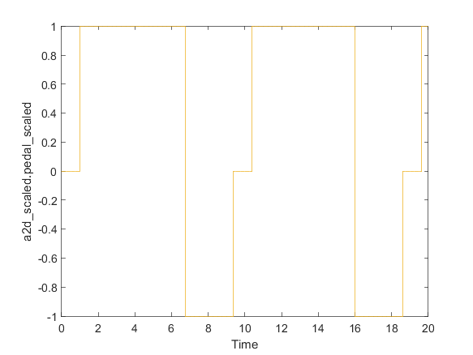

|  |  |
| --- | --- |
| Back to Report Summary | Back to Signal Summary |

|  |  |  |  |  |  |
| --- | --- | --- | --- | --- | --- |
| **Name** | **Data Type** | **Units** | **Sample Time** | **Interp** | **Sync** |
| a2d_scaled.angle_scaled | double |  | 0.01 | zoh | union |

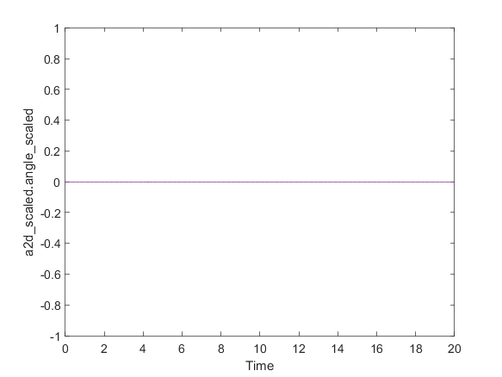

|  |  |
| --- | --- |
| Back to Report Summary | Back to Signal Summary |

|  |  |  |  |  |  |
| --- | --- | --- | --- | --- | --- |
| **Name** | **Data Type** | **Units** | **Sample Time** | **Interp** | **Sync** |
| Test Sequence:2 | boolean |  | 0.01 | zoh | union |

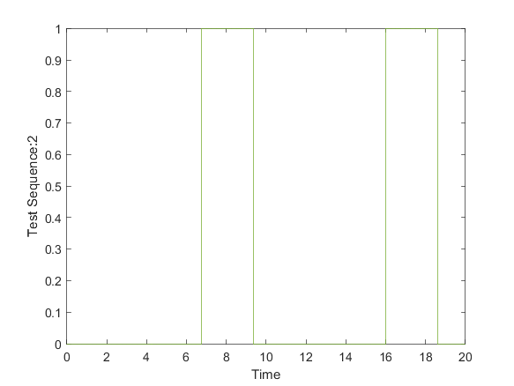

|  |  |
| --- | --- |
| Back to Report Summary | Back to Signal Summary |

|  |  |  |  |  |  |
| --- | --- | --- | --- | --- | --- |
| **Name** | **Data Type** | **Units** | **Sample Time** | **Interp** | **Sync** |
| controller_output | double |  | 0.01 | zoh | union |

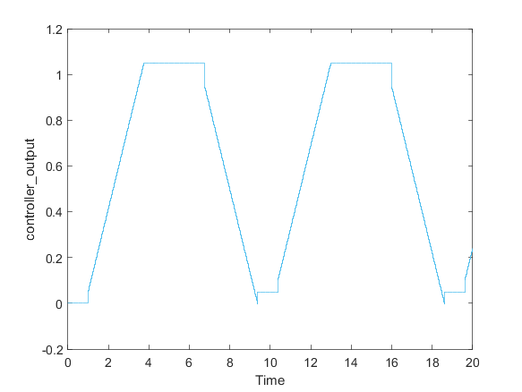

|  |  |
| --- | --- |
| Back to Report Summary | Back to Signal Summary |

|  |
| --- |
| **Parameter Tunability Test** |

|  |  |
| --- | --- |
| **Test Result Information** | |
| Result Type: | Test Case Result |
| Parent: | PI Controller |
| Start Time: | 09-Mar-2019 14:43:52 |
| End Time: | 09-Mar-2019 14:43:58 |
| Outcome: | Passed |
| Description: |  |

Simulate the PI controller model with parameter overrides and compare it to expected outputs.

|  |  |
| --- | --- |
| **Test Case Information** | |
| Name: | Parameter Tunability Test |
| Type: | Baseline Test |
| **Test Case Requirements** | | |
| Description: | Proportional and integral gains should be adjustable and tunable. | |
| Document: | [..\documents\throttleReqs.doc](./documents/throttleReqs.doc) | |

|  |
| --- |
| **Iteration1** |

|  |  |
| --- | --- |
| **Test Result Information** | |
| Result Type: | Test Iteration Result |
| Parent: | Parameter Tunability Test |
| Start Time: | 09-Mar-2019 14:43:52 |
| End Time: | 09-Mar-2019 14:43:55 |
| Outcome: | Passed |

|  |  |
| --- | --- |
| **Test Case Information** | |
| Name: | Iteration1 |
| Type: | Baseline Test |
| Baseline Name: | piExpectedOutput1.mat |
| Baseline File: | C:\Perforce\sandbox\english\slvv\files\ch5\withTestSuite\tests\piExpectedOutput1.mat |

**Iteration Settings**

**Test Overrides**

|  |  |
| --- | --- |
| **Parameter Name** | **Value** |
| SignalBuilderGroup | PI Test 1 |
| Baseline | C:\Perforce\sandbox\english\slvv\files\ch5\withTestSuite\tests\piExpectedOutput1.mat |

**Baseline Comparison**

|  |  |  |  |  |  |  |  |  |  |  |  |  |  |  |
| --- | --- | --- | --- | --- | --- | --- | --- | --- | --- | --- | --- | --- | --- | --- |
| **Name** | **Abs Tol** | **Rel Tol** | **Lead Tol** | **Lag Tol** | **Max Diff** | **Data Type 1** | **Units 1** | **Sample Time 1** | **Data Type 2** | **Units 2** | **Sample Time 2** | **Interp** | **Sync** | **Link to Plot** |
| a2d_scaled.pedal_scaled | 0.01 | 0.05 | 0 | 0 | 0 | double |  | 0.01 | double |  | 0.01 | zoh | union | Link |
| a2d_scaled.angle_scaled | 0.01 | 0.05 | 0 | 0 | 0 | double |  | 0.01 | double |  | 0.01 | zoh | union | Link |
| controller_output | 0.01 | 0.05 | 0 | 0 | 0 | double |  | 0.01 | double |  | 0.01 | zoh | union | Link |

|  |  |  |  |  |  |  |  |  |  |  |  |  |  |
| --- | --- | --- | --- | --- | --- | --- | --- | --- | --- | --- | --- | --- | --- |
| **Name** | **Abs Tol** | **Rel Tol** | **Lead Tol** | **Lag Tol** | **Max Diff** | **Data Type 1** | **Units 1** | **Sample Time 1** | **Data Type 2** | **Units 2** | **Sample Time 2** | **Interp** | **Sync** |
| a2d_scaled.pedal_scaled | 0.01 | 0.05 | 0 | 0 | 0 | double |  | 0.01 | double |  | 0.01 | zoh | union |

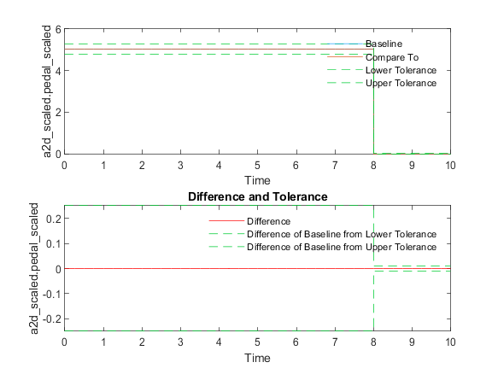

|  |  |
| --- | --- |
| Back to Report Summary | Back to Criteria Results |

|  |  |  |  |  |  |  |  |  |  |  |  |  |  |
| --- | --- | --- | --- | --- | --- | --- | --- | --- | --- | --- | --- | --- | --- |
| **Name** | **Abs Tol** | **Rel Tol** | **Lead Tol** | **Lag Tol** | **Max Diff** | **Data Type 1** | **Units 1** | **Sample Time 1** | **Data Type 2** | **Units 2** | **Sample Time 2** | **Interp** | **Sync** |
| a2d_scaled.angle_scaled | 0.01 | 0.05 | 0 | 0 | 0 | double |  | 0.01 | double |  | 0.01 | zoh | union |

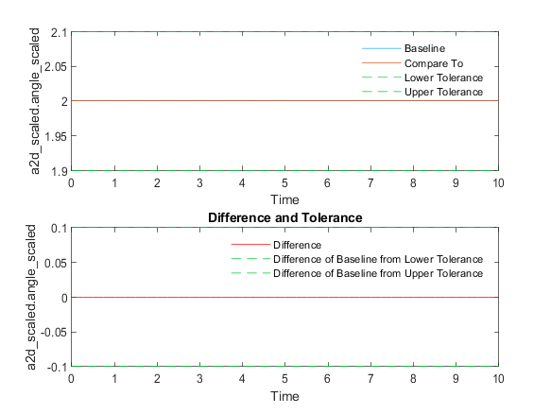

|  |  |
| --- | --- |
| Back to Report Summary | Back to Criteria Results |

|  |  |  |  |  |  |  |  |  |  |  |  |  |  |
| --- | --- | --- | --- | --- | --- | --- | --- | --- | --- | --- | --- | --- | --- |
| **Name** | **Abs Tol** | **Rel Tol** | **Lead Tol** | **Lag Tol** | **Max Diff** | **Data Type 1** | **Units 1** | **Sample Time 1** | **Data Type 2** | **Units 2** | **Sample Time 2** | **Interp** | **Sync** |
| controller_output | 0.01 | 0.05 | 0 | 0 | 0 | double |  | 0.01 | double |  | 0.01 | zoh | union |

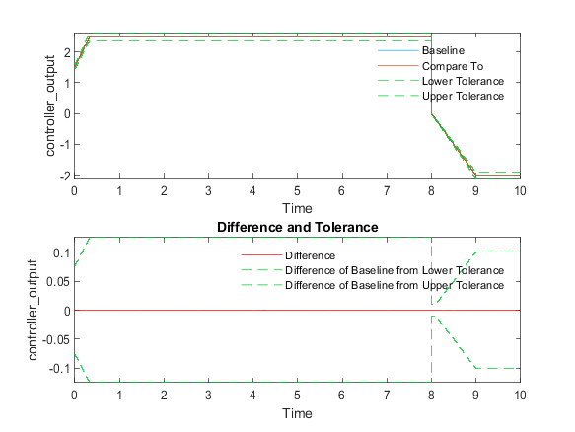

|  |  |
| --- | --- |
| Back to Report Summary | Back to Criteria Results |

**Simulation**

|  |  |
| --- | --- |
| **System Under Test Information** | |
| Model: | piCtrl |
| Harness: | piCtrl_Harness |
| Harness Owner: | piCtrl |
| Simulation Mode: | normal |
| Configuration Set: | Configuration1 |
| Signal Builder Block: | piCtrl_Harness/Harness Inputs |
| Signal Builder Group: | PI Test 1 |
| Start Time: | 0 |
| Stop Time: | 10 |
| Checksum: | 139475585 3713416244 2408504657 787736295 |
| Simulink Version: | 9.3 |
| Model Version: | 1.9 |
| Model Author: | bneiswan |
| Date: | Sat Mar 09 13:12:36 2019 |
| User ID: | bneiswan |
| Model Path: | C:\Perforce\sandbox\english\slvv\files\ch5\withTestSuite\models\piCtrl.slx |
| Machine Name: | AH-BNEISWAN |
| Solver Name: | FixedStepDiscrete |
| Solver Type: | Fixed-Step |
| Fixed Step Size: | 0.01 |
| Simulation Start Time: | 2019-03-09 14:43:53 |
| Simulation Stop Time: | 2019-03-09 14:43:53 |
| Platform: | PCWIN64 |

**Parameter Overrides**

|  |  |  |  |
| --- | --- | --- | --- |
| **Workspace Variable** | **Value** | **Source** | **Model Element** |
| Parameter Set 1 | | | |
| Ki | *1* | base workspace | piCtrl_Harness/piCtrl |
| Kp | *0.5* | base workspace | piCtrl_Harness/piCtrl |

**Simulation Output**

|  |  |  |  |  |  |  |
| --- | --- | --- | --- | --- | --- | --- |
| **Name** | **Data Type** | **Units** | **Sample Time** | **Interp** | **Sync** | **Link to Plot** |
| a2d_scaled.pedal_scaled | double |  | 0.01 | zoh | union | Link |
| a2d_scaled.angle_scaled | double |  | 0.01 | zoh | union | Link |
| controller_output | double |  | 0.01 | zoh | union | Link |

|  |  |  |  |  |  |
| --- | --- | --- | --- | --- | --- |
| **Name** | **Data Type** | **Units** | **Sample Time** | **Interp** | **Sync** |
| a2d_scaled.pedal_scaled | double |  | 0.01 | zoh | union |

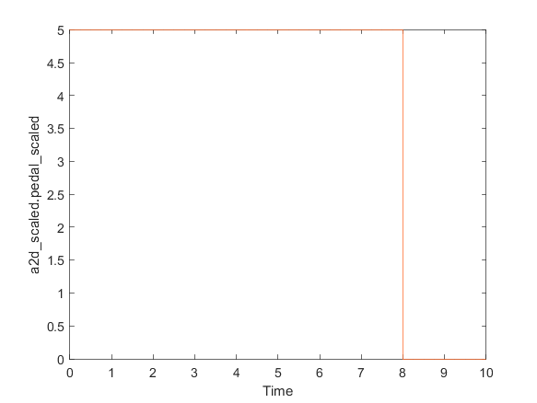

|  |  |
| --- | --- |
| Back to Report Summary | Back to Signal Summary |

|  |  |  |  |  |  |
| --- | --- | --- | --- | --- | --- |
| **Name** | **Data Type** | **Units** | **Sample Time** | **Interp** | **Sync** |
| a2d_scaled.angle_scaled | double |  | 0.01 | zoh | union |

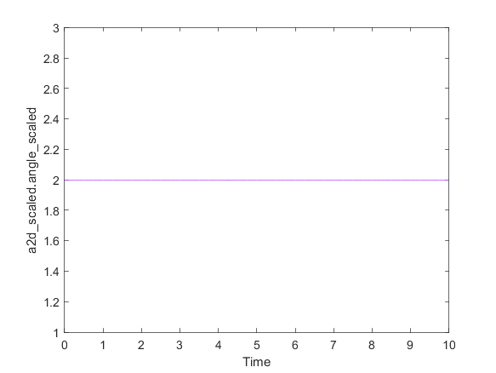

|  |  |
| --- | --- |
| Back to Report Summary | Back to Signal Summary |

|  |  |  |  |  |  |
| --- | --- | --- | --- | --- | --- |
| **Name** | **Data Type** | **Units** | **Sample Time** | **Interp** | **Sync** |
| controller_output | double |  | 0.01 | zoh | union |

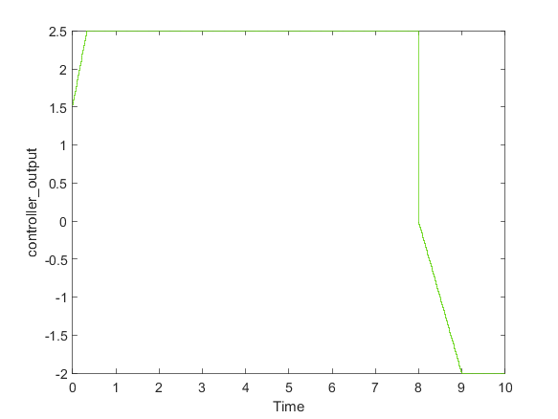

|  |  |
| --- | --- |
| Back to Report Summary | Back to Signal Summary |

|  |
| --- |
| **Iteration2** |

|  |  |
| --- | --- |
| **Test Result Information** | |
| Result Type: | Test Iteration Result |
| Parent: | Parameter Tunability Test |
| Start Time: | 09-Mar-2019 14:43:55 |
| End Time: | 09-Mar-2019 14:43:58 |
| Outcome: | Passed |

|  |  |
| --- | --- |
| **Test Case Information** | |
| Name: | Iteration2 |
| Type: | Baseline Test |
| Baseline Name: | piExpectedOutput2.mat |
| Baseline File: | C:\Perforce\sandbox\english\slvv\files\ch5\withTestSuite\tests\piExpectedOutput2.mat |

**Iteration Settings**

**Test Overrides**

|  |  |
| --- | --- |
| **Parameter Name** | **Value** |
| SignalBuilderGroup | PI Test 2 |
| Baseline | C:\Perforce\sandbox\english\slvv\files\ch5\withTestSuite\tests\piExpectedOutput2.mat |

**Baseline Comparison**

|  |  |  |  |  |  |  |  |  |  |  |  |  |  |  |
| --- | --- | --- | --- | --- | --- | --- | --- | --- | --- | --- | --- | --- | --- | --- |
| **Name** | **Abs Tol** | **Rel Tol** | **Lead Tol** | **Lag Tol** | **Max Diff** | **Data Type 1** | **Units 1** | **Sample Time 1** | **Data Type 2** | **Units 2** | **Sample Time 2** | **Interp** | **Sync** | **Link to Plot** |
| a2d_scaled.pedal_scaled | 0.01 | 0.05 | 0 | 0 | 0 | double |  | 0.01 | double |  | 0.01 | zoh | union | Link |
| a2d_scaled.angle_scaled | 0.01 | 0.05 | 0 | 0 | 0 | double |  | 0.01 | double |  | 0.01 | zoh | union | Link |
| controller_output | 0.01 | 0.05 | 0 | 0 | 0 | double |  | 0.01 | double |  | 0.01 | zoh | union | Link |

|  |  |  |  |  |  |  |  |  |  |  |  |  |  |
| --- | --- | --- | --- | --- | --- | --- | --- | --- | --- | --- | --- | --- | --- |
| **Name** | **Abs Tol** | **Rel Tol** | **Lead Tol** | **Lag Tol** | **Max Diff** | **Data Type 1** | **Units 1** | **Sample Time 1** | **Data Type 2** | **Units 2** | **Sample Time 2** | **Interp** | **Sync** |
| a2d_scaled.pedal_scaled | 0.01 | 0.05 | 0 | 0 | 0 | double |  | 0.01 | double |  | 0.01 | zoh | union |

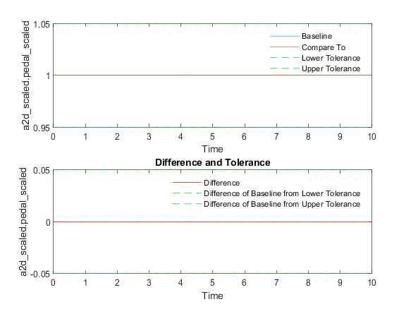

|  |  |
| --- | --- |
| Back to Report Summary | Back to Criteria Results |

|  |  |  |  |  |  |  |  |  |  |  |  |  |  |
| --- | --- | --- | --- | --- | --- | --- | --- | --- | --- | --- | --- | --- | --- |
| **Name** | **Abs Tol** | **Rel Tol** | **Lead Tol** | **Lag Tol** | **Max Diff** | **Data Type 1** | **Units 1** | **Sample Time 1** | **Data Type 2** | **Units 2** | **Sample Time 2** | **Interp** | **Sync** |
| a2d_scaled.angle_scaled | 0.01 | 0.05 | 0 | 0 | 0 | double |  | 0.01 | double |  | 0.01 | zoh | union |

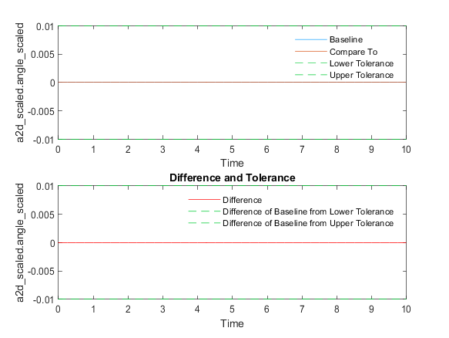

|  |  |
| --- | --- |
| Back to Report Summary | Back to Criteria Results |

|  |  |  |  |  |  |  |  |  |  |  |  |  |  |
| --- | --- | --- | --- | --- | --- | --- | --- | --- | --- | --- | --- | --- | --- |
| **Name** | **Abs Tol** | **Rel Tol** | **Lead Tol** | **Lag Tol** | **Max Diff** | **Data Type 1** | **Units 1** | **Sample Time 1** | **Data Type 2** | **Units 2** | **Sample Time 2** | **Interp** | **Sync** |
| controller_output | 0.01 | 0.05 | 0 | 0 | 0 | double |  | 0.01 | double |  | 0.01 | zoh | union |

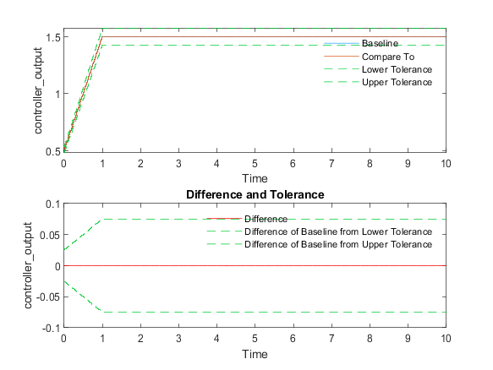

|  |  |
| --- | --- |
| Back to Report Summary | Back to Criteria Results |

**Simulation**

|  |  |
| --- | --- |
| **System Under Test Information** | |
| Model: | piCtrl |
| Harness: | piCtrl_Harness |
| Harness Owner: | piCtrl |
| Simulation Mode: | normal |
| Configuration Set: | Configuration1 |
| Signal Builder Block: | piCtrl_Harness/Harness Inputs |
| Signal Builder Group: | PI Test 2 |
| Start Time: | 0 |
| Stop Time: | 10 |
| Checksum: | 139475585 3713416244 2408504657 787736295 |
| Simulink Version: | 9.3 |
| Model Version: | 1.9 |
| Model Author: | bneiswan |
| Date: | Sat Mar 09 13:12:36 2019 |
| User ID: | bneiswan |
| Model Path: | C:\Perforce\sandbox\english\slvv\files\ch5\withTestSuite\models\piCtrl.slx |
| Machine Name: | AH-BNEISWAN |
| Solver Name: | FixedStepDiscrete |
| Solver Type: | Fixed-Step |
| Fixed Step Size: | 0.01 |
| Simulation Start Time: | 2019-03-09 14:43:56 |
| Simulation Stop Time: | 2019-03-09 14:43:56 |
| Platform: | PCWIN64 |

**Parameter Overrides**

|  |  |  |  |
| --- | --- | --- | --- |
| **Workspace Variable** | **Value** | **Source** | **Model Element** |
| Parameter Set 1 | | | |
| Ki | *1* | base workspace | piCtrl_Harness/piCtrl |
| Kp | *0.5* | base workspace | piCtrl_Harness/piCtrl |

**Simulation Output**

|  |  |  |  |  |  |  |
| --- | --- | --- | --- | --- | --- | --- |
| **Name** | **Data Type** | **Units** | **Sample Time** | **Interp** | **Sync** | **Link to Plot** |
| a2d_scaled.pedal_scaled | double |  | 0.01 | zoh | union | Link |
| a2d_scaled.angle_scaled | double |  | 0.01 | zoh | union | Link |
| controller_output | double |  | 0.01 | zoh | union | Link |

|  |  |  |  |  |  |
| --- | --- | --- | --- | --- | --- |
| **Name** | **Data Type** | **Units** | **Sample Time** | **Interp** | **Sync** |
| a2d_scaled.pedal_scaled | double |  | 0.01 | zoh | union |

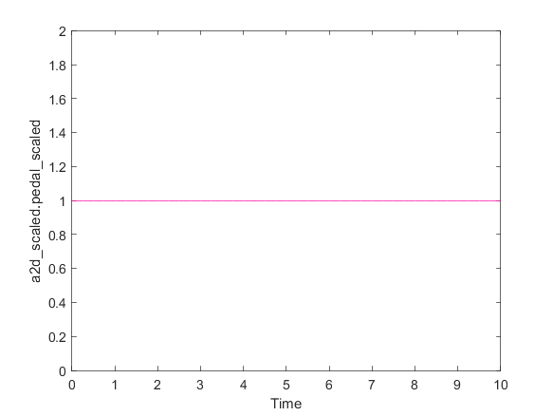

|  |  |
| --- | --- |
| Back to Report Summary | Back to Signal Summary |

|  |  |  |  |  |  |
| --- | --- | --- | --- | --- | --- |
| **Name** | **Data Type** | **Units** | **Sample Time** | **Interp** | **Sync** |
| a2d_scaled.angle_scaled | double |  | 0.01 | zoh | union |

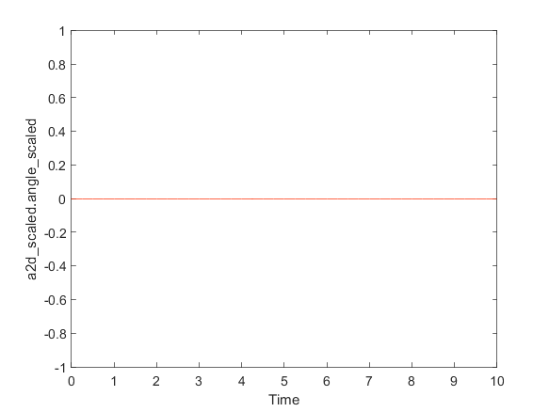

|  |  |
| --- | --- |
| Back to Report Summary | Back to Signal Summary |

|  |  |  |  |  |  |
| --- | --- | --- | --- | --- | --- |
| **Name** | **Data Type** | **Units** | **Sample Time** | **Interp** | **Sync** |
| controller_output | double |  | 0.01 | zoh | union |

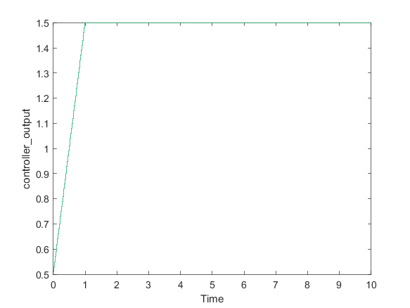

|  |  |
| --- | --- |
| Back to Report Summary | Back to Signal Summary |