**Practical 3:**

**Code:**

**1) Java file codes**

**MainActivity.java**

package com.example.myapplicationfragment;

import android.os.Bundle;

import androidx.appcompat.app.AppCompatActivity;

public class MainActivity extends AppCompatActivity {

@Override

protected void onCreate(Bundle savedInstanceState) {

super.onCreate(savedInstanceState);

setContentView(R.layout.activity_main);

// Check if the savedInstanceState is null, which means it's the first creation

if (savedInstanceState == null) {

// Add the Fragment1 to the container initially

getSupportFragmentManager().beginTransaction()

.add(R.id.fragment_container, new FirstFragment()).commit();

}

}

}

**FirstFragment.java**

package com.example.myapplicationfragment;

import android.os.Bundle;

import android.view.LayoutInflater;

import android.view.View;

import android.view.ViewGroup;

import androidx.fragment.app.Fragment;

import android.widget.Button;

public class FirstFragment extends Fragment {

public FirstFragment() {

// Required empty public constructor

}

@Override

public View onCreateView(LayoutInflater inflater, ViewGroup container,

Bundle savedInstanceState) {

View rootView = inflater.inflate(R.layout.fragment_first, container, false);

// Get the button reference

Button buttonGet = rootView.findViewById(R.id.button_get);

// Set click listener for the button

buttonGet.setOnClickListener(new View.OnClickListener() {

@Override

public void onClick(View v) {

// Add Fragment2 on top of Fragment1

SecondFragment fragment2 = new SecondFragment();

getParentFragmentManager().beginTransaction()

.add(R.id.fragment_container, fragment2)

.addToBackStack(null)

.commit();

}

});

return rootView;

}

}

**SecondFragment.java**

package com.example.myapplicationfragment;

import android.os.Bundle;

import android.view.LayoutInflater;

import android.view.View;

import android.view.ViewGroup;

import androidx.fragment.app.Fragment;

public class SecondFragment extends Fragment {

public SecondFragment() {

// Required empty public constructor

}

@Override

public View onCreateView(LayoutInflater inflater, ViewGroup container,

Bundle savedInstanceState) {

// Inflate the layout for this fragment

return inflater.inflate(R.layout.fragment_second, container, false);

}

}

**2) xml file codes**

**activity_main.xml**

<?xml version="1.0" encoding="utf-8"?>

<androidx.coordinatorlayout.widget.CoordinatorLayout xmlns:android="http://schemas.android.com/apk/res/android"

xmlns:app="http://schemas.android.com/apk/res-auto"

xmlns:tools="http://schemas.android.com/tools"

android:layout_width="match_parent"

android:layout_height="match_parent"

tools:context=".MainActivity">

<RelativeLayout xmlns:android="http://schemas.android.com/apk/res/android"

android:layout_width="match_parent"

android:layout_height="match_parent">

<FrameLayout

android:id="@+id/fragment_container"

android:layout_width="match_parent"

android:layout_height="match_parent"/>

</RelativeLayout>

</androidx.coordinatorlayout.widget.CoordinatorLayout>

**fragment_first.xml**

<?xml version="1.0" encoding="utf-8"?>

<androidx.constraintlayout.widget.ConstraintLayout xmlns:android="http://schemas.android.com/apk/res/android"

xmlns:app="http://schemas.android.com/apk/res-auto"

xmlns:tools="http://schemas.android.com/tools"

android:layout_width="match_parent"

android:layout_height="match_parent"

tools:context=".FirstFragment">

<RelativeLayout xmlns:android="http://schemas.android.com/apk/res/android"

android:layout_width="match_parent"

android:layout_height="match_parent">

<Button

android:id="@+id/button_get"

android:layout_width="wrap_content"

android:layout_height="wrap_content"

android:text="Get"

android:layout_centerInParent="true"/>

</RelativeLayout>

</androidx.constraintlayout.widget.ConstraintLayout>

**fragment_second.xml**

<?xml version="1.0" encoding="utf-8"?>

<androidx.constraintlayout.widget.ConstraintLayout xmlns:android="http://schemas.android.com/apk/res/android"

xmlns:app="http://schemas.android.com/apk/res-auto"

xmlns:tools="http://schemas.android.com/tools"

android:layout_width="match_parent"

android:layout_height="match_parent"

tools:context=".SecondFragment">

<RelativeLayout xmlns:android="http://schemas.android.com/apk/res/android"

android:layout_width="match_parent"

android:layout_height="match_parent">

<LinearLayout xmlns:android="http://schemas.android.com/apk/res/android"

android:layout_width="match_parent"

android:layout_height="match_parent"

android:orientation="vertical"

android:padding="16dp">

<EditText

android:id="@+id/edit_text_name"

android:layout_width="match_parent"

android:layout_height="wrap_content"

android:hint="Name"/>

<EditText

android:id="@+id/edit_text_phone"

android:layout_width="match_parent"

android:layout_height="wrap_content"

android:hint="Phone Number"/>

<EditText

android:id="@+id/edit_text_query"

android:layout_width="match_parent"

android:layout_height="wrap_content"

android:hint="Query"/>

</LinearLayout>

</RelativeLayout>

</androidx.constraintlayout.widget.ConstraintLayout>

**Output:**

**First Fragment:**

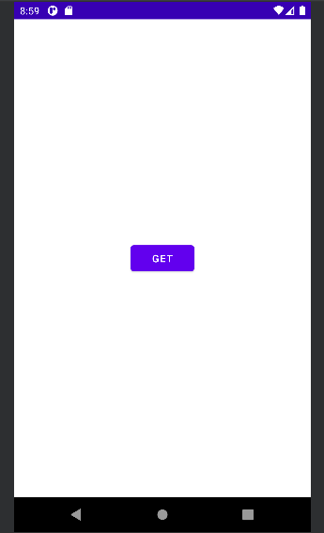

**Second Fragment:**

