Create an AWS Databricks Workspace
- Login to your AWS account in a separate browser tab.
- Open a new tab and login to AWS Databricks Account Console using your databricks user-id (You need to have Databricks Admin access)
  - Link: https://accounts.cloud.databricks.com/
- Click on Workspaces menu option and click Create Workspace button.
  - Workspace name: <suitable name>
  - Workspace name: <your region>
  - Storage and compute: select Use your existing Cloud account option
  - Select the options as shown and click on create workspace button. Click Continue
  - It will take a few minutes to provision and activate your workspace.

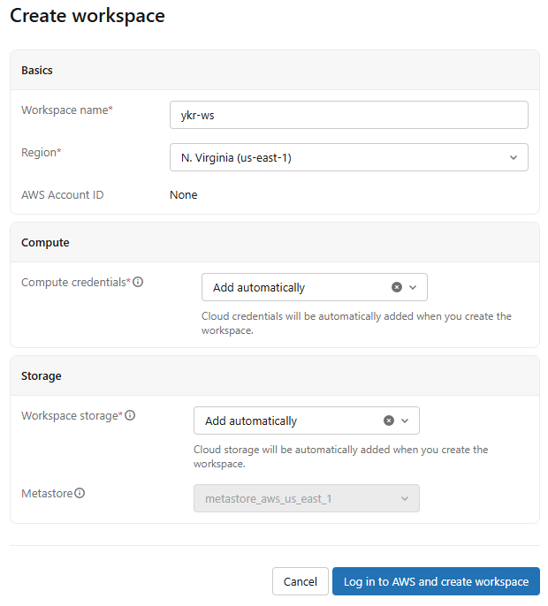
Create Storage Credential
Step 1: Setup an IAM Role (Custom trust policy)
- Open IAM Console, go to 'Roles' and click on 'Create Role'
- Select 'Custom trust policy'
- Paste the JSON code of SNIPPET-1 in trust relationship tab
- Give the role a name and create it
  - Name: CTSDatabricksExternalDataRole
- Modify the trust relationship policy to make it self-assuming.
  - Return to your saved IAM role and go to the Trust Relationships tab.
  - Edit the trust relationship policy.
  - Add the following ARN to the Principal of the “Allow” statement.
arn:aws:iam::<YOUR-AWS-ACCOUNT-ID>:role/<THIS-ROLE-NAME>
  - Replace <YOUR-AWS-ACCOUNT-ID> and <THIS-ROLE-NAME> with actual values.
- Save the changes.
Step 2: Create an S3 Bucket
- Create an S3 bucket. (The credential we create, grants permission to access this S3 bucket)
  - S3 bucket name: cts-databricks-data

Step 3: Create a policy for the role to access S3 bucket
- Click on 'Policies' menu option and click on 'Create Policy' button.
- Create policy with the following:
  - Name: CTSDatabricksExternalDataS3Policy
  - Service: S3
  - JSON: As in Snippet 2
- Attach the policy to the IAM role.
  - On the IAM role’s Permissions tab, attach the IAM policy you just created.

Step 4: Attach a bucket policy to the S3 bucket
- Open the S3 bucket
- Navigate to Permissions Tab
- Click on Edit button to edit the bucket policy
- Bucket Policy JSON: As in Snippet 3
  - Make sure to replace the place-holders with corresponding values.

Step 5: Create the Credential in Databricks UI
- Log in to your Databricks workspace.
- In the left sidebar, click Catalog.
- Click Connect > Credentials from the sub-menus.
- Select Create credential.
- Set the Credential Type to AWS IAM Role.
- Provide a Name for the credential and paste your AWS IAM Role ARN.
- Click Create.

Step 6: Establish the Trust Relationship (AWS Side)
Once the credential is saved, a unique External ID is generated. You must update your AWS IAM Role's trust policy to allow Databricks to assume it safely.
- Copy the External ID from the "Credential created" popup inside Databricks.
- Go to your AWS IAM Console, locate your role, and edit the Trust Relationship Policy to match the JSON provided by the credential:
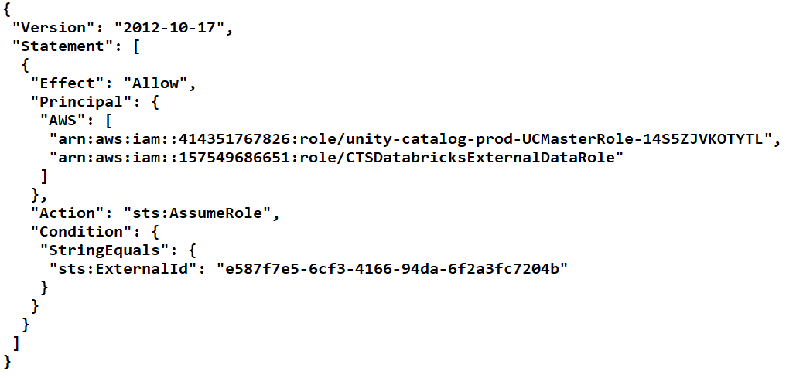
(Note: 414351767826 is the standard Databricks AWS account ID used for cross-account Unity Catalog requests).

Step 7: Validate the Connection
- Return to the Catalog > Credentials page in Databricks.
- Click on your newly created storage credential.
- Click Validate Configuration.
- If it turns green, your Databricks account is authenticated to securely communicate with your AWS S3 resource!

You can now use this credential to build an External Location mapping to specific bucket paths.

--------------------------------------------
Snippet 1
--------------------------------------------
{
"Version": "2012-10-17",
"Statement": [
{
"Sid": "Statement1",
"Effect": "Allow",
"Principal": {
"AWS": [
"arn:aws:iam::414351767826:role/unity-catalog-prod-UCMasterRole-14S5ZJVKOTYTL"
]
},
"Action": "sts:AssumeRole",
"Condition": {
"StringEquals": {
"sts:ExternalId": "<DATABRICKS_ACCOUNT_ID>"
}
}
}
]
}

--------------------------------------------
Snippet 2
--------------------------------------------

{
"Version": "2012-10-17",
"Statement": [
{
"Action": [
"s3:GetObject",
"s3:ListBucket",
"s3:GetBucketLocation",
"s3:GetLifecycleConfiguration",
"s3:PutLifecycleConfiguration"
],
"Resource": [
"arn:aws:s3:::<BUCKET>/*",
"arn:aws:s3:::<BUCKET>"
],
"Effect": "Allow"
},
{
"Action": [
"sts:AssumeRole"
],
"Resource": [
"arn:aws:iam::<AWS-ACCOUNT-ID>:role/<AWS-IAM-ROLE-NAME>"
],
"Effect": "Allow"
}
]
}

--------------------------------------------
Snippet 3 (Bucket Policy)
--------------------------------------------

{
"Version": "2012-10-17",
"Statement": [
{
"Sid": "Statement1",
"Principal": {
"AWS": "arn:aws:iam::<YOUR-AWS-ACCOUNT-ID>:role/<ROLE-NAME>"
},
"Effect": "Allow",
"Action": [ "s3:*" ],
"Resource": [
"arn:aws:s3:::<BUCKET>/*",
"arn:aws:s3:::<BUCKET>"
]
}
]
}

