ASSIGNMENT 4

Yograj Karki

20121-04-22

# Markdown Basics

## Favorite Foods

1. Kheer
2. Mo:Mo
3. Biryani

## Images

All Cases (Log Plot)

All Cases (Log Plot)

## Add a Quote

Be the change you want to see in the world.  
You miss 100% of the shots you don’t take.

## Add an Equation

$Area=π*r^{2}$

## Add a Footnote

footnote.[1]

## Add Citations

* R for Everyone
* Discovering Statistics Using R

# Inline Code

## NY Times COVID-19 Data

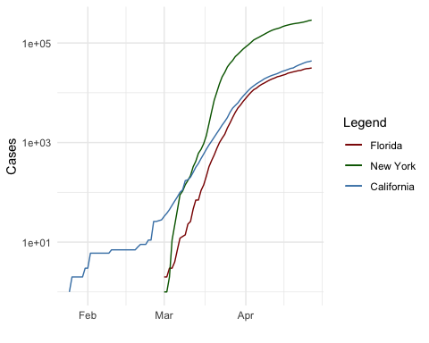

COVID-19 in 3 US states

## R4DS Height vs Earnings

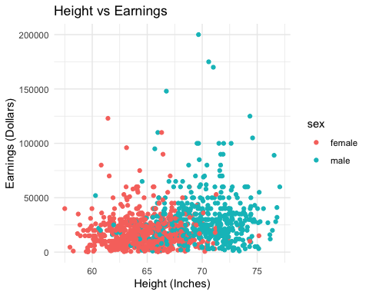

Height vs Earnings

# Tables

## Knitr Table with Kable

One Ring to Rule Them All

|  |  |  |  |  |
| --- | --- | --- | --- | --- |
| name | race | in_fellowship | ring_bearer | age |
| Aragon | Men | TRUE | FALSE | 88 |
| Bilbo | Hobbit | FALSE | TRUE | 129 |
| Frodo | Hobbit | TRUE | TRUE | 51 |
| Galadriel | Elf | FALSE | FALSE | 7000 |
| Sam | Hobbit | TRUE | TRUE | 36 |
| Gandalf | Maia | TRUE | TRUE | 2019 |
| Legolas | Elf | TRUE | FALSE | 2931 |
| Sauron | Maia | FALSE | TRUE | 7052 |
| Gollum | Hobbit | FALSE | TRUE | 589 |

## Pandoc Table

|  |  |  |  |  |
| --- | --- | --- | --- | --- |
| Name | Race | In Fellowship? | Is Ring Bearer? | Age |
| Aragon | Men | Yes | No | 88 |
| Bilbo | Hobbit | No | Yes | 129 |
| Frodo | Hobbit | Yes | Yes | 51 |
| Sam | Hobbit | Yes | Yes | 36 |
| Sauron | Maia | No | Yes | 7052 |

# References

* R for Everyone
* Discovering Statistics Using R

1. Here is the footnote.