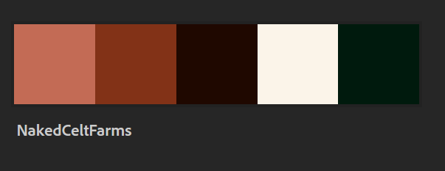

**Left to Right Hex Values**

#C36B55

#823217

#1F0800

#FBF4E9

#001A0D

**Selected Fonts – Frederica the Great**

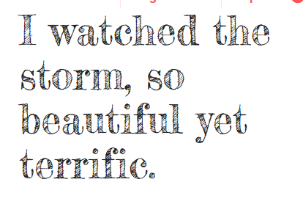

**Body Text – Amiko**

**A close up of a logo

Description generated with very high confidence**

**A screenshot of a social media post

Description generated with very high confidence**

**A screenshot of a cell phone

Description generated with very high confidence**

**A screenshot of a cell phone

Description generated with very high confidence**