**INTRODUCTION**

OVERVIEW

To-do-list-app is an application that allows you to manage a list of tasks to do. It is one of the simplest solution for task management in which you can perform adding, updating and deleting the tasks according to usage. It has minimalistic design and basic functionality.

Our aim is to design a simple and elegant to-do-list web page which can be used to keep a track on the daily tasks. Making a to-do-list is an easy and important task that everyone should do. The immense satisfaction that one gets when completing the task and marking it on the list is incomparable. Moreover, creating a list of tasks ensure you don’t miss out on anything. It’s a scientific fact that when you write the tasks that you need to complete, you are even more motivated to complete it. With this in mind, we prepared a web platform which will help you to create own task list. And this is our project of TO-DO-LIST-APP based on **front end development**.

ABOUT PROJECT AND ITS PURPOSE

To create and execute any web page or app we need a developing platform with modern tools and technology. So we opted **VISUAL STUDIO CODE** one of the web developing platform/interface to finish our project viz. SIMPLE TO-DO-LIST APP. In this we developed HTML (Hypertext markup language) for the base structure of the app, CSS (cascading style sheets) to improve the background texture of the app by giving it a decent look & JavaScript by which the functions of our web page are regulated and can perform required tasks.

Ours is the simple to-do-list which consists of an input task column, where you can enter the task which you want to perform in a short period of time such as in one day or within a week. After entering the task you can click enter or add button which is located just right to the input column. The task will be added to the webpage and will be stored in the local storage, every time you open the web page no task will be deleted. Until you delete the tasks will be shown in the web page. There will be a checkbox appears with every task you added, once any task is completed you can click on that checkbox, than the task will be stroked and be blurred that indicates the task is completed and you can go for other task.

There is a task filtering button on clicking which you will get three filters All, complete & Incomplete. All is selected by default and all the complete and incomplete tasks will be appeared on the web page. The tasks you have stroked will be appeared when you click complete button and incomplete or pending tasks will be appeared when you click incomplete button. This will help you more in detecting completed and pending tasks. If there are multiple tasks which are completed then you can delete them and it will be helpful to complete the pending tasks. Every time you visit the web page you will be remembered about the tasks.

**LITERATURE SURVEY**

EXISTING PROBLEM

To-do list is an important task management program which is used by everyone to complete their particular tasks in their day to day life. It helps them in saving their tasks, implementing their tasks and to complete their tasks. But the problem with the previously built to-do list app is it’s very simple in performing. There you can only give the task and can modify/delete it’s after its completion. It didn’t had ant task filtering system due to which you are unable determine which tasks are completed or which tasks are pending and by mistake when you delete all some incomplete tasks also deleted. ‘As you have to work on some important task you saved in it will be deleted and you forget about that’ assuming this it’s very hard. So we updated the simple to-do list app to overcome the above problem.

PROPOSED SOLUTION

As subjected to the app and to overcome the problems in the app described above, some exciting features are added to the app they are task filtering and dynamic updating of the tasks. There is a checkbox provided with every task you add in the app, after the completion of task click on that, the task will be stoked and blurred that indicates the task is completed. The provided task filtering consists of three types of filters I.e. All, Completed and Incomplete. All is selected by default and all tasks are visible in this. When you click the completed button the completed tasks will be appear on the screen as usually the purpose of incomplete button is same but it shows pending tasks. Which will improve the performance of app by defining between completed and incomplete tasks that makes easier to user to define tasks. User can delete the completed tasks when task list is fully occupied and pending tasks will not be deleted and there will be space to add new tasks in to the list.

**THEORITICAL ANALYSIS**

BLOCK DIAGRAM

Request goes to platform

MODIFY/

DELETE TASK

APPLICATION

PLATFORM

UI SCREEN

ENTER AND ADD THE TASK

USER

LOCAL STORAGE

Task filtering

Filter button

INCOMPLETE BUTTON

COMPLET BUTTON

ACCESS TO COMPLETED TASKS

MODIFY/DELETE TASK

PENDING TASKS

IT IS SELECTED BY DEFAULT, ALL TASKS ARE SHOWN HERE

HARDWARE AND SOFTWARE REQUIREMENTS

* PROCESSOR – INTEL
* OPTICAL MOUSE
* KEY BOARD
* HARD DISK -1gb
* RAM -512mb
* OPERATING SYSTEM – WINDOWS 10
* INTERFACE – VISUAL STUDIO CODE

**RESULT**

OUTPUT/FINAL FINDINGS OF THE PROJECT

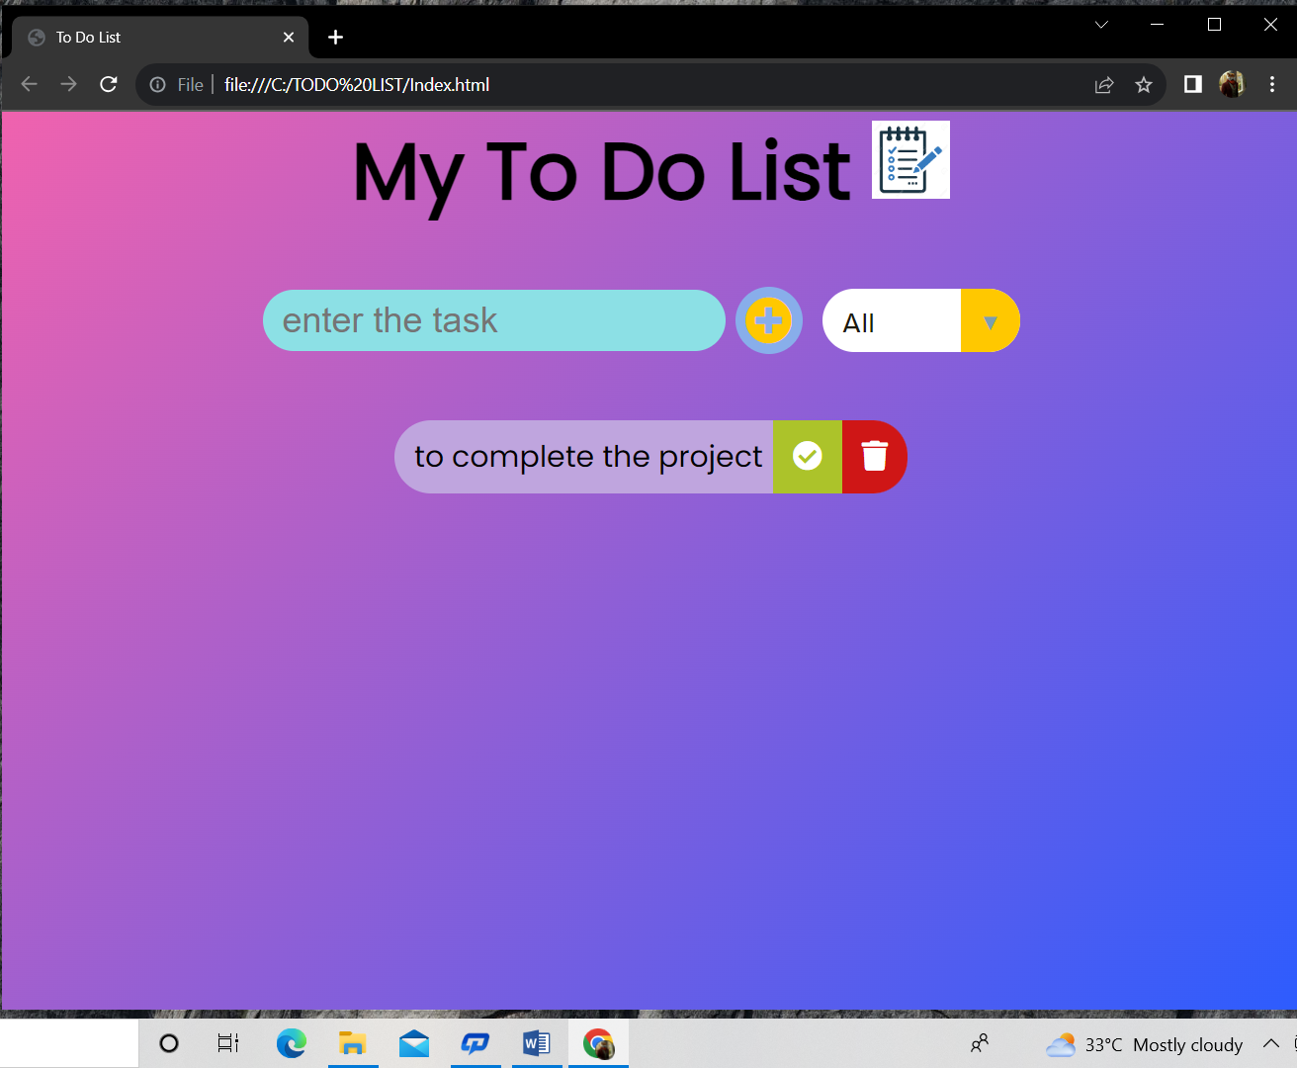

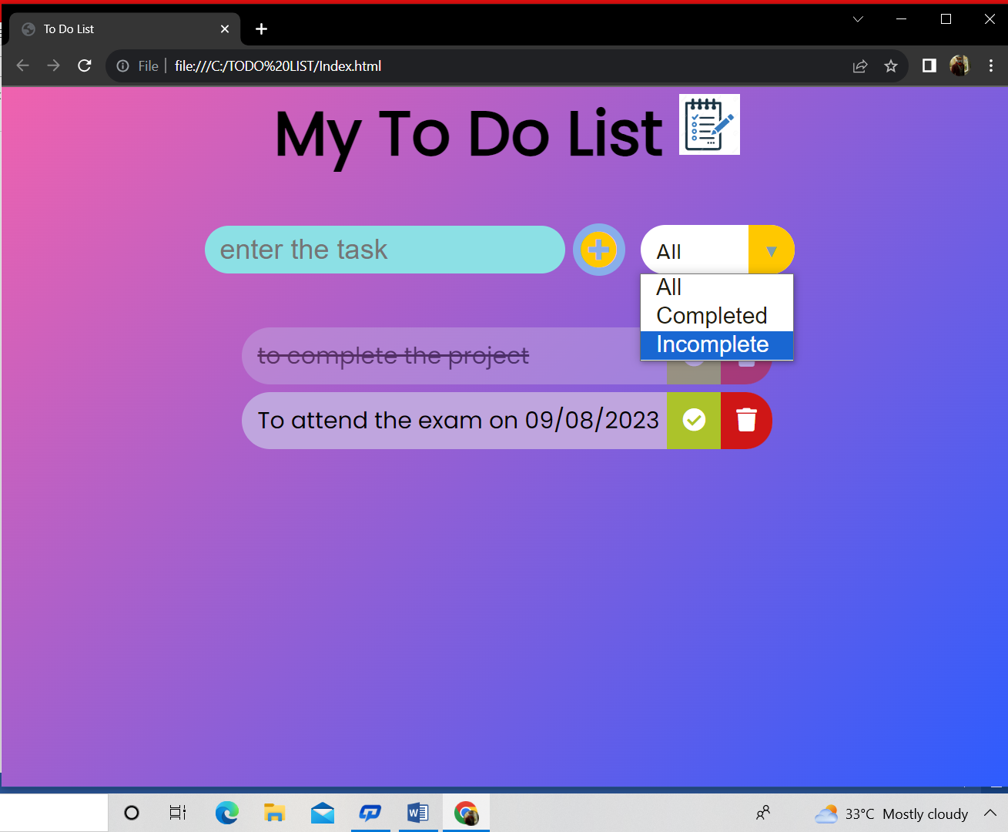

**ADVANTAGES AND DISADVANTAGES**

**OF THE PROPOSED SOLUTION**

ADVANTAGES:

1. The task filtering helps in filtering the tasks into completed, active or pending tasks, which makes user to define tasks on the basis of its completion on incompletion.
2. The tasks will be updated as completed when user clicks on the checkbox given with the task.
3. There will be no more confusion between completed and pending tasks.
4. Once the task is completed user can check it and delete on his own.
5. Every time he visited the filtering buttons he will be remembered of his completed and his active tasks.

DISADVANTAGES:

1. The user has to do somethings manually that is the biggest disadvantage such of them are deleting the completed task manually since it does not delete automatically.
2. As time and date update not provided in this the user will be confused between several tasks he stored.
3. There is no notification remainder provided in the app for sure user has to open app every time when he want to check the tasks.
4. There are no specific filters are provided to indicate or differentiate tasks on its importance i.e. some are important to complete in a given period of time and some matters in day to day life and so on.
5. The last and final disadvantage is you cannot put tasks in weekly order and the app will be filled with previous tasks until you delete.

**APPLICATIONS**

* Todoist
* Any.do
* Microsoft To Do
* Google Keep
* Google Tasks
* Evernote
* Simplenote
* TickTick
* Focus To-Do
* To-Do List
* Taskade
* My daily planner
* To Do Remainder
* Simple To-Do List

**CONCLUSION**

In these modern days task management is a very important thing to be done by everyone. The person who has less tasks or work to be done can remember on his own but if he had lot of things to do in a particular time period than it is difficult to remember everything. That’s where the To-Do List app is useful. Here you don’t need to remember everything because you can store your tasks in that app. Every time you visit the app you will be updated and remembered of each and every task. This is useful to students who had lots of projects to be done and for the web and app developers who had dead line to complete their projects and in so prospects to-do app is very useful. Now a days the to-do apps are so updated that they can filter the tasks and can be updated dynamically. They are updated such that they give notification with alarm. We can divide different tasks according to their use and importance and so on. And finally there all lot of uses of the To-Do list app in these modern days of development.

**FURURE SCOPE**

* Time to time update tasks
* Deadline notification
* Automatic filtration on the basis of time period
* Update/modify date and time
* Automatic deletion of previous week/month completed tasks
* Active status of tasks
* Useful for traveling also to remind the traveling date and time
* Automatically updating tasks on the basis of week
* Tasks will be filtered weekly