Semester-Project: Tour Planner
  - Software Engineering 2 Labor

Team 2
Lena Gampenrieder – if24b255
Yusuf Kaymaz – if24b121
Jasmina Mojdehkar – if24b250

UX

Wireframe
Drawio-File can be found in the zip.

Personas
The “Personas” we have, that can interact with the system are:
Visitor – a Visitor has no account.
User – a User has an account.

Scenarios:
the wireframes in the documentation are not supposed to show the actual design, which has been improved since the creation of the Wireframe, but instead represent the flow of the scenarios

“As a visitor I want to register an account, so that I can log in”
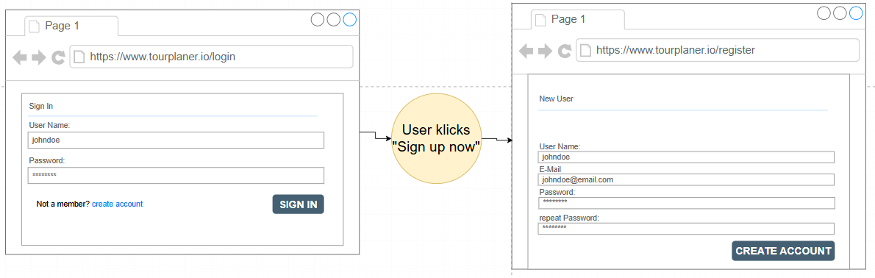

“As a User I want to login, so that I can create a Tour”
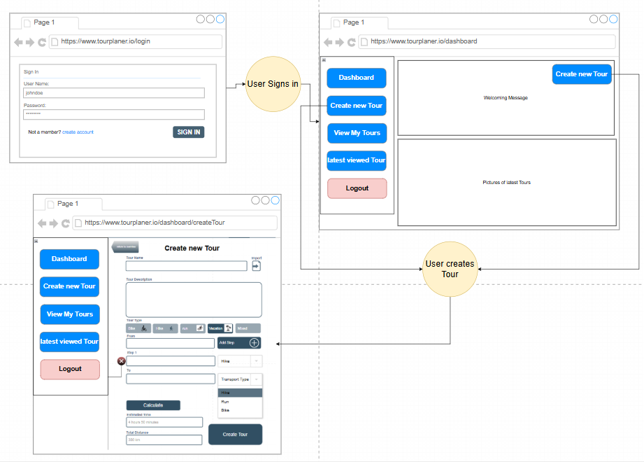
Since “Creating a Tour” is one of the main Use-Cases of our Tour-Planner we gave the User multiple options to reach that screen.
However we also did not want to just throw the user into a functionality, once they are logged in, which is why we have the dashboard-screen.

“As a User I want to view a specific Tour, so that I can easily manage it”
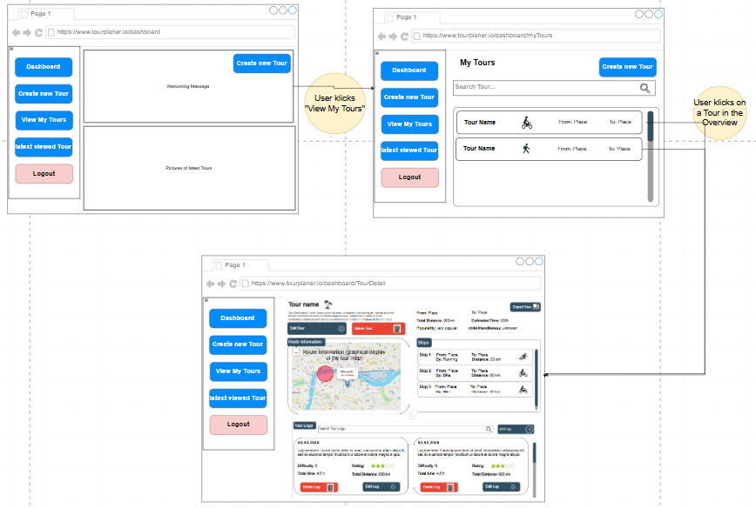
From the Dashboard the user has the option to see an overview of their tours.
From the Overview the user can select a Tour by klicking on it and ist navigated to the overview, where they are given the Option to “Modifiy” or “Delete” the Tour
As well as add or delete Logs.
The tour that was the last one to be selected by the user is saved in the App-State. This way the User also has the easy option to navigate to this tour by klicking “latest viewed Tour”. Creating a Tour saves that one to the App-State as the latest selected and navigates to the detail-screen.

Improving User-Experience
A Decision that was made to improve the User-Experience was to make the List-Containers:
- Steps in Detail-Screen
- Logs in Detail-Screen
Scrollable when the User is using a desktop (large Screen)
And collapsible, when the User is using a small device.
This makes it easier to navigate for the user.
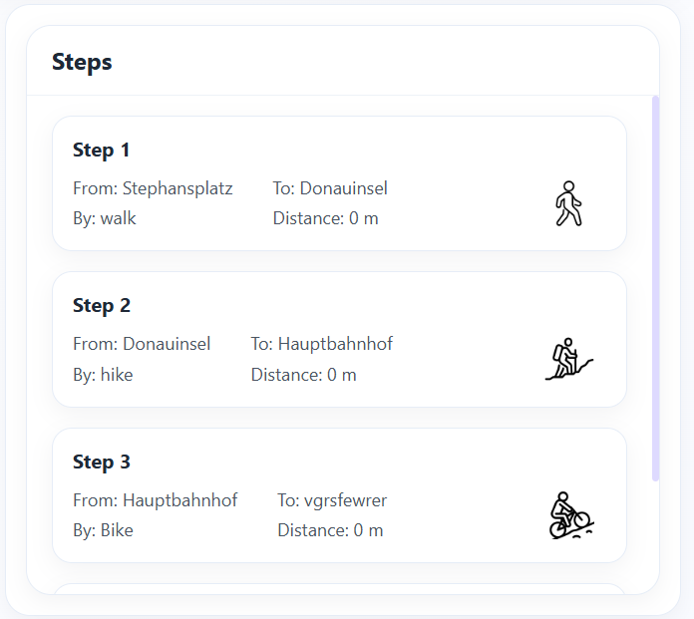
Steps on Desktop:

Steps on Mobile – not collapsed: Steps on Mobile – collapsed:
