Semester-Project: Tour Planner
  - Software Engineering 2 Labor

Team 2
Lena Gampenrieder – if24b255
Yusuf Kaymaz – if24b121
Jasmina Mojdehkar – if24b250

Link zu Git
https://github.com/ykay12/tourplanner

Set-Up
To use the application you need to:
- create a .env file in the root of tourplanner-backend. In this .env file save OPEN_ROUTE_SERVICE_API_KEY=/your API key/
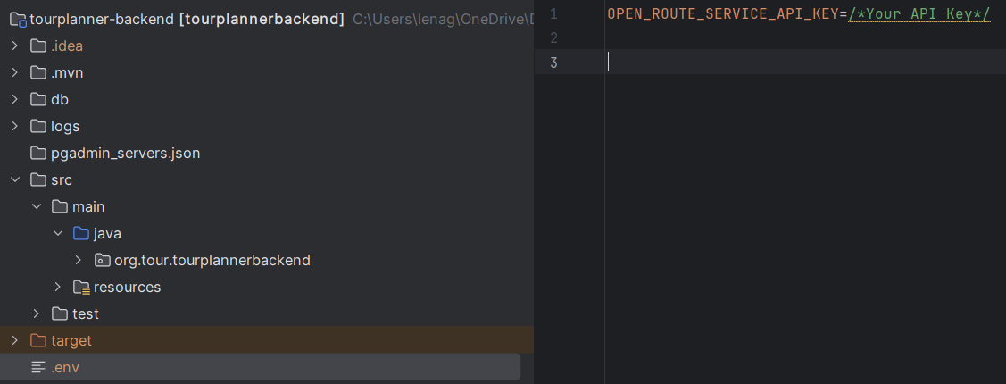

Tracked Time
To track Lenas time we counted the commits to github and calculated a half hour per commit (since this was about the average time per commit) I then added around 10 hours for meetings in which we discussed how to proceed
Commits: 81 comits * 0.5 + 10 = 50,5 hours.
Time Yusuf:
Time Jasmina:
Overall time:

App Architecture
For the Architecture in the Backend we used a Layer-Based-Architecture, with the Layers “Presentation” , “Business” and “Persistence”.
The Presentation Layer contains things that communicate with the outside world and things that are needed to do so. For example controllers, DTOs and Mapper.
The Business Layer contains our internal Business Logic, such es the services. And the Persistence Layer contains our internal Data Structures, which double as the entities that are saved to the database. The Persistence Layer also contains the repositories which are the “gateway” to the database. Apart from these Layers we also have the integration-directory, which contains a façade to communicate with the Open Route Service API. And a Config-Directory, which is used to make “secret” parts of the Application available.
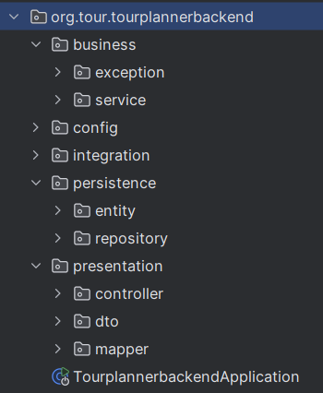
In the Front End, we use an MVVM pattern, which integrates nicely with Angular,
For the View we use the components html files. And for the Model we have an App-State in which we hold for example the users Tours as well as the id of the latest selected Tour:
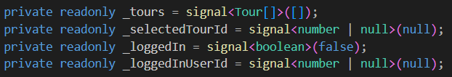
The .ts files of the components act as the View Model, which mediates between the View and the Model.

Unique Feature
Our unique feature is the ability to create “Mixed Tours”. Mixed Tours contain multiple steps, and the user can choose a different mode of transport for each step.
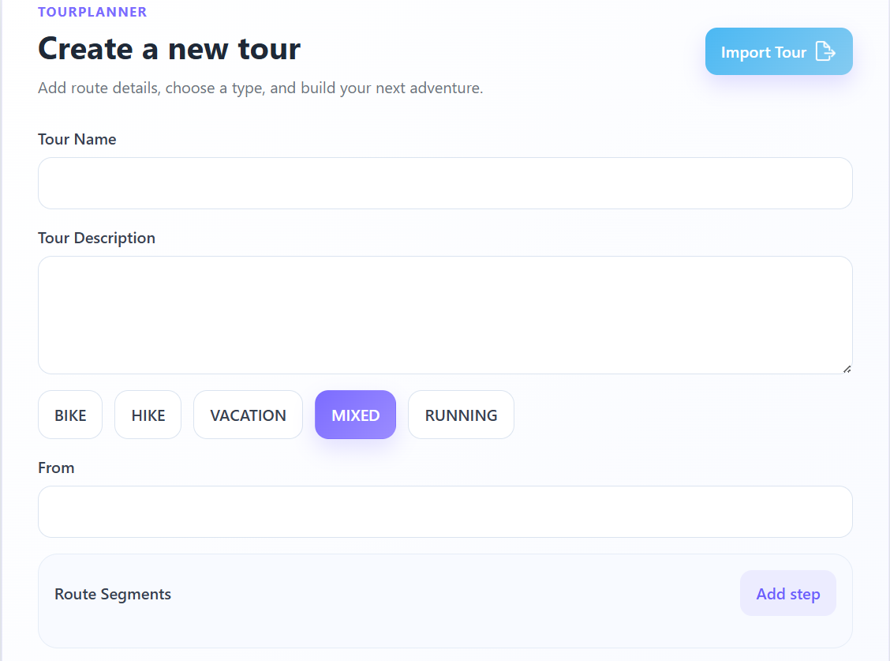
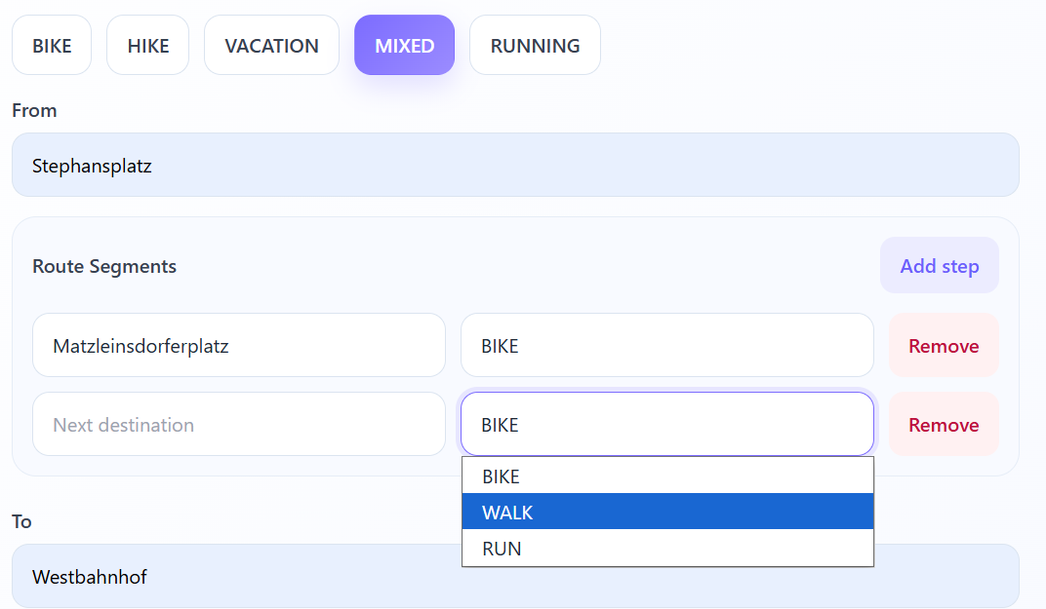In the backend a request to Open Route Service for every step is made with the fitting mode of transport, so that the duration is correctly calculated for every step (by foot takes longer than by bike).
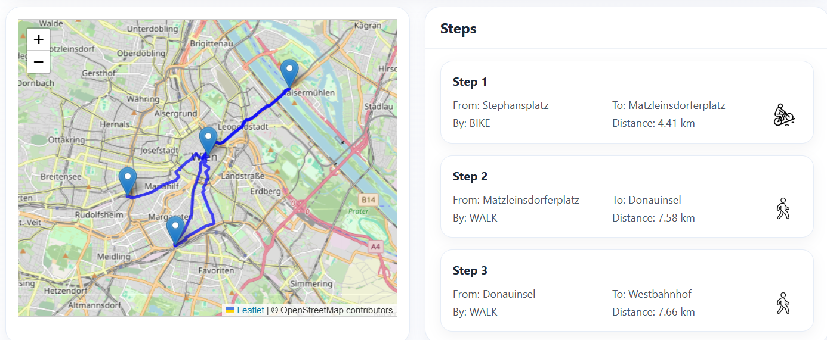
In the front end, a marker is set on the map for every intermediate step that the user has created. And In the steps the mode of transport is marked by text as well as an image.
In order to do this we have separate ways of storing the intermediate steps chosen by the user and the waypoints that we get from Open Route Service.
A Tour has TourRoutes which correspond with the intermediate step that the user has created.
And a TourRoute has a List / Array of Coordinates which contain a latitude and a longitude: the waypoints that we get from Open Route Service.

Unit Testing Decisions
Jasmina?

Design Pattern

Library Decisions
????

Use Cases
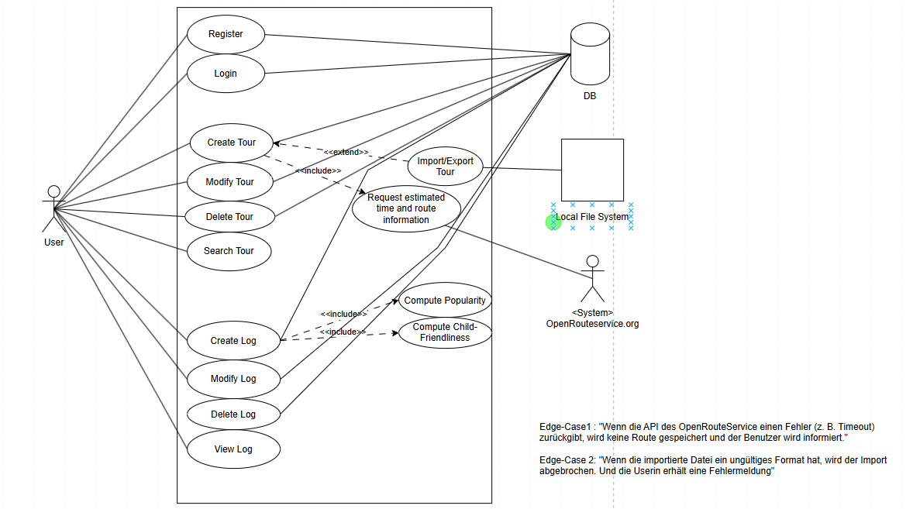
- neues erstellen mit Front End und Backend??

UX
The following is the same as in the documentation for the intermediate hand-in.

Wireframe
Drawio-File can be found in the zip.

Personas
The “Personas” we have, that can interact with the system are:
Visitor – a Visitor has no account.
User – a User has an account.

Scenarios:
the wireframes in the documentation are not supposed to show the actual design, which has been improved since the creation of the Wireframe, but instead represent the flow of the scenarios

“As a visitor I want to register an account, so that I can log in”
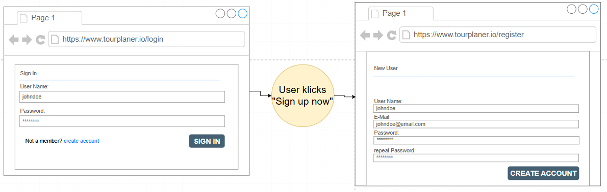

“As a User I want to login, so that I can create a Tour”
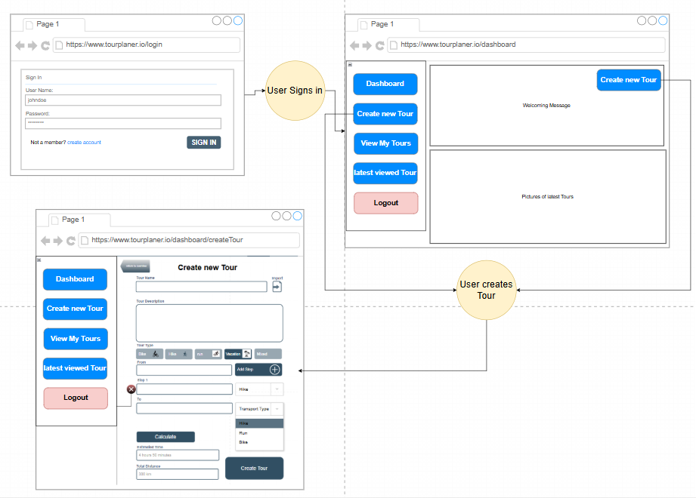
Since “Creating a Tour” is one of the main Use-Cases of our Tour-Planner we gave the User multiple options to reach that screen.
However we also did not want to just throw the user into a functionality, once they are logged in, which is why we have the dashboard-screen.

“As a User I want to view a specific Tour, so that I can easily manage it”
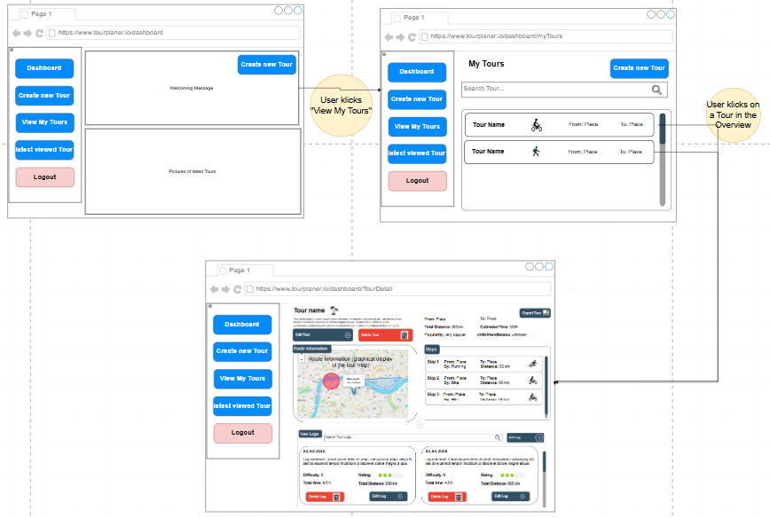
From the Dashboard the user has the option to see an overview of their tours.
From the Overview the user can select a Tour by klicking on it and ist navigated to the overview, where they are given the Option to “Modifiy” or “Delete” the Tour
As well as add or delete Logs.
The tour that was the last one to be selected by the user is saved in the App-State. This way the User also has the easy option to navigate to this tour by klicking “latest viewed Tour”. Creating a Tour saves that one to the App-State as the latest selected and navigates to the detail-screen.

Improving User-Experience

List-Containers Scrollable/Collapsable
A Decision that was made to improve the User-Experience was to make the List-Containers:
- Steps in Detail-Screen
- Logs in Detail-Screen
Scrollable when the User is using a desktop (large Screen)
And collapsible, when the User is using a small device.
This makes it easier to navigate for the user.
This had been the plan on the original wireframe:
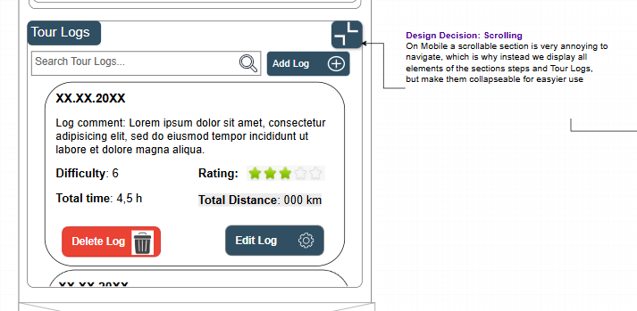
And has been implemented like this:
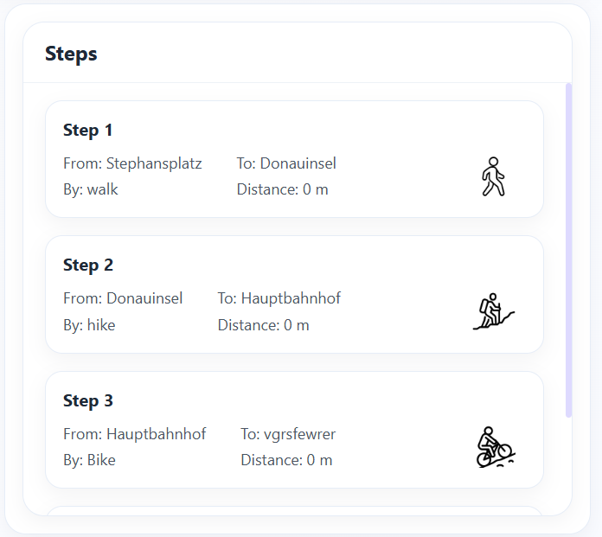
Steps on Desktop:

Steps on Mobile – not collapsed: Steps on Mobile – collapsed:
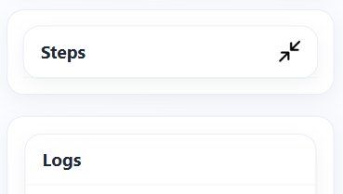
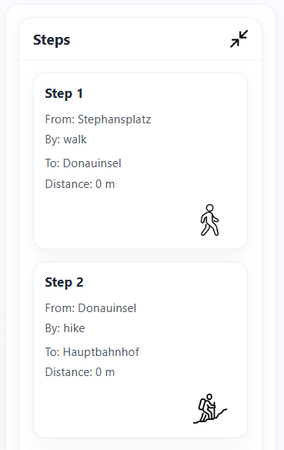

Navigation
Something we changed in our design was the way the user navigates the website. While in the original wireframe then user would navigate by using a top-nav-bar:
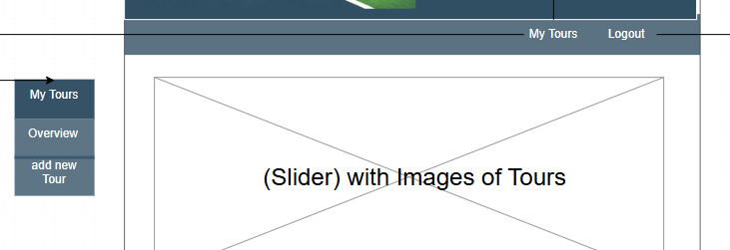

In the actual implementation we decided to use a side-nav-bar instead, to give it a more modern look:
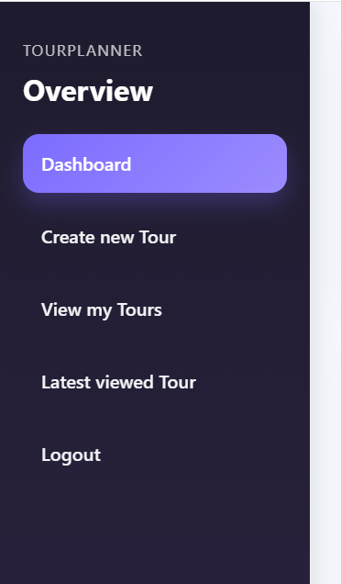

Icons
We decided to use intuitive icons to make it easy for the user to navigate/get information.
For Example in the steps we are displaying the route-type (the transport-mode by which the step is taken) by using icons.
Wireframe:
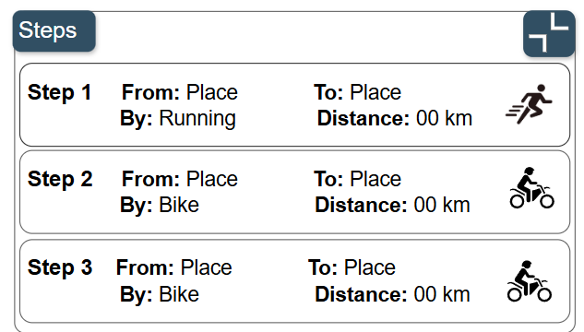
Implementation:
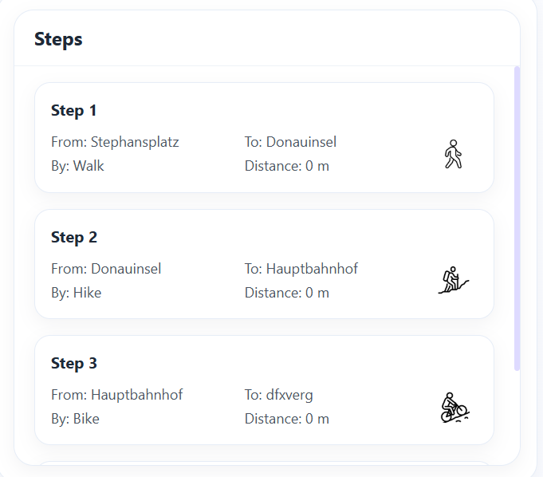
Another Example for this are the Buttons:
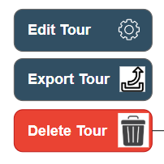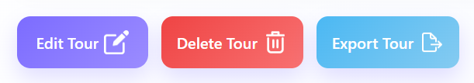
Wireframe implementation
Here we also decided to use 3 different colors to make the distinction easier.

Banner
While in the wireframe a Banner was used, we decided against it in the implementation to freshen up the look of the website.
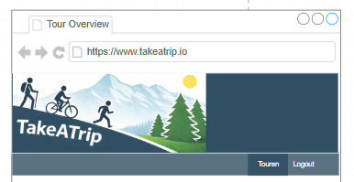
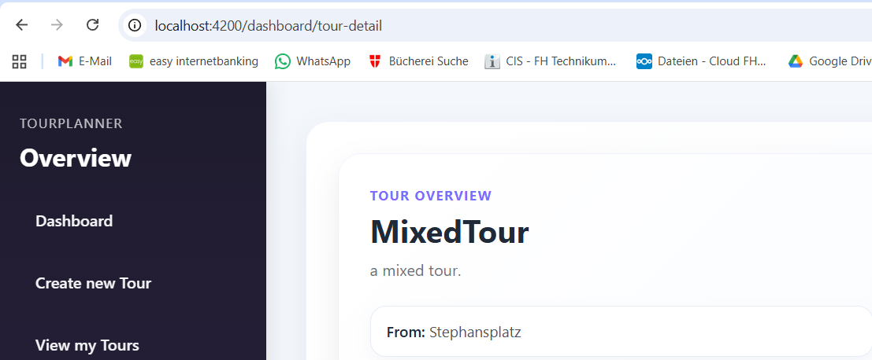

Maps in Tour Overview
In the wireframe we did not have a “picture” aka map on the tour overview:
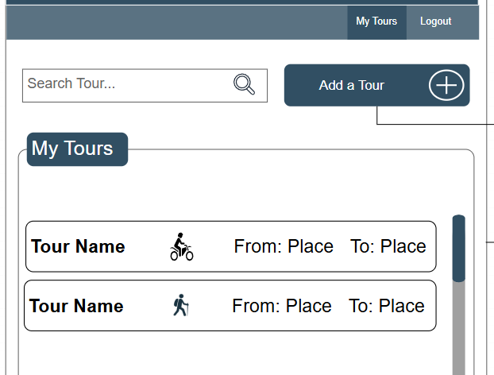

However, since this was a requirement for the intermediate hand-in we added them:

