

**Term Work**

**Compiler Design**

**(PCS-601)**

**2022-23**

**Submitted to: Submitted by:**

Mr. Mukesh Kumar Name: Yogesh K. Bhatt

(Associate Professor) Section: H

GEHU, DDN Roll No.: 64

Semester: 06

Student ID: 20011189

**DEPARTMENT OF COMPUTER SCIENCE AND ENGINEERING**

**GRAPHIC ERA HILL UNIVERSITY, DEHRADUN**

**ACKNOWLEDGEMENT**

I would like to particularly thank my Compiler Design Lab Faculty Mr. Mukesh Kumar for his patience, support, and encouragement throughout the completion of this Term work.

At last, but not the least I greatly indebted to all other persons who directly or indirectly helped me during this course.

**Yogesh Kumar Bhatt**

**University. Roll No.- 2018886**

**B. Tech CSE-H-VI Sem**

**Session: 2022-23**

**GEHU, Dehradun**

**INDEX**

|  |  |  |  |  |
| --- | --- | --- | --- | --- |
| **S.no** | **PROGRAM NAME** | **Date** | **Page no.** | **Sign.** |
| 1. | Design a LEX Code to count the number of lines, space, tab meta character and rest of characters in a given Input pattern. |  |  |  |
| 2. | Design a LEX Code to identify and print valid Identifier of C/C++ in given Input pattern. |  |  |  |
| 3. | Design a LEX Code to identify and print integer and float value in given Input pattern. |  |  |  |
| 4. | Design a LEX Code for Tokenizing (Identify and print  OPERATORS, SEPERATORS, KEYWORDS, IDENTIFERS) |  |  |  |
| 5. | Design a LEX Code to count and print the number of total characters, words, white spaces in given 'Input.txt' file. |  |  |  |
| 6. | Design a LEX Code to replace white spaces of 'Input.txt' file by a single blank character into 'Output.txt' file. |  |  |  |
| 7. | Design a LEX Code to remove the comments from any C Program given at run-time and store into 'out.c' file. |  |  |  |
| 8. | Design a LEX Code to extract all html tags in the given HTML file at run time and store into Text file given at run time. |  |  |  |
| 9. | Design a DFA in LEX Code which accepts string containing even number of 'a' and even number of 'b' over input alphabet (a, b). |  |  |  |
| 10. | Design a DFA in LEX Code which accepts string containing third last element 'a' over input alphabet (a, b). |  |  |  |
| 11. | Design a DFA in LEX Code to Identify and print Integer & Float Constants and Identifier. YACC/LEX code: |  |  |  |
| 12. | Design YACC/LEX code to recognize valid arithmetic expression with operators +, -, * and /. |  |  |  |
| 13. | Design YACC/LEX code to evaluate arithmetic expression involving operators +, -, * and / without operator precedence grammar & with operator precedence grammar. |  |  |  |
| 14. | Design YACC/LEX code that translates infix expression to postfix expression. |  |  |  |
| 15. | Design Desk Calculator using YACC/LEX Code. |  |  |  |

**Study of Lex and Yacc**

**Lex:**

* Lex is a tool which converts the source code into stream of tokens.
* It is also called scanner/tokenizer.

**Functions of Lex:**

* Firstly lexical analyzer creates a program lex.l in the Lex language. Then Lex compiler runs the lex.1 program and produces a C program lex.yy.c.
* Finally C compiler runs the lex.yy.c program and produces an object program a.out.
* a.out is lexical analyzer that transforms an input stream into a sequence of tokens.

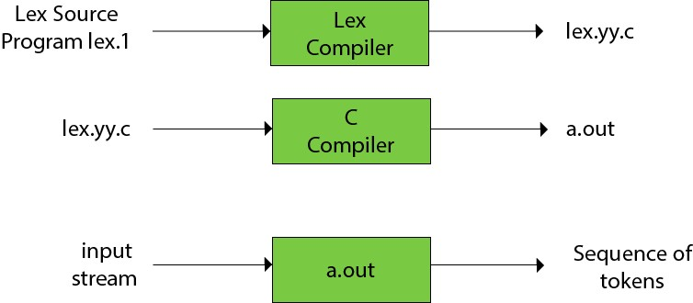

**Lex Program Format:**

%{ Definition/Declaration Section

//header files, definitions, variables

%}

%%

Rule Section. //Regular expressions and corresponding actions.

%%

{Auxiliary Functions}

**YACC:**

* YACC stands for **Yet Another Compiler Compiler**.
* YACC provides a tool to produce a parser for a given grammar.
* The input of YACC is the rule or grammar and the output is a C program.
* YACC is a program designed to compile a LALR (1) grammar.
* It is used to generate the parse tree.

**Functions:**

File.y →[yacc tool/compiler]→y.tab.c

y.tab.c→[c compiler]→a.out tokens→[a.out]→[parse tree with the help of the grammar]

**Yacc Program Format:**

The declarations section consists of two parts: (i) C declarations and (ii) YACC declarations .

%{

/*Beginning of C declarations*/

/*End of C declarations*/

%}

/*Beginning of YACC declarations */

/*End of YACC declarations */

/* End of Declarations Part */

%%

/* Rules Section begins here */

--------------------

/* Rules Section ends here */

%%

{

Auxiliary functions

}

**Program No. 1**

**Ques 1**. Design a LEX Code to count the number of lines, space, tab-meta character and rest of characters in a given Input pattern.

**Source Code:**

%{

#include <stdio.h>

int l=0, c=0, s=0, t=0;

%}

%%

[\n] {l++;c++;}

[\t] {t++;c++;}

[ ] {s++;c++;}

[^\t\n ] {c++;}

%%

int yywrap() {

return 1;

}

int main() {

printf("Enter the input string: ");

yylex();

printf("\nLines=%d\nCharacters=%d\nSpaces=%d\nTab=%d\n", l, c, s, t);

return 0;

}

**Output**

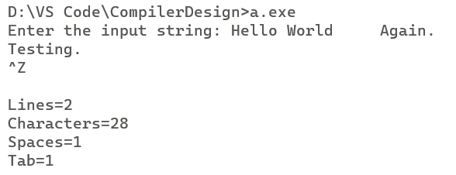

**Program No. 2**

**Ques 2.** Design a LEX Code to identify and print valid Identifier of C/C++ in given Input pattern.

**Source Code:**

%{

#include <stdio.h>

%}

%%

[a-zA-Z_][a-zA-Z0-9_]* {printf("Valid Identifier");}

.* {printf("Not a Valid Identifier");}

%%

int yywrap() {

return 1;

}

int main() {

printf("\nEnter the input: ");

yylex();

return 0;

}

**Output**

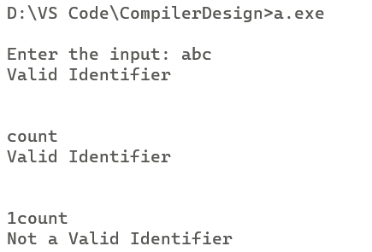

**Program No. 3**

**Ques 3.** Design a LEX Code to identify and print integer and float value in given Input pattern.

**Source Code:**

%{

#include <stdio.h>

%}

%%

[0-9]+"."[0-9]+ {printf("\nDecimal Number\n");}

[0-9]+ {printf("\nInteger Number\n");}

%%

int yywrap()

{

return 1;

}

int main()

{

yylex();

return 0;

}

**Output**

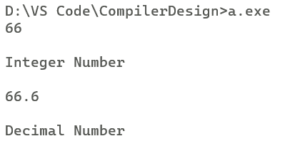

**Program No. 4**

**Ques 4.** Design a LEX Code for Tokenizing (Identify and print OPERATORS, SEPERATORS, KEYWORDS, IDENTIFERS).

**Source Code:**

%{

#include <stdio.h>

%}

%%

[+ - = * /] {printf("Operator\n");}

[{}()] {printf("Separator\n");}

int|float|if|else|while|bool|for|do|double|char|printf|scanf|default|auto|goto|break|continue|case|switch|enum|extern|inline|long|short|return|sizeof|signed|static|unsigned|typedef|union|void {printf("Keyword\n");}

[a-z A-Z][a-z A-Z 0-9]* {printf("Identifier\n");}

%%

int yywrap() {

return 1;

}

int main() {

yylex();

return 0;

}

**Output**

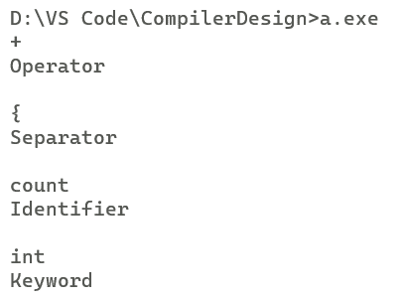

**Program No. 5**

**Ques 5.** Design a LEX Code to count and print the number of total characters, words, white spaces in given 'Input.txt' file.

**Source Code:**

%{

#include <stdio.h>

int tWord=0, tChar=0, tSpace=0;

%}

%%

[^\n \t] {tChar++;}

" " {tWord++; tSpace++;}

[\n \t] {tWord++;}

%%

int yywrap() {

return 1;

}

int main() {

yyin=fopen("p5.txt", "r");

yylex();

printf("\nTotal Word = %d, Total Character = %d, Total Space = %d\n", tWord, tChar, tSpace);

return 0;

}

**Output**

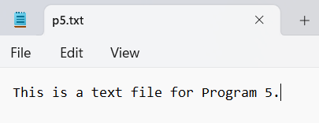

**Program No. 6**

**Ques 6.** Design a LEX Code to replace white spaces of 'Input.txt' file by a single blank character into 'Output.txt' file.

**Source Code:**

%{

#include <stdio.h>

%}

%%

[\t " "]+ {fprintf(yyout, " ");}

%%

int yywrap() {

return 1;

}

int main() {

yyin = fopen("p6_Input.txt", "r");

yyout = fopen("p6_Output.txt", "w");

yylex();

return 0;

}

**Output:**

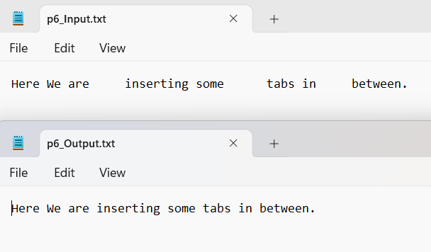

**Program No. 7**

**Ques 7.** Design a LEX Code to remove the comments from any C Program given at run-time and store into 'out.c' file.

**Source Code:**

%{

#include <stdio.h>

%}

%%

\/\/(.*) {};

\/\*(.*\n)*.*\*\/ {};

%%

int yywrap() {

return 1;

}

int main() {

yyin = fopen("p7_Input.c", "r");

yyout = fopen("p7_Output.c", "w");

yylex();

return 0;

}

**Output:**

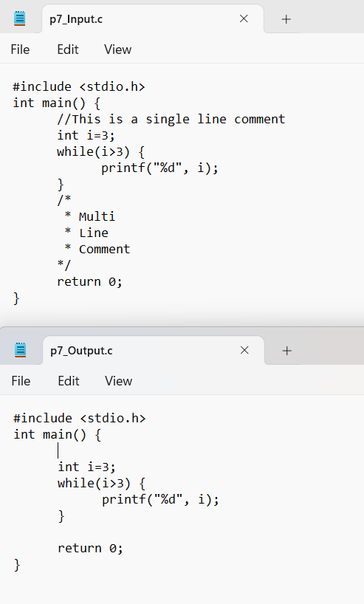

**Program No. 8**

**Ques 8.** Design a LEX Code to extract all html tags in the given HTML file at run time and store into Text file given at run time.

**Source Code:**

%{

#include <stdio.h>

%}

%%

"<"[^>]*> {fprintf(yyout,"%s\n",yytext);}

. {};

%%

int yywrap() {

return 1;

}

int main() {

yyin = fopen("p8_htmlIn.html", "r");

yyout = fopen("p8_htmlOut.txt", "w");

yylex();

return 0;

}

**Output:**

